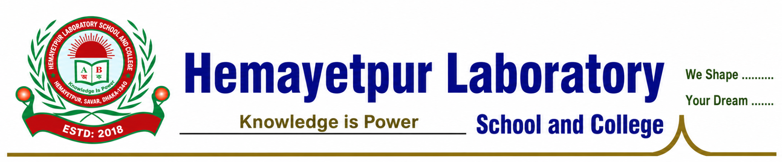
NOC No.: HLSC/EC/2026/001 | Date: 31 July 2026

EXPERIENCE CERTIFICATE (EC)

TO WHOM IT MAY CONCERN

This is to certify that Mr. Md. Abu Sayed is currently serving as a Senior Assistant Teacher at Hemayetpur Laboratory School and College, Hemayetpur, Savar-1340, Dhaka, Bangladesh, since 10 April 2025.

He has demonstrated professional competence, integrity, dedication, and a strong sense of responsibility in the performance of his assigned duties. His conduct and professional performance have been satisfactory throughout his service.

This certificate is issued as an official record of his employment and professional service for employment, higher education, scholarship, visa, immigration, and other official purposes in Bangladesh or abroad.

We wish him continued success in his future career.

Issued by:
___________________
Principal
Hemayetpur Laboratory School and College
Hemayetpur, Saver-1340, Dhaka, Bangladesh


