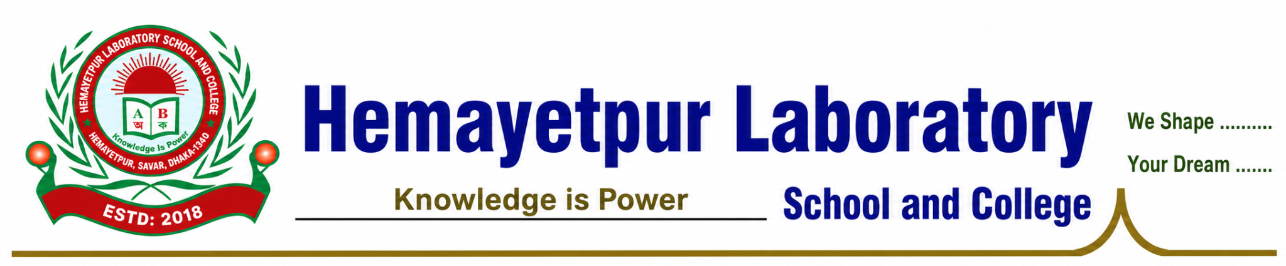
NOC No.: HLSC/NOC/2026/001 | Date: 31 July 2026

NO OBJECTION CERTIFICATE (NOC)

TO WHOM IT MAY CONCERN

This is to certify that Mr. Md. Abu Sayed is currently serving as a Senior Assistant Teacher at Hemayetpur Laboratory School and College, Hemayetpur, Savar-1340, Dhaka, Bangladesh.

This is further to certify that the institution has no objection to Md. Abu Sayed is pursuing higher studies at any recognized university or higher educational institution in Bangladesh or abroad.

This No Objection Certificate is issued to him upon his request for the purpose of higher studies and related academic and official requirements.

The issuance of this certificate signifies that the institution has no objection to his pursuing higher studies.

We wish him every success in his higher studies and future professional endeavors.

Issued by:
___________________
Principal
Hemayetpur Laboratory School and College
Hemayetpur, Saver-1340, Dhaka, Bangladesh


