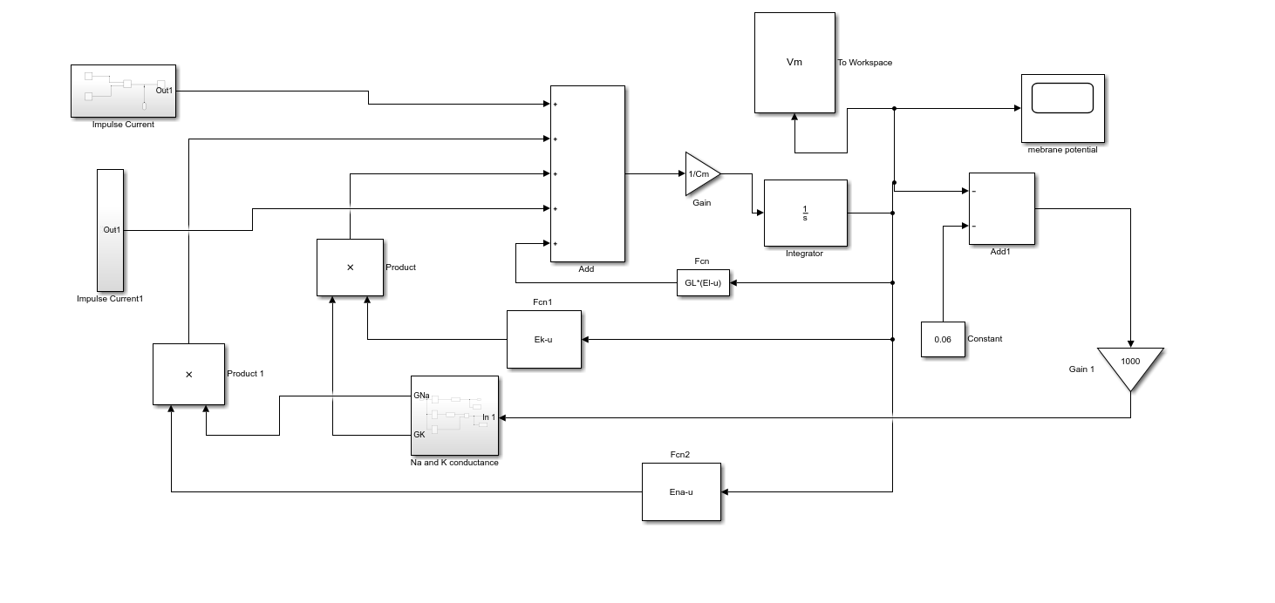

Fig no: 5.1 Hodgkin-Huxley Model of Action Potential

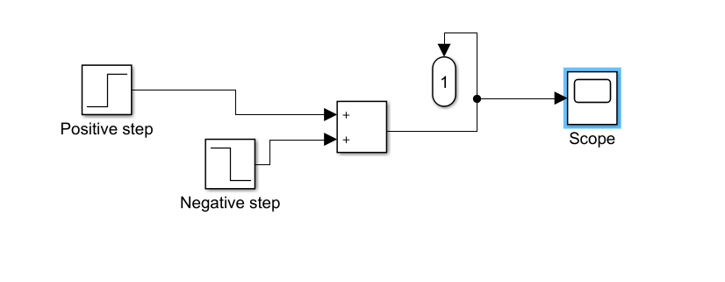

Fig no: 5.2 Impulse Current 1

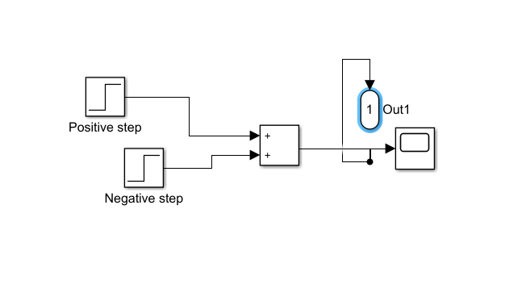

Fig no: 5.3 Impulse Current 2

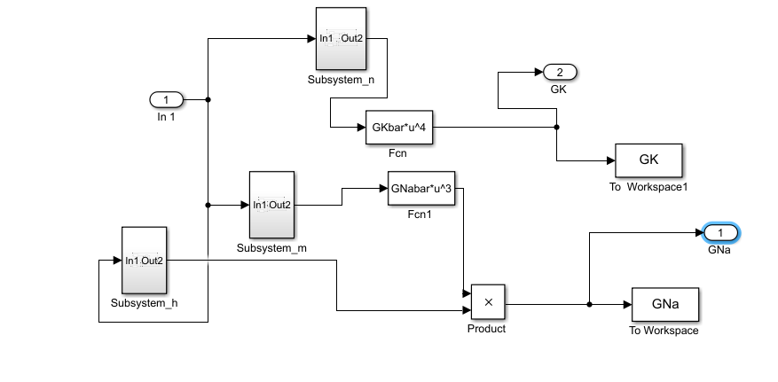

Fig no: 5.4 Na-K Conductances

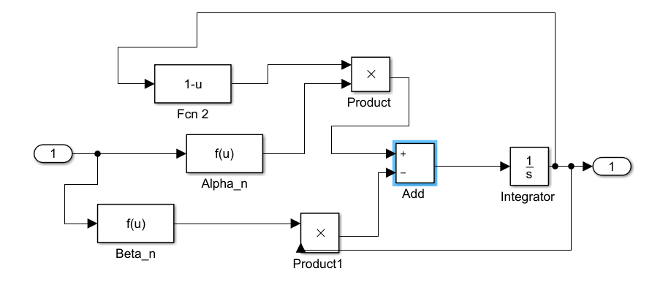

Fig no: 5.5 Subsystem n

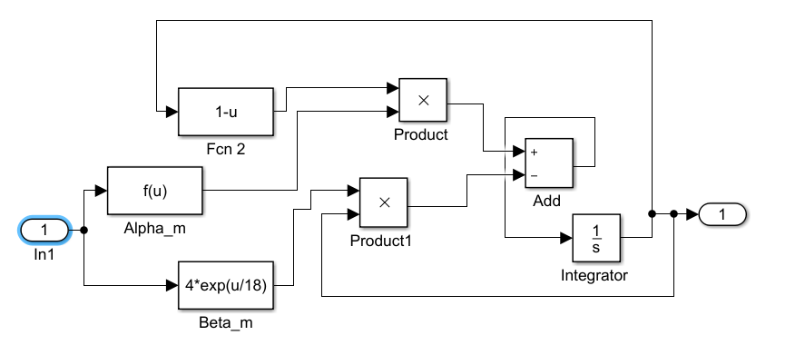

Fig no: 5.6 Subsystem m

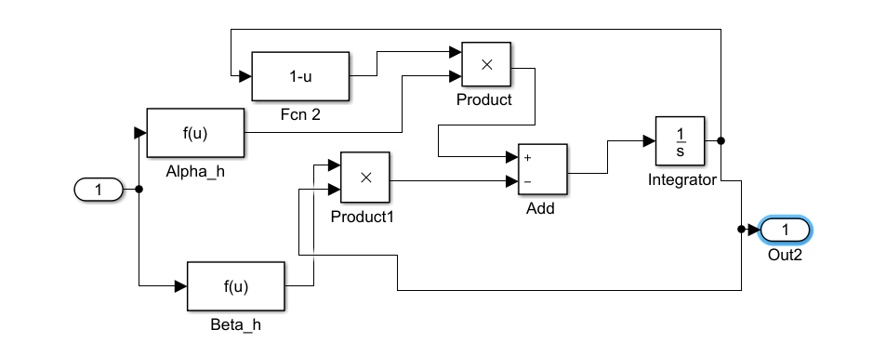

Fig no: 5.7 Subsystem h

GL=0.3\*10^-3;

GKbar=36\*10^-3;

GNabar=120\*10^-3;

Ek=-72\*10^-3;

Ena=55\*10^-3;

El=-49.4\*10^-3;

Cm=1\*10^-6;

sti=16;

K=30\*10^-6;

t0=10\*10^-3;

sti2=25;

K2=0\*50\*10^-6;

t02=15\*10^-3;

plot(GNa,'r')

hold on

plot(GK,'g')

hold on

plot(Vm)

hold on

p=GNa+GK;

plot(p)

axis([-inf inf -0.08 0.05])

grid on

legend('GNa','GK','Vm','p')

