clear all

close all

a=dicomread('img_036.dcm');

b=dicominfo('img_036.dcm')

subplot(1,2,1)

imshow(a,[])

title('Spine image in DICOM Format')

subplot(1,2,2)

imagesc(a)

title('Spine image in DICOM Format')

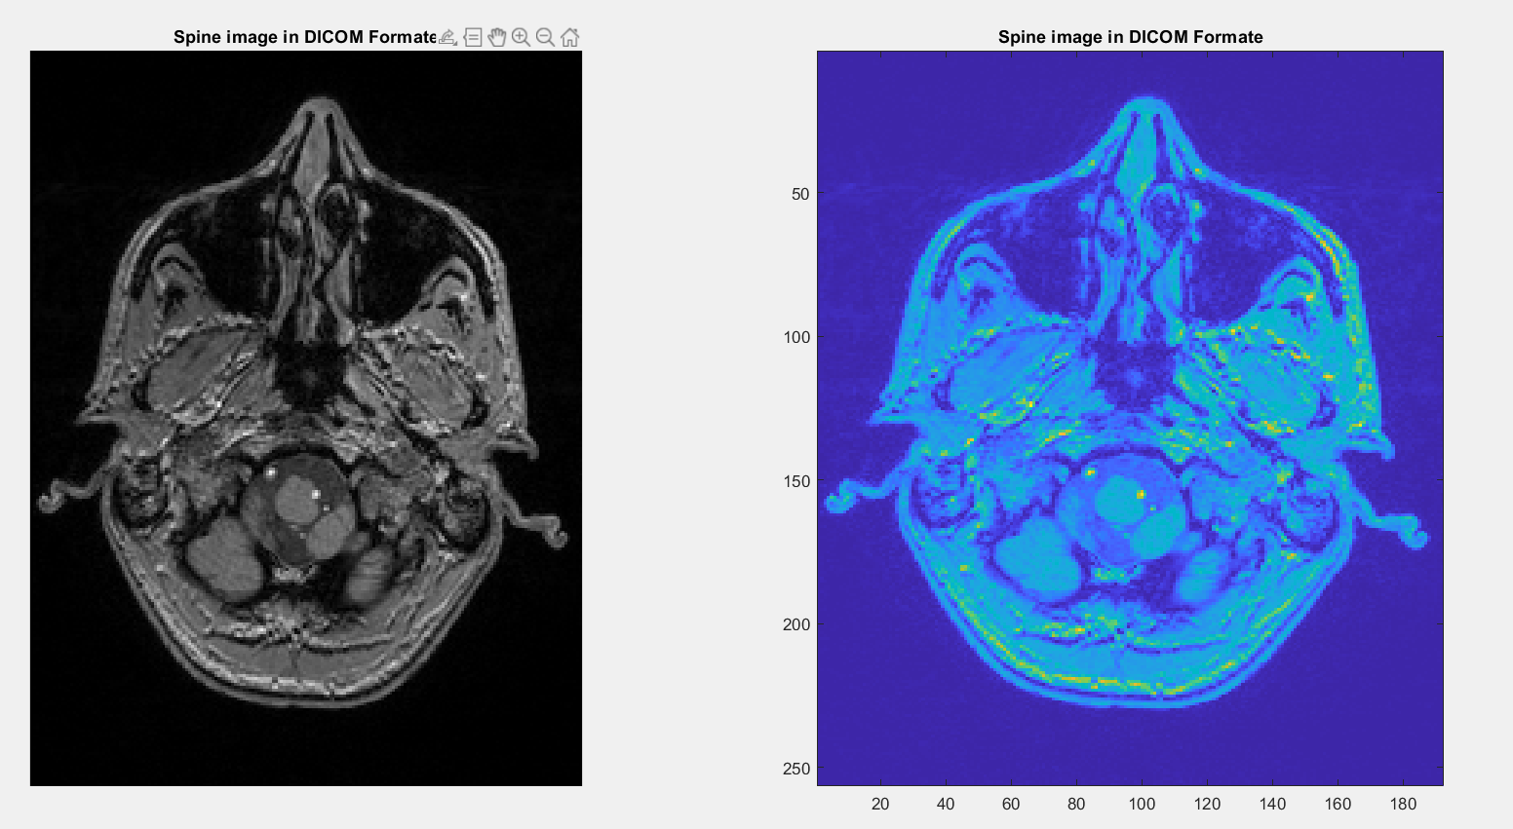 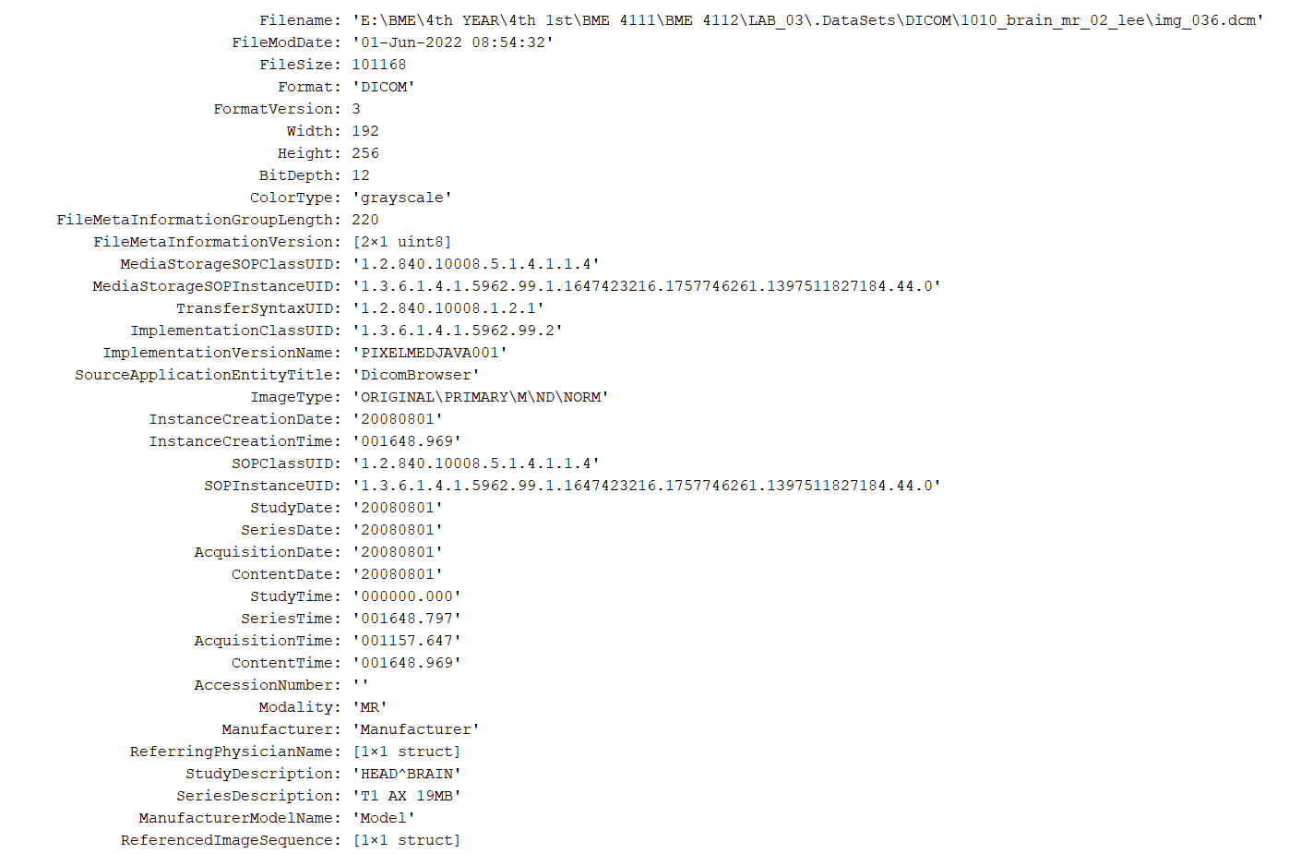

Fig: Spine image in DICOM Format

clc

clear all

close all

a=dicomread('img_084.dcm');

b=dicominfo('img_084.dcm')

subplot(1,2,1)

imshow(a,[])

title('Brain image in DICOM Format')

subplot(1,2,2)

imagesc(a)

title('Brain image in DICOM Format')

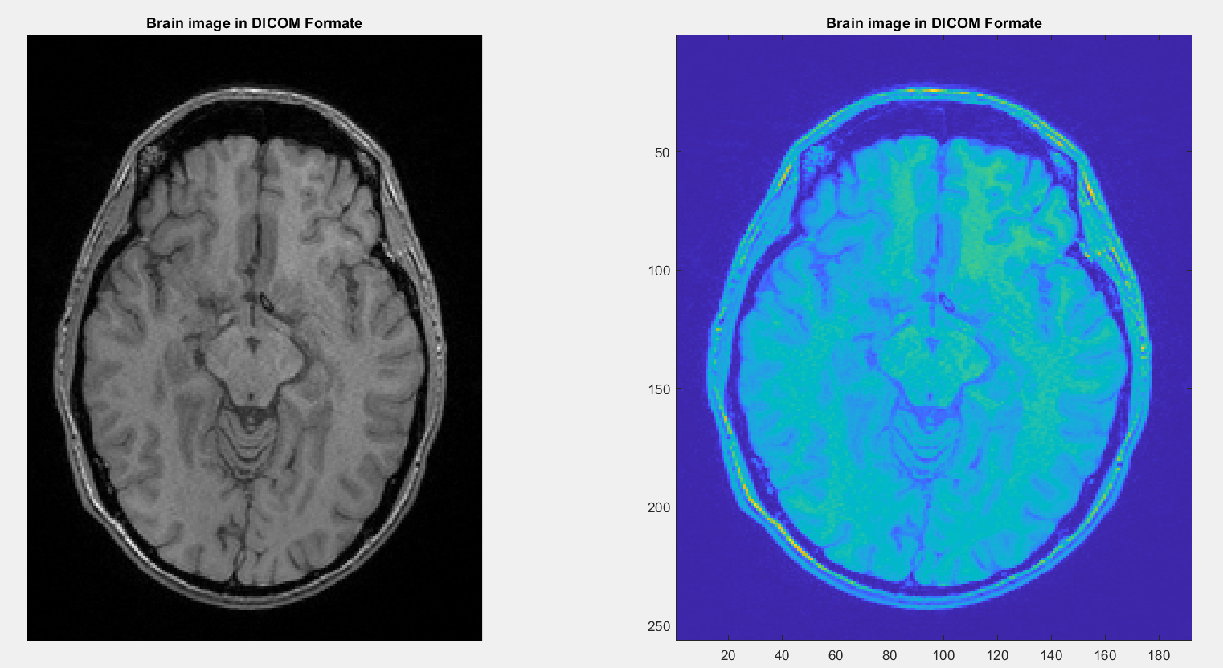 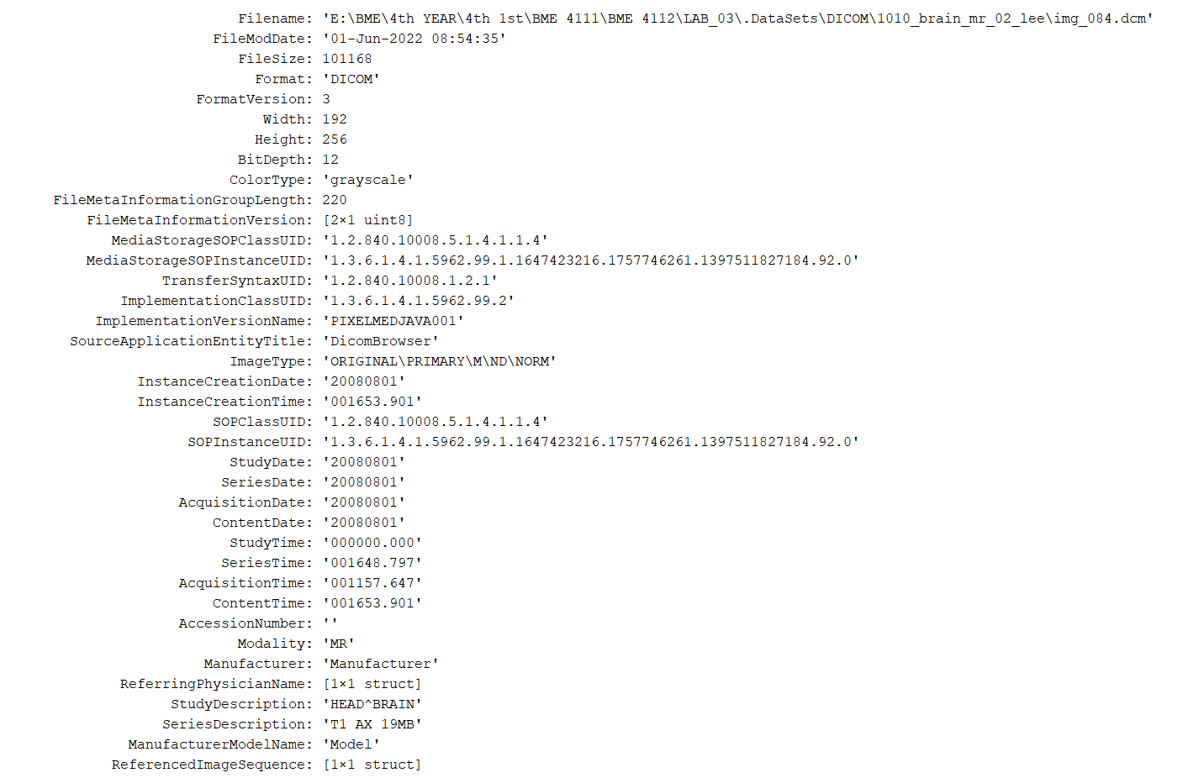

Fig: Brain image in DICOM Format

clear all

close all

a=analyze75read('MR-MONO2-12-an1.hdr');

anaXinfo = analyze75info('MR-MONO2-12-an1.hdr')

subplot(1,2,1)

imshow(a,[])

title('Brain image in ANLYZE Format')

subplot(1,2,2)

imagesc(a)

title('Brain image in ANLYZE Format')

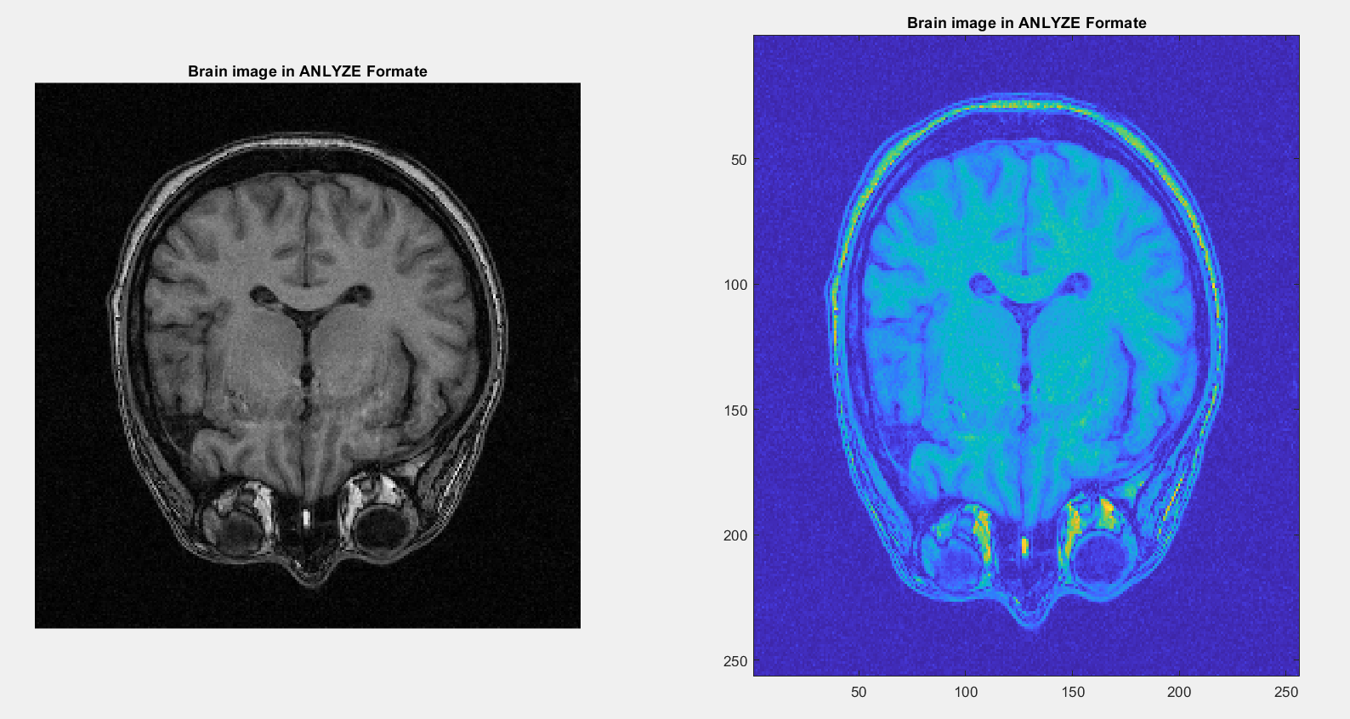 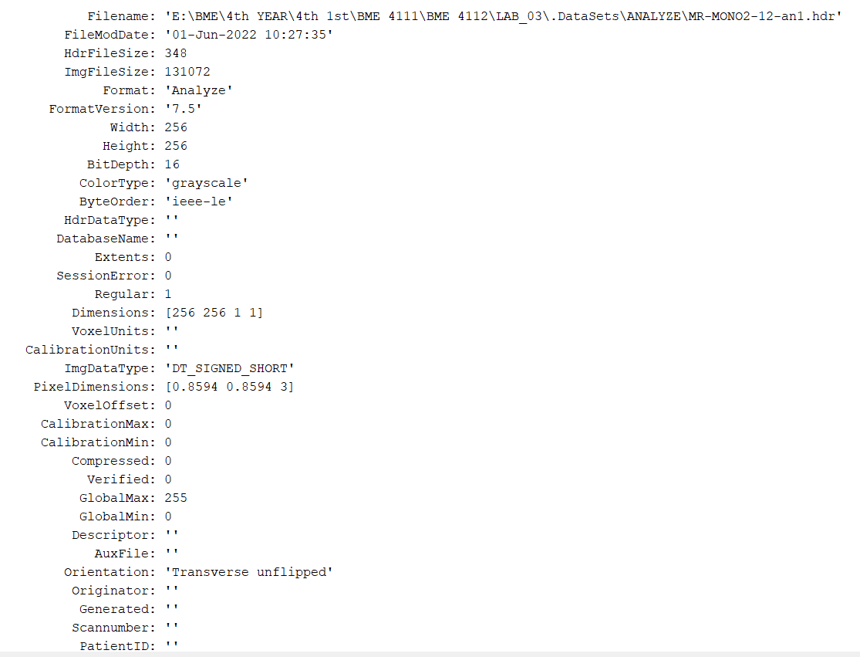

Fig: Brain image in ANLYZE Format

clc

clear all

close all

a=analyze75read('OT-MONO2-8-a7.hdr');

anaXinfo = analyze75info('OT-MONO2-8-a7.hdr')

subplot(1,2,1)

imshow(a,[])

title('Vessel image of eye in ANLYZE Format')

subplot(1,2,2)

imagesc(a)

title('Vessel image of eye in ANLYZE Format')

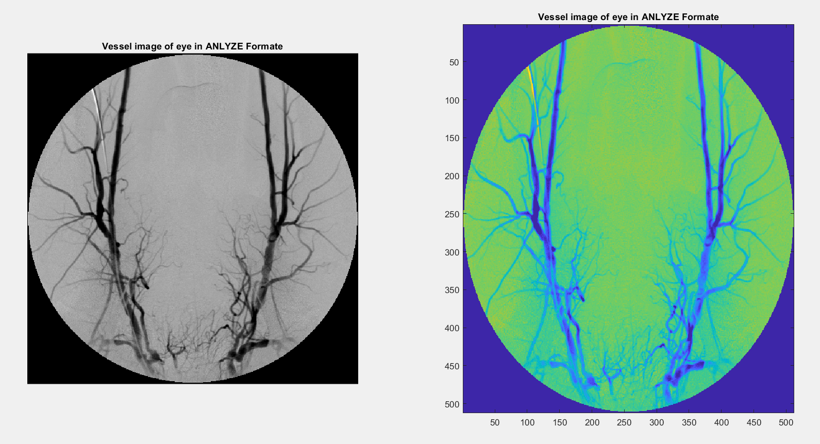 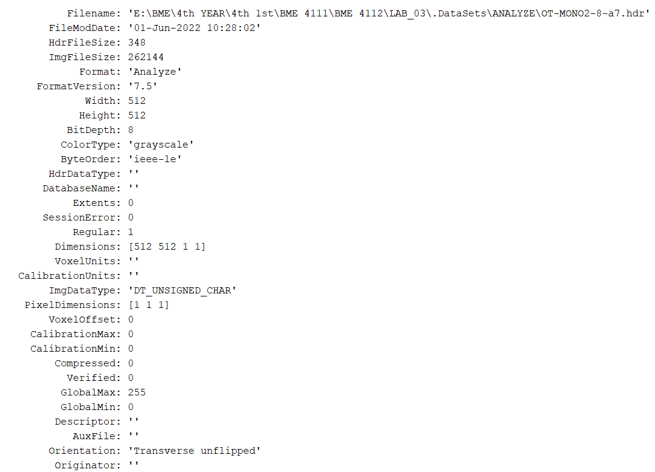

Fig: Vessel image of eye in ANLYZE Format

clear all

close all

V = niftiread('ircad_e03_orig');

U = niftiinfo('ircad_e03_orig')

a = V(:,:,50);

subplot(1,2,1)

imshow(a,[])

title('Thoracic image in NIFTI Format')

subplot(1,2,2)

imagesc(a)

title('Thoracic image in NIFTI Format')

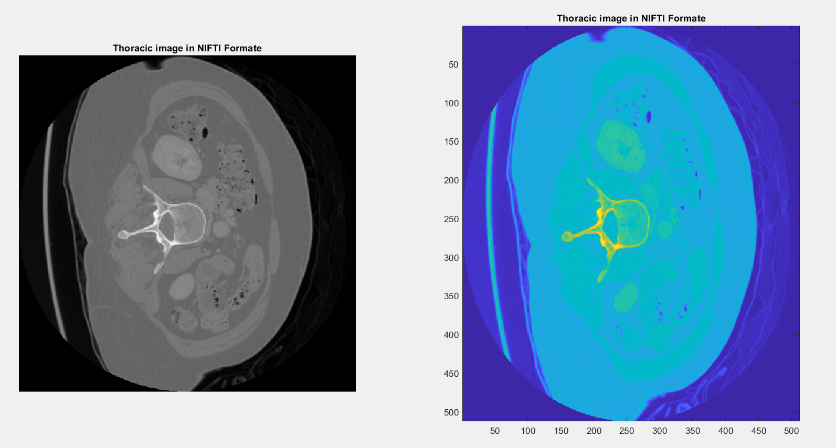 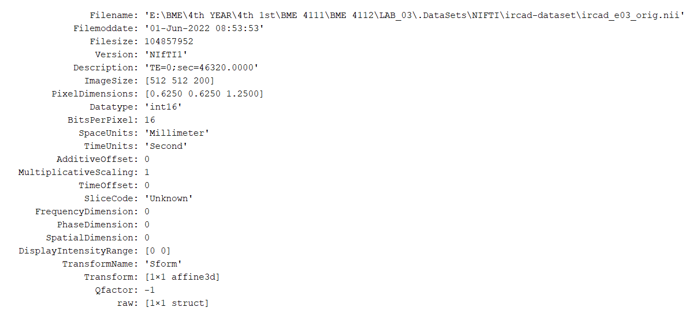

Fig: Thoracic image in NIFTI Format

clear all

close all

V = niftiread('inia19-tissue');

U = niftiinfo('inia19-tissue')

a = V(:,:,100);

subplot(1,2,1)

imshow(a,[])

title('Brain image in NIFTI Format')

subplot(1,2,2)

imagesc(a)

title('Brain image in NIFTI Format')

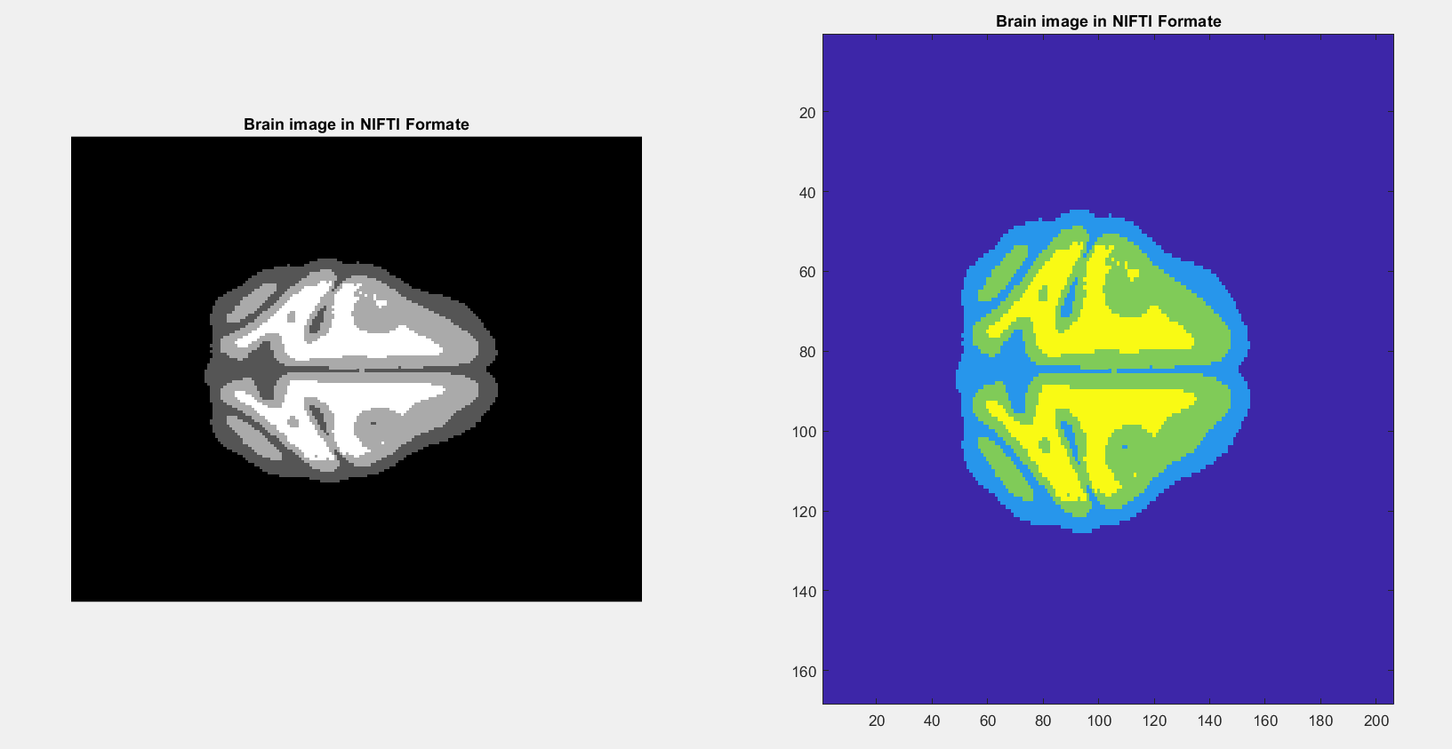 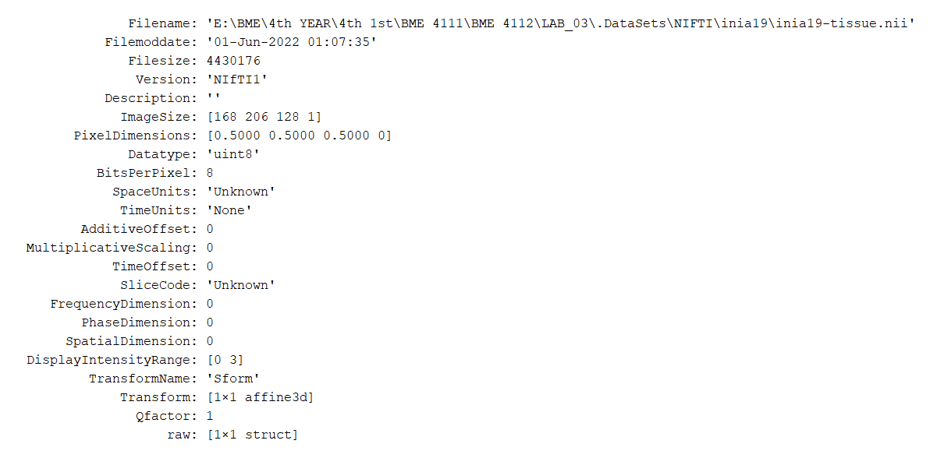

Fig: Brain image in NIFTI Format

clear all

close all

[minc,scaninfo] = loadminc('subject04_wm_gt.mnc');

scaninfo

a=minc(:,:,250);

subplot(1,2,1)

imshow(a,[])

title('Brain image in MINC Format')

subplot(1,2,2)

imagesc(a)

title('Brain image in MINC Format')

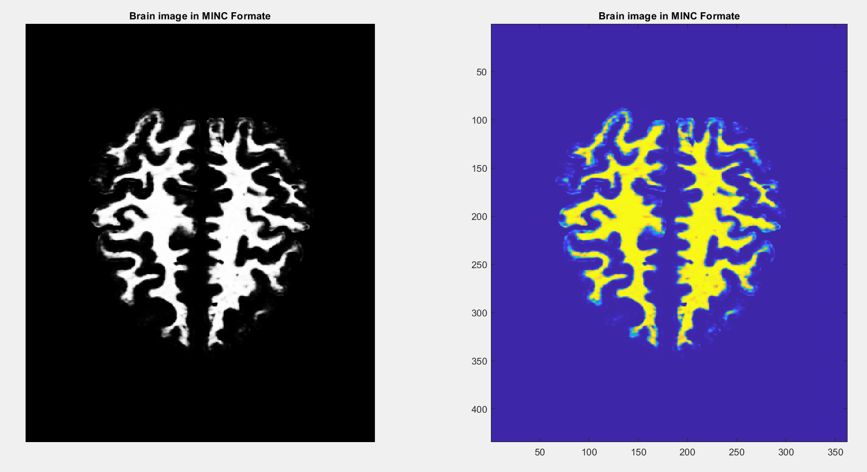 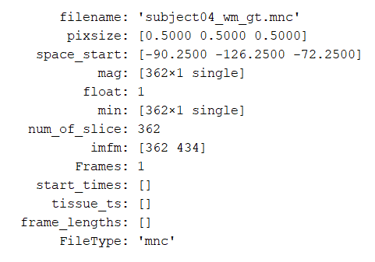

Fig: Brain image in MINC Format

clear all

close all

[minc,scaninfo] = loadminc('subject05_csf_gt.mnc');

scaninfo

a=minc(:,:,250);

subplot(1,2,1)

imshow(a,[])

title('Brain image in MINC Format')

subplot(1,2,2)

imagesc(a)

title('Brain image in MINC Format')

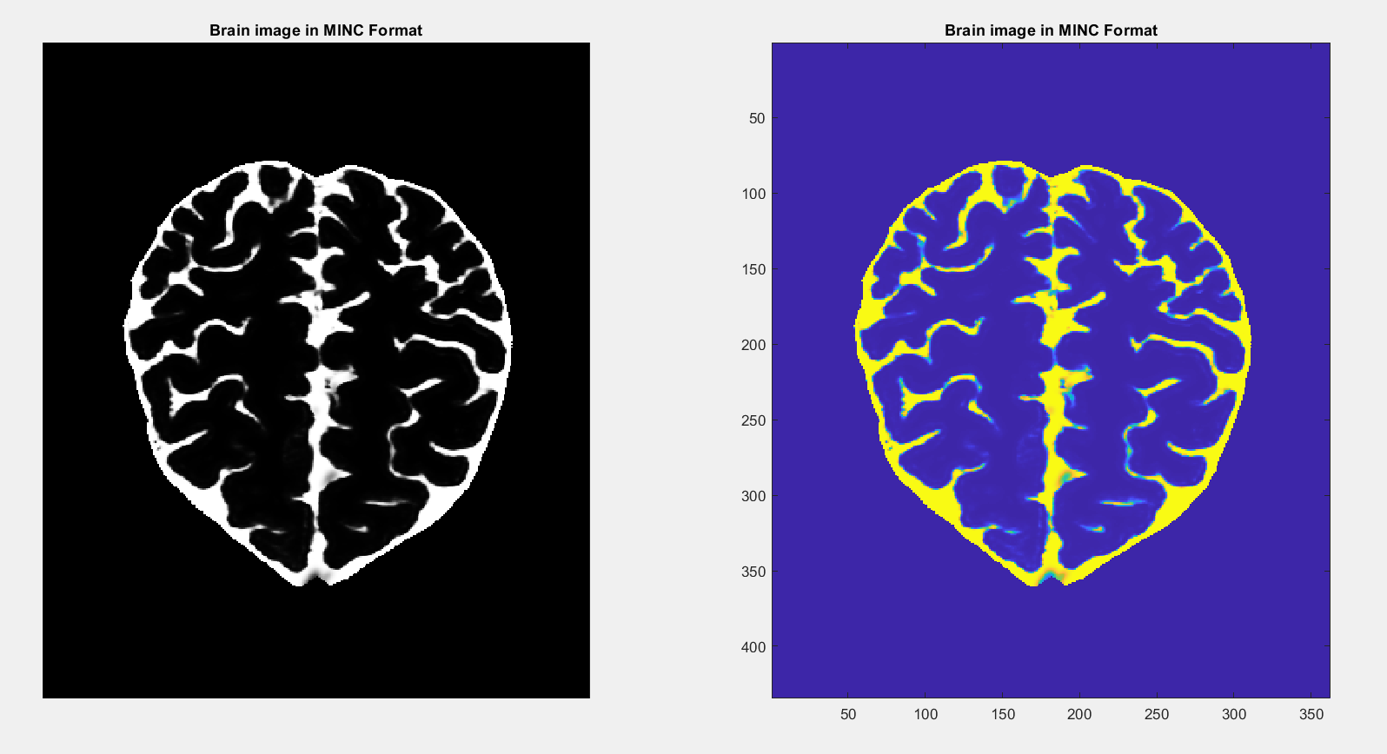 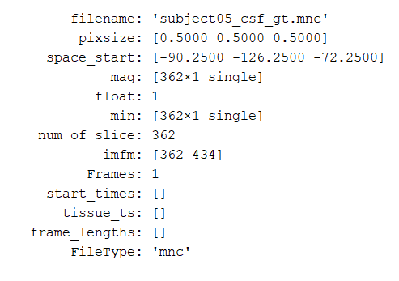

Fig: Brain image in MINC Format