WEEK 2 TASK
Exploratory Data Analysis (EDA)
& Visualization Framework Design
Framework for the Student Academic Performance Prediction and Analysis Project

Project Detail | Information
Internship | Virtual Data Science Explorer Internship
Organization | YuvaIntern
Intern | Sayed Ajmal Rizavi
Task | Week 2 — Exploratory Data Analysis & Visualization Framework Design
Planned Effort | 34 hours
Dataset Status | No dataset provided; framework designed to be adaptable

Prepared for internship submission

1. Introduction to Exploratory Data Analysis
Exploratory Data Analysis (EDA) is the systematic process of inspecting, summarising, visualising, and questioning a dataset before formal statistical modeling or machine-learning development. EDA helps a data scientist understand the structure and quality of data, discover patterns and relationships, identify unusual observations, and formulate useful analytical questions.
For the proposed Student Academic Performance project, EDA will be used to understand how variables such as attendance, study hours, assignment performance, midterm score, previous semester performance, and participation may relate to the final academic outcome. Because Week 2 provides no dataset, this document defines a reusable framework rather than reporting findings from actual observations.

1.1 Why EDA Matters
- Reveals data-quality problems before modeling.
- Shows distributions, ranges, variability and potential skewness.
- Identifies missing values, duplicates and unusual observations.
- Helps detect relationships between predictors and the target.
- Guides feature engineering and model selection.
- Provides visual evidence that makes analytical findings easier to communicate.
- Reduces the risk of building models on misunderstood or unsuitable data.

2. EDA Objectives
- Understand dataset structure, size, variables and data types.
- Assess completeness, consistency and validity of the data.
- Summarise individual variables using descriptive statistics.
- Explore pairwise and multivariable relationships.
- Identify potential outliers, skewness and unusual patterns.
- Select appropriate visualizations based on analytical questions and variable types.
- Generate hypotheses and insights that can guide later modeling.
- Document every major analytical decision for reproducibility.

3. Potential Data Types & Dataset Profiling
The framework is designed to work with common structured-data types. Correctly identifying data types is important because it determines which summaries, statistical techniques and visualizations are appropriate.
Data Type | Examples | Typical EDA / Visualization
Numeric — continuous | Attendance %, study hours, final score | Histogram, KDE, box plot, scatter plot
Numeric — discrete | Number of assignments, absence count | Bar chart, histogram, box plot
Categorical — nominal | Participation level, subject, program | Count plot, bar chart
Categorical — ordinal | Low / Medium / High performance | Ordered bar chart, box plot
Boolean / binary | Passed/failed, yes/no | Count plot, proportion bar
Datetime | Submission date, exam date | Line chart, time trend
Text | Comments or free-form responses | Length/frequency analysis; NLP only if in scope

3.1 Initial Dataset Profiling
- Load data with Pandas and inspect rows and columns.
- Check data shape, column names and data types.
- Review sample records using head() and tail().
- Generate descriptive statistics for numeric and categorical fields.
- Measure missingness by column and, where useful, by row.
- Check duplicate records and unique category values.
- Confirm units, valid ranges and target definition against the data dictionary.

4. Proposed EDA Workflow
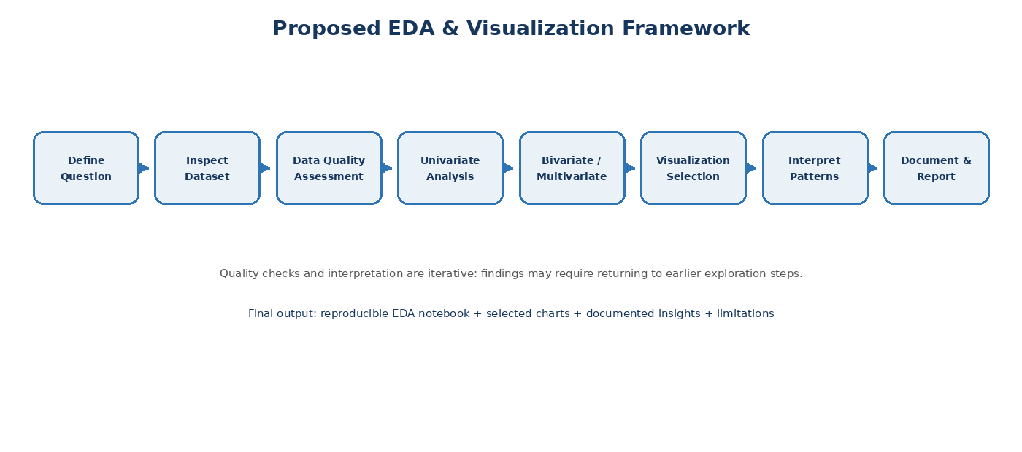
Figure 1. Planned EDA and visualization workflow.

5. Data Quality Assessment

5.1 Missing Data
Missing values will first be quantified and investigated rather than automatically replaced. The treatment will depend on the amount of missingness, variable meaning, missingness pattern, and analytical objective.
Situation | Possible Treatment | Decision Principle
Small amount of random missing numeric values | Median/mean imputation or appropriate model-based method | Preserve records while limiting distortion.
Categorical missing values | Explicit 'Unknown' category or mode when justified | Avoid hiding meaningful missingness.
Large missingness in a critical feature | Investigate source; consider excluding feature | Avoid unreliable information.
Missing target values | Usually exclude from supervised training | Target is required for evaluation.
Systematic missingness | Investigate collection process | Missingness itself may carry information.

5.2 Duplicates & Invalid Values
- Identify exact duplicates and assess whether they represent repeated observations or errors.
- Validate numeric ranges such as attendance percentages and assessment scores.
- Standardize units and categorical labels.
- Check impossible dates, negative counts and inconsistent identifiers.
- Record all cleaning decisions rather than silently changing data.

5.3 Outlier Detection
Outliers will be treated as observations requiring investigation, not automatically as errors. Detection methods may include the Interquartile Range (IQR) rule, box plots, z-scores where assumptions are appropriate, and visual inspection.
- Verify whether an extreme value is valid and meaningful.
- Correct clear data-entry errors when reliable evidence exists.
- Consider transformation or robust methods when extreme values are legitimate.
- Compare results with and without influential observations when appropriate.

6. Univariate Analysis
Univariate analysis examines one variable at a time. The objective is to understand its distribution, central tendency, variability, frequency and unusual values.
Variable Type | Techniques | Example Question
Numeric | Mean, median, quantiles, standard deviation, histogram, KDE, box plot | What is the distribution of attendance and final scores?
Categorical | Frequency table, unique count, bar/count plot | Which participation levels are most common?
Datetime | Minimum/maximum date, frequency over time, line plot | Are observations concentrated in particular periods?

7. Bivariate Analysis
Bivariate analysis examines the relationship between two variables. The chosen method depends on whether the variables are numeric, categorical, or mixed.
Variable Pair | Techniques | Suggested Visualization
Numeric + Numeric | Correlation, covariance, scatter plot | Scatter plot / regression trend
Categorical + Numeric | Group statistics, distribution comparison | Box plot / violin plot / bar chart
Categorical + Categorical | Cross-tabulation, proportions | Grouped or stacked bar chart
Datetime + Numeric | Trend analysis | Line chart

8. Multivariate Analysis
Multivariate analysis examines several variables together to identify interactions, clusters, correlated features, and broader patterns that may not be visible in one- or two-variable analysis.
- Correlation heatmap for numerical variables.
- Pair plots for selected numerical features.
- Grouped comparisons across multiple categorical dimensions.
- Faceted charts when subgroup comparison is analytically justified.
- Feature relationships with the target while monitoring redundancy and leakage.
Multivariate exploration will be selective rather than generating every possible chart. The objective is to answer meaningful questions and avoid visual noise.

9. Visualization Strategies
Visualization will be question-driven. Each chart should communicate a specific analytical message, use appropriate scales and labels, and avoid unnecessary decoration.
Chart | Best Use | Example in Project
Histogram | Distribution of one numeric variable | Final score distribution
KDE plot | Smooth view of numeric distribution | Attendance or study-hours density
Box plot | Spread and outliers; group comparison | Final score by participation level
Violin plot | Distribution shape across groups | Score distribution across attendance bands
Bar / Count plot | Category frequencies or group summaries | Number of students by performance category
Scatter plot | Relationship between two numeric variables | Study hours vs final score
Line chart | Trends over ordered time | Average score across assessment dates
Heatmap | Correlation or matrix-style comparison | Correlation among academic variables
Pair plot | Multiple pairwise numeric relationships | Selected academic predictors
Stacked / Grouped bar | Composition or category comparison | Performance category by participation level

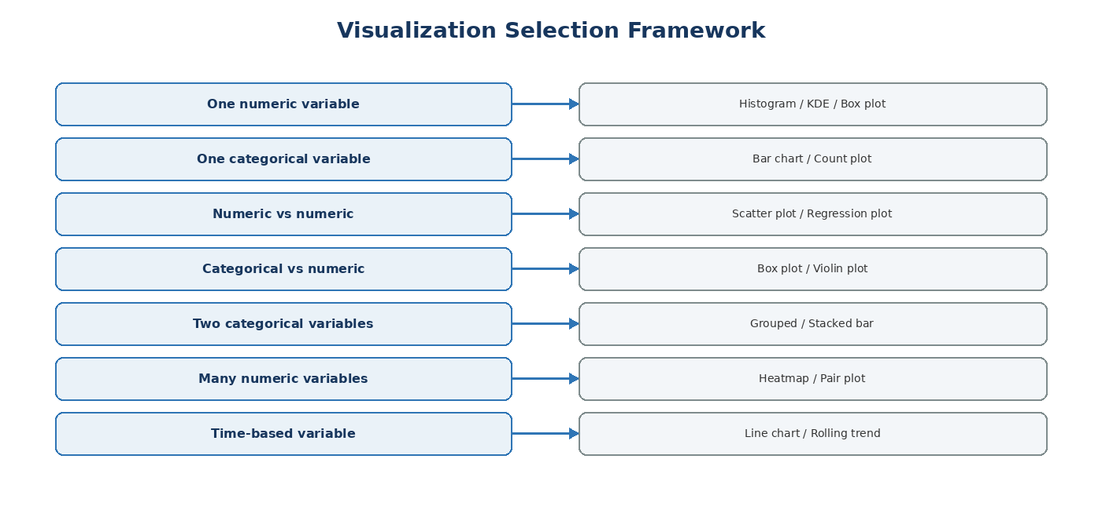
Figure 2. Decision framework for selecting visualizations based on analytical questions and variable types.

10. Visualization Design Principles
- Give every chart a clear, descriptive title.
- Label axes and include units where relevant.
- Use consistent categorical ordering and terminology.
- Avoid misleading scales, unnecessary 3D effects, and excessive decoration.
- Use legends only when they improve interpretation.
- Keep charts readable and appropriately sized for reports and presentations.
- Use annotations when a specific insight needs emphasis.
- Consider accessibility, including readable text and distinguishable categories.
- Save important figures with reproducible filenames and document their purpose.

11. Python Tools & Libraries
Tool / Library | Contribution to EDA Framework
Python | Core programming environment.
Pandas | Data loading, inspection, filtering, grouping, missing-value analysis and summaries.
NumPy | Numerical calculations and array operations.
Matplotlib | Flexible, publication-oriented base plotting library.
Seaborn | Statistical visualization with concise syntax and strong EDA support.
Plotly | Interactive charts useful for exploratory dashboards and presentations.
Jupyter Notebook | Combines code, narrative explanations, tables and visualizations.
VS Code | Project development, code organization and debugging.
Git & GitHub | Version control, collaboration and reproducible project history.

12. Proposed EDA Question Bank
- What is the overall distribution of final academic scores?
- Are attendance percentages concentrated within a particular range?
- Is there an apparent relationship between study hours and final score?
- How does assignment performance compare across performance categories?
- Do participation levels show different score distributions?
- Which numerical variables appear strongly correlated with each other?
- Are there unusual or potentially invalid records?
- Are categorical classes balanced enough for later classification?
- Which variables may require transformation or encoding before modeling?
- What limitations in the data could affect interpretation?

13. Reporting & Documentation Plan
The EDA work will be documented so another person can understand what was analysed, why each method was selected, what was discovered, and what limitations remain.
Report Section | Content
1. Executive Summary | Purpose, major findings and most important implications.
2. Dataset Overview | Source, size, variables, target and data dictionary.
3. Data Quality | Missing values, duplicates, invalid values and outlier assessment.
4. Univariate Analysis | Distributions, frequencies and descriptive statistics.
5. Bivariate Analysis | Relationships between key variables.
6. Multivariate Analysis | Combined patterns, correlations and subgroup analysis.
7. Visualization Findings | Key charts with concise interpretation.
8. Limitations | Data gaps, assumptions, sampling and analytical limitations.
9. Recommendations | Actionable next steps supported by the evidence.
10. Appendix | Additional charts, tables, code notes and technical details.

14. Notebook Documentation Standard
- Begin with project purpose, analytical questions and dataset description.
- Use clear Markdown headings for each EDA stage.
- Explain the purpose of important code blocks before executing them.
- Display intermediate quality checks and relevant summary tables.
- Give each important chart a meaningful title and interpretation.
- Record transformations and assumptions.
- Separate exploratory experiments from final selected analyses.
- Finish with a concise findings, limitations and next-steps section.

15. 34-Hour Work Plan
Work Package | Hours | Planned Output
EDA Foundations & Analytical Questions | 3 h | EDA objectives, question bank and workflow
Data Types & Dataset Profiling | 4 h | Profiling checklist and data-type framework
Missing Data & Outlier Strategy | 5 h | Quality-control and treatment framework
Univariate Analysis Framework | 5 h | Methods, statistics and chart selection
Bivariate & Multivariate Framework | 5 h | Relationship-analysis strategy
Visualization Design & Library Plan | 5 h | Chart framework and Python-tool mapping
Reporting, Documentation & QA | 4 h | Report structure, notebook standard and final review
TOTAL | 34 h | Within the required 30–35 hour range

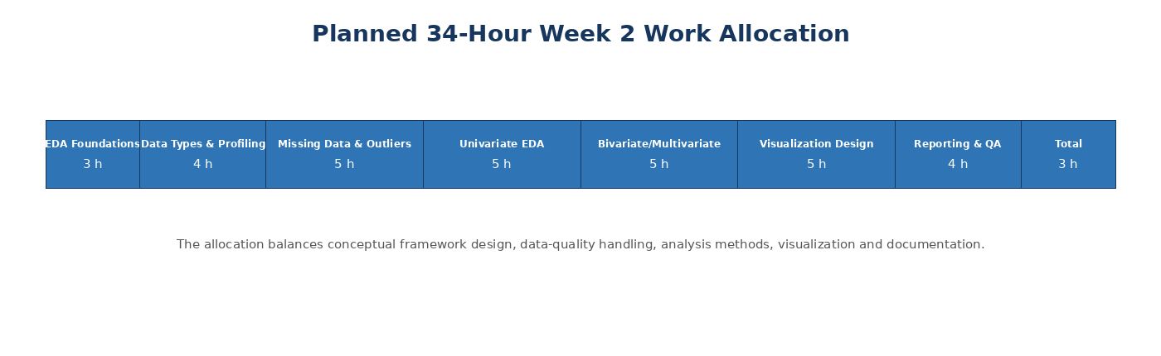
Figure 3. Visual allocation of the planned 34 hours.

16. Quality & Reproducibility Checklist
- Dataset source and definitions are documented.
- Column names and data types are verified.
- Missingness is measured and treatment decisions are recorded.
- Duplicates and invalid values are checked.
- Outliers are investigated with context.
- EDA questions are defined before generating large numbers of charts.
- Charts have titles, labels and units where relevant.
- Key findings are supported by appropriate visual or statistical evidence.
- Limitations and assumptions are explicitly stated.
- Notebook execution order is clear and reproducible.
- Project changes are tracked using Git/GitHub.

17. Expected Outcomes
- A reusable EDA framework applicable to structured datasets.
- A clear strategy for selecting analysis techniques based on variable types.
- A visualization plan covering distributions, relationships, comparisons and multivariate patterns.
- A documented process for missing data, duplicates, invalid values and outliers.
- A professional reporting structure for communicating analytical findings.
- A reproducible Python/Jupyter workflow that can be applied when an actual dataset becomes available.

18. Conclusion
This Week 2 framework establishes a systematic approach to Exploratory Data Analysis and visualization for the proposed Student Academic Performance project. It covers dataset profiling, data types, data-quality assessment, univariate, bivariate and multivariate analysis, missing-data and outlier strategies, visualization selection, Python libraries, reporting standards, and a 34-hour work plan. Because no dataset is provided for this task, the document intentionally focuses on methodology rather than claiming findings. The framework is designed to transition directly into practical Python analysis when data becomes available.

Appendix A — Suggested Project Structure
student-academic-performance-data-science/
│
├── data/
│ ├── raw/
│ └── processed/
├── notebooks/
│ ├── 01_data_understanding.ipynb
│ └── 02_eda_visualization.ipynb
├── src/
│ ├── data_cleaning.py
│ └── visualization.py
├── reports/
│ ├── figures/
│ └── Week-2_EDA_Framework.docx
├── Week-1/
└── README.md

Appendix B — Planned Example Code Pattern
# Load and inspect
import pandas as pd
import matplotlib.pyplot as plt
import seaborn as sns
df = pd.read_csv("data/raw/student_performance.csv")
print(df.shape)
print(df.info())
print(df.isna().sum())
# Example univariate visualization
sns.histplot(data=df, x="Final_Score", kde=True)
plt.title("Distribution of Final Scores")
plt.xlabel("Final Score")
plt.ylabel("Count")
plt.show()

