WEEK 1 TASK
Data Science Project
Planning & Strategy Design
Hypothetical Project: Student Academic Performance Prediction and Analysis Using Python

Project Detail | Information
Internship | Virtual Data Science Explorer Internship
Organization | YuvaIntern
Intern | Sayed Ajmal Rizavi
Project Type | Hypothetical Data Science Planning Project
Planned Duration | 30–35 hours
Internship Week | Week 1

Prepared for internship submission

1. Executive Summary
This project plan proposes a Python-based data science solution for analysing student academic performance and developing a predictive model that can estimate whether a student is likely to achieve a target academic outcome. The project is hypothetical and is designed to demonstrate how a data science professional would plan the complete workflow before working with an actual dataset.
The proposed approach follows a structured lifecycle: problem definition, data collection, data understanding, data cleaning, exploratory data analysis (EDA), feature engineering, model development, evaluation, interpretation, and reporting. The plan prioritizes data quality, responsible interpretation, reproducibility, and actionable insights.

2. Project Background & Problem Statement

2.1 Background
Educational institutions generate information related to attendance, assessment scores, study habits, participation, and other academic indicators. Analysing these variables can help identify patterns associated with academic performance and support evidence-based academic planning.

2.2 Problem Statement
The hypothetical problem is to determine which measurable student-related factors are associated with academic performance and to build a basic predictive model that can classify students into performance categories or predict a final score.

2.3 Motivation
- Identify patterns in academic performance using data rather than assumptions.
- Understand which variables appear most strongly associated with outcomes.
- Create a repeatable Python workflow for data preparation and analysis.
- Demonstrate how predictive analytics could support early academic intervention.

3. Project Objectives
- Define a clear analytical problem and measurable success criteria.
- Plan collection or sourcing of a structured student-performance dataset.
- Prepare a clean, consistent, analysis-ready dataset.
- Perform exploratory data analysis using descriptive statistics and visualizations.
- Engineer suitable features where necessary while avoiding data leakage.
- Develop baseline and candidate machine-learning models.
- Evaluate model performance using appropriate metrics.
- Translate analytical findings into practical, understandable recommendations.
- Document assumptions, limitations, risks, and reproducible project steps.

4. Project Scope
In Scope | Out of Scope
Structured academic-performance data; data dictionary and variable understanding. | Collection of sensitive personal information not required for the analysis.
Missing-value handling, duplicate checks, type correction, outlier review and consistency checks. | Deployment of a production-grade student monitoring system.
EDA, correlations/associations, distributions and comparative analysis. | Automated disciplinary or admissions decisions based solely on model output.
Baseline and candidate predictive models using Python. | Large-scale deep-learning architecture or complex MLOps infrastructure.
Model evaluation, interpretation, limitations and recommendations. | Claiming causation from observational relationships.

5. Proposed Data & Variables
Because this is a planning task, no real dataset is required at this stage. The future dataset is expected to be structured in tabular form, with each row representing a student record and columns representing academic or behavioural indicators.
Variable / Feature | Type | Purpose
Attendance Percentage | Numeric | Measure regularity of attendance.
Study Hours per Week | Numeric | Represent approximate study effort.
Assignment Average | Numeric | Capture continuous assessment performance.
Midterm Score | Numeric | Provide an intermediate academic indicator.
Previous Semester Score | Numeric | Provide historical performance context.
Participation Level | Categorical | Represent classroom participation.
Final Score / Performance Category | Numeric / Categorical | Target outcome for analysis/modeling.

6. Methodology & Strategy
The methodology is designed as an iterative pipeline. Each stage produces outputs that are checked before moving to the next stage.
Stage | Planned Activities | Primary Output
1. Problem Definition | Define target, users, assumptions, success criteria and constraints. | Project specification
2. Data Collection | Identify a suitable dataset source and required variables; document provenance. | Raw dataset + data dictionary
3. Data Understanding | Inspect shape, types, distributions, missingness and target balance. | Data-quality profile
4. Data Cleaning | Handle duplicates, missing values, invalid values, inconsistent categories and data types. | Clean dataset
5. EDA | Use summary statistics, distributions, group comparisons and correlation analysis. | Analytical insights + charts
6. Feature Engineering | Encode categorical fields, scale where appropriate and select useful predictors. | Model-ready features
7. Modeling | Create a baseline and compare suitable classification/regression models. | Candidate models
8. Evaluation | Use train/test strategy and relevant metrics; inspect errors and overfitting. | Evaluation report
9. Interpretation | Explain important patterns, model behaviour and limitations. | Findings + recommendations
10. Reporting | Document methodology, results, limitations and next steps. | Final project report

7. Data Science Workflow Diagram
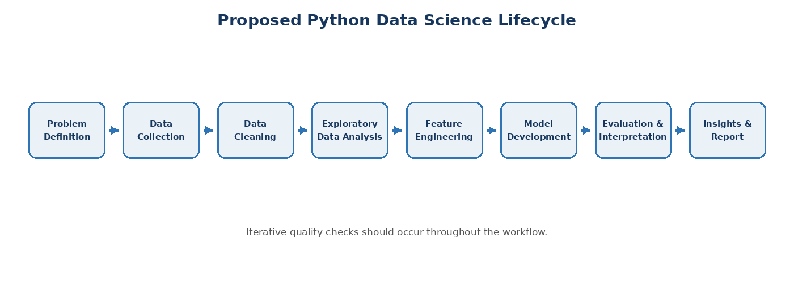
Figure 1. Planned end-to-end workflow for the hypothetical Student Academic Performance project.

8. Detailed Strategy

8.1 Data Collection Strategy
- Define the minimum variables required to answer the project question.
- Use a suitable public, simulated, or institution-approved dataset in the technical phase.
- Record source, collection date, field definitions, units, and any known limitations.
- Avoid collecting personally identifiable information unless strictly necessary and authorized.

8.2 Data Cleaning Strategy
- Inspect missing values and determine whether to impute, retain, or remove records based on context.
- Detect duplicate records and verify whether duplicates are genuine or accidental.
- Correct data types and standardize categorical labels.
- Check impossible values such as attendance below 0% or above 100%.
- Review outliers using distribution-based methods and domain context rather than automatically deleting them.

8.3 Exploratory Data Analysis Strategy
- Calculate mean, median, standard deviation, minimum, maximum and relevant quantiles.
- Visualize distributions using histograms and box plots.
- Compare academic outcomes across attendance, study-hours and participation groups.
- Examine relationships among numerical variables using correlation analysis and scatter plots.
- Check class balance if the target is categorical.

8.4 Modeling Strategy
The exact modeling task will depend on the target selected during the technical phase. If the target is a continuous final score, regression models can be evaluated. If the target is a performance category, classification models can be evaluated.
Model / Approach | Role in Plan
Baseline model | Establish a simple reference point before using more complex models.
Linear Regression / Logistic Regression | Interpretable baseline depending on target type.
Decision Tree | Capture non-linear relationships and provide intuitive decision rules.
Random Forest | Candidate ensemble model for stronger non-linear predictive performance.

8.5 Evaluation Strategy
Task Type | Primary Metrics | Additional Checks
Regression | MAE, RMSE, R² | Residual patterns, overfitting, prediction errors
Classification | Accuracy, Precision, Recall, F1-score | Confusion matrix, class balance, threshold behaviour

Model selection will not be based only on the highest metric. Interpretability, data quality, generalization, error patterns, and the practical purpose of the model will also be considered.

9. Tools & Technologies
Tool / Library | Planned Use
Python | Core programming language and project workflow.
Pandas | Data loading, manipulation, cleaning and tabular analysis.
NumPy | Numerical operations and array-based computation.
Matplotlib | Core data visualization.
Seaborn | Statistical and exploratory visualizations.
Scikit-learn | Preprocessing, model training, evaluation and baseline ML.
Jupyter Notebook | Interactive analysis, documentation and experimentation.
VS Code | Project development and code organization.
Git & GitHub | Version control and project documentation.

10. Timeline — 30–35 Hours
Work Package | Hours | Key Deliverable
1. Project Definition & Planning | 3 h | Problem, objectives, scope, assumptions
2. Data Source & Data Understanding | 4 h | Dataset plan, variables, quality checks
3. Data Cleaning & Preprocessing | 6 h | Missing values, duplicates, types, consistency
4. Exploratory Data Analysis | 6 h | Statistics, visualizations, relationships
5. Feature Engineering | 3 h | Encoding, transformations, feature selection
6. Model Development | 5 h | Baseline + candidate models
7. Evaluation & Interpretation | 4 h | Metrics, errors, model comparison
8. Reporting & Presentation | 3 h | Findings, diagrams, recommendations
TOTAL | 34 h | Within the requested 30–35 hour range

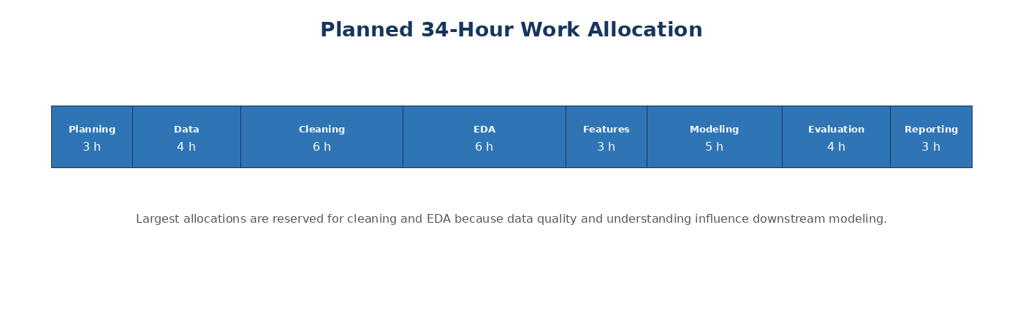
Figure 2. Visual allocation of the planned 34 hours.

11. Expected Outcomes
- A documented, reproducible data science workflow for student academic performance analysis.
- A cleaned and analysis-ready dataset once the technical phase begins.
- A set of meaningful visualizations and descriptive insights.
- A baseline predictive model and comparative candidate models.
- A clear evaluation report showing strengths, weaknesses and error patterns.
- Practical recommendations based on observed patterns, with appropriate limitations.
- A professional project structure that can be extended into later technical internship tasks.

12. Anticipated Challenges & Mitigation
Potential Challenge | Impact | Mitigation Strategy
Missing or incomplete data | May reduce reliability of analysis. | Profile missingness; use context-appropriate imputation or exclusion; document decisions.
Inconsistent categories / formats | Can produce incorrect summaries or model inputs. | Standardize labels, units and data types during preprocessing.
Class imbalance | Can make accuracy misleading for classification. | Inspect class distribution and use suitable metrics; consider resampling only when justified.
Outliers | May distort statistics or model performance. | Investigate with domain context before transforming or removing.
Overfitting | Model may perform well on training data but poorly on unseen data. | Use train/test separation, cross-validation where appropriate, and simpler baselines.
Data leakage | Can make model performance unrealistically high. | Ensure target-derived information is not used as a predictor.
Correlation interpreted as causation | Could lead to incorrect recommendations. | Clearly distinguish association from causality.
Limited dataset size | May reduce generalizability. | Report limitations and avoid overclaiming model capability.

13. Data Ethics & Responsible Analysis
- Use only data that is legally and ethically available for the intended analysis.
- Minimize personally identifiable information and remove unnecessary identifiers.
- Treat model outputs as decision-support information rather than unquestionable judgments.
- Check for potential bias across relevant groups when such information is legitimately available.
- Document assumptions and limitations so users understand what the analysis can and cannot conclude.

14. Success Criteria
Area | Success Indicator
Planning | All major data science stages are clearly defined before implementation.
Data Quality | A documented cleaning strategy addresses missing, duplicate, invalid and inconsistent data.
Analysis | EDA produces understandable, relevant statistics and visualizations.
Modeling | At least one baseline and appropriate candidate model are planned.
Evaluation | Metrics are selected according to the modeling task and limitations are documented.
Project Management | Planned effort totals 34 hours and includes all required deliverables.
Communication | Results and recommendations can be explained to a non-technical stakeholder.

15. Project Deliverables
- Project planning document.
- Data dictionary and data-quality assessment during the technical phase.
- Cleaned dataset.
- EDA notebook and visualizations.
- Modeling and evaluation notebook.
- Final findings and recommendation summary.
- Version-controlled project repository with documentation.

16. Conclusion
This Week 1 plan establishes a structured foundation for a hypothetical Student Academic Performance Prediction and Analysis project. It defines the problem, objectives, scope, methodology, tools, time allocation, expected outcomes, and risk controls before technical implementation begins. The approach emphasizes data quality, transparent analysis, appropriate evaluation, and responsible interpretation. The resulting plan can serve as a practical blueprint for subsequent data collection, Python preprocessing, exploratory analysis, and modeling tasks.

Appendix A — Proposed Project Structure
student-performance-data-science/
│
├── data/
│ ├── raw/
│ └── processed/
├── notebooks/
│ ├── 01_data_understanding.ipynb
│ ├── 02_data_cleaning.ipynb
│ ├── 03_eda.ipynb
│ └── 04_modeling_evaluation.ipynb
├── src/
│ ├── data_cleaning.py
│ ├── feature_engineering.py
│ └── modeling.py
├── reports/
│ └── figures/
├── README.md
└── requirements.txt

Appendix B — Planned Python Workflow
The technical phase is expected to begin with data loading and inspection in Pandas, followed by cleaning and exploratory analysis. Scikit-learn will then be used for preprocessing, model training and evaluation. Matplotlib and Seaborn will support visual analysis. Jupyter Notebook will document experiments, while Git/GitHub will provide version control.

