**Smartfx Signup**

1. Click the below button from [www.smartfx.com](http://www.smartfx.com) to sign up.



1. Fill out the signup form - <https://my.smartfx.com/en/signup>

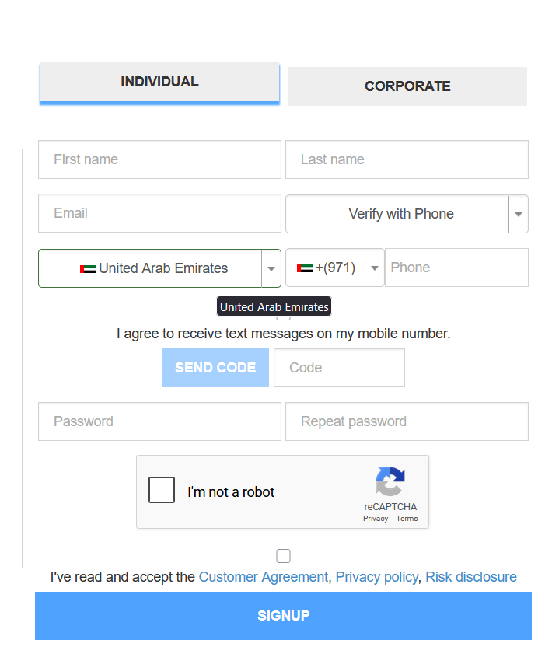

1. After filling in the personal data verify OTP with phone or email.
2. After Signup you will receive an Activation Link to your above-registered email id.
3. After clicking the activation button in the email, you will receive your login credentials.