1. How many units / sub-departments are there in an IT Department?

2 departments

* Software Developer
* Digital Marketing

1. Please provide a detailed IT Organizational Chart, including roles and responsibilities.

**IT Department Organizational Structure**

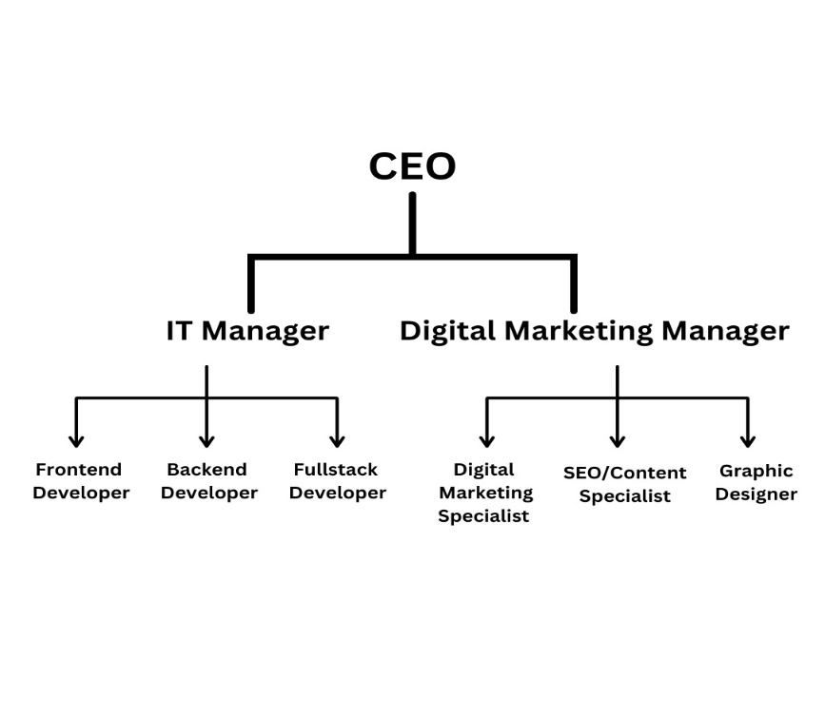

**Chief Executive Officer (CEO)**

Reports to: Executive Leadership/Board of Directors

Key Roles & Responsibilities:

a. Oversees the overall business strategy and vision.

b. Aligns IT and digital marketing functions with business objectives.

c. Drives innovation and growth across all departments, including IT and marketing.

1: **IT Department**

Key Units / Sub-Departments:

Software Development

System Operations

Team Structure:

1. **IT Manager** (Reports to CEO)

Roles & Responsibilities:

o Manages IT developers and ensures smooth operations.

o Oversees system security, server performance, and integrations.

o Collaborates with brokers, compliance, and marketing teams.

1. **Backend Developer**

Roles & Responsibilities:

o Optimizes backend performance and security.

o Develops server-side logic and ensures system scalability.

1. **Full-Stack Developer**

Roles & Responsibilities:

o Works on both front-end and back-end development.

o Develops custom features like reporting dashboards.

o Ensures system security and API stability.

2: **Marketing Department**

Key Units / Sub-Departments:

SEO & Content Creation

Paid Campaigns and Social Media

Creative Design

Team Structure:

1: **Digital Marketing Manager** (Reports to CEO)

Roles & Responsibilities:

o Develops and implements marketing strategies for client acquisition.

o Oversees paid campaigns, SEO, social media efforts, and design projects.

o Coordinates with IT for website optimization and tracking.

2: **Digital Marketing Specialist**

Roles & Responsibilities:

o Manages paid ads (Google Ads, Facebook, LinkedIn).

o Runs social media campaigns for lead generation.

o Optimizes ad performance and tracks conversion rates.

3: **SEO & Content Specialist**

Roles & Responsibilities:

o Optimizes the website for search engines (e.g., Forex keywords, landing pages).

o Creates educational content and blog articles.

o Analyzes performance metrics (Google Analytics, SEMRush).

4: **Graphic Designer**

Roles & Responsibilities:

o Designs visual assets for campaigns, social media, and the website.

o Creates branding materials (e.g., logos, banners, brochures).

o Collaborates with the marketing team to align visuals with strategy.

o Optimizes graphics for digital and print media.

1. Is there any IT Strategy in Place?

YES

1. Systems Interface diagram showing all the systems and their interfaces?

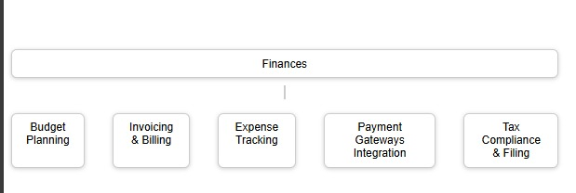

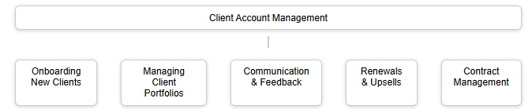

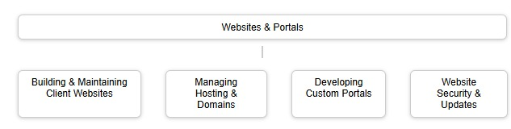

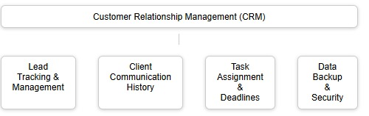

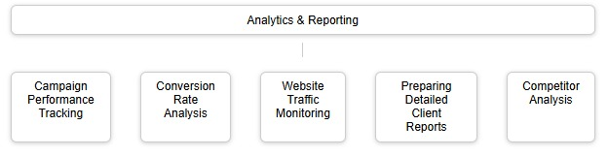

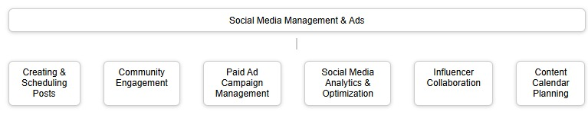

1. List of vendors along with their respective service.
2. **Payment Gateway Providers**

* MyFatoorah

1. **VoIP & Communication Solutions**

* Zoiper

1. **Website, Client Portal & Marketing Tools**

* Google Ads & Meta Ads
* SEMrush & Ahrefs
* Whatsapp Marketing tools
* Email Marketing ( Mailchimp )
* Wordpress

1. **Security & Infrastructure**

* **Cloudflare** – DDoS protection and website security.

1. **Bulk SMS Providers**

* Bulk SMS