1. Create an array of 10 elements and print them using the for each loop.

Sayed Ali-211506

SBA-1

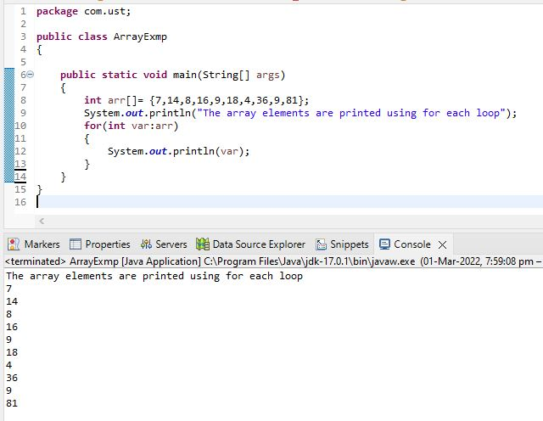

1. Take the number input from the console and add all the positive numbers. (not to consider the negative number if entered)

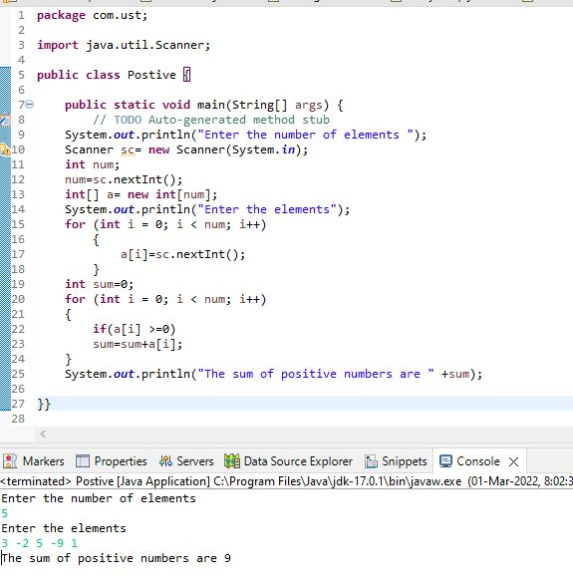

3.Create a labeled break and write a simple logic and execute the program.

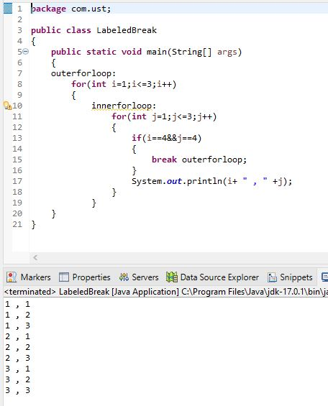

4.Do the addition of around 10 even numbers, but use the continue statement in the logic.

