SBA-2

Sayed Ali 211506

1.Write a program to reverse the String (use char[] or String built in method).

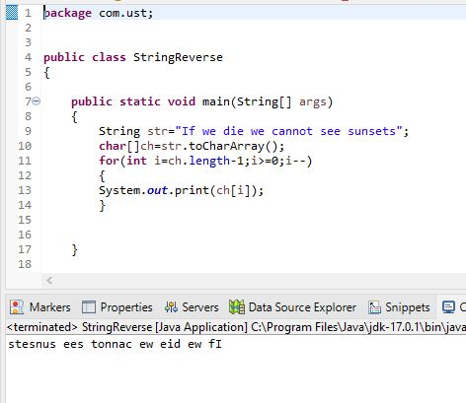

2.Write programs to depict the usage of contains(), length(), replace(), concat(), equals()

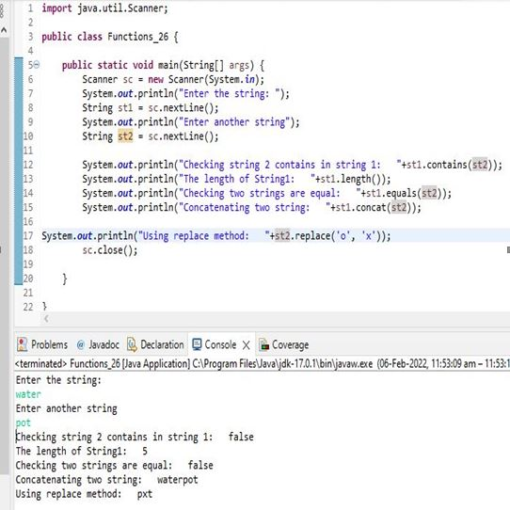

3.Write a customized Exception class for a Banking project

