Project Aurora
API Specification - OpenAPI Ready
Version 0.1 | Engineering Draft | Australian Fintech MVP
Purpose: define the API contract for Aurora mobile apps, web admin, merchant dashboard, internal services, and external integrations. This document is written so it can be translated directly into OpenAPI 3.1 YAML and developer tickets.

1. API Design Principles
- Contract-first: endpoints and schemas are designed before implementation.
- Versioned: all public APIs are prefixed with /v1.
- Secure by default: every endpoint requires authentication unless explicitly public.
- Idempotent money movement: payment initiation must use idempotency keys.
- Auditable: business-critical API calls generate immutable audit events.
- Consistent errors: all services return the same error envelope.
- Privacy-aware: APIs return only the minimum data required by the client.

2. High-Level API Request Flow
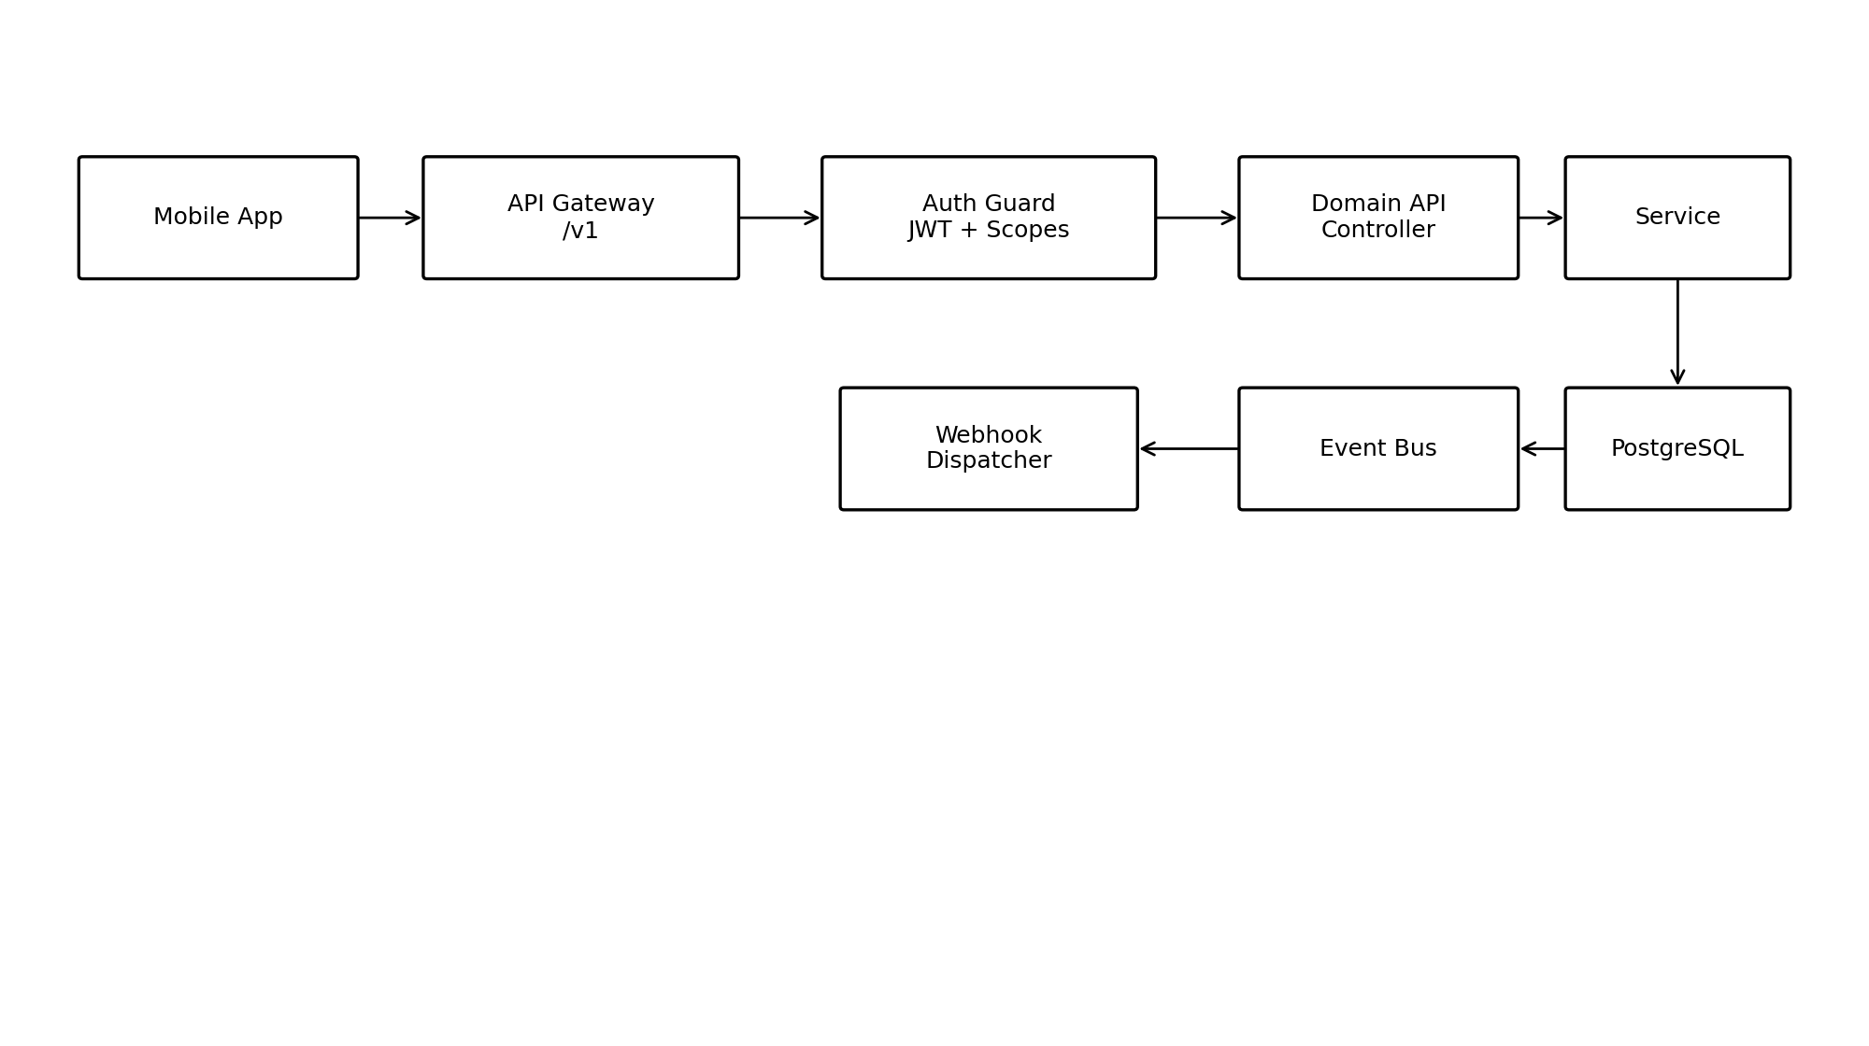
Requests enter through the API Gateway, pass through authentication and authorization guards, then route to a bounded-context controller. Domain services write to PostgreSQL, publish events, and optionally trigger webhooks or notifications.

3. API Surface by Domain
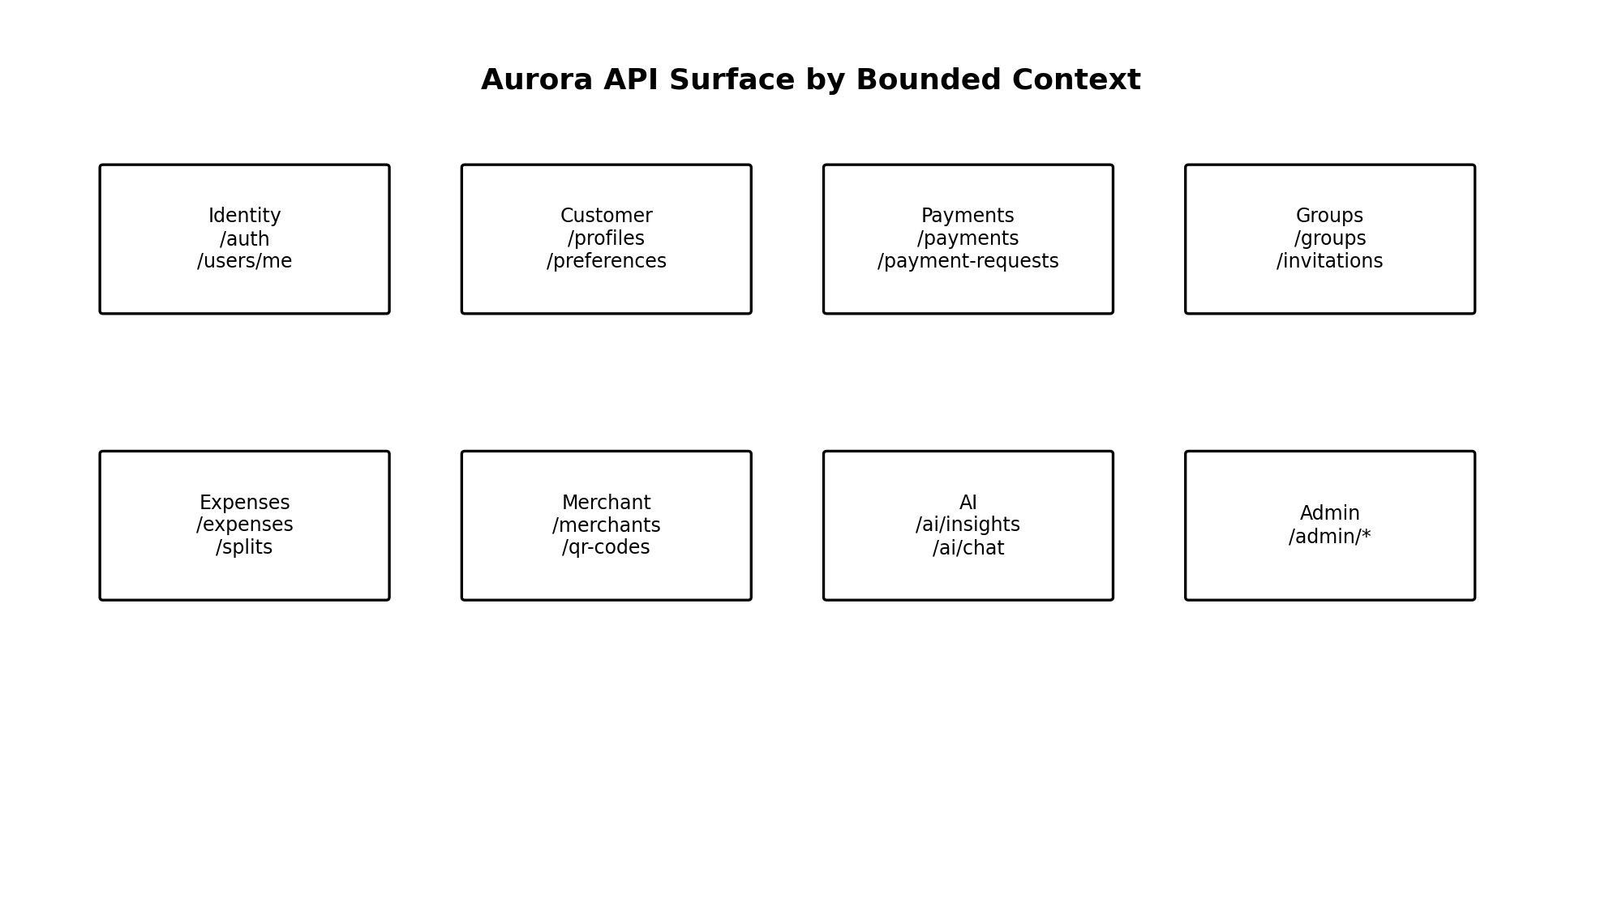

4. Global Conventions
Area | Standard
Base URL | https://api.aurora.example/v1
Transport | HTTPS only; TLS 1.2+ minimum, TLS 1.3 preferred
Content-Type | application/json; charset=utf-8
Identifiers | UUID v7 or ULID-style sortable identifiers for primary resources
Pagination | Cursor-based pagination using limit and cursor
Dates | ISO 8601 UTC timestamps
Amounts | Integer minor units, e.g. 1250 = AUD 12.50
Currency | ISO 4217, MVP default AUD
Idempotency | Required on POST endpoints that create payments, refunds, or irreversible state changes
Correlation | X-Correlation-Id accepted and returned for tracing

5. Authentication and Authorization
Aurora uses OAuth 2.1-style flows with short-lived access tokens and refresh tokens. Mobile clients authenticate through OTP and device-bound sessions. Sensitive actions require step-up authentication.
Token/Control | Purpose | Lifetime/Rule
Access token | Authorize API requests | Short lived, recommended 10-15 minutes
Refresh token | Renew access token | Rotated on use; device-bound
Device token | Bind session to enrolled device | Revoked on logout or suspicious activity
Scopes | Least-privilege access control | Examples: payments:create, groups:read
Step-up MFA | Confirm sensitive actions | Required for new payee, large payment, password/security changes

6. Standard Response and Error Envelopes
// Success envelope
{
"data": { ... },
"meta": {
"request_id": "req_01J...",
"timestamp": "2026-07-06T02:10:00Z"
}
}
// Error envelope
{
"error": {
"code": "PAYMENT_LIMIT_EXCEEDED",
"message": "The payment exceeds the allowed daily limit.",
"details": { "limit_minor": 200000 },
"request_id": "req_01J..."
}
}
HTTP Status | Use
200 | Successful read or synchronous state update
201 | Resource created
202 | Accepted for asynchronous processing
400 | Validation error
401 | Unauthenticated
403 | Authenticated but not authorized
404 | Resource not found or not accessible
409 | Conflict or duplicate idempotency key
422 | Business rule violation
429 | Rate limit exceeded
500 | Unexpected server error
503 | Dependency unavailable

7. Endpoint Catalogue
Domain | Method | Path | Description | Access
Auth | POST | /auth/register | Register consumer account | Public
Auth | POST | /auth/login | Login with OTP/passwordless flow | Public
Auth | POST | /auth/refresh | Refresh access token | Refresh token
Auth | POST | /auth/logout | Logout current device | User
Auth | POST | /auth/mfa/verify | Verify MFA challenge | User
Users | GET | /users/me | Get current user | User
Users | PATCH | /users/me | Update profile fields | User
Users | GET | /users/me/devices | List enrolled devices | User
Users | DELETE | /users/me/devices/{device_id} | Revoke device | User
KYC | POST | /kyc/sessions | Start KYC session | User
KYC | GET | /kyc/status | Get KYC status | User
Wallet | GET | /wallets/me | Get wallet summary | User
Wallet | GET | /bank-accounts | List linked bank accounts | User
Wallet | POST | /bank-accounts/link | Create bank-link consent/session | User
Wallet | DELETE | /bank-accounts/{id} | Remove linked account | User
Payments | POST | /payments | Initiate payment | User + idempotency
Payments | GET | /payments/{id} | Get payment status | Participant
Payments | POST | /payment-requests | Create payment request | User
Payments | POST | /payment-requests/{id}/accept | Accept request | Recipient + MFA when required
Payments | POST | /refunds | Create refund | Merchant/Admin
Groups | POST | /groups | Create group | User
Groups | GET | /groups | List user groups | User
Groups | GET | /groups/{id} | Get group detail | Member
Groups | POST | /groups/{id}/invitations | Invite member | Group admin
Groups | PATCH | /groups/{id}/members/{member_id} | Update member role | Group admin
Expenses | POST | /expenses | Create expense | User
Expenses | GET | /expenses/{id} | Get expense detail | Participant
Expenses | POST | /expenses/{id}/splits | Define splits | Owner
Expenses | POST | /expenses/{id}/settle | Settle balance | Participant
Merchant | POST | /merchants | Create merchant profile | User
Merchant | GET | /merchants/{id} | Get merchant profile | Merchant member
Merchant | POST | /merchants/{id}/qr-codes | Create QR code | Merchant member
Merchant | GET | /merchants/{id}/transactions | Merchant transaction list | Merchant member
AI | POST | /ai/insights/generate | Generate spending insights | User
AI | POST | /ai/chat | Ask financial assistant question | User
AI | GET | /ai/recommendations | List recommendations | User
Notifications | GET | /notifications | List notifications | User
Notifications | PATCH | /notifications/{id}/read | Mark read | User
Webhooks | POST | /webhooks/endpoints | Register merchant webhook | Merchant admin
Admin | GET | /admin/users | Search users | Admin
Admin | GET | /admin/audit-events | Search audit events | Admin

8. Core Resource Schemas

User
Field
id
email
phone
display_name
status
kyc_status
created_at
updated_at

Wallet
Field
id
user_id
status
default_currency
created_at

Payment
Field
id
sender_user_id
recipient_user_id
amount_minor
currency
status
payment_rail
idempotency_key
created_at
completed_at

PaymentRequest
Field
id
requester_user_id
payer_user_id
amount_minor
currency
message
status
expires_at

Group
Field
id
name
type
owner_user_id
status
created_at

Expense
Field
id
group_id
created_by_user_id
amount_minor
currency
description
status
receipt_id

Merchant
Field
id
legal_name
trading_name
abn
status
created_at

Insight
Field
id
user_id
type
summary
confidence_score
source_period_start
source_period_end

9. Representative Endpoint Specifications

9.1 POST /payments
Headers:
Authorization: Bearer <access_token>
Idempotency-Key: pay_20260706_000001
Request:
{
"recipient": { "type": "user_id", "value": "usr_01J..." },
"amount_minor": 2500,
"currency": "AUD",
"description": "Dinner split",
"source_bank_account_id": "ba_01J..."
}
Response 202:
{
"data": {
"id": "pay_01J...",
"status": "processing",
"amount_minor": 2500,
"currency": "AUD"
}
}

9.2 POST /expenses
Request:
{
"group_id": "grp_01J...",
"amount_minor": 18600,
"currency": "AUD",
"description": "Restaurant bill",
"split_strategy": "equal",
"participant_user_ids": ["usr_1", "usr_2", "usr_3"]
}

9.3 POST /ai/chat
Request:
{
"message": "How much did I spend on coffee last month?",
"context": { "period": "previous_month" }
}
Response:
{
"data": {
"answer": "You spent AUD 142.50 on coffee last month across 18 transactions.",
"supporting_insight_ids": ["ins_01J..."]
}
}

10. Webhooks and Events
Merchant and partner webhooks are signed using HMAC SHA-256. Consumers of webhooks must verify timestamp and signature to prevent replay attacks.
Event | Published When | Typical Consumers
user.registered | User completes registration | Profile, Wallet, Notifications, Analytics
kyc.status_changed | KYC provider updates state | Compliance, User, Admin
payment.initiated | Payment accepted for processing | Ledger, Notifications
payment.completed | Payment settles successfully | Groups, Expenses, AI, Analytics
payment.failed | Payment fails | Notifications, Support
expense.created | Expense created | Groups, Notifications
merchant.qr_scanned | Customer scans QR | Merchant analytics
Webhook payload:
{
"id": "evt_01J...",
"type": "payment.completed",
"created_at": "2026-07-06T02:20:00Z",
"data": { "payment_id": "pay_01J..." }
}

11. Rate Limits and Abuse Controls
Area | Initial Policy
Authentication | Strict per-phone/email/IP limits; progressive cooldown
Payments | Per-user and per-device limits; risk-score based limits
AI | Quota by user tier; block prompt injection attempts
Admin | IP allowlisting and privileged audit logging
Webhooks | Retry with exponential backoff; dead-letter after configured attempts

12. OpenAPI 3.1 Starter Appendix
openapi: 3.1.0
info:
title: Aurora API
version: 0.1.0
servers:
- url: https://api.aurora.example/v1
security:
- bearerAuth: []
components:
securitySchemes:
bearerAuth:
type: http
scheme: bearer
bearerFormat: JWT
schemas:
ErrorEnvelope:
type: object
required: [error]
properties:
error:
type: object
required: [code, message, request_id]
properties:
code: { type: string }
message: { type: string }
request_id: { type: string }
PaymentCreateRequest:
type: object
required: [recipient, amount_minor, currency]
properties:
recipient:
type: object
properties:
type: { type: string, enum: [user_id, phone, payid, merchant_qr] }
value: { type: string }
amount_minor: { type: integer, minimum: 1 }
currency: { type: string, default: AUD }
description: { type: string, maxLength: 280 }
paths:
/payments:
post:
summary: Initiate a payment
operationId: createPayment
parameters:
- in: header
name: Idempotency-Key
required: true
schema: { type: string }
requestBody:
required: true
content:
application/json:
schema:
$ref: '#/components/schemas/PaymentCreateRequest'
responses:
'202':
description: Payment accepted for processing
'400':
description: Validation error
'409':
description: Idempotency conflict

13. Engineering Decisions Still Open
Decision | Options | Recommendation for MVP
API style | REST, GraphQL, gRPC | REST externally; gRPC/internal events later if needed
ID format | UUID v4, UUID v7, ULID | UUID v7 or ULID for time ordering
OpenAPI generation | Manual YAML, code-first, contract-first | Contract-first OpenAPI stored in repository
Payment rail abstraction | Single provider, adapter layer | Adapter layer to avoid provider lock-in
Admin API | Same gateway, separate gateway | Separate admin gateway and stricter controls

14. Next Step
The next engineering artifact should be the Security Architecture Blueprint. It will define authentication flows, authorization model, encryption, token handling, KYC/AML boundaries, fraud controls, logging, secrets management, and incident response assumptions.

