Project Aurora
Database Design Blueprint
MVP Data Model, Relationships, Governance and Implementation Standards
Version 0.1 | Founder / Engineering Draft
Prepared for: Aurora Financial OS founding team
Purpose: Define the data foundation for the MVP backend, API specification, security model and engineering implementation.
Decision Area | Recommendation
Database platform | PostgreSQL on managed cloud database for ACID consistency, constraints and operational maturity.
Identifier strategy | UUID primary keys for public entity references; no sequential IDs exposed through APIs.
Financial tables | Immutable transaction status history, provider event log and internal ledger mirror.
MVP funds model | Aurora should orchestrate payments through licensed providers and avoid holding customer funds in MVP.
Data governance | Privacy-by-design, purpose limitation, encryption for sensitive fields, and auditability from day one.

Table of Contents
- 1. Executive Summary
- 2. Design Principles
- 3. Domain Ownership Model
- 4. Conceptual ERD
- 5. MVP Data Dictionary
- 6. Payment and Ledger Model
- 7. Key Table Definitions
- 8. Indexing Strategy
- 9. Audit, Events and Versioning
- 10. Privacy, Retention and Compliance Notes
- 11. Migration and Environment Strategy
- 12. Open Decisions
- 13. References

1. Executive Summary
This blueprint defines the initial Aurora database design for an Australian AI-powered financial operating system. The model supports identity, profiles, linked accounts, payments, payment requests, groups, shared expenses, merchants, QR payments, receipts, AI insights, audit trails and operational controls.
The MVP data model is designed for a partner-led payments approach. Aurora coordinates user experience, requests, groups, receipts and status updates while payment initiation, settlement and regulated money movement are handled by licensed providers. This reduces early regulatory and operational burden while preserving a path to deeper payment capabilities later.
The model deliberately separates product concepts from regulated payment execution. For example, an expense is not a payment; it is a collaboration object that may later be settled through one or more transactions. A transaction is not the ledger; it is the canonical payment state machine whose lifecycle is mirrored into provider events, status history, audit logs and internal ledger entries.

2. Design Principles
Principle | Design Implication
Money data must be correct before it is clever | Use ACID transactions, constraints and idempotency for payment-related workflows. AI should interpret data but not become the source of financial truth.
Minimise sensitive data | Store references, hashes, masks and encrypted fields. Avoid storing raw identity documents, account credentials or unnecessary banking data.
Separate collaboration from settlement | Groups, expenses and splits belong to the collaboration domain. Payment transactions settle obligations but should not own the group model.
Append-only where evidence matters | Audit logs, provider events, status histories and ledger entries should be append-only except for controlled operational corrections.
Provider portability | Use provider reference columns and normalized provider events so Aurora can change or add partners without rewriting product tables.
Privacy by design | Every table should have a clear purpose, retention posture and access pattern. CDR-derived data should be scoped to consent and minimised.

3. Domain Ownership Model
The data model is grouped by bounded context. Each domain owns its tables and exposes data to other domains through APIs, events or read models rather than direct cross-domain mutation.
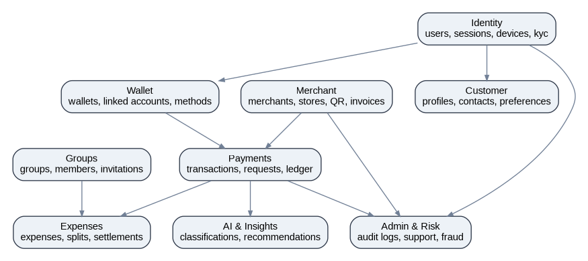
Domain | Owns | Must Not Own
Identity | Users, sessions, MFA, devices, roles, KYC workflow state | Customer spending insights, group balances or merchant settlement logic
Customer | Profiles, contacts, preferences, consent records | Authentication credentials or payment execution state
Wallet & Banking | Linked accounts, payment methods, wallet metadata, CDR connection metadata | Provider settlement truth or expense splitting rules
Payments | Transactions, requests, provider events, refunds, disputes, ledger mirror | Group membership and expense definitions
Groups & Expenses | Groups, members, invitations, expenses, splits, settlements and receipts | Provider callbacks or merchant legal onboarding
Merchant | Merchant entities, stores, QR codes, invoices and settlement reports | Consumer identity proofing beyond required merchant relationships
AI & Analytics | Classifications, insights, budgets, predictions | Authoritative payment balances or compliance outcomes
Admin & Risk | Audit, support, fraud alerts, feature flags | Core business ownership of customer or payment data

4. Conceptual Entity Relationship Diagram
The following conceptual ERD shows the core MVP relationships. The detailed physical design will be refined during backend implementation, but this view is sufficient to align engineering, product and API design.
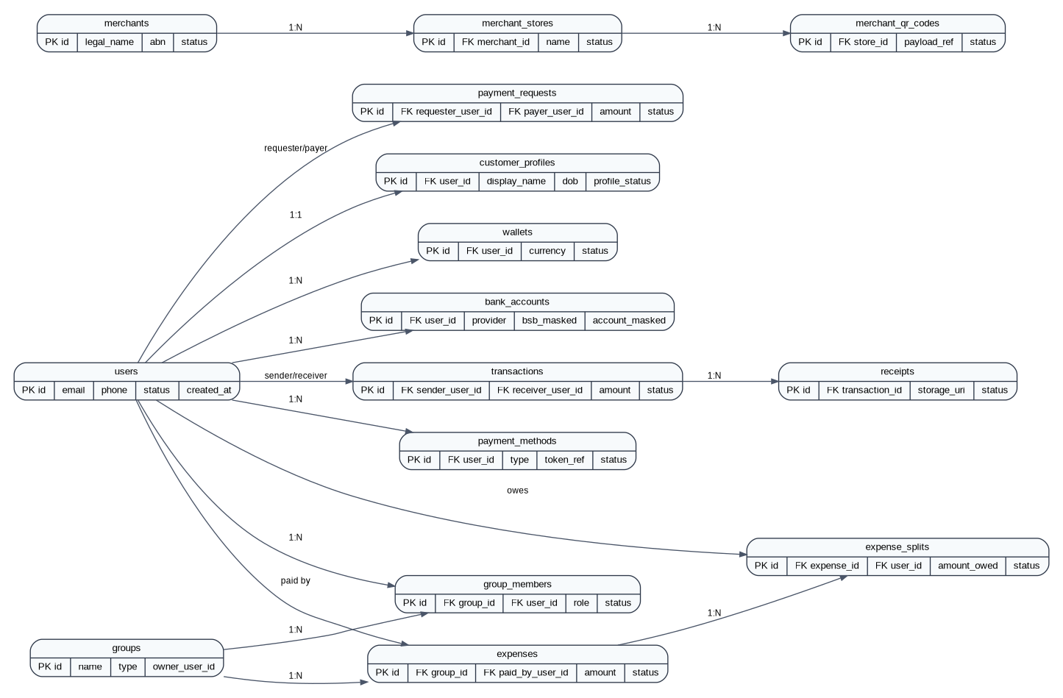

5. MVP Data Dictionary
The MVP schema contains approximately 55 tables. Not every table must be fully implemented in Sprint 1, but the naming and ownership conventions should be established before code generation or migrations begin.

Identity & Access
Table | Purpose | Key Columns
users | Primary account record. Stores minimal identity fields and status. | id, email, phone_e164, password_hash_ref, status, risk_level, created_at, updated_at, deleted_at
user_identities | External identity bindings: Apple, Google, passkeys, SSO later. | id, user_id, provider, provider_subject, verified_at, created_at
roles | Application roles for customers, merchants, admins. | id, code, name, description
permissions | Fine-grained permissions used by admin portal and future business roles. | id, code, resource, action
role_permissions | Many-to-many mapping between roles and permissions. | role_id, permission_id
user_roles | Role grants scoped globally, to merchant, or group where needed. | id, user_id, role_id, scope_type, scope_id, created_at
sessions | Refresh session registry and revocation state. | id, user_id, device_id, refresh_token_hash, expires_at, revoked_at
devices | Trusted device registry for biometrics, push tokens and risk scoring. | id, user_id, platform, device_fingerprint_hash, push_token_ref, trusted_at, last_seen_at
mfa_factors | MFA factors such as SMS, email OTP, authenticator or passkey. | id, user_id, factor_type, status, verified_at
kyc_cases | KYC workflow state managed with a provider and manual review option. | id, user_id, provider, status, verification_level, reviewed_by, completed_at
kyc_documents | Metadata only for KYC files; encrypted files live in object storage/provider vault. | id, kyc_case_id, document_type, storage_uri, hash, created_at

Customer
Table | Purpose | Key Columns
customer_profiles | Customer display profile and personal metadata needed by product flows. | id, user_id, display_name, legal_name_encrypted, date_of_birth_encrypted, avatar_uri, profile_status
customer_addresses | Addresses used for KYC, billing, merchant onboarding or compliance. | id, user_id, address_type, line1_encrypted, suburb, state, postcode, country, verified_at
contacts | User-approved contact graph for payments and invitations. | id, owner_user_id, contact_user_id, display_name, phone_hash, email_hash, source, created_at
notification_preferences | Per-channel, per-event opt-in preferences. | id, user_id, event_type, push_enabled, email_enabled, sms_enabled
privacy_consents | Consent records for privacy, marketing, data sharing and CDR scopes. | id, user_id, consent_type, version, granted_at, revoked_at

Wallet & Banking
Table | Purpose | Key Columns
wallets | Logical Aurora wallet/profile; MVP should not hold stored value unless licensing changes. | id, user_id, currency, status, provider_wallet_ref, created_at
bank_accounts | Linked bank account metadata; masks and tokens only, no raw account credentials. | id, user_id, provider, bsb_masked, account_number_masked, account_name_encrypted, token_ref, status
payment_methods | Reusable tokenised funding instruments. | id, user_id, method_type, provider, token_ref, last4, expiry_month, expiry_year, status
payid_profiles | PayID alias mapping metadata where supported by partner arrangements. | id, user_id, alias_type, alias_value_hash, provider_ref, status
cdr_connections | Open Banking / CDR consented data connection metadata. | id, user_id, data_recipient_ref, consent_ref, scopes, status, expires_at
account_balances_cache | Short-lived balance snapshots from CDR/provider APIs. | id, bank_account_id, balance_type, amount, currency, observed_at, expires_at

Payments & Ledger
Table | Purpose | Key Columns
payment_requests | Request for another user to pay. | id, requester_user_id, payer_user_id, group_id, amount, currency, note, due_at, status
transactions | Canonical payment transaction state machine. | id, type, sender_user_id, receiver_user_id, merchant_id, amount, currency, status, provider_ref, idempotency_key, created_at
transaction_status_history | Append-only status transition history. | id, transaction_id, from_status, to_status, reason_code, actor_type, actor_id, occurred_at
payment_provider_events | Raw normalized provider webhooks/callbacks. | id, provider, provider_event_id, event_type, payload_hash, received_at, processed_at, status
ledger_entries | Internal accounting mirror using double-entry style records; no customer funds in MVP unless model changes. | id, transaction_id, account_code, direction, amount, currency, posted_at
refunds | Refund lifecycle linked to original transaction. | id, original_transaction_id, amount, currency, status, provider_ref, reason
payment_disputes | User or merchant payment disputes and investigation state. | id, transaction_id, opened_by_user_id, reason_code, status, resolution, opened_at

Groups & Expenses
Table | Purpose | Key Columns
groups | Collaborative money context: house, trip, family, club. | id, owner_user_id, name, group_type, currency, status, created_at
group_members | Membership and role within a group. | id, group_id, user_id, role, status, joined_at
group_invitations | Pending invitations by phone/email/link. | id, group_id, invited_by_user_id, invitee_contact_hash, token_hash, expires_at, status
expenses | Expense recorded in a group or between users. | id, group_id, paid_by_user_id, merchant_id, title, amount, currency, expense_date, status
expense_splits | Split rows showing who owes what. | id, expense_id, user_id, split_type, amount_owed, percentage, status
settlements | Settlement plan or payment that clears one or more splits. | id, group_id, from_user_id, to_user_id, amount, currency, linked_transaction_id, status
expense_reminders | Reminder schedule and delivery status. | id, expense_split_id, reminder_type, scheduled_at, sent_at, status
receipts | Receipt metadata and OCR/AI extraction status. | id, expense_id, transaction_id, uploaded_by_user_id, storage_uri, extracted_total, status

Merchant & Commerce
Table | Purpose | Key Columns
merchants | Legal merchant entity. | id, legal_name, trading_name, abn_hash, status, risk_rating, created_at
merchant_users | Users associated with merchant entity. | id, merchant_id, user_id, role, status
merchant_stores | Physical or online store locations. | id, merchant_id, name, location_encrypted, status
merchant_qr_codes | Static or dynamic QR payment payload references. | id, merchant_id, store_id, qr_type, payload_ref, status
invoices | Merchant invoice header. | id, merchant_id, customer_user_id, invoice_number, amount_due, currency, due_at, status
invoice_items | Invoice line items. | id, invoice_id, description, quantity, unit_price, tax_amount, total_amount
merchant_settlements | Settlement reporting from payment partner. | id, merchant_id, provider_ref, gross_amount, fees_amount, net_amount, settlement_date, status

AI, Analytics & Operations
Table | Purpose | Key Columns
spending_categories | System and user-defined category taxonomy. | id, parent_id, code, name, is_system
transaction_classifications | AI/user classification results for transactions and receipts. | id, transaction_id, category_id, confidence, source, model_version, created_at
ai_insights | Generated insights shown to users. | id, user_id, insight_type, summary, payload_json, status, generated_at
budgets | User or group budgets. | id, owner_type, owner_id, category_id, amount, period, status
domain_events | Internal event log/outbox for event-driven workflows. | id, aggregate_type, aggregate_id, event_type, payload_json, occurred_at, published_at
audit_logs | Tamper-evident audit trail. | id, actor_type, actor_id, action, entity_type, entity_id, metadata_hash, occurred_at
fraud_alerts | Fraud/risk signals and operational case linkage. | id, user_id, transaction_id, alert_type, severity, status, assigned_to, created_at
support_cases | Customer support and operations workflow. | id, user_id, merchant_id, case_type, status, priority, created_at
feature_flags | Progressive rollout flags. | id, key, description, enabled, targeting_rules_json, updated_at

6. Payment and Ledger Model
Aurora should treat the payment provider as the regulated system of execution and settlement during MVP. Aurora still needs a robust internal model to reconcile user-visible state, provider callbacks, support investigations and analytics.
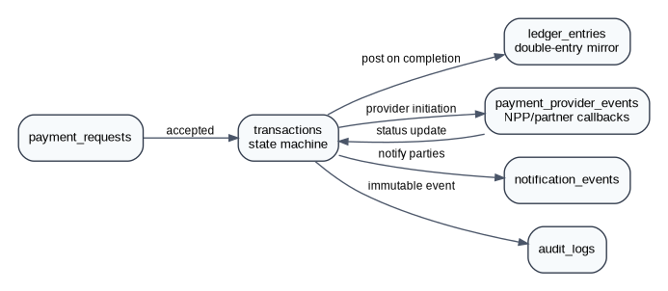
Recommended transaction states: CREATED, PENDING_USER_ACTION, SUBMITTED_TO_PROVIDER, PROCESSING, COMPLETED, FAILED, CANCELLED, REFUNDED, DISPUTED. All transitions should be inserted into transaction_status_history and important transitions should produce domain_events.
transactions
- id uuid primary key
- type text check in ('P2P','REQUEST_PAYMENT','MERCHANT_QR','EXPENSE_SETTLEMENT','REFUND')
- sender_user_id uuid null references users(id)
- receiver_user_id uuid null references users(id)
- merchant_id uuid null references merchants(id)
- amount numeric(18,2) not null check (amount > 0)
- currency char(3) not null default 'AUD'
- status text not null
- provider text null
- provider_ref text null
- idempotency_key text not null unique
- created_at timestamptz not null
- updated_at timestamptz not null
The ledger_entries table is not a replacement for a regulated settlement ledger. In MVP, it is an internal accounting mirror to support reconciliation, analytics and incident investigation. If Aurora later holds stored value, this table must be redesigned with financial accounting, safeguarding and regulatory input.

7. Key Table Definitions
The following table definitions are representative physical designs for the most important MVP tables. Engineering should convert these into migrations using the selected migration framework.

users
id uuid primary key
email citext unique null
phone_e164 text unique null
password_hash_ref text null
status text not null default 'PENDING'
risk_level text not null default 'NORMAL'
created_at timestamptz not null default now()
updated_at timestamptz not null default now()
deleted_at timestamptz null

kyc_cases
id uuid primary key
user_id uuid not null references users(id)
provider text not null
provider_case_ref text null
status text not null
verification_level text not null default 'BASIC'
reviewed_by uuid null references users(id)
completed_at timestamptz null
created_at timestamptz not null default now()
updated_at timestamptz not null default now()

payment_requests
id uuid primary key
requester_user_id uuid not null references users(id)
payer_user_id uuid null references users(id)
group_id uuid null references groups(id)
amount numeric(18,2) not null check (amount > 0)
currency char(3) not null default 'AUD'
note text null
due_at timestamptz null
status text not null default 'PENDING'
created_at timestamptz not null default now()
updated_at timestamptz not null default now()

expenses
id uuid primary key
group_id uuid null references groups(id)
paid_by_user_id uuid not null references users(id)
merchant_id uuid null references merchants(id)
title text not null
amount numeric(18,2) not null check (amount > 0)
currency char(3) not null default 'AUD'
expense_date date not null
status text not null default 'OPEN'
created_at timestamptz not null default now()
updated_at timestamptz not null default now()

expense_splits
id uuid primary key
expense_id uuid not null references expenses(id)
user_id uuid not null references users(id)
split_type text not null default 'EQUAL'
amount_owed numeric(18,2) not null check (amount_owed >= 0)
percentage numeric(5,2) null
status text not null default 'OWING'
created_at timestamptz not null default now()
unique(expense_id, user_id)

audit_logs
id uuid primary key
actor_type text not null
actor_id uuid null
action text not null
entity_type text not null
entity_id uuid null
metadata_hash text null
ip_hash text null
occurred_at timestamptz not null default now()

domain_events
id uuid primary key
aggregate_type text not null
aggregate_id uuid not null
event_type text not null
payload_json jsonb not null
occurred_at timestamptz not null default now()
published_at timestamptz null
processing_status text not null default 'PENDING'

8. Indexing and Performance Strategy
Indexes should be based on actual query paths, but the following indexes are recommended for MVP. Transaction, audit and event tables should be partition-ready from day one even if physical partitioning starts after initial launch.
Table(s) | Recommended Index | Purpose
users | unique lower(email), unique phone_e164 where not null | Login, duplicate prevention
sessions | user_id, device_id, expires_at; refresh_token_hash unique | Session validation and revocation
transactions | idempotency_key unique; sender_user_id created_at; receiver_user_id created_at; provider_ref | Idempotency, history, provider reconciliation
payment_provider_events | unique provider + provider_event_id; status received_at | Webhook de-duplication and processing
ledger_entries | transaction_id; account_code posted_at | Reconciliation and accounting reports
groups/group_members | group_id status; unique group_id + user_id | Membership lookup
expenses/expense_splits | group_id expense_date; expense_id; user_id status | Group balances and reminders
merchants/stores | merchant status; merchant_id status | Merchant dashboard queries
audit_logs/domain_events | occurred_at BRIN/partition key; entity_type + entity_id | Investigation and event processing
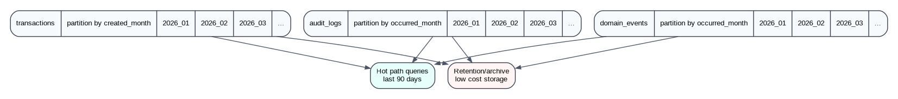

9. Audit, Events and Versioning
Aurora should use a transactional outbox pattern. When a domain operation completes inside a database transaction, the service writes business state and a domain_events row in the same transaction. A background publisher then sends events to the event bus and marks published_at.
Audit logs should answer: who did what, to which entity, when, from which risk context, and through which channel. Audit logs must not become a dumping ground for raw PII. Use hashes, references and structured metadata instead.
Pattern | Recommendation
Soft deletes | Use deleted_at for user-facing product data where recovery/audit matters. Do not soft-delete immutable financial records.
Optimistic locking | Add version integer to high-contention mutable records such as group membership and preferences.
Status history | Use separate status history tables for transactions, KYC cases, disputes and merchant onboarding.
Idempotency | Require idempotency keys for payment and request creation endpoints.
Event payloads | Keep domain event payloads small and versioned. Store references, not full sensitive objects.

10. Privacy, Retention and Compliance Notes
This section is not legal advice. It records technical design assumptions that should be reviewed by counsel and compliance specialists before launch.
Australian design context: the Privacy Act and Australian Privacy Principles regulate personal information handling for many organisations; CDR provides a regulated framework for consumer-directed sharing of data in banking and energy; AUSTRAC requires tailored AML/CTF programs for reporting entities where obligations apply; and NPP access is typically via participating institutions or providers rather than direct NPP APIs.
Data Category | Retention Posture | Implementation Note
Identity/session records | Active account lifetime plus defined compliance retention | Delete or anonymise after closure when no legal basis remains.
KYC metadata | Compliance-driven retention period to be confirmed with counsel/provider | Keep encrypted references and verification outcomes; minimise document copies.
Transactions/ledger/audit | Long-lived, immutable financial history | Restrict access, partition monthly, archive cold partitions.
AI insights/cache | Short retention by default | Regenerate where possible; delete when no longer needed.
CDR/banking data cache | Shortest practical retention based on consent and purpose | Respect consent expiry/revocation and data minimisation.
Sensitive field handling: legal names, birth dates, addresses, account names and identity document metadata should use field-level encryption or provider vault references. Queryable matching should use hashes with salt/pepper where appropriate. Never store raw bank credentials.

11. Migration and Environment Strategy
Area | Recommendation
Migration tool | Use a repeatable migration framework such as Prisma Migrate, TypeORM migrations, Knex, Flyway or Liquibase; choose once and enforce through CI.
Migration discipline | Every schema change must be backward-compatible during rolling deploys. Destructive changes require a two-step migration.
Environments | local, dev, test, staging, production with separate databases and secrets.
Seed data | Use synthetic seed data only. Never copy production PII into lower environments.
Backups | Automated point-in-time recovery for production and tested restore runbooks.
Observability | Track slow queries, lock waits, replication lag, partition health and migration duration.

12. Open Decisions
Decision | Options | Recommendation for MVP
ORM/query layer | Prisma / TypeORM / SQL-first | Use SQL-first or Prisma only if team is comfortable with migration discipline.
CDR model | Accredited data recipient / outsourced provider | Use accredited provider initially; store only consent metadata and short-lived cache.
Merchant onboarding | Manual approval / automated risk scoring | Manual + provider KYC/KYB initially; automate later.
Stored value | No wallet balance / customer funds held | Do not hold customer funds in MVP.
Event bus | Postgres outbox only / SNS-SQS / Kafka | Start with Postgres outbox + queue; graduate to Kafka only at scale.
Analytics warehouse | Postgres read replica / dedicated warehouse | Start with read replica or export pipeline; avoid querying production for heavy analytics.

13. References
- Australian Payments Plus - NPP for developers / NPP information: NPP access and developer context; many NPP Participant institutions expose APIs rather than NPP Australia itself.
- Consumer Data Right official website: CDR gives consumers control to share data between providers and is active in banking and energy.
- OAIC - Australian Privacy Principles and Privacy Act guidance: APPs govern standards, rights and obligations around personal information.
- AUSTRAC - AML/CTF program overview: AML/CTF programs must be tailored to business risk and circumstances where obligations apply.

Appendix A - MVP Table List by Build Phase
Phase | Tables
Sprint 1-2 Identity Foundation | users, user_identities, sessions, devices, mfa_factors, roles, permissions, user_roles
Sprint 3-4 Customer & KYC | customer_profiles, customer_addresses, privacy_consents, kyc_cases, kyc_documents
Sprint 5-6 Wallet & Payments | wallets, bank_accounts, payment_methods, payment_requests, transactions, transaction_status_history, payment_provider_events
Sprint 7-8 Groups & Expenses | groups, group_members, group_invitations, expenses, expense_splits, settlements, receipts
Sprint 9-10 Merchant MVP | merchants, merchant_users, merchant_stores, merchant_qr_codes, invoices, invoice_items
Sprint 11-12 Operations & AI | audit_logs, domain_events, notification_preferences, fraud_alerts, support_cases, spending_categories, transaction_classifications, ai_insights

