Project Aurora
System Architecture Blueprint
Version 0.1 | Engineering Foundation Draft | Australia MVP
Prepared for founder review. This is not legal, financial, or compliance advice. Validate with licensed advisers and regulated partners before implementation.

Table of Contents
- 1. Executive Summary
- 2. Architecture Principles
- 3. Assumptions and Regulatory Context
- 4. Component Architecture
- 5. Service Interactions
- 6. Data Flow Diagrams
- 7. AWS Deployment Architecture
- 8. Security Boundaries
- 9. Identity Flows
- 10. Payment Orchestration
- 11. Database Relationships
- 12. API Gateway Design
- 13. AI Service Interactions
- 14. Observability and Operations
- 15. Engineering Decisions and Open Questions
- 16. References

1. Executive Summary
Aurora is an AI-powered financial operating system for the Australian market. The MVP should not hold customer funds. Instead, it should orchestrate payments through licensed providers and focus on superior collaborative money management: send/request money, split expenses, manage groups, merchant QR payments, receipts, notifications, and AI-powered insights.
This blueprint defines the technical foundation for a modular monolith on AWS, designed to evolve into service-oriented architecture after product-market fit and higher transaction scale.

2. Architecture Principles
Use existing Australian payment rails and regulated partners where possible; do not build payment infrastructure before validation.
Prefer a modular monolith for MVP speed and operational simplicity; isolate modules internally so they can be extracted later.
Never compromise ledger integrity: all financial state transitions must be auditable and immutable where possible.
Design security boundaries early: public edge, application services, data layer, partner integrations, operations console, and AI boundary.
AI should explain, classify, summarize, and recommend; it must not execute payments or financial commitments without explicit user approval.

3. Assumptions and Regulatory Context
Aurora MVP is an orchestration and user-experience layer, not a stored-value facility. Customer funds remain with banks or licensed partners.
Payment execution should be integrated through a licensed Australian payment partner with NPP, PayID, or PayTo capability where commercially available.
Bank data access, if used, should follow Consumer Data Right/Open Banking rules through accredited providers or compliant partner access.
AML/CTF obligations must be assessed with legal/compliance advisers; the architecture assumes a risk-based financial crime framework, audit trails, sanctions/PEP screening support, and suspicious activity escalation workflows.
Privacy-by-design is mandatory: minimize data, separate sensitive data, encrypt at rest and in transit, define retention periods, and give users clear control over consent.

4. Component Architecture
The component architecture separates customer channels, API gateway, domain modules, data stores, external partners, and operational tooling. The MVP should be implemented as a modular monolith with domain modules and clear internal interfaces.
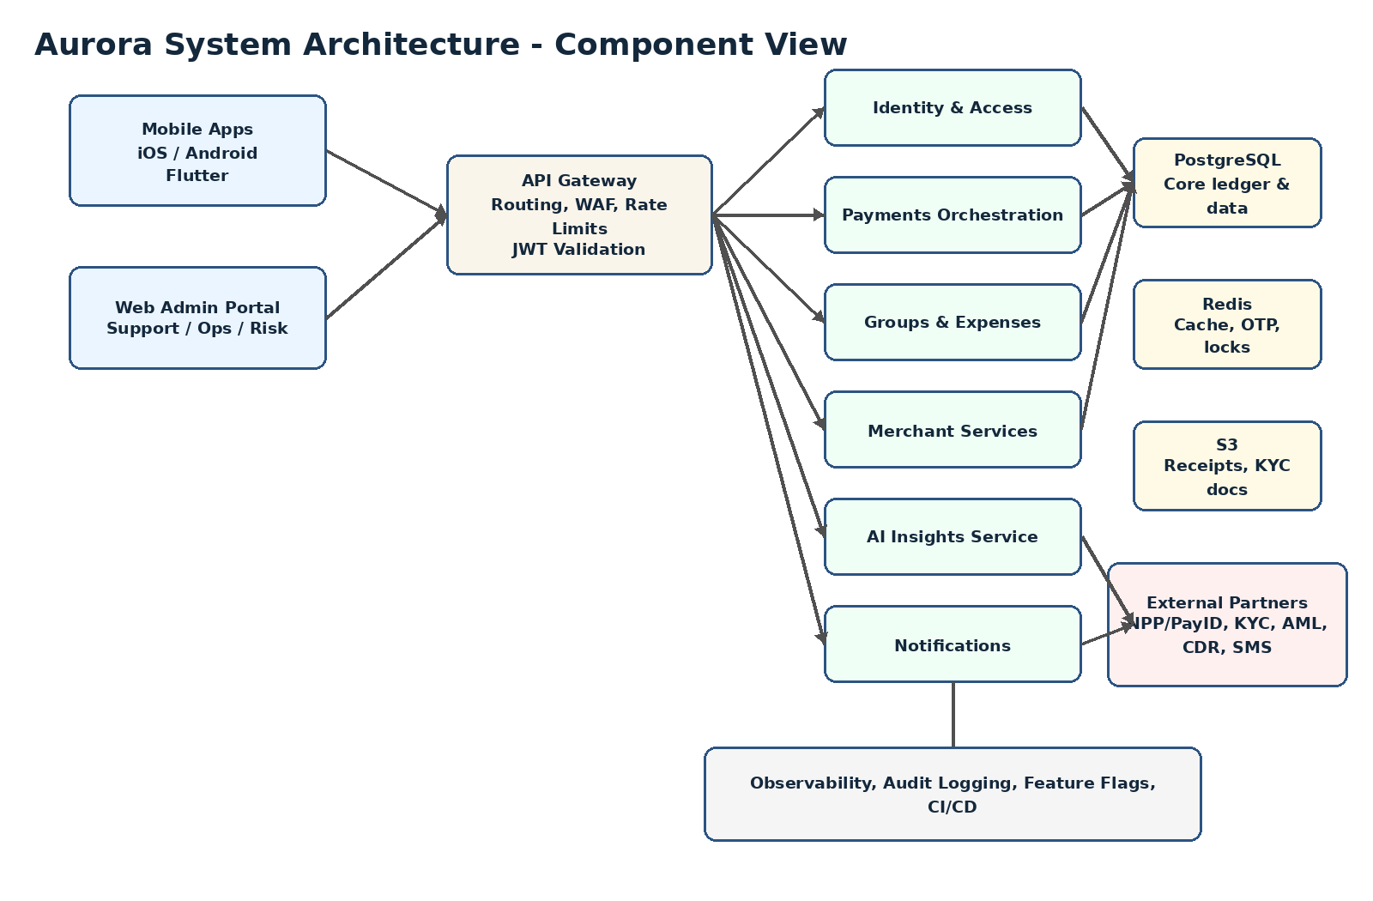
Figure 1. Component view of Aurora MVP.

6. Data Flow Diagrams
Critical flows should be event-aware and auditable. Payment state should progress through explicit statuses such as created, pending_risk_review, submitted_to_partner, completed, failed, reversed, or cancelled.
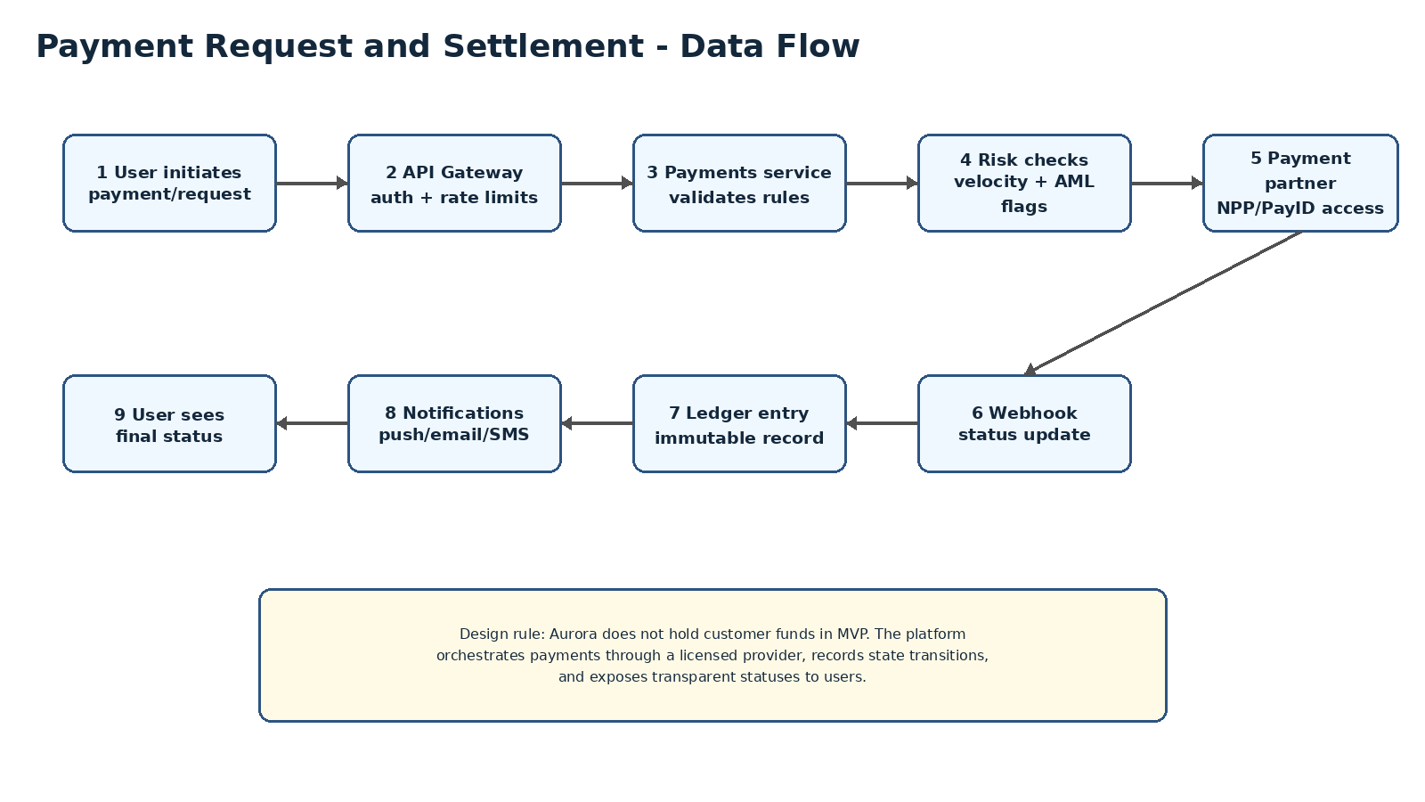
Figure 2. Payment request and settlement data flow.

7. AWS Deployment Architecture
The MVP deployment should use managed AWS services to reduce operational overhead and support security-by-default. All application and database resources should run in private subnets where possible.
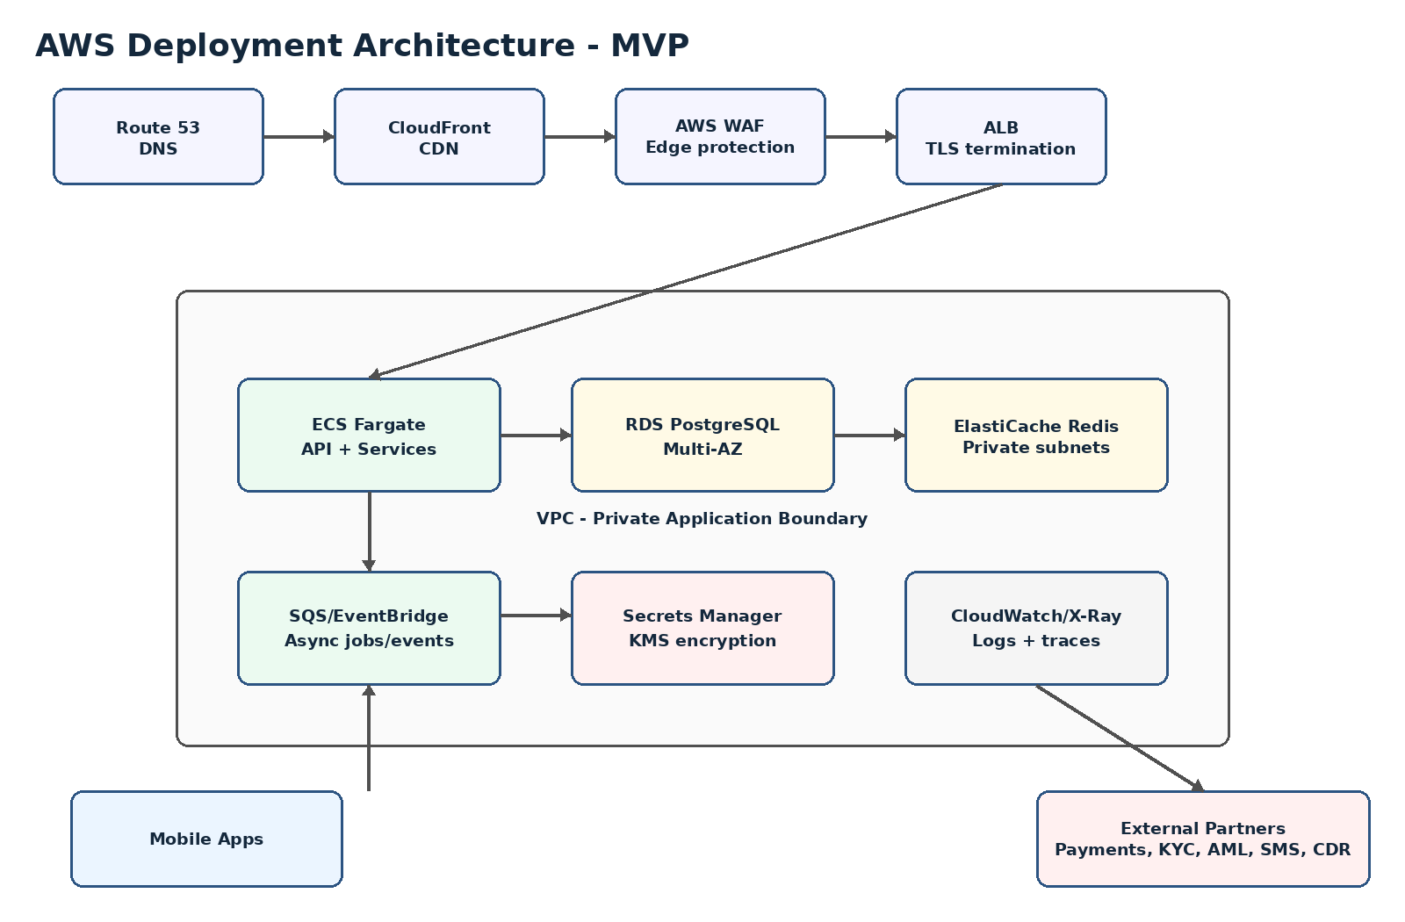
Figure 3. AWS deployment architecture for MVP.

9. Identity Flows
Identity is a high-trust module. Registration, login, KYC, device trust, token management, and step-up authentication must be designed as one system rather than separate features.
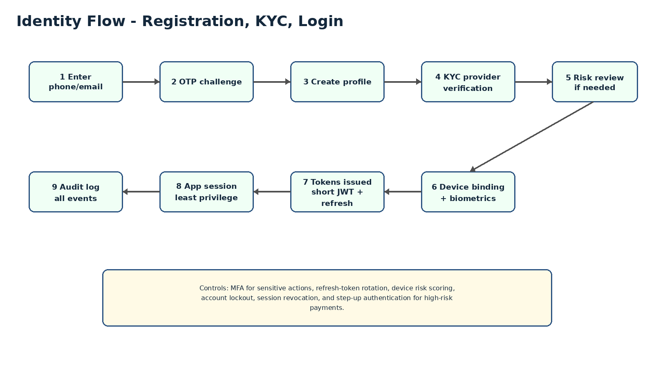
Figure 4. Registration, KYC, login, and session flow.

11. Database Relationships
The schema should distinguish operational data, ledger-style transaction records, identity data, consent data, audit data, and AI-derived insights. Financial records should be append-oriented and traceable.
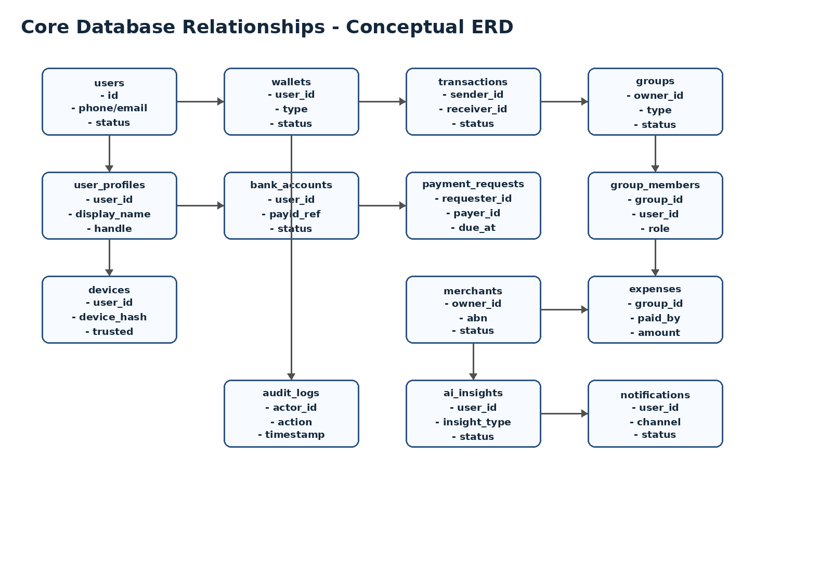
Figure 5. Conceptual core database relationships.

5. Service Interactions
Interaction | Primary Services | Synchronous Path | Asynchronous Events | Notes
User registration | Identity, KYC, Notifications | Mobile -> Gateway -> Identity | user.created, kyc.requested, kyc.completed | KYC partner response may be async.
Send payment | Payments, Risk, Ledger, Partner Adapter | Mobile -> Gateway -> Payments | payment.created, risk.checked, payment.submitted, payment.completed | Never mark completed until partner confirmation.
Split bill | Groups, Expenses, Payment Requests | Mobile -> Gateway -> Expenses | expense.created, request.created, reminder.scheduled | Payment collection is separate from expense creation.
Merchant QR payment | Merchant, Payments, Risk, Ledger | Mobile -> Gateway -> Merchant/Payments | merchant.payment.created, settlement.updated | QR payload must be signed or validated server-side.
AI insight generation | Transactions, AI, Consent, Notifications | App -> Gateway -> AI for on-demand query | insight.generated, insight.viewed | AI sees only data allowed by consent and policy.

8. Security Boundaries
Boundary | Protected Assets | Main Controls
Public edge | APIs, web assets | CloudFront, WAF, TLS, rate limits, bot controls
Application boundary | Business services | Private subnets, IAM roles, service authorization, secrets management
Data boundary | PII, transaction history, audit logs | KMS encryption, row-level access patterns, least privilege, backups
Partner boundary | Payment/KYC/CDR/SMS connectors | mTLS or signed webhooks, allowlists, replay protection, idempotency
Operations boundary | Admin portal and support tools | SSO, MFA, RBAC, approval workflows, audit logs
AI boundary | Prompts, insights, user financial data | Data minimization, consent checks, prompt injection defenses, human approval for actions

10. Payment Orchestration
Payment orchestration is the most important backend workflow. It must handle idempotency, state transitions, risk checks, partner submission, webhook reconciliation, user notifications, and auditability.
Step | State | System Responsibility
Create intent | created | Validate payer, payee, amount, currency, limits, and idempotency key.
Risk pre-check | pending_risk_review or approved | Apply velocity rules, device risk, sanctions/AML flags, and merchant risk controls.
Partner submission | submitted_to_partner | Submit to licensed payment provider using signed requests and retry-safe semantics.
Partner callback | completed or failed | Verify webhook signature, reconcile amount/reference, and update immutable payment event trail.
User notification | notified | Send push/email/SMS according to user preference and transaction severity.
Reconciliation | reconciled | Daily automated reconciliation between Aurora records and partner settlement/reporting files.

12. API Gateway Design
- All external traffic enters through the API Gateway and never directly reaches internal services.
- Gateway responsibilities: TLS enforcement, routing, API versioning, JWT validation, rate limiting, request size limits, correlation IDs, and coarse-grained authorization.
- Business authorization remains inside domain modules; for example, only the Expenses module decides whether a user can view a group expense.
- All mutating endpoints require idempotency keys where retries could create duplicate financial actions.
- Recommended API style for MVP: REST with OpenAPI 3.1 specification; event contracts documented separately.
API Area | Example Endpoints | Notes
Identity | POST /v1/auth/otp/start, POST /v1/auth/otp/verify, POST /v1/kyc/start | Short-lived access token and rotating refresh token.
Payments | POST /v1/payments, GET /v1/payments/{id}, POST /v1/payment-requests | Idempotency required for create operations.
Groups/Expenses | POST /v1/groups, POST /v1/groups/{id}/expenses, GET /v1/groups/{id}/balances | Group authorization checks required.
Merchants | POST /v1/merchants, POST /v1/merchants/{id}/qr, GET /v1/merchants/{id}/transactions | Merchant onboarding and review state required.
AI | POST /v1/ai/query, GET /v1/ai/insights | Consent-aware data access; no autonomous payment execution.

13. AI Service Interactions
The AI service should be built as a controlled application service, not as a direct connection from the mobile app to an AI model. It should retrieve only policy-approved data, transform it into minimal context, call the model, then store explainable insights.
AI Capability | Inputs | Outputs | Guardrails
Spending categorization | Transaction descriptions, merchant metadata | Category labels and confidence | Human override, confidence thresholds
Budget insight | Transactions, recurring bills, goals | Narrative insight and suggested actions | No financial advice beyond general guidance unless licensed
Subscription detection | Recurring payments | Candidate subscriptions | User confirmation before cancellation or action
Group assistant | Expenses, balances, due dates | Who owes what, reminders | No payment execution without explicit approval
Merchant analytics | Merchant transactions, product categories | Sales trends and campaign suggestions | Aggregate where possible; protect consumer privacy

14. Observability and Operations
- Every request should carry a correlation ID from gateway to service, logs, events, and partner adapter calls.
- Financial workflows require structured audit events with actor, timestamp, action, object, previous state, new state, source IP/device, and correlation ID.
- Dashboards should track API latency, payment success rate, partner webhook lag, KYC completion time, fraud queue volume, notification delivery, and error budgets.
- Runbooks are required for payment partner outage, webhook delay, duplicate transaction alert, compromised account report, data breach triage, and high-risk merchant investigation.

15. Engineering Decisions and Open Questions
Decision Area | Recommendation | Open Question
Funds model | Do not hold customer funds in MVP | Which licensed partner offers the best API, pricing, and settlement model?
Architecture style | Modular monolith initially | At what scale do we extract Payments/Risk into independent services?
Mobile stack | Flutter | Confirm native requirements for biometrics, secure storage, and QR scanning.
Database | PostgreSQL with append-oriented financial events | Define final ledger model with payment partner and accountant/legal review.
AI | Central AI service with consent-aware retrieval | Define exact AI policy boundaries and disclaimers for financial guidance.
Admin portal | Build from MVP stage | Which workflows require four-eyes approval from launch?

16. References
Australian Payments Plus - NPP / real-time payments: https://www.auspayplus.com.au/solutions/npp
Reserve Bank of Australia - New Payments Platform: https://www.rba.gov.au/payments-and-infrastructure/new-payments-platform/
Consumer Data Right - official site: https://www.cdr.gov.au/
ACCC - Consumer Data Right: https://www.accc.gov.au/by-industry/banking-and-finance/the-consumer-data-right
AUSTRAC - obligations and guidance: https://www.austrac.gov.au/industry-and-business/obligations-and-guidance/your-obligations
OAIC - Australian Privacy Principles: https://www.oaic.gov.au/privacy/australian-privacy-principles

