Project 2

Sayed Erfan Arefin

RWP

For the Random Way Point, the drone starts from (0,0) and selects a random point in the given rectangle area. It goes straight to that point and then, waits for a pause time. Then it selects another random pont to visit.

This process is repeated in my project 5 times.

You can run this with the following command:

pro2_Arefin_SayedErfan(0,2,5,0)

Total Flying Distance: 3416.35 meters

Total Flying Time: 1733.17 seconds

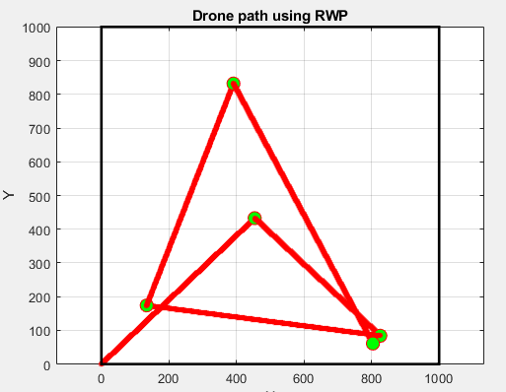

An example of a second run:

pro2_Arefin_SayedErfan(0,2,5,0)

Total Flying Distance: 2126.34 meters

Total Flying Time: 1088.17 seconds

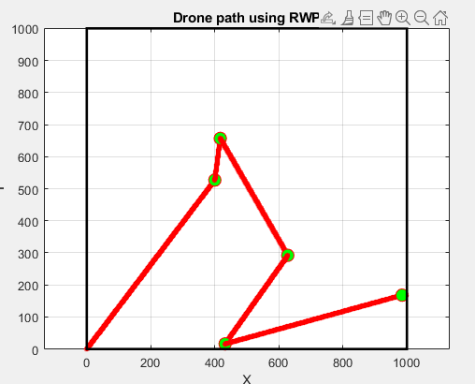

PPR:

The