Project 3 Report

Sayed Erfan Arefin

# Clustering

First this displays the clusters locations

You can run this with the following command:

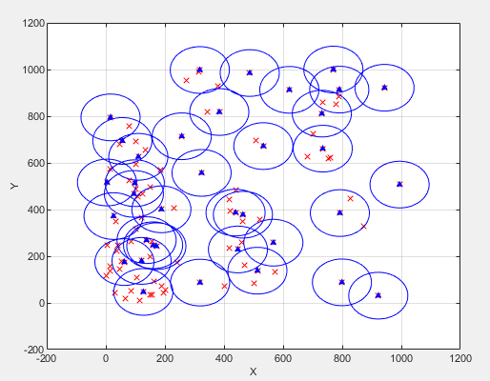

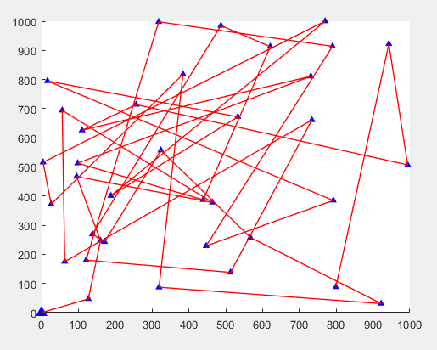

For rand and clustering

Pro3_Arefin_SayedErfan(0)

Total Flying Distance: 1.8500e+04 meters

An example of a second run:

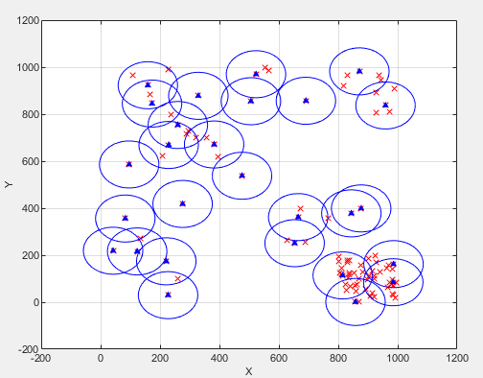

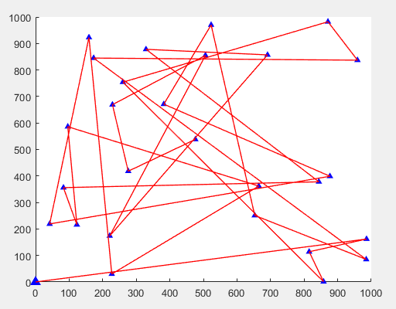

pro2_Arefin_SayedErfan(0)

Total Flying Distance: 1.5349e+04 meters

Clustering and NNF:

This displays based on nearest neigbour

Example run from the question:

pro2_Arefin_SayedErfan(1)

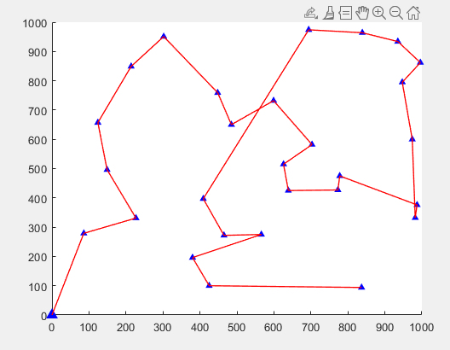

A second run of the same problem:

