Exploratory Data Analysis (EDA) Project
Diabetes Risk Factor Analysis — Patient Health Dataset

1. Objective
This project analyzes a patient health dataset to uncover patterns and trends related to diabetes risk. The analysis uses statistical summaries and visualizations to identify correlations and the key factors that influence whether a patient is diagnosed as diabetic, and presents the findings in a structured report.

2. Dataset Overview
The dataset contains 773 raw patient records (768 after removing duplicates) with 8 clinical features and one binary outcome:
- Pregnancies — number of times pregnant
- Glucose — plasma glucose concentration
- BloodPressure — diastolic blood pressure (mm Hg)
- SkinThickness — triceps skinfold thickness (mm)
- Insulin — 2-hour serum insulin (mu U/ml)
- BMI — body mass index
- DiabetesPedigreeFunction — genetic diabetes risk score
- Age — age in years
- Outcome — 1 = diabetic, 0 = non-diabetic (target variable)

3. Data Cleaning
Initial inspection revealed two data quality issues that needed to be addressed before analysis:
- 5 exact duplicate rows, removed.
- Biologically implausible zero-values in Glucose (7), BloodPressure (15), SkinThickness (69), Insulin (138), and BMI (17) — a living patient cannot have a value of 0 for these measurements, so they were treated as missing data.
Missing values were imputed using the median within each Outcome group (diabetic vs. non-diabetic) rather than a single global median, which preserves the distributional difference between the two groups instead of blurring it.

4. Statistical Summary
Metric | Value
Total records (after cleaning) | 768
Features analyzed | 8 clinical + 1 outcome
Diabetic cases | 46 (6.0%)
Non-diabetic cases | 722 (94.0%)
Mean Glucose | 116.2
Mean BMI | 24.5
Mean Age | 51.0 years
Mean Blood Pressure | 79.9 mm Hg

5. Visual Analysis

5.1 Class Balance
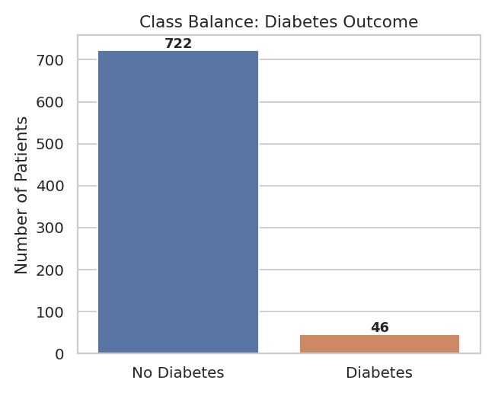
Figure 1 — The dataset is imbalanced: diabetic patients are a clear minority class.

5.2 Feature Distributions
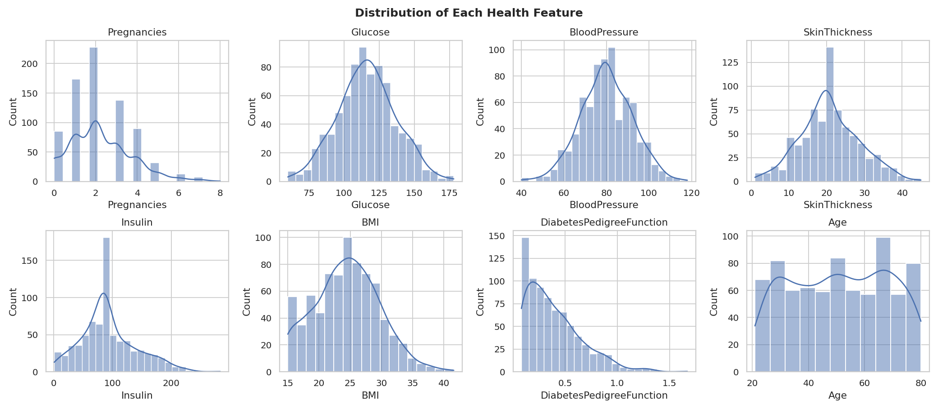
Figure 2 — Distribution of each health feature. Glucose, BMI, and Age approximate a normal spread; Insulin and DiabetesPedigreeFunction are right-skewed.

5.3 Outlier Check by Outcome
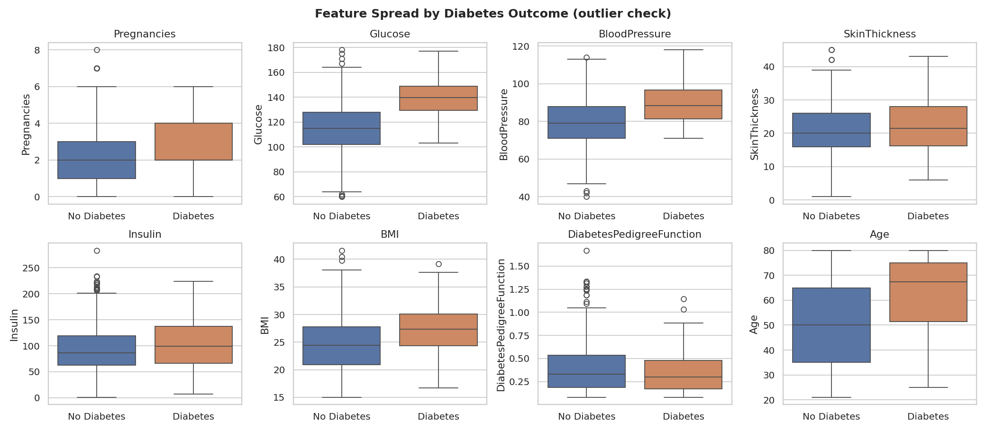
Figure 3 — Boxplots comparing each feature between diabetic and non-diabetic patients. Diabetic patients show visibly higher medians for Glucose, BMI, and Age.

5.4 Correlation Matrix
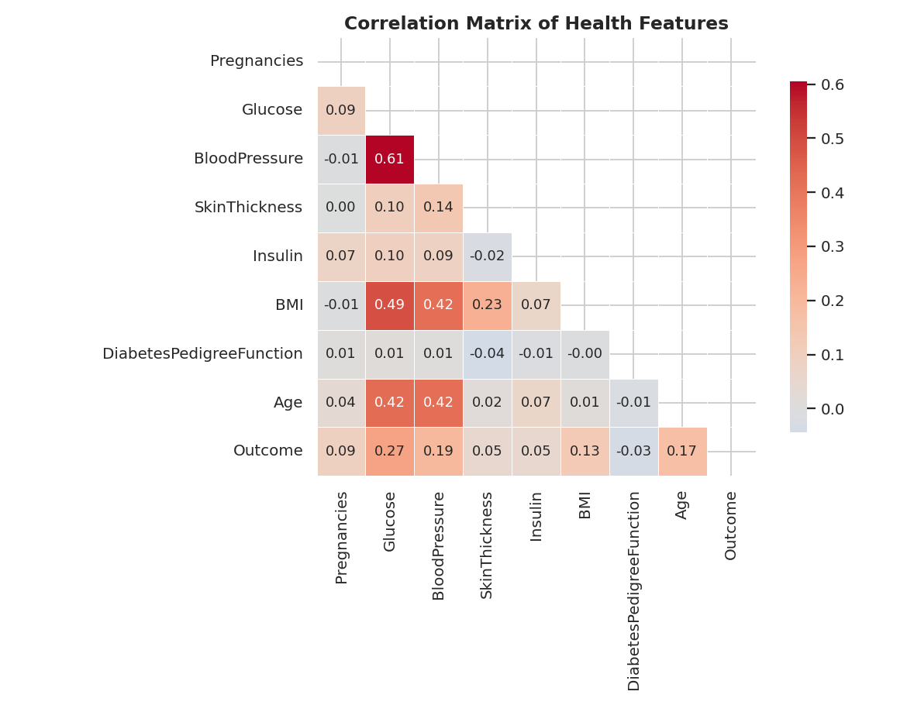
Figure 4 — Correlation matrix across all features. Glucose and BMI show the strongest relationships with the diabetes outcome.

5.5 Ranked Correlation with Outcome
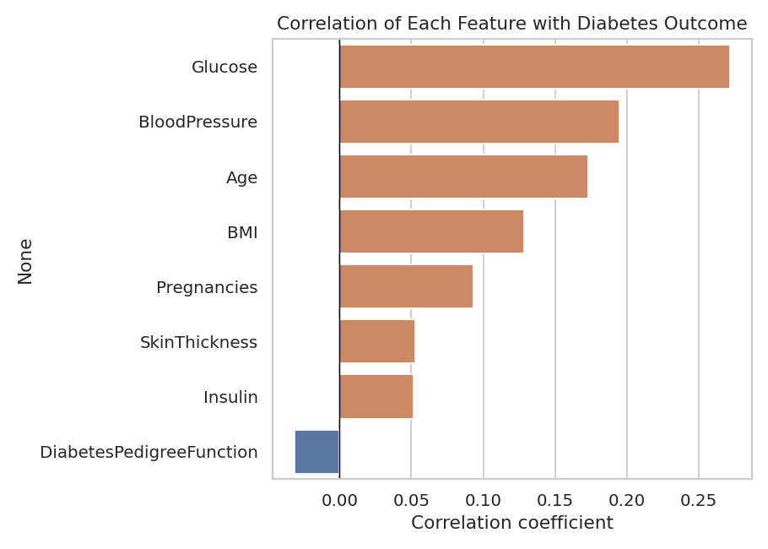
Figure 5 — Features ranked by strength of correlation with diabetes outcome.

5.6 Glucose vs. BMI
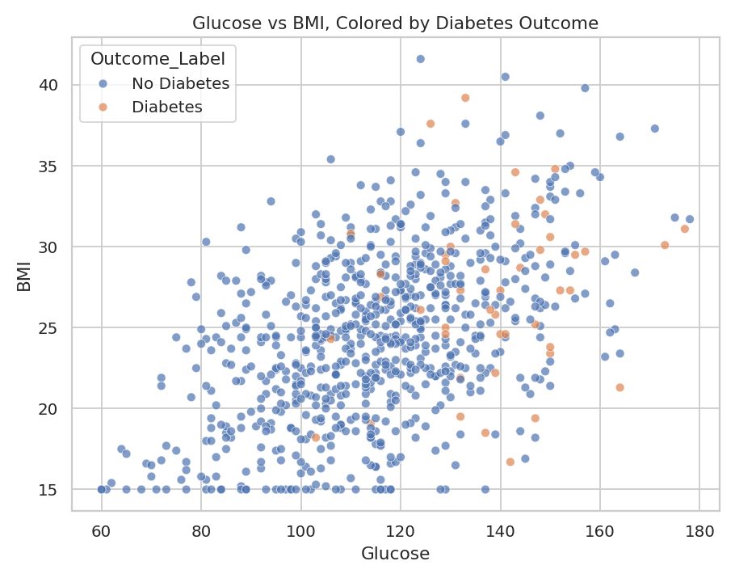
Figure 6 — Patients with both elevated glucose and elevated BMI cluster toward diabetic outcomes, suggesting a compounding effect between the two factors.

5.7 Age Distribution by Outcome
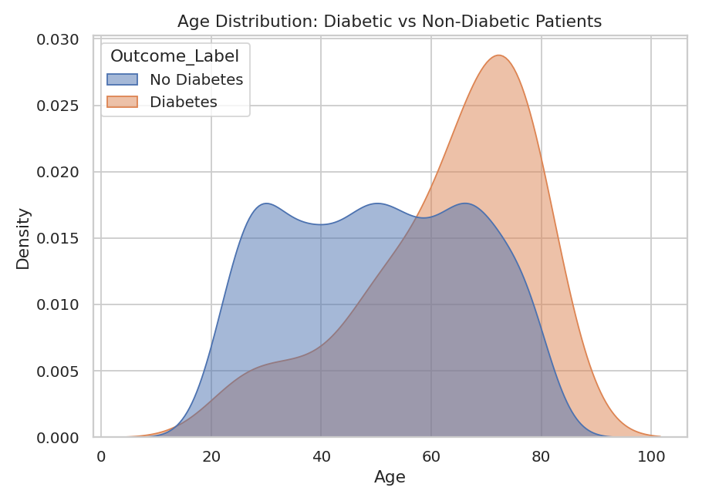
Figure 7 — Diabetic patients skew toward an older age distribution.

5.8 Pairwise Relationships of Top Risk Factors
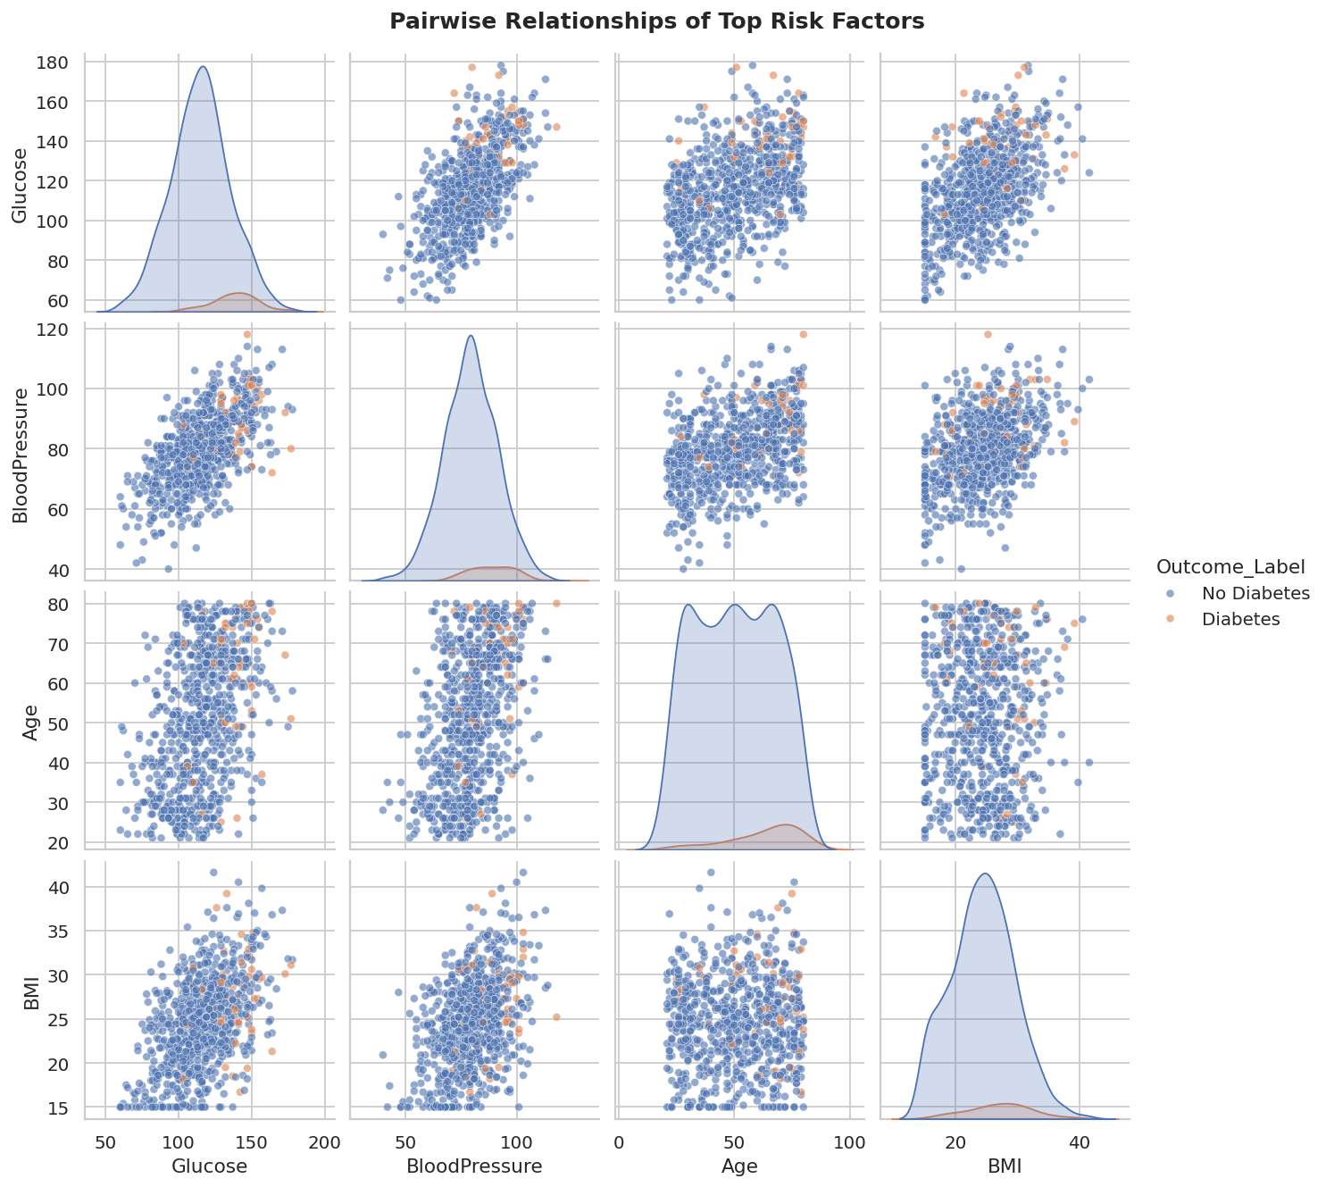
Figure 8 — Pairwise scatter and density plots of the four most correlated features (Glucose, BloodPressure, Age, BMI), split by outcome.

6. Key Findings
- Glucose is the single strongest predictor of diabetes outcome in this dataset, followed by BloodPressure, Age, and BMI.
- Risk factors compound: patients with both high Glucose and high BMI show a markedly higher concentration of diabetic outcomes than either factor alone would suggest.
- The diabetic class is a minority (~6% of records) — an important consideration for any future predictive model, since plain accuracy would be a misleading evaluation metric.
- DiabetesPedigreeFunction, SkinThickness, and Insulin show comparatively weak linear correlation with the outcome individually, though they may still contribute through interaction effects not captured by a simple correlation.

7. Conclusion
The exploratory analysis shows that a small set of measurable clinical indicators — glucose level, blood pressure, age, and BMI — carry most of the signal for identifying diabetes risk in this dataset. These findings support prioritizing these four measurements in any future screening tool or predictive model, while treating pedigree/genetic and insulin-related features as secondary, exploratory signals that may still matter in combination with other variables.
Prepared as part of the EDA Project assignment — Thiranex Skill Development & Future Tech.

