Real-World Data Project
Retail Sales Analysis & Revenue Forecasting

1. Objective
This project applies data science techniques to a retail sales dataset spanning two years, five product categories, and five cities. It performs end-to-end analysis to uncover revenue trends, category performance, weekday and seasonal patterns, and the effect of promotions, then builds a predictive model to forecast daily revenue.

2. Dataset Overview
The dataset contains 3,665 raw daily category-level sales records (3,650 after removing duplicates) with the following fields:
- Date, Category, City
- Units_Sold, Unit_Price, Revenue
- Customer_Count, Avg_Customer_Age
- Promotion (0/1 flag for promotional days)

3. Data Cleaning
- 15 exact duplicate rows removed.
- 25 rows had an implausible zero Unit_Price, treated as missing and imputed with the category median; Revenue was recomputed afterward.
- 30 rows had missing Avg_Customer_Age, imputed with the category median.
- Engineered Month, Weekday, Is_Weekend, and Promotion_Label features for analysis.

4. Statistical Summary
Metric | Value
Total records (cleaned) | 3,650
Date range | Jan 2024 – Dec 2025 (2 years)
Categories | Electronics, Clothing, Groceries, Furniture, Toys
Top category by revenue | Electronics (₹43.3L)
Avg. revenue, no promotion | ₹2,753 / day
Avg. revenue, with promotion | ₹3,624 / day (+31.6%)

5. Visual Analysis

5.1 Revenue Trend Over Time
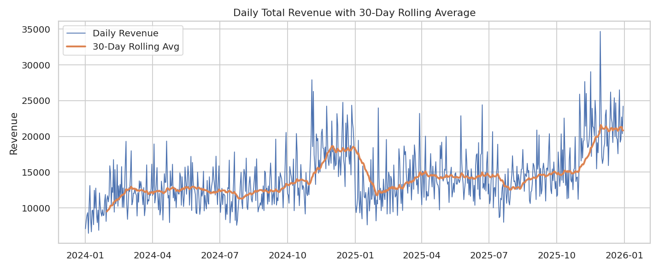
Figure 1 — Daily revenue with a 30-day rolling average showing a steady upward trend with a sharp seasonal spike around November–December.

5.2 Revenue by Category
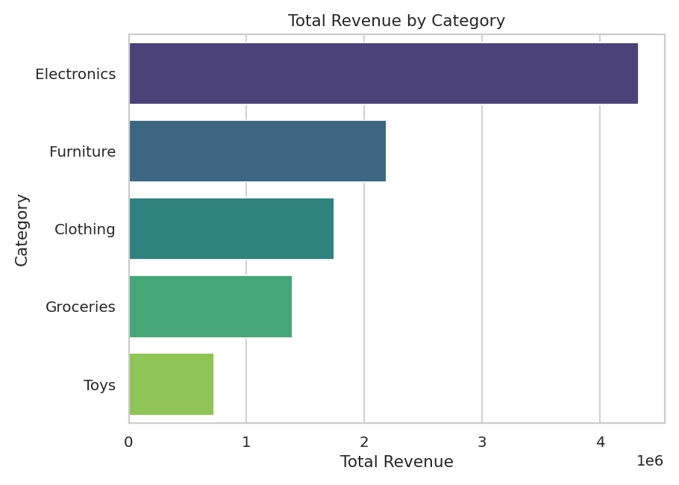
Figure 2 — Electronics and Furniture dominate total revenue despite lower unit volumes, due to higher price points.

5.3 Revenue by Weekday
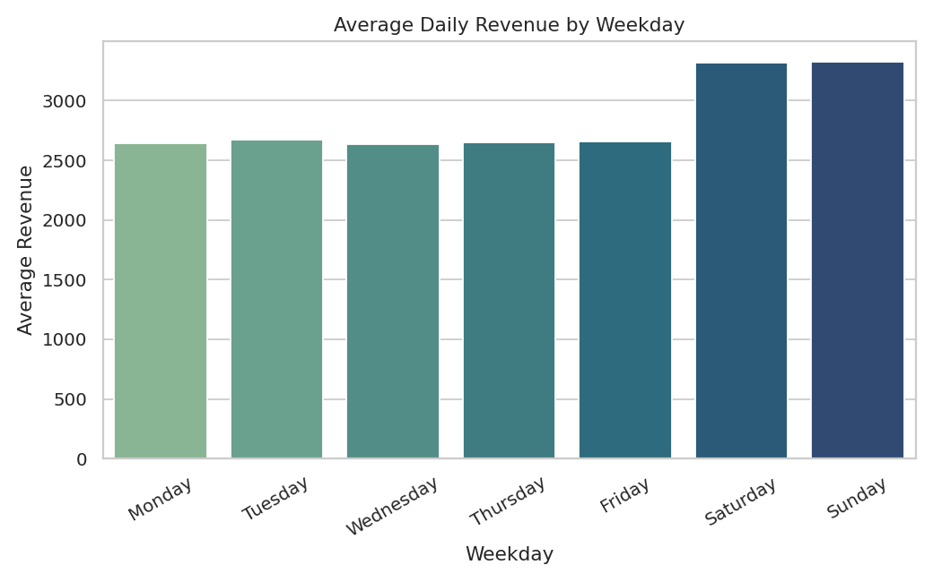
Figure 3 — Weekends generate noticeably higher average daily revenue than weekdays.

5.4 Promotion Effect
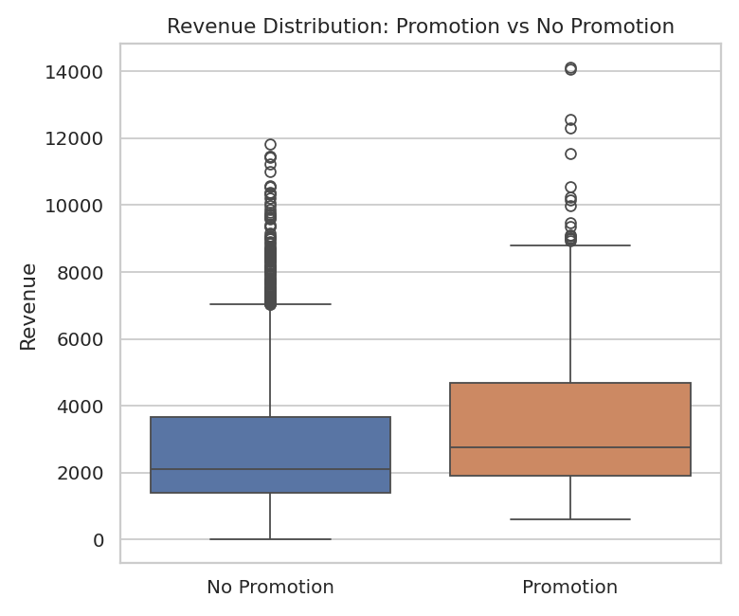
Figure 4 — Promotional days show a clear upward shift in the revenue distribution.

5.5 Correlation Matrix
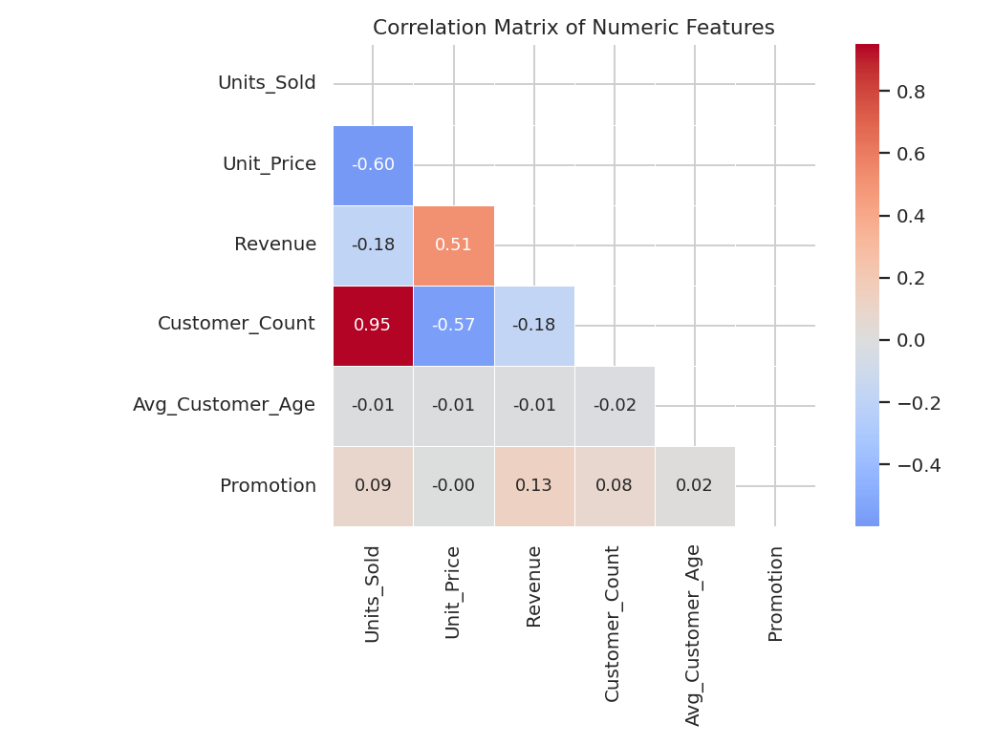
Figure 5 — Revenue correlates most strongly with Units_Sold and Customer_Count, as expected.

5.6 Monthly Revenue
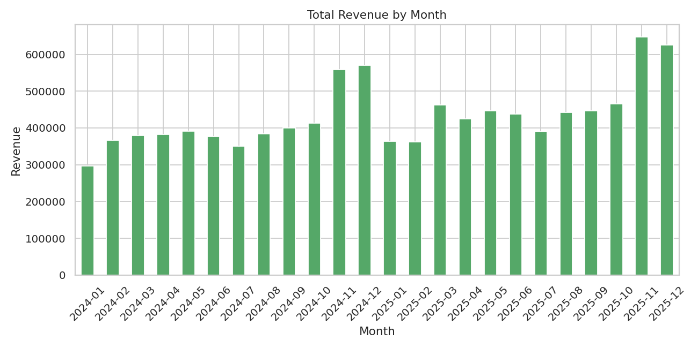
Figure 6 — November and December stand out clearly as the strongest months, consistent with holiday shopping season.

5.7 Customers vs Revenue
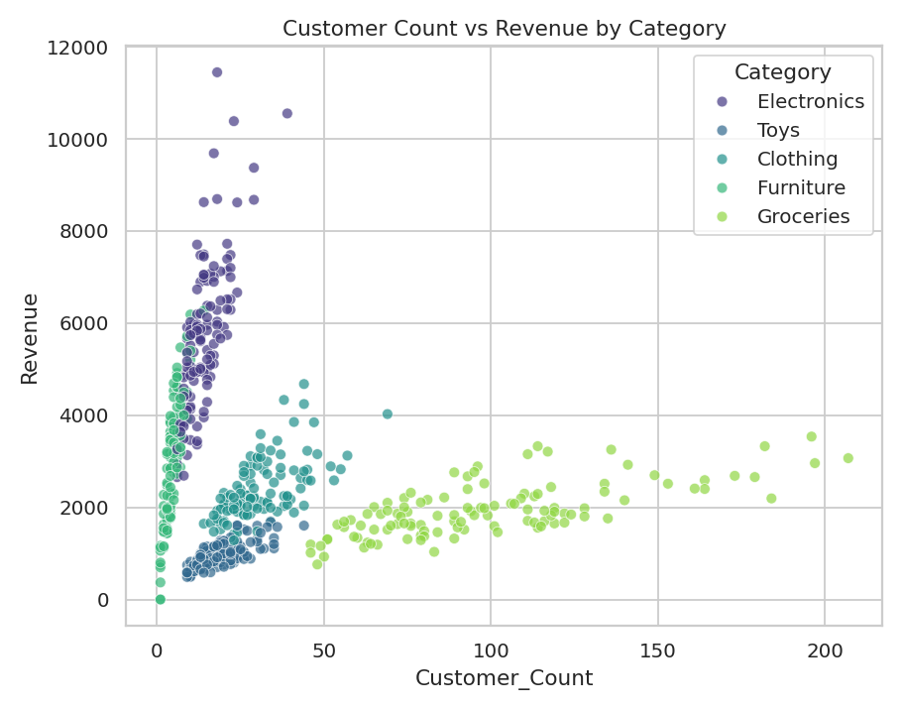
Figure 7 — Revenue scales with customer count, with Electronics and Furniture showing steeper slopes due to higher price points.

5.8 Category vs Weekday Heatmap
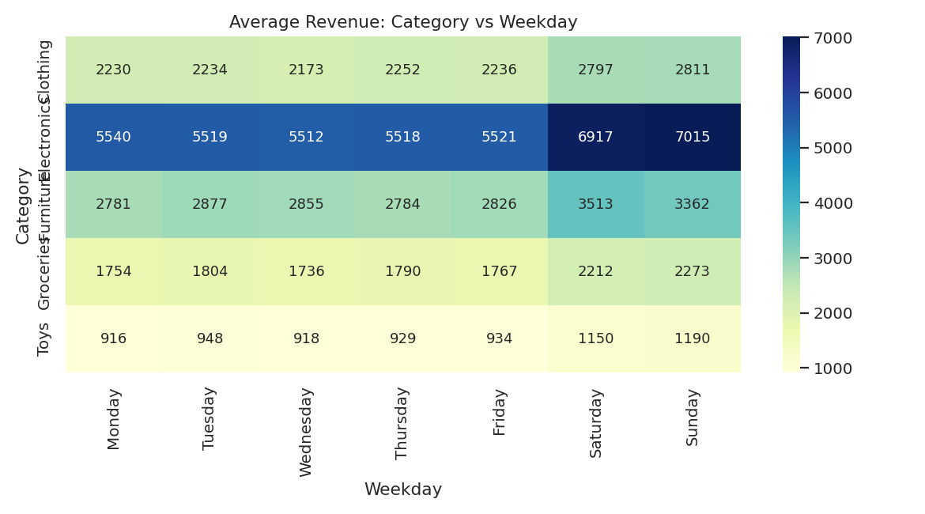
Figure 8 — Every category follows the same weekend-boost pattern, with Electronics showing the largest weekday-to-weekend swing.

6. Sales Prediction Model
A RandomForestRegressor was trained to forecast daily category-level revenue using calendar features (month, weekday, weekend flag), the promotion flag, category, and lagged revenue (previous day and previous week). The final 15% of the timeline was held out as a test set to simulate forecasting unseen future days.
Metric | Value
Model | RandomForestRegressor (300 trees, max depth 10)
Train / Test split | 85% / 15%, time-based
MAE | 676.56
RMSE | 1,051.84
MAPE | 18.75%
R² Score | 0.8165

6.1 Feature Importance
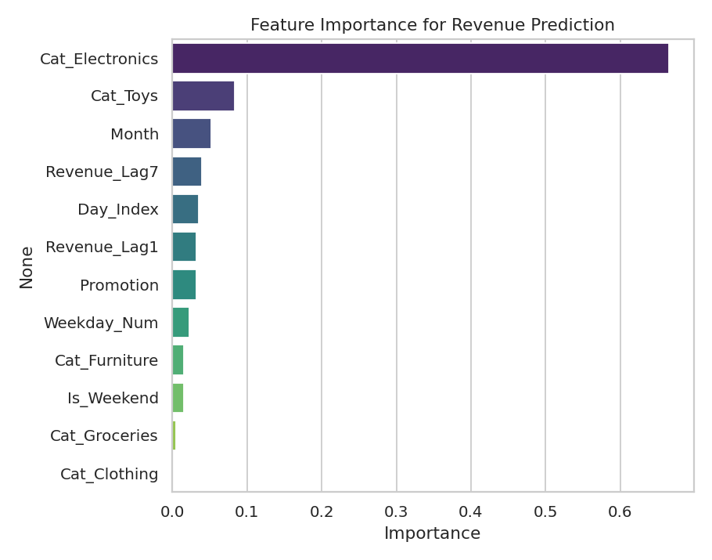
Figure 9 — Lagged revenue (previous week and previous day) and the day-of-timeline index are the strongest predictors.

6.2 Actual vs Predicted Revenue
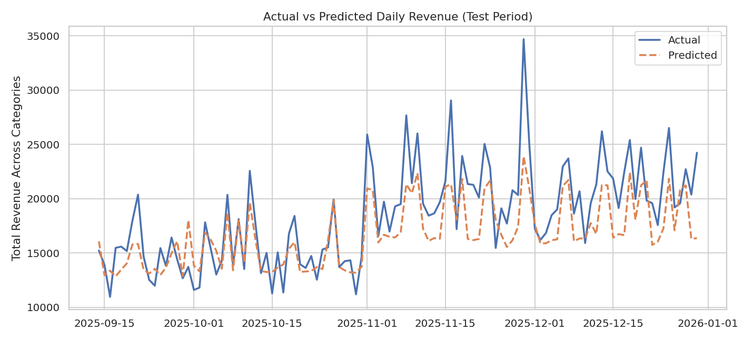
Figure 10 — The model tracks the overall pattern well but underpredicts the sharpest holiday-season spikes, a common limitation when only two years of history are available.

6.3 Prediction Accuracy Scatter
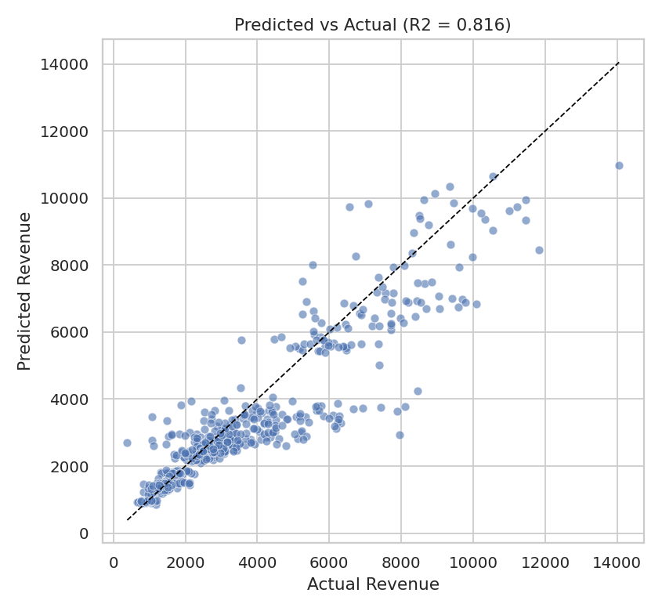
Figure 11 — Predicted vs actual revenue values cluster closely around the diagonal, confirming the R² of 0.82.

7. Key Findings
- Electronics and Furniture are the top revenue-generating categories despite moderate unit volumes, due to higher average price points.
- Weekends consistently outperform weekdays across every category.
- Promotions lift average daily revenue by roughly 31.6%.
- November–December is the strongest seasonal window, consistent with holiday shopping behavior.
- A lag-based Random Forest model explains about 82% of the variance in daily revenue, but underpredicts extreme holiday-season peaks — suggesting more historical years of data would improve seasonal forecasting.

8. Conclusion
Category mix, weekday timing, and promotions are the strongest and most consistent levers on retail revenue in this dataset. A relatively simple lag-based machine learning model captures the overall demand pattern with good accuracy (R² ≈ 0.82), making it a solid baseline for revenue forecasting, though holiday-season extremes remain the hardest period to predict precisely with only two years of history.
Prepared as part of the Real-World Data Project assignment — Thiranex Skill Development & Future Tech.

