**DataScienceDataCurationProject: A DSL for Initial and Exploratory Data Analysis for Data Analytics Projects. Sayed Ahmed, and Sepehr Bayat.**

Contents

Model Creation from Meta Model 1

Model creation using the Editor 5

Example EVL Creation for the Project 9

Dummy EOL creation in the Project: 10

EGL Creation in an Editor where Model is created 11

EGL Template for showing Data Summary for IDA/EDA purposes 11

Update EGX and EGL 14

Example run of the example egl 15

Creating the GMF Diagram 16

With the metal model where StateTransition is not there 16

With State Transition. I eventually want to use this. 17

Utilizing the generated .diagram editor. 17

# Model Creation from Meta Model

**Epackage Registration:**

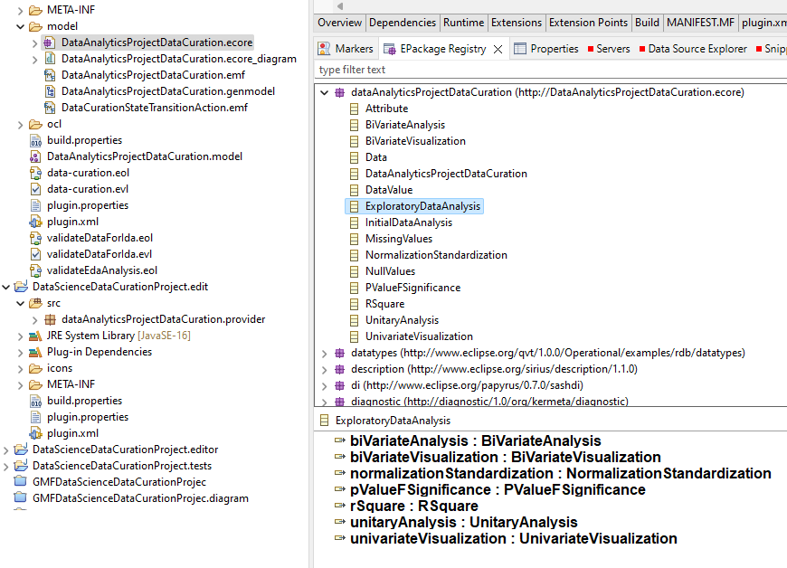

## Model creation using the Editor

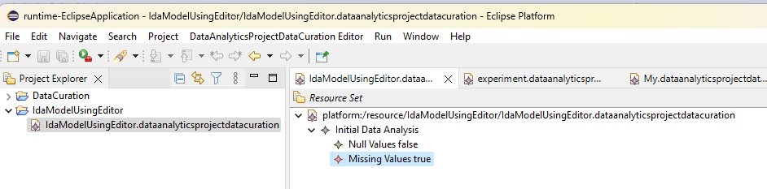

# Example EVL Creation for the Project

**To execute EVL/EOL giving reference to the corresponding Model**

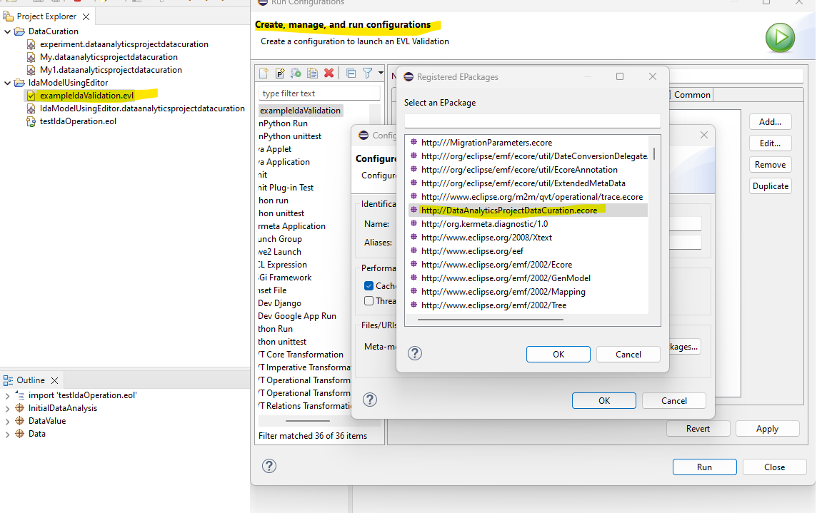

## Dummy EOL creation in the Project:

**At this point just creating the components and flow with pseudocode.**

EGL Creation in an Editor where Model is created**. i.e. I am using .Editor, not in the same place where meta model was. Although I registered using EPackage registry and could do it there as well.**

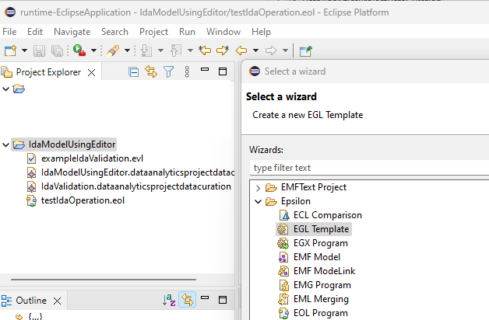

## EGL Template for showing Data Summary for IDA/EDA purposes

**Rename file/template.**

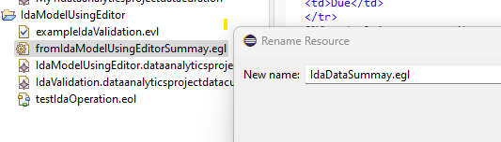

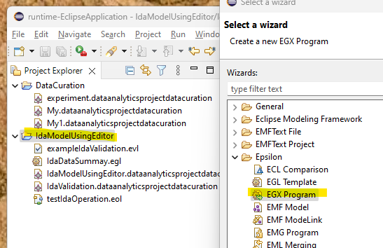

## Update EGX and EGL

## Example run of the example egl

## Creating the GMF Diagram

## With the metal model where StateTransition is not there

## With State Transition. I eventually want to use this.

## Utilizing the generated .diagram editor.

**We could execute and use the diagram; However, at this point, we did not configure the drag and drop state transition yet for this project although tried those for small examples such as FSM.**

