Context:

Step 1: Corresponding Meta Model in Diagram

Note:

I want to introduce a Data element under State.

Step 2: Create the model from the meta model

**Files:**

IdaDataDescription.egl

IdaEdaDataDescription.egx

dataDescription.txt

Egx for Creating Data Descriptions. EGX is the program that use EGL files as templates

EGX:

EGL:

**Execution Output:**

**Example 2:**

Generate Data Cleaning Summary using M2T.

Files: IdaEdaDataCleaningSummary.egx, IdaEdaDataCleaningSummary.egl, dataCleanSummary.txt

**Code/Template:**

**Egx:**

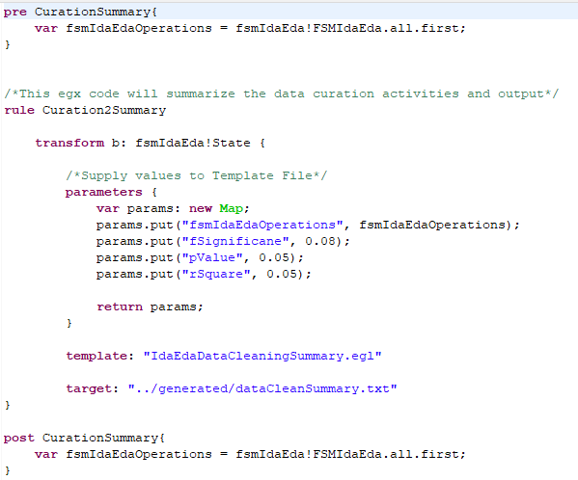

**EGL:**

**Execution Success:**

**Output:**

