**DataScienceDataCurationProject: A DSL for Initial and Exploratory Data Analysis for Data Analytics Projects. Sayed Ahmed, and Sepehr Bayat.**

Contents

Meta Models 1

EMF Generator Model 3

Model Creation 6

Model Creation Using .Editor 8

Using .Editor 12

Trying to use OCL and/or Validation Rules: 13

# Meta Models

Note: we will add more attributes and properties to this metamodel. Also, will add state, transition, action/event (ongoing). At this point ref, val, Opposites, cardinalities, and similar are not finalized yet.

EMF/Ecore Model. Cardinalities as shown are not planned yet.

* 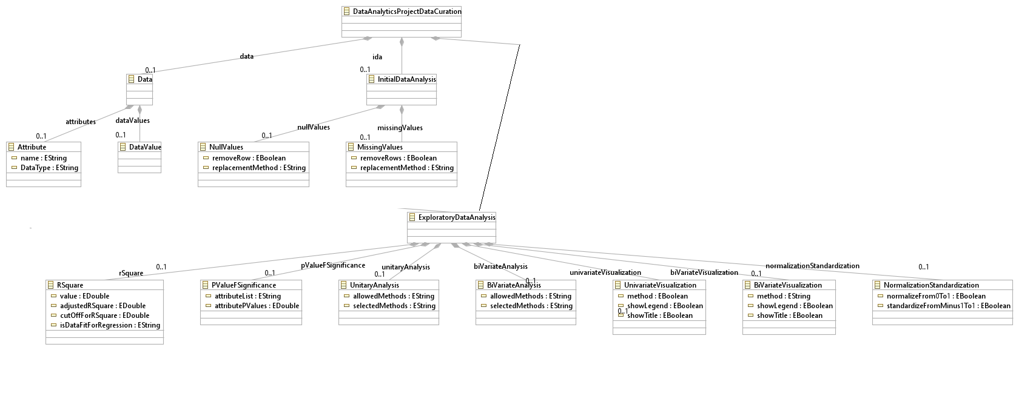another approach ---

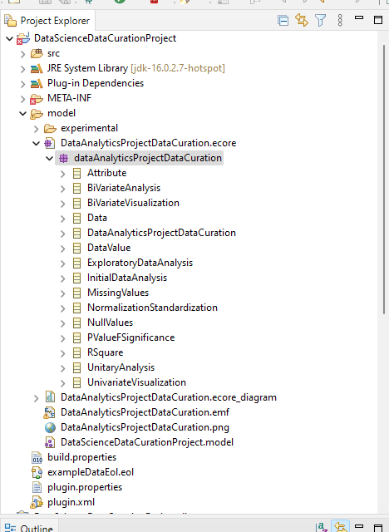

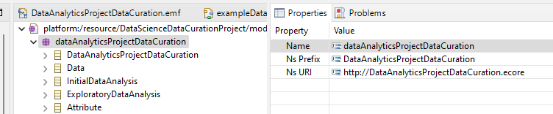

# EMF Generator Model

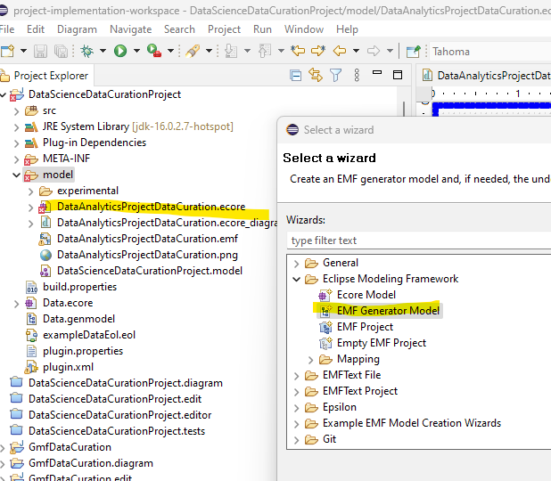

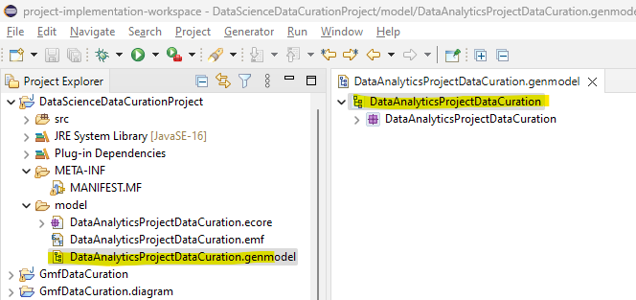

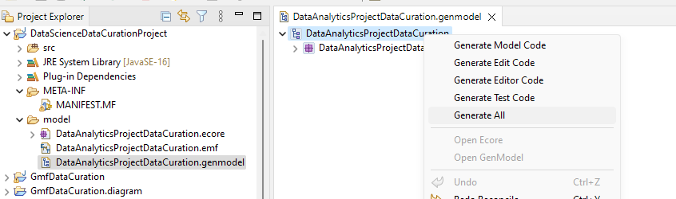

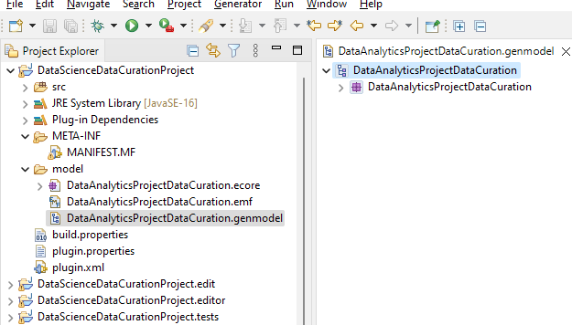

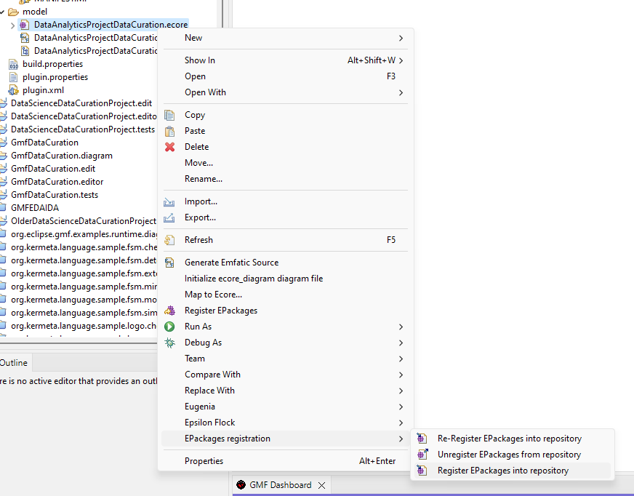

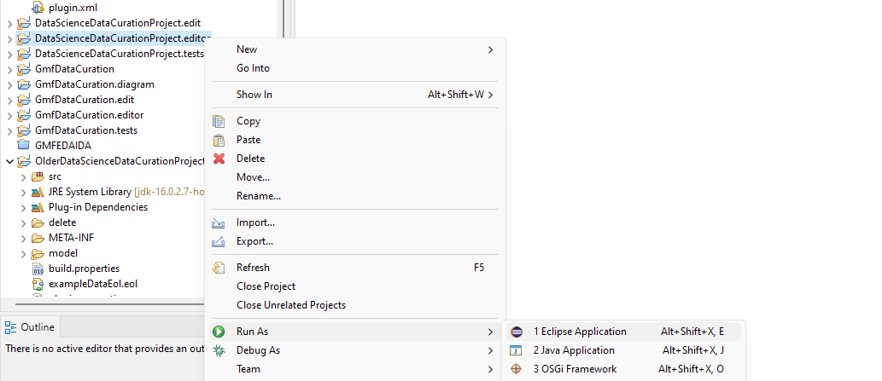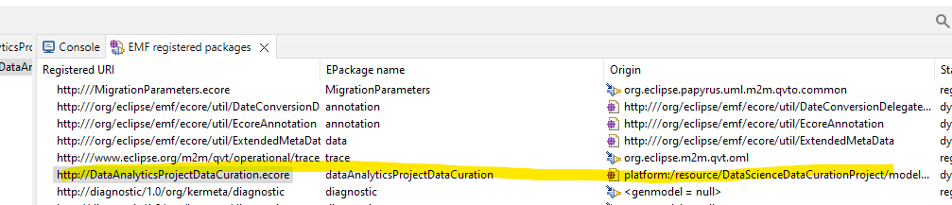

# Model Creation

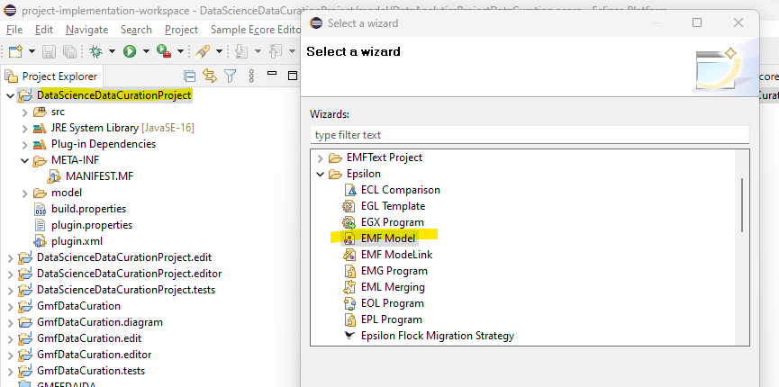

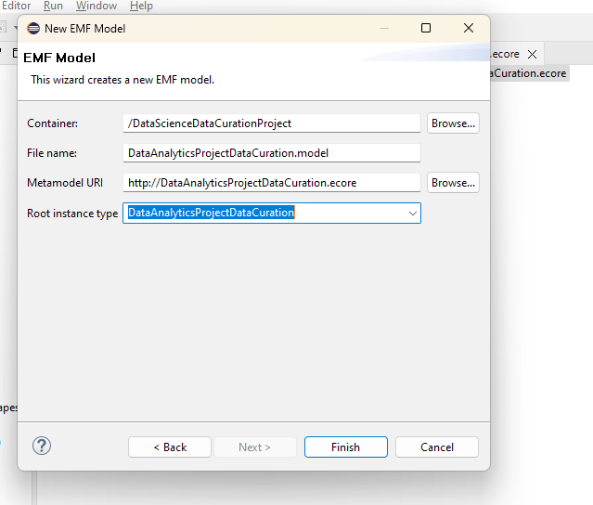

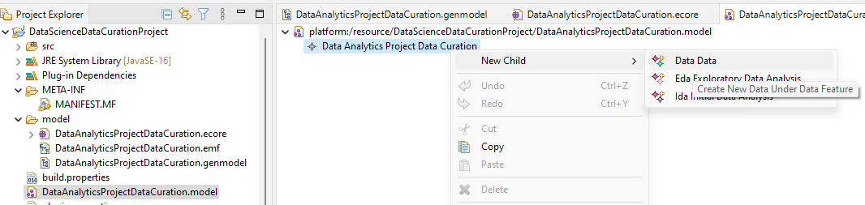

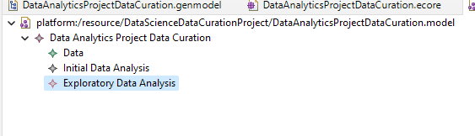

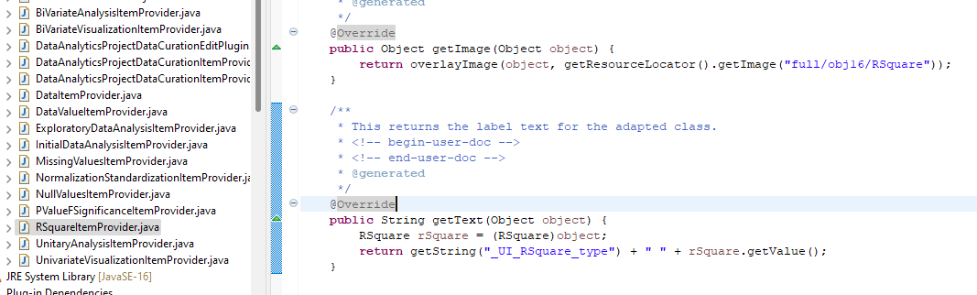

## Model Creation Using .Editor

Older version

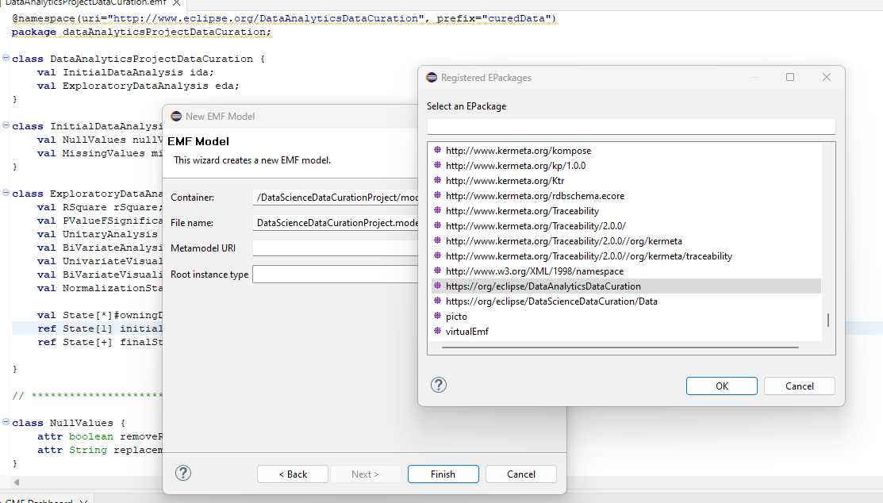

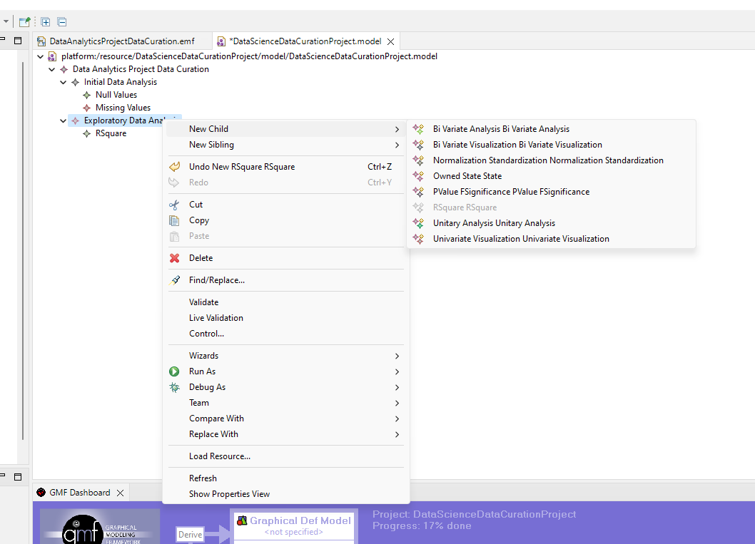

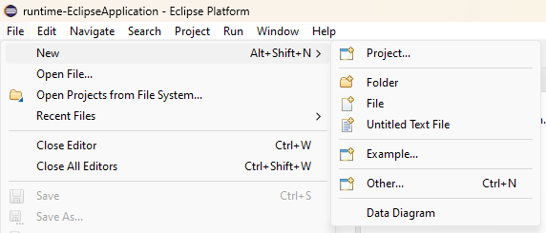

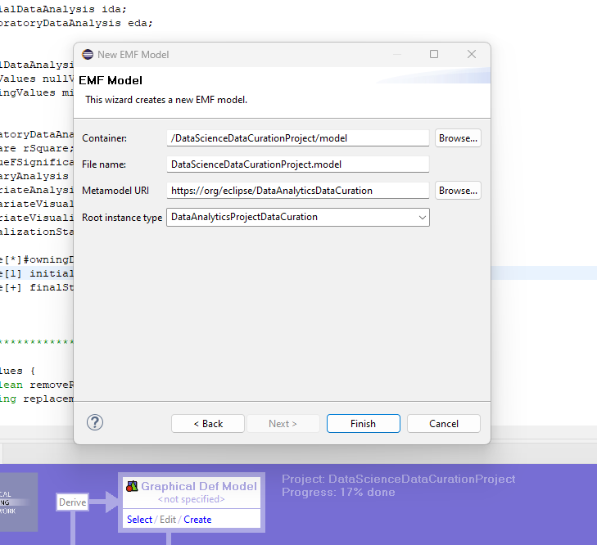

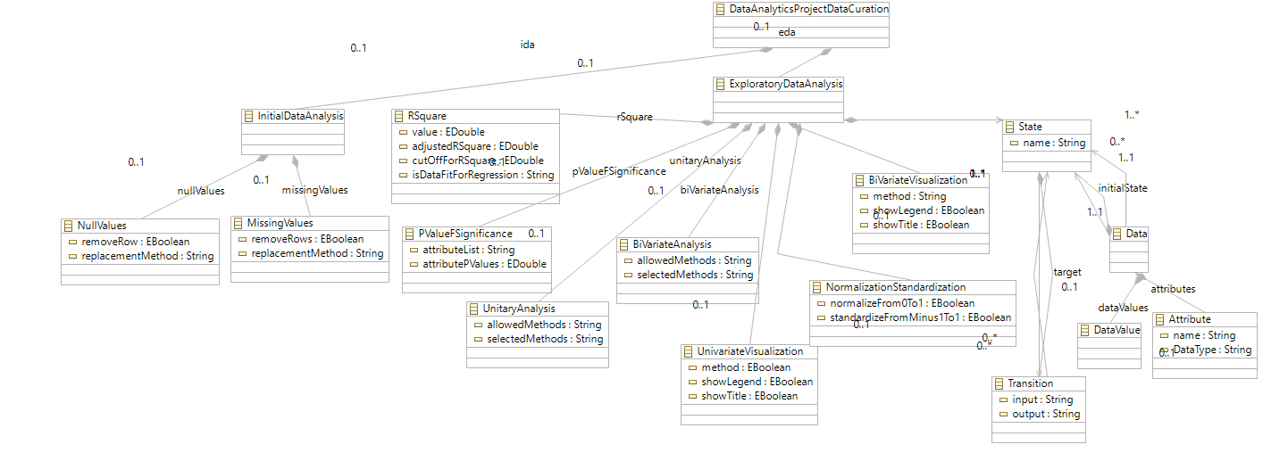

## Using .Editor

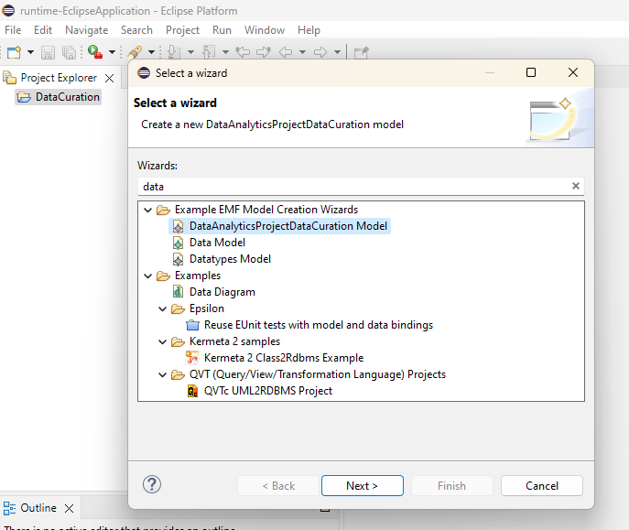

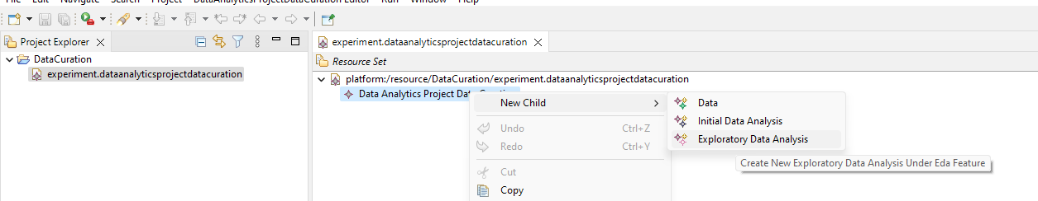

# Trying to use OCL and/or Validation Rules:

