HOLMES INSTITUTE UNIVERSITY
Database Design and Use - HS2021
Assessment
Student Name:
Student ID:

PART A: DATABASE DESIGN
Case Study Summary
SmartPark is an emerging smart parking management company which operates in several cities and offers smart parking services with automated systems and mobile apps. The company handles various business operations like parking facilities, parking zones, parking spaces, users, vehicles, bookings, payments, staff, and offences.
The company needs a relational database to manage data related to its operations. A city has multiple parking facilities, and each facility has multiple zones, including General, VIP, Disabled and Electric Vehicle zones. These zones have multiple parking spaces, which, in turn, have a status (Available, Occupied, Reserved or Out of Service).
The system allows users to register and have multiple vehicles. These users can book parking spaces, with each booking containing details of the entry and exit times, as well as the cost. Bookings can be paid for using various payment methods and payments need to be tracked.
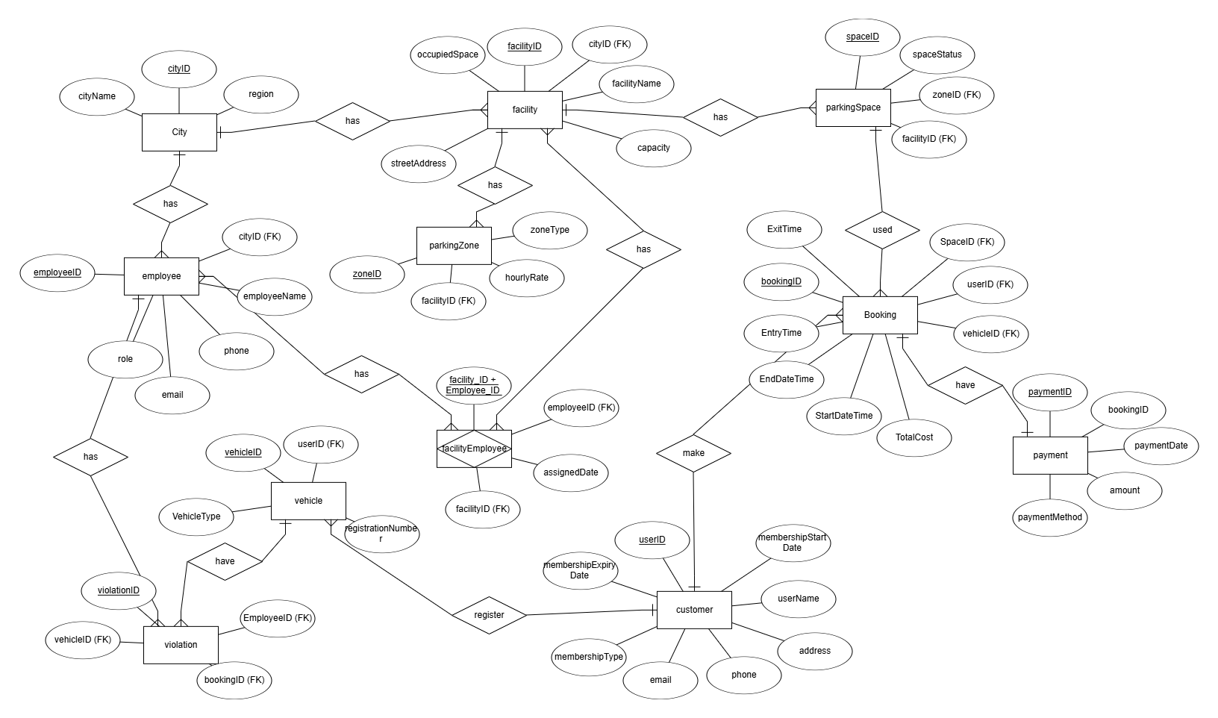
Facilities are managed and monitored by employees. An employee can manage more than one facility, so there is a many-to-many relationship, which is solved by introducing an associative entity. It also records violations that can be overstay, no payment or improper parking, which are associated with vehicles and issued by employees. The database structure maintains correct relationships among entities and facilitates data storage, retrieval and reporting. This system will help SmartPark enhance efficiency, maintain data integrity and plan for growth.
Figure 1: ERD Diagram of SmartPark
Data Dictionary:
- City Table:
Fields Name | Data Type | PK/FK | Description | Constraints
cityID | INT | PK | Unique city ID | NOT NULL
cityName | VARCHAR(100) |  | Name of city | NOT NULL
region | VARCHAR(50) |  | State | NOT NULL

- Facility Table:
Fields Name | Data Type | PK/FK | Description | Constraints
facilityID | INT | PK | Unique facility ID | NOT NULL
facilityName | VARCHAR(100) |  | Facility name | NOT NULL
streetAddress | VARCHAR(150) |  | Facility address | NOT NULL
capacity | INT |  | Total parking spaces | CHECK (capacity > 0)
OccupiedSpaces | INT |  | Occupied spaces | CHECK (occupied spaces >= 0)
cityID | INT | FK | Linked City | REFERENCES CITY

- Parking Zone Table:
Field Name | Data Type | PK/FK | Description | Constraints
zone_id | INT | PK | Unique zone ID | NOT NULL
zone_type | VARCHAR(50) |  | Zone category | NOT NULL
hourly_rate | DECIMAL(10,2) |  | Parking rate | CHECK (hourly_rate > 0)
max_duration | INT |  | Max hours allowed | CHECK (max_duration > 0)
facility_id | INT | FK | Linked facility | REFERENCES FACILITY

- Parking Space Table:
Field Name | Data Type | PK/FK | Description | Constraints
space_id | INT | PK | Unique space ID | NOT NULL
space_status | VARCHAR(30) |  | Status of space | CHECK (space_status IN ('Available','Occupied','Reserved','Out of Service'))
zone_id | INT | FK | Linked zone | REFERENCES PARKING_ZONE
facility_id | INT | FK | Linked facility | REFERENCES FACILITY

- User Table:
Field Name | Data Type | PK/FK | Description | Constraints
user_id | INT | PK | Unique user ID | NOT NULL
user_name | VARCHAR(100) |  | Name of user | NOT NULL
address | VARCHAR(150) |  | Address
phone | VARCHAR(20) |  | Phone number
email | VARCHAR(100) |  | Email address | UNIQUE
membership_type | VARCHAR(20) |  | Type of membership | CHECK (membership_type IN ('Casual','Monthly','Premium'))
membership_start_date | DATE |  | Start date
membership_expiry_date | DATE |  | Expiry date

- Vehicle Table:
Field Name | Data Type | PK/FK | Description | Constraints
vehicle_id | INT | PK | Unique vehicle ID | NOT NULL
registration_number | VARCHAR(20) |  | Vehicle number | UNIQUE
vehicle_type | VARCHAR(30) |  | Type of vehicle
user_id | INT | FK | Owner user | REFERENCES USER

- Booking Table:
Field Name | Data Type | PK/FK | Description | Constraints
booking_id | INT | PK | Unique booking ID | NOT NULL
start_datetime | TIMESTAMP |  | Start time | NOT NULL
end_datetime | TIMESTAMP |  | End time
entry_time | TIMESTAMP |  | Entry time
exit_time | TIMESTAMP |  | Exit time
total_cost | DECIMAL(10,2) |  | Parking cost | CHECK (total_cost >= 0)
user_id | INT | FK | Linked user | REFERENCES USER
vehicle_id | INT | FK | Linked vehicle | REFERENCES VEHICLE
space_id | INT | FK | Linked space | REFERENCES PARKING_SPACE

- Payment Table:
Field Name | Data Type | PK/FK | Description | Constraints
payment_id | INT | PK | Unique payment ID | NOT NULL
payment_date | DATE |  | Date of payment | NOT NULL
amount | DECIMAL(10,2) |  | Payment amount | CHECK (amount > 0)
payment_method | VARCHAR(30) |  | Payment type
booking_id | INT | FK | Linked booking | REFERENCES BOOKING

- Employee Table:
Field Name | Data Type | PK/FK | Description | Constraints
employee_id | INT | PK | Unique employee ID | NOT NULL
employee_name | VARCHAR(100) |  | Name | NOT NULL
phone | VARCHAR(20) |  | Contact
email | VARCHAR(100) |  | Email
role | VARCHAR(50) |  | Job role
city_id | INT | FK | Assigned city | REFERENCES CITY

- Facility_Employee Table:
Field Name | Data Type | PK/FK | Description | Constraints
facility_id | INT | PK, FK | Facility ID | REFERENCES FACILITY
employee_id | INT | PK, FK | Employee ID | REFERENCES EMPLOYEE
assigned_date | DATE |  | Assignment date

- Violation Table:
Field Name | Data Type | PK/FK | Description | Constraints
violation_id | INT | PK | Unique violation ID | NOT NULL
violation_type | VARCHAR(50) |  | Type of violation
issue_date | DATE |  | Date issued | NOT NULL
fine_amount | DECIMAL(10,2) |  | Fine amount | CHECK (fine_amount > 0)
vehicle_id | INT | FK | Related vehicle | REFERENCES VEHICLE
employee_id | INT | FK | Issued by | REFERENCES EMPLOYEE
booking_id | INT | FK | Related booking | NULL allowed

PART B: DATABASE DESIGN REFLECTION QUESTIONS
Q1: How do you ensure data integrity and enforce constraints in a relational database?
Data integrity refers to the accuracy, consistency and reliability of data stored in a database. In a relational database like the SmartPark Parking Management System, data integrity is achieved through entity integrity, referential integrity and domain integrity.
Entity integrity guarantees that each table has a primary key and that this key is not null. For instance, in the Booking table, the booking_id is the primary key for each booking. This avoids duplicate and null entries, meaning that each transaction will be uniquely identified and stored. Lacking entity integrity could result in duplicate bookings or missing IDs, and could distort reporting and create operational problems.
Referential integrity allows us to define how tables are related. This is achieved using foreign keys. For example, in the Booking table, user_id will have to be in the User table and vehicle_id will have to be in the Vehicle table. This ensures no orphaned records, like a booking for a user who doesn't exist. Likewise, the Payment table uses booking_id to ensure that payments are made for valid bookings. Without referential integrity, anomalies like payments without related bookings or violations without related vehicles may arise.
Domain integrity, refers to the validity of the data entered into a field. This is achieved through constraints like NOT NULL, UNIQUE and CHECK. For instance, the email in the User table should be unique to avoid duplicate user accounts, whereas the fine_amount in the Violation table must be greater than zero (using a CHECK constraint). The status of a parking space can also be limited to certain values such as ‘Available’, ‘Occupied’, ‘Reserved’ or ‘Out of Service’.
Other constraints also contribute to data integrity. The NOT NULL constraint ensures critical attributes like user_name or facility_name are specified. The UNIQUE constraint ensures no duplicates, such as multiple vehicles sharing the same registration_number. CHECK constraints can be used to enforce specific business rules, such as that membership_expiry_date is beyond membership_start_date. The FOREIGN KEY constraint ensures table relationships.
For instance, without constraints, a user could book a vehicle that is not valid, or enter a negative amount for payment, making the financial aspects of the system inaccurate. Constraints ensure that the database system does not allow invalid data, maintains referential integrity between tables, and enables accurate reporting and reporting.
In summary, maintaining data integrity through primary keys, foreign keys and constraints in the SmartPark system ensures reliability, minimises data errors and optimises system operations.
Q2: What factors should be considered when selecting data types and designing attributes for a database?
Choosing the right data types and designing attributes are crucial for creating an efficient and effective database system. In the SmartPark Parking Management System, using the appropriate data types affects the efficiency, performance, and accuracy of the data.
The first factor is the type of data for each attribute. For attributes such as capacity, fine_amount and total_cost, we should use numeric data types like INT or DECIMAL. The use of numeric types allows for calculations to be made. For instance, the total_cost attribute in the Booking table should be of type DECIMAL to avoid issues with rounding.
An email address, user name and facility name are examples of text types (e.g. VARCHAR). It's crucial to specify the length of these attributes. For example, the email attribute can be defined as VARCHAR(100) (this is enough but not too big). Too large a size will consume more space and affect performance.
Time data types are also important. The columns start_datetime, end_datetime and payment_date should be of type DATE or TIMESTAMP. This enables time-related operations, like calculating the duration of parking or producing reports for each day. Using the wrong types, such as storing dates as strings, would result in inefficient and unreliable queries.
Use of Boolean or enumerated types should be considered. For instance, the space_status in the Parking_Space table can be limited to certain values like ‘Available’, ‘Occupied’, ‘Reserved’ or ‘Out of Service’. This helps maintain data integrity and prevents inconsistent values.
Precision and scale is also crucial. For monetary attributes such as payment or fines, the DECIMAL(10,2) data type should be used to store monetary values up to two decimal points. Using the wrong precision could cause rounding issues, which could impact calculations in the financial reports.
Attributes also need to be designed to meet business needs. For instance, registration_number in the Vehicle table should be unique to identify vehicles. Also, membership dates should allow active and inactive memberships to be tracked.
Scalability is also important. We need to consider how the database will manage expansion of the number of users, bookings and facilities. Selection of flexible data types means that the system can be easily scaled.
Incorrect data types can result in inefficient storage, reduced query speed and data integrity problems. For instance, storing numbers as text would not allow calculations, while short field lengths might lead to data loss.
Overall, choosing suitable data types and carefully designing attributes provides efficient storage, performance gains, accurate data and scalability for the SmartPark system.

