Resume Management System

User Manual V1.0

Author: RMS Idea Engineers.
Date: 15/07/2011

Browser Compatibility

Browser | Engine
Internet Explorer 7+ | Internet Explorer
Mozilla Firefox 3.0+* | Gecko
Google Chrome 12.0+ | Webkit Layout
* For using the application in mozzila Please follow the below steps to configure the browser as by default mozzila doesn’t allow auto close of the window.
- Write “about:config” on the address bar of your Mozzila browser.
- In filter type “window”
- Search for the preference “dom.allow_scripts_to_close_windows” and the set the value to “true”
Screen Resolution

Resolution | 800x600 1024x768 1280x1024
Colors | 256 Thousands (12-bit) Millions (24-bit)

Functionalities:

- The Resume Management system has three types of user privileges i.e. Normal User, Admin, Staffing Team/People Strategist. The detailed functionalities available for different users are explained below.
- Time out of the Application is 15 minutes.

Normal User:-

Login
- For using Resume Management System the User has to Login to the application. When the User joins Sapient, she/he is automatically added to the RMS on fortnightly basis(thru a batch which is fed by oracle).
- Once the user is added to the RMS an automatically generated E-mail will be sent to the User with the user credentials (User Name and the temporary password) and the application details.
- The Login Credentials would as follows:
  - User Name: NTLOGIN ID
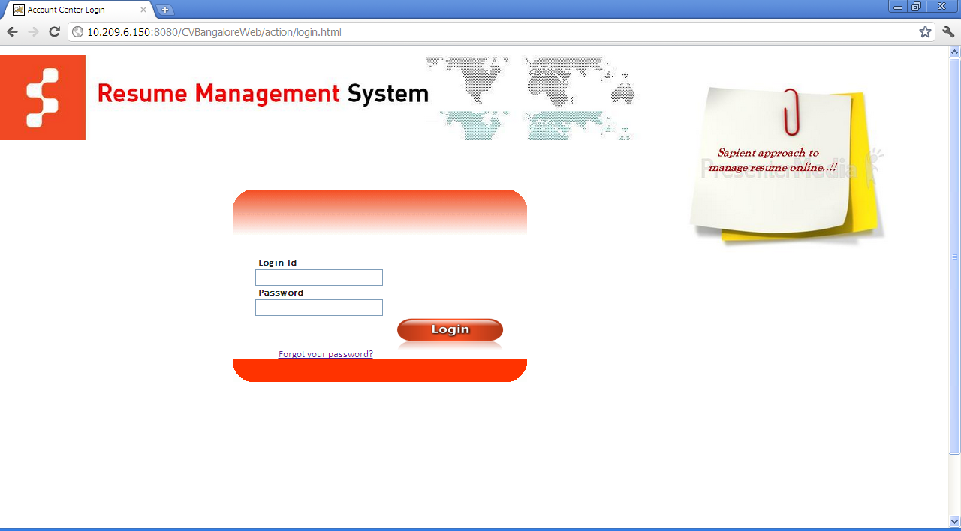
  - Password: (Temporary Password).

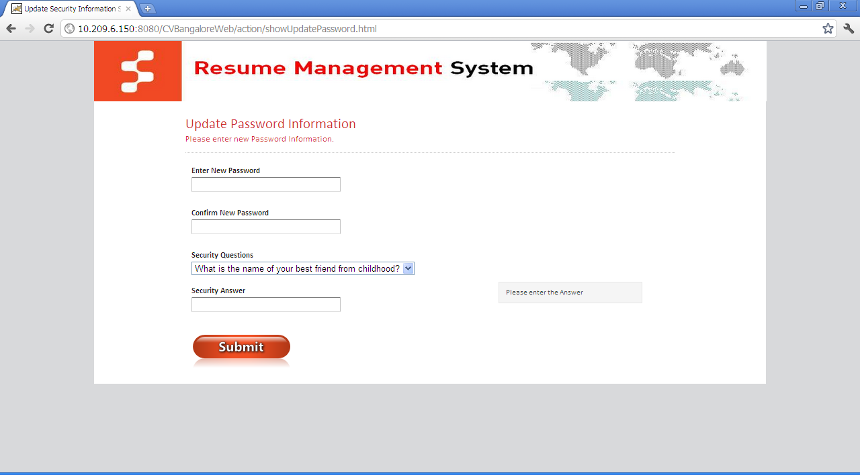
- As soon as the User logs in to the RMS for the first time with temporary password she/he will be redirected to the Change password screen

- Once the user updates the Password He/she will be redirected back to the Login Page to enter User name and Updated password for logging into the Application.
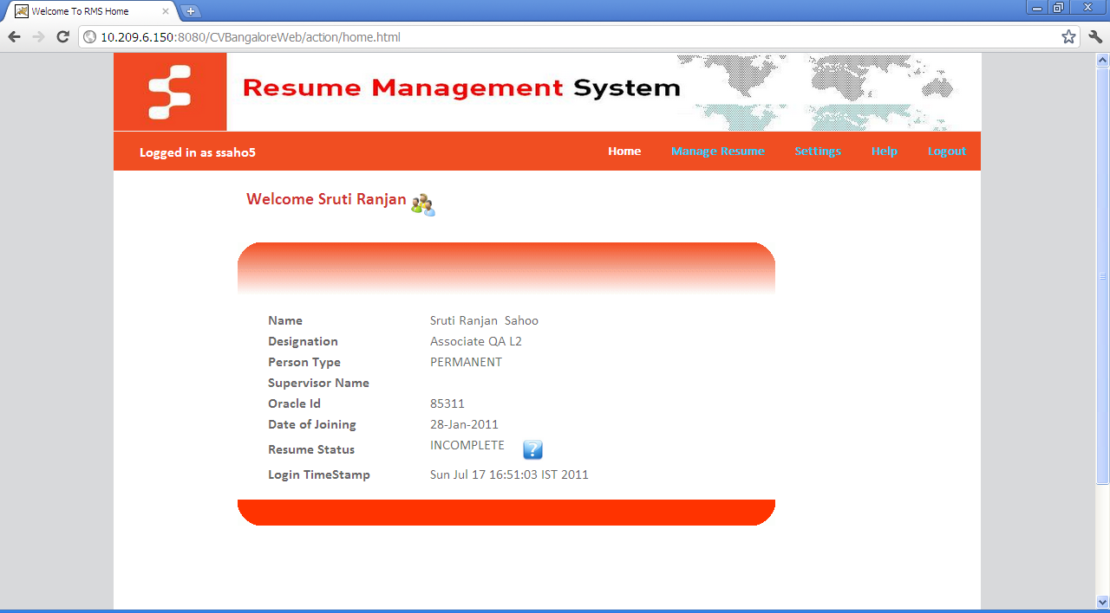
- Once the User logs into the application successfully he/she will be redirected to Home screen of RMS.

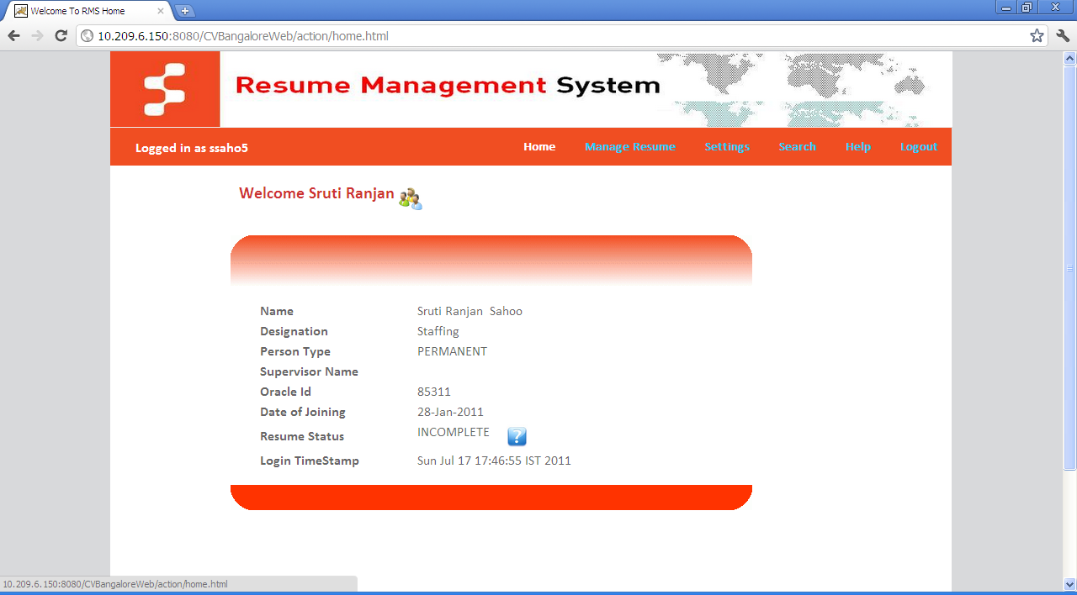
- On the home page the users sees her/his Personal details present in Sapient PDR (Personal Data Report, resume completion status (Tips to create/complete the resume based on the status) and Time stamp the user logged into the system.

Forgot Password:
- If the user forgets the password she/he will be able to reset the password by clicking on the Forgot password link on the Login screen.
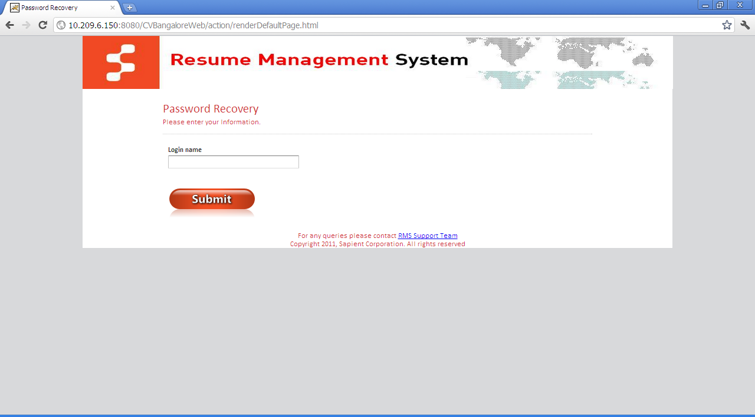
- Once clicked on the forgot password link the user will be redirected to forgot password page asking the user name.

- If the User exists in the database then he will be asked to enter the answer of the secret question entered at the time of update password/change password.

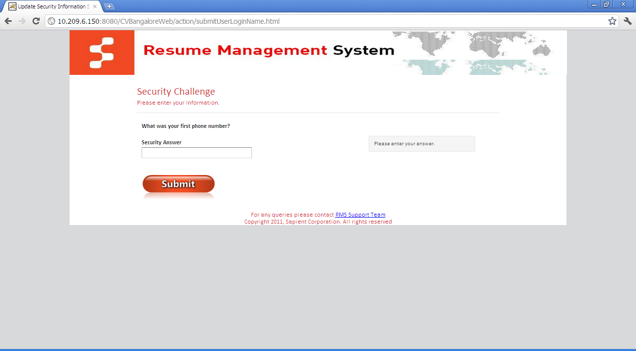
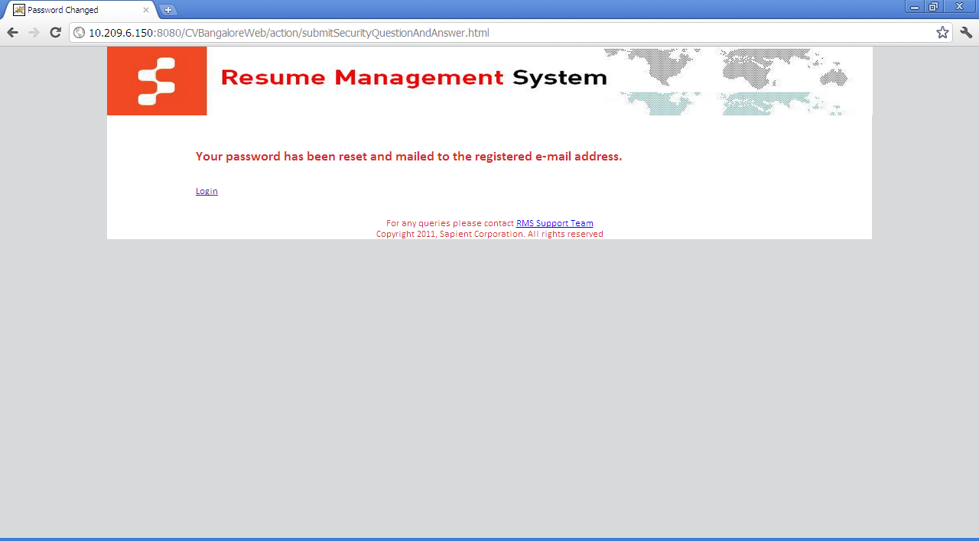
- Once the user enters the correct answer for the question on the screen an automatically generated password will be sent to the user with the temporary password.

- Once the user logs in with the temporary password the user will be again redirected to update password screen.

Create Resume:
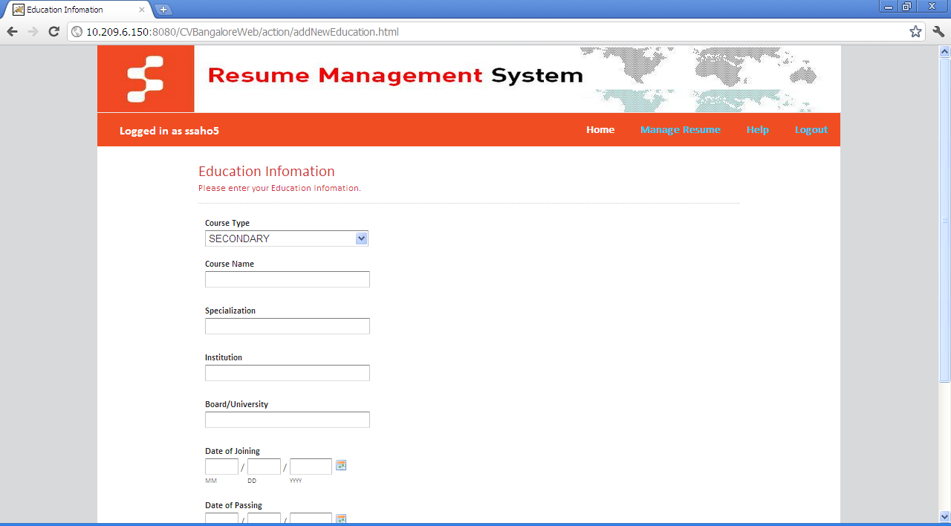
- Once logged into the application Click on Manage resume link. Click on Educational Information link. The user will be redirected to the Educational Information screen.

- Fill all the required data to be displayed on your resume. (If the user has not completed Graduation then Resume status will be always incomplete).
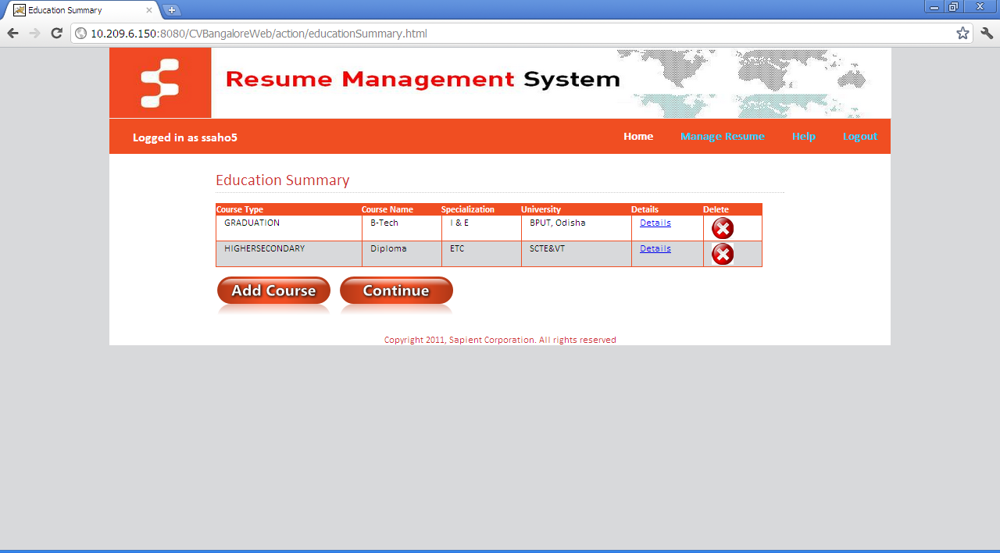
- Click on Submit button.
- Click add button to add as many educational records as you want.
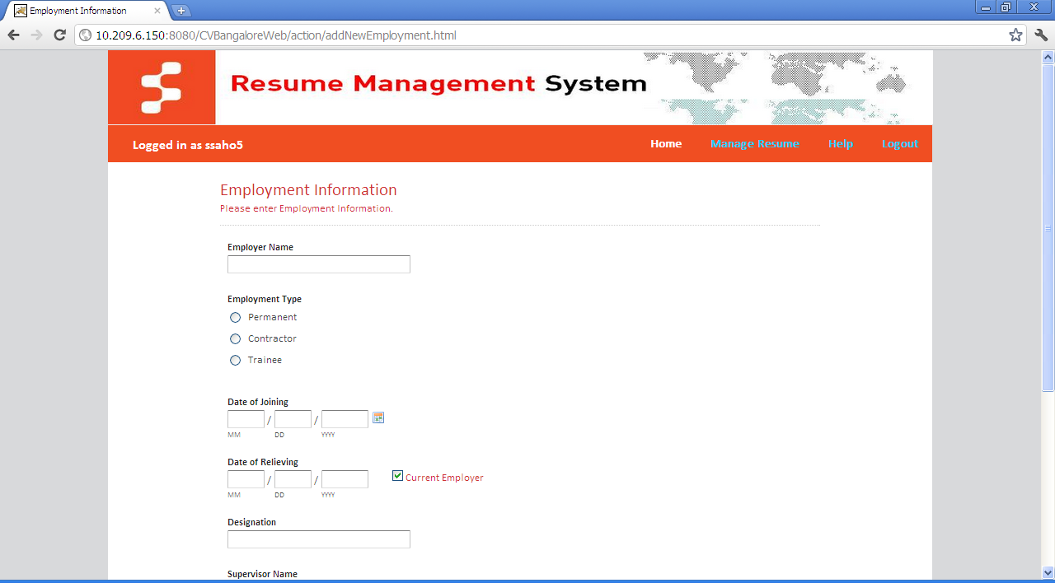
- Once done with the adding education details click on Continue button it will take the user to Employment Information screen.

- Fill all the required data to be displayed on the Resume
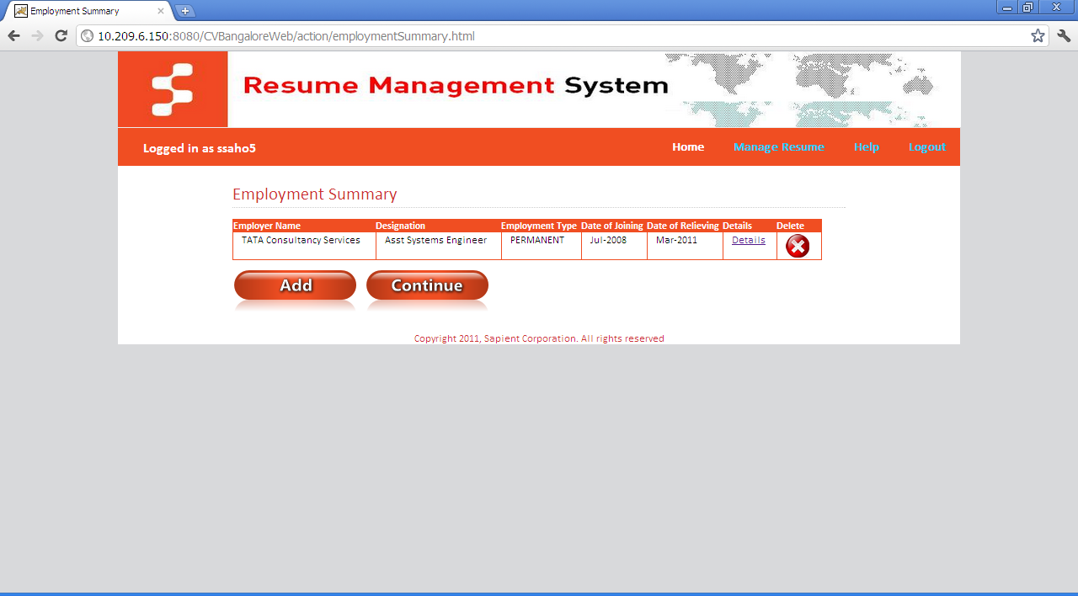
- Click on Submit button.
- Click add button to add as many Employment history as you want.
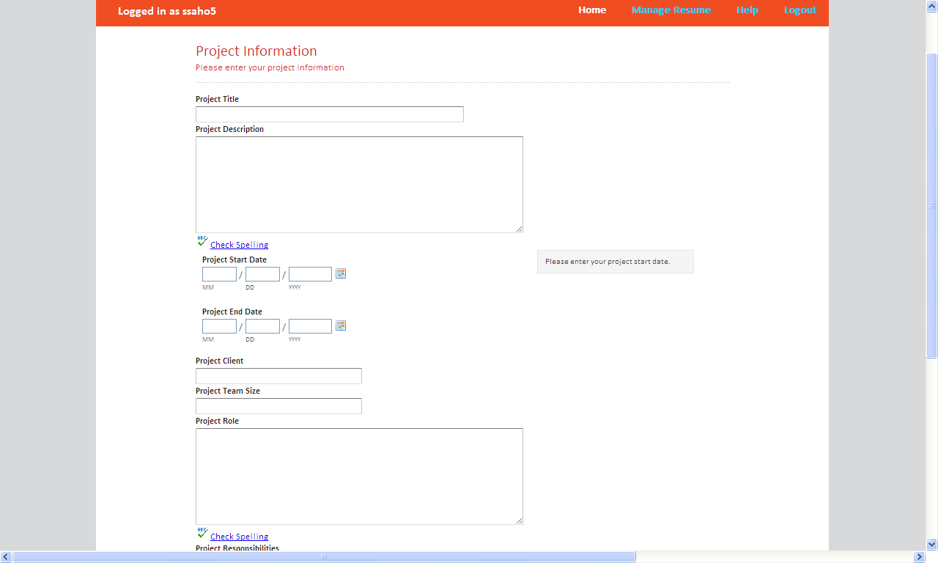
- Once done with the adding Employment details click on Continue button it will take the user to Project Information screen.
- Fill all the required data to be displayed on the Resume
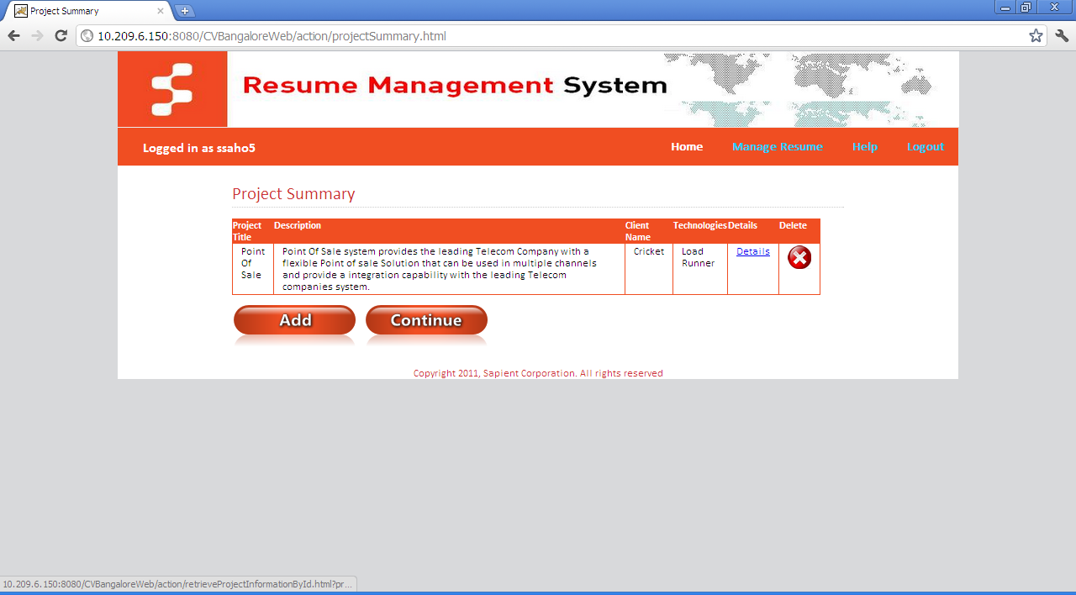
- Click on Submit button.
- Click add button to add as many Projects you have completed as you want.
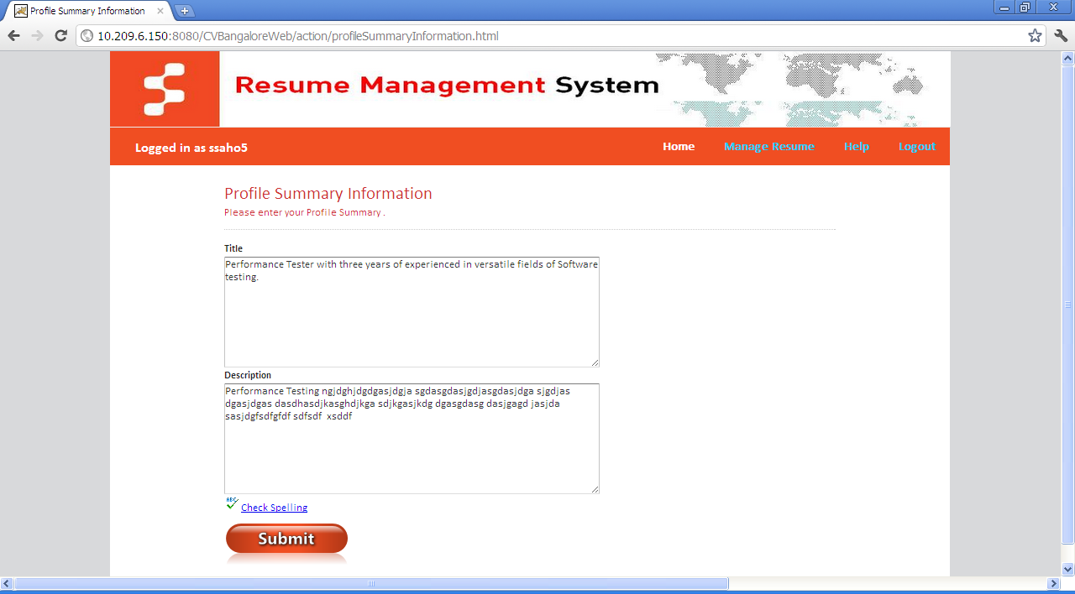
- Once done with the adding Project details click on Continue button it will take the user to Profile Summary Information screen.
- Fill all the required data to be displayed on the Resume
- Click Submit button it will take the user to Skill Sets Information screen.
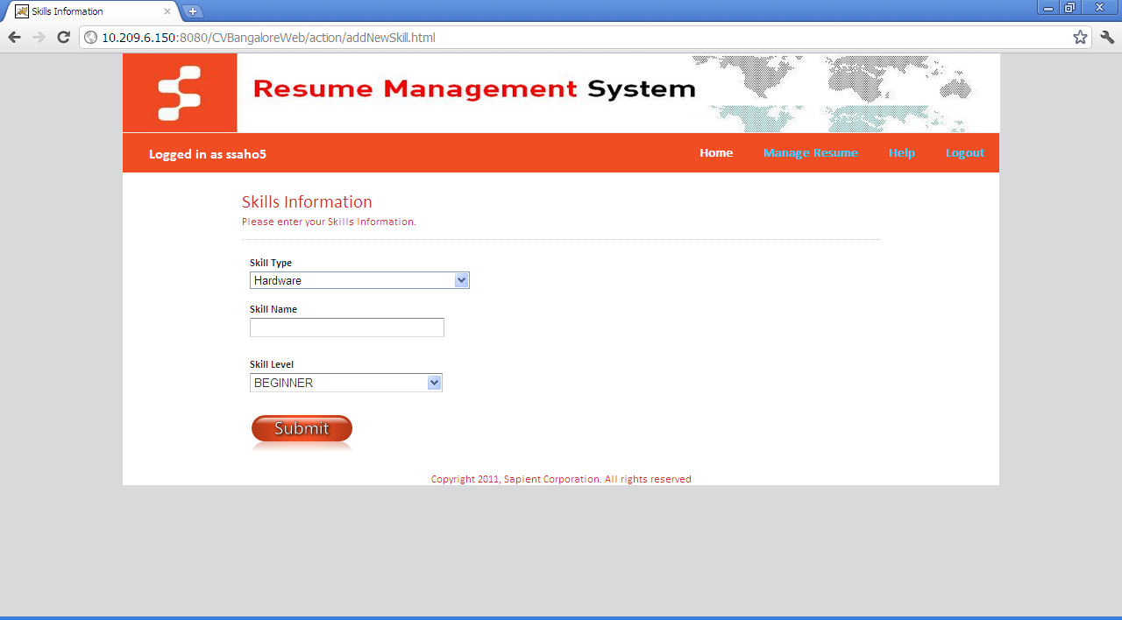
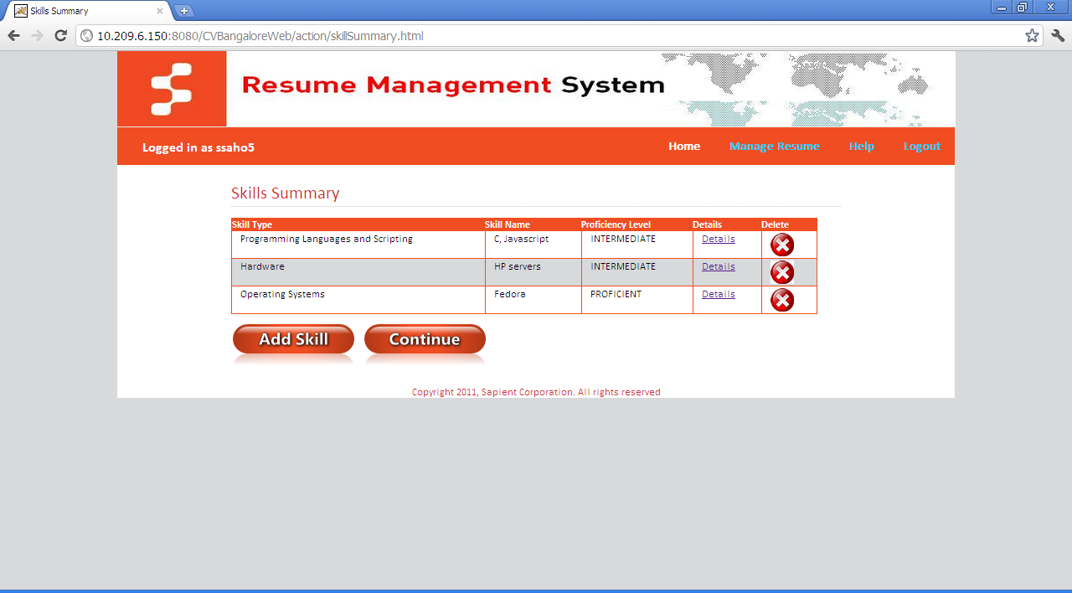
- Fill all the required skill sets information to be displayed on the Resume
- Click on Submit button.

- Click add button to add as many Skill Sets Information you have.
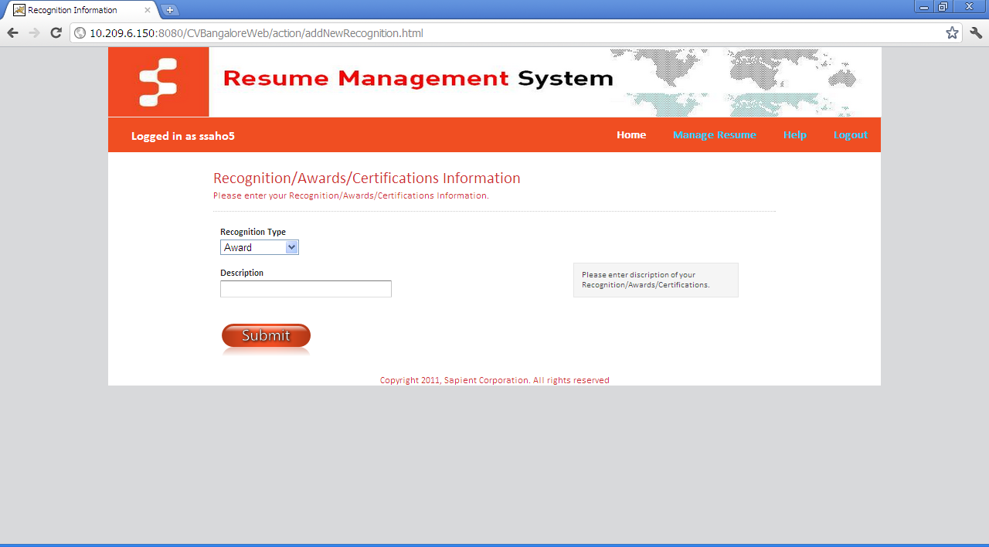
- Once done with the adding Skill Sets details click on Continue button it will take the user to Recognitions screen.

- Fill all the required data to be displayed on the Resume as part of Recognitions/award/Certifications information.
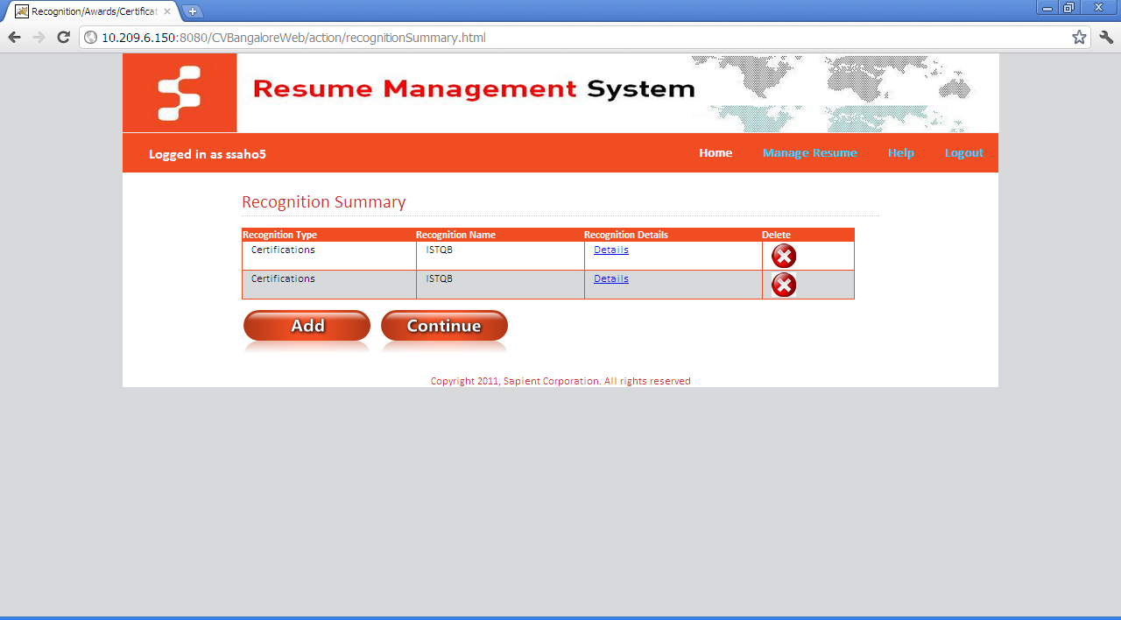
- Click on Submit button.
- Click add button to add as many Awards/Recognitions/Certifications Information you have.
- Once done with the adding Awards/Recognitions/Certifications Information details
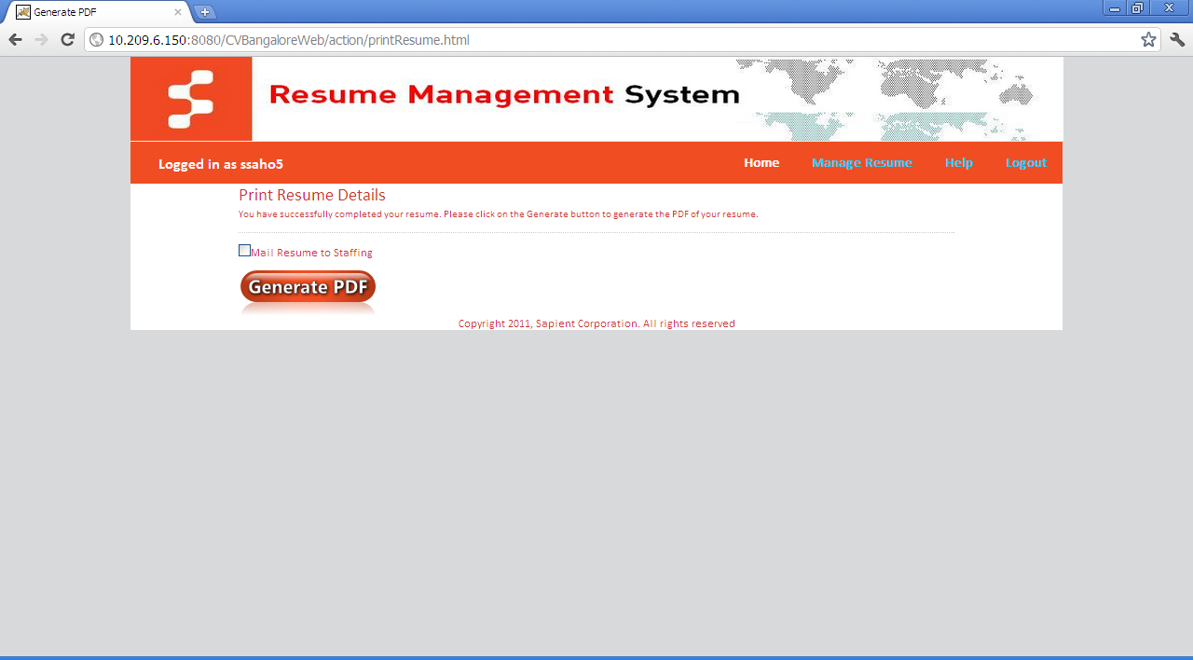
- Click on Continue button it will take the user to Print Resume screen

- Click on Generate PDF to generate the resume in PDF format.
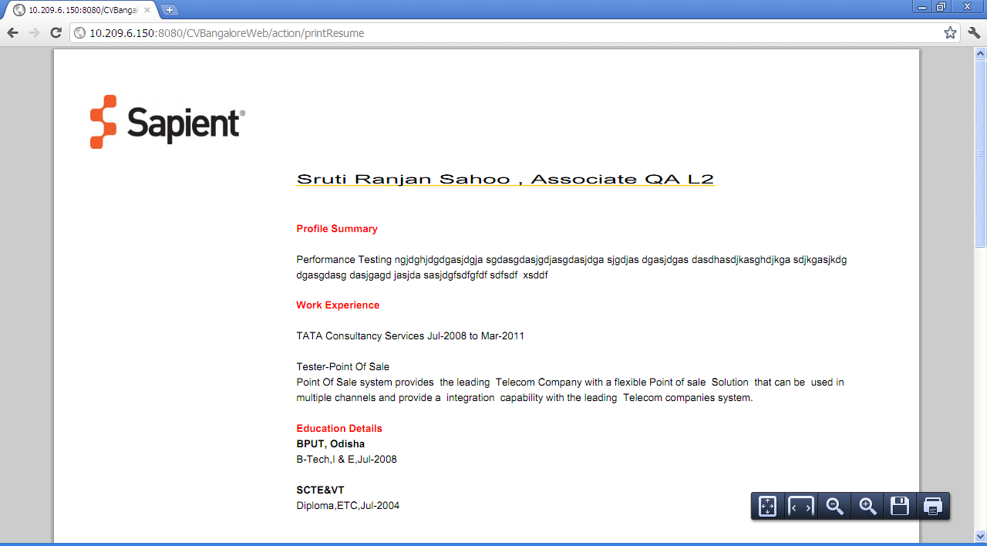
- Select Mail Resume to Staffing for sending the Resume direct to Staffing Team.

Download Resume
- Once The Resume Status is complete the User will able to see a PDF download logo  next to Resume Status to download the Resume in PDF format.
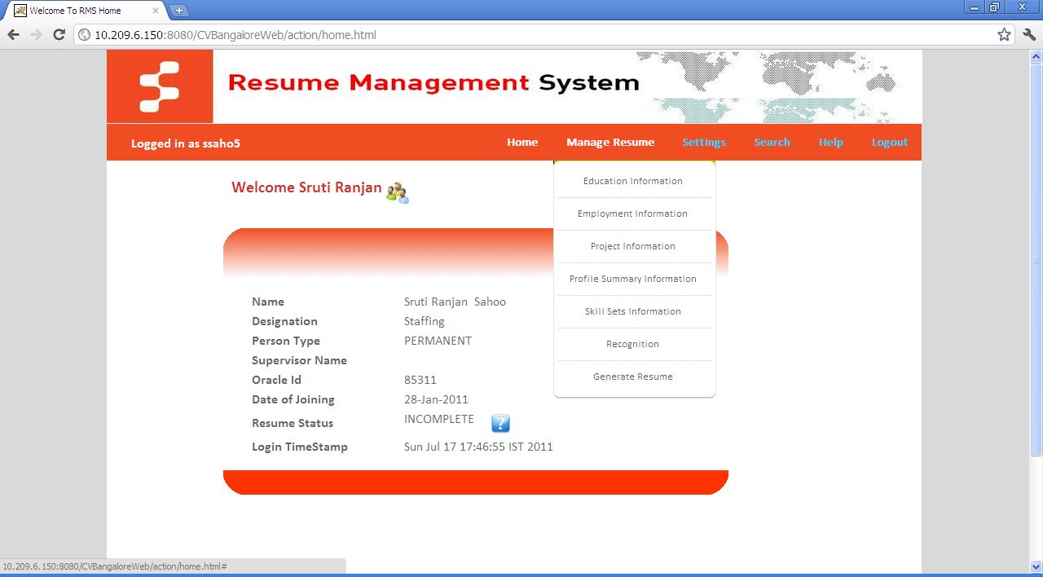
- If Users wants to download the incomplete Resume then click on Manage Resume→ Generate PDF.

Resume Completion tips
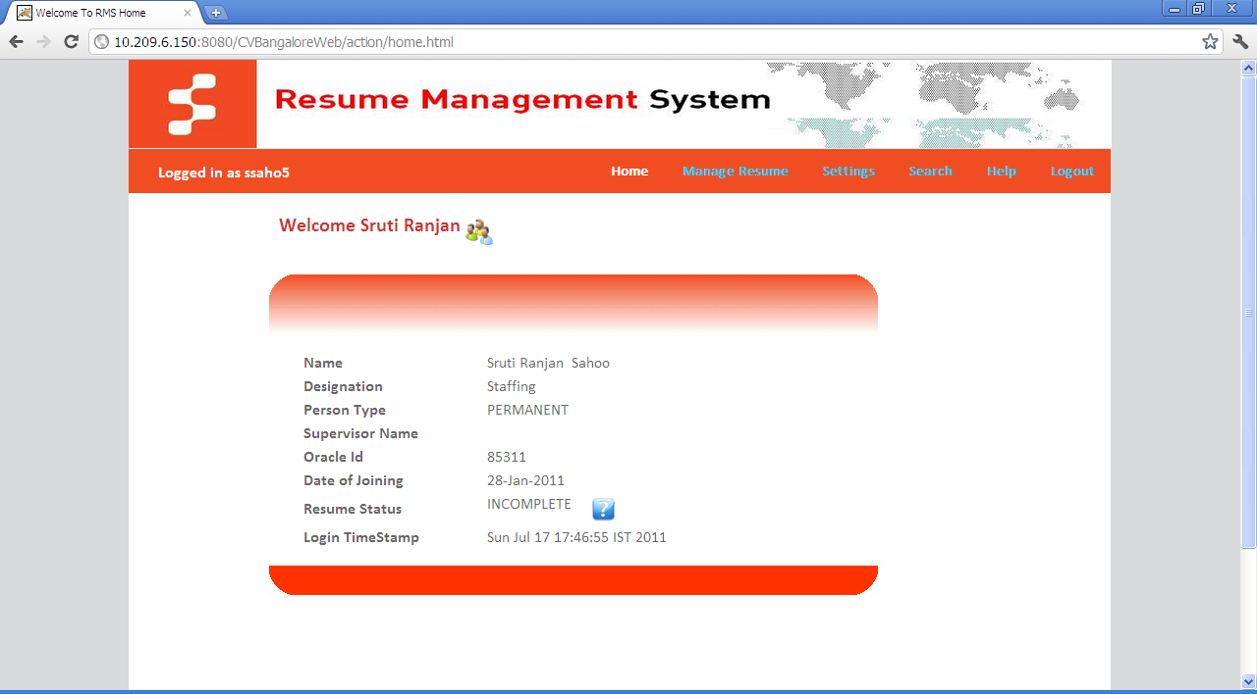
- If the resume is incomplete then in the home screen the resume status will shown as incomplete and next to it a  will be shown.

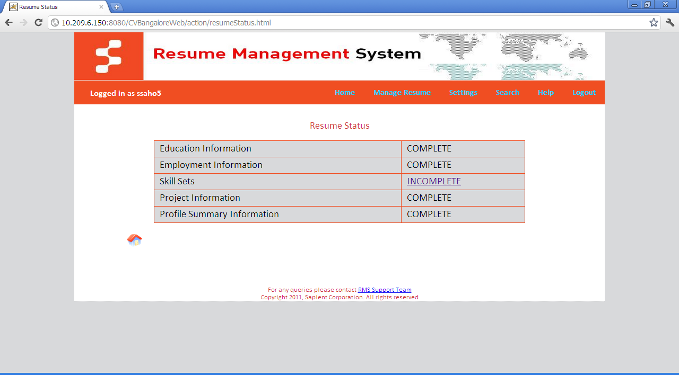
- By clicking on it will take the user to resume status screen whichever is incomplete by clicking on incomplete the user will be directly navigated to the respective page.

Send Resume to Staffing Team

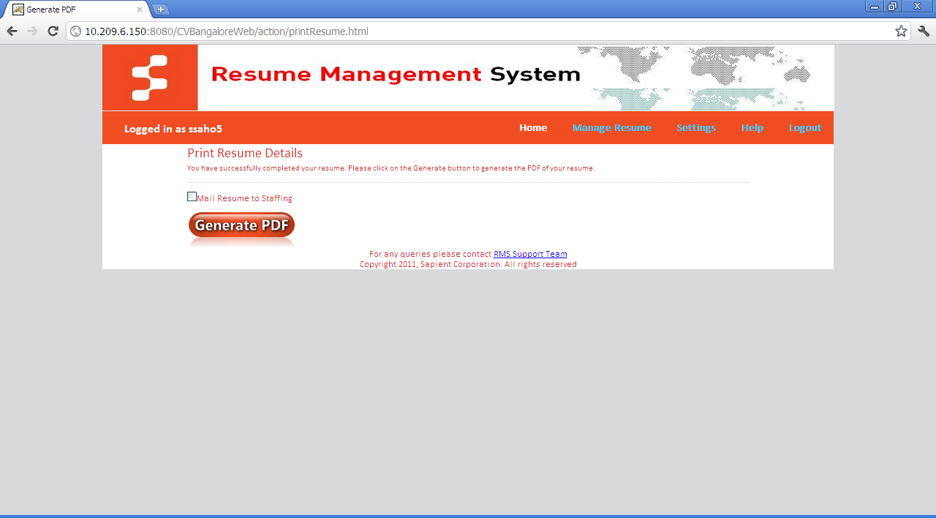
- By Checking this Check box in Print Resume Screen and clicking generate PDF button will send the resume to the Staffing Team directly from the application itself.

Change Password
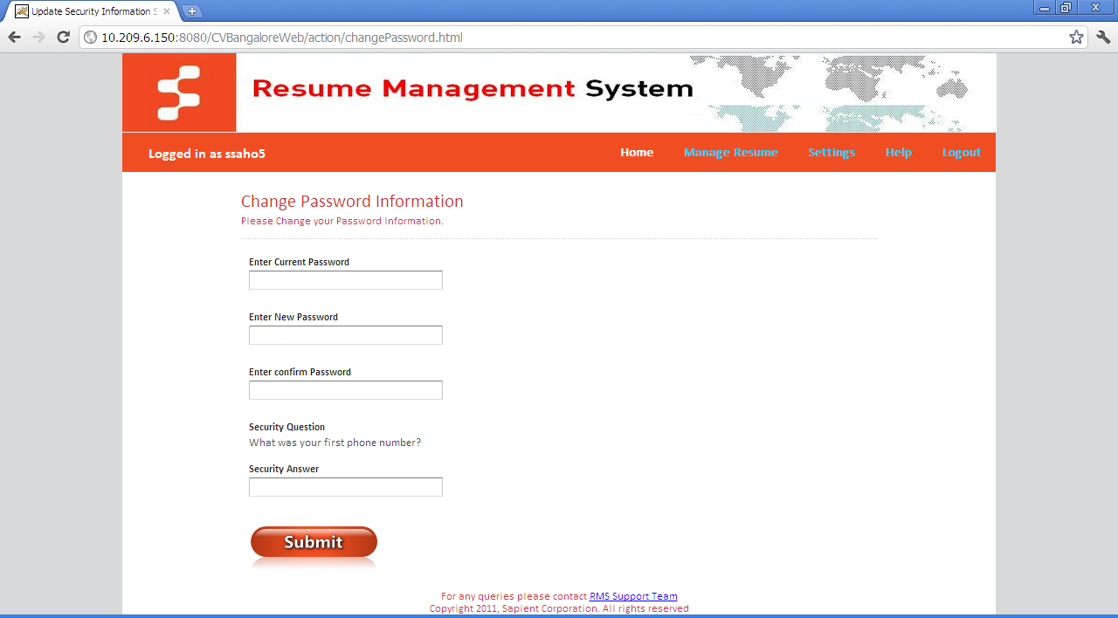
- If the User wants to change her/his password at any time he can change it by traversing Settings→ Change Password.

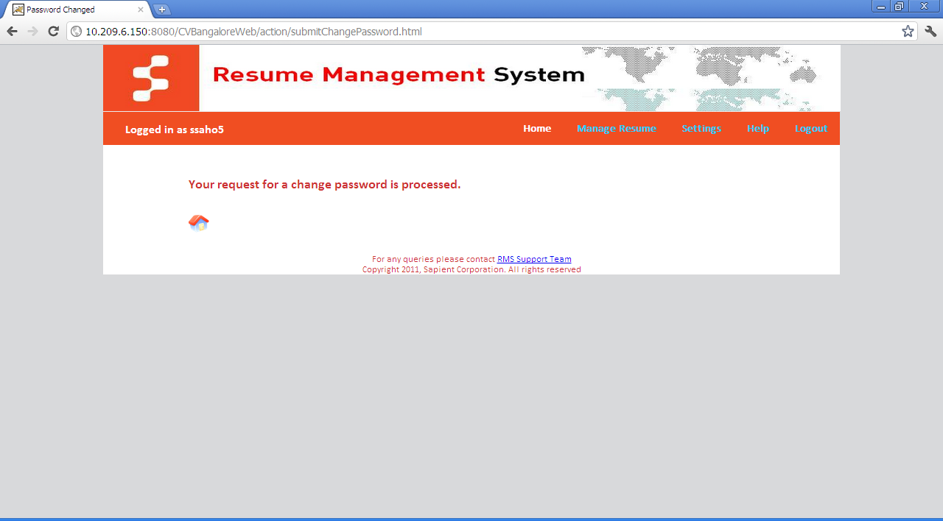
- Enter your current password, new password, confirm password and the security answer that the user had given at the time of updating the password.

URL for Public profile viewing
- Once the Resume status is complete a link comes in the home page for public viewing of the Resume.
- User can simply paste this link to the mail or document. Just by pasting the link on the address bar of a browser anyone can see the Resume.
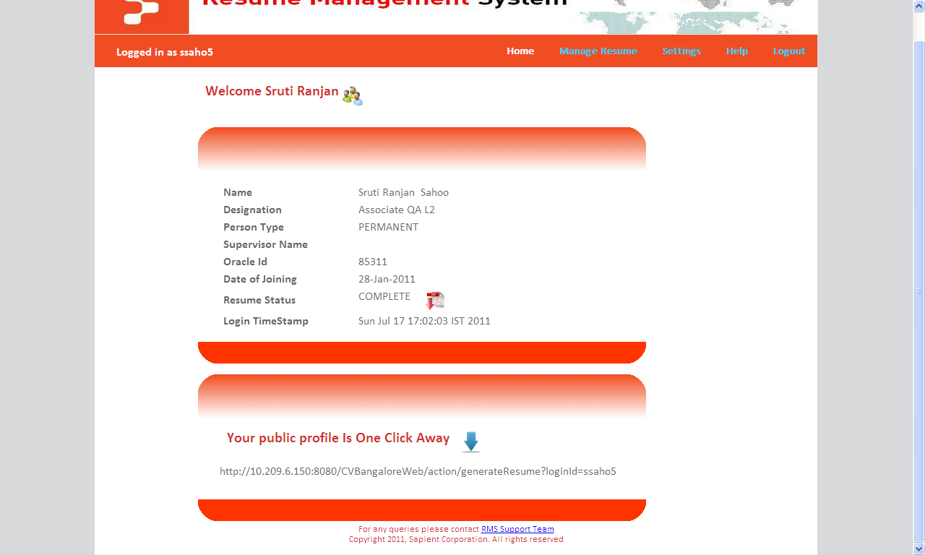
Subordinate Management
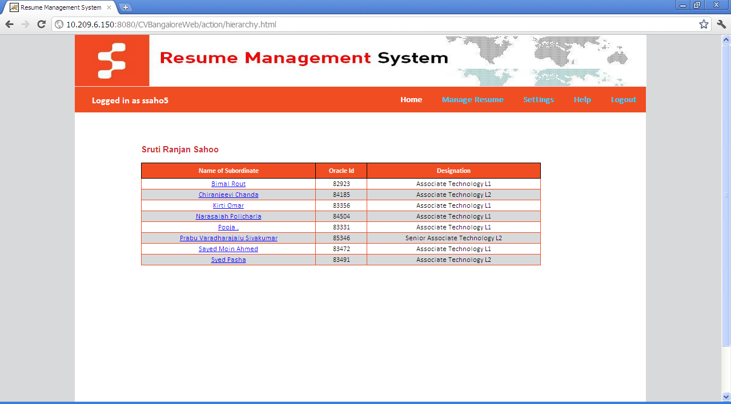
If any associates are directly reporting to the User then by clicking  on the Home screen.
Also the User can view their resume by clicking on the name User can see their resume in PDF format.

Help
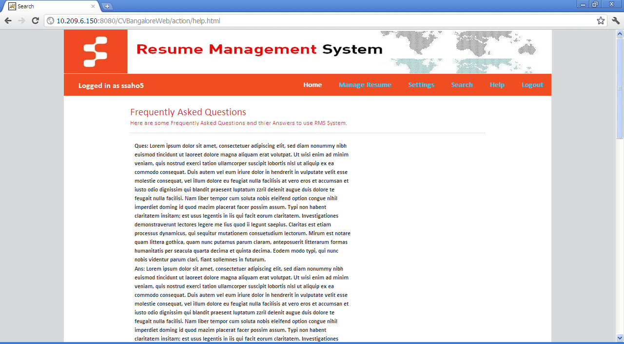
Some FAQs will be there for helping the user in using Resume Management System in a better way.

Logout
Once Logout button is clicked the application display a pop-up saying “Thanks you for Using RMS. You have successfully logged out!!” on clicking “ok” button or closing the pop-up, the browser/Tab will close automatically.

Staffing Team/People Strategist:
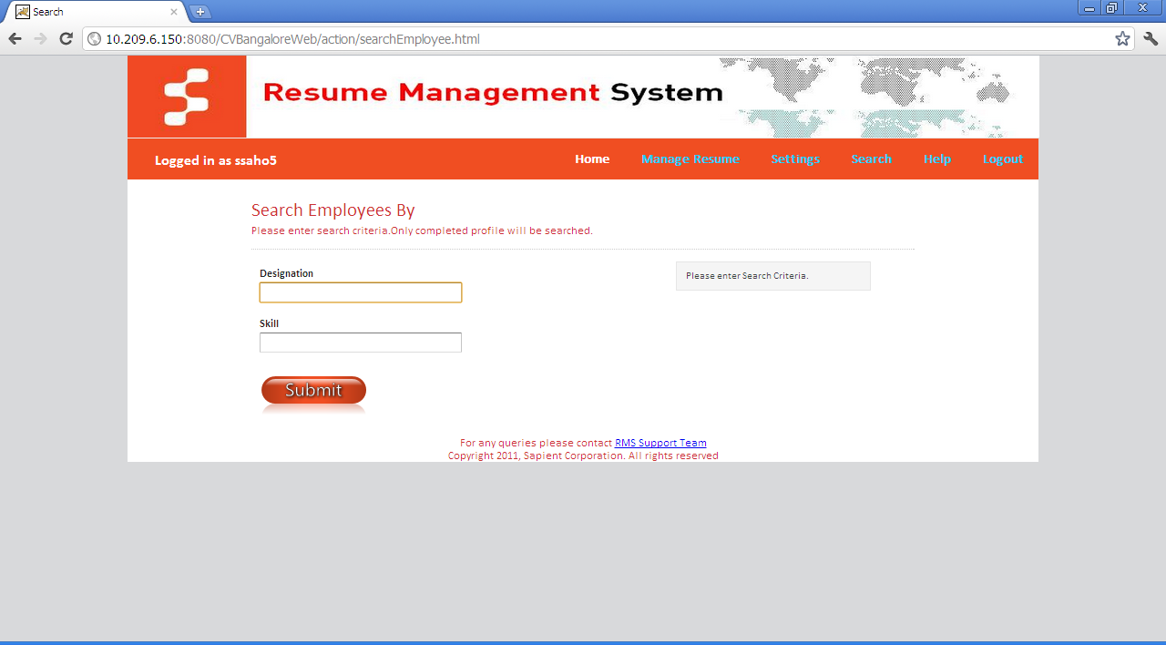
- Except all the features above explained the Staffing Team/People Strategist team would be able to “Search” link on their home page after logging in. where they can search based on the designation and the skill sets requirement.

- Also they can search by combination of both the fields to narrow down the search.
- More search fields are coming on soon…..

Report generation
- Coming soon………

Admin:
- Coming Soon…..

----------------------The End----------------------

