“TrafficEase BD”
An all-in-one smart traffic and transit web application

Software Requirements Specification
Prepared by:
Student ID | Name
22201631 | Md. Mushroor Muttakin Khan
22201940 | Raisha Tasnim Khan
22341036 | Sayed Sohanul Islam
23301060 | Maisha Maliha Nisa

1. Introduction

1.1 Purpose
This Software Requirement Specification (SRS) document outlines the requirements for developing “TrafficEase BD” - an all-in-one smart traffic and transit web application using the MERN stack (MongoDB, Express.js, React.js, Node.js). The primary goal of this application is to facilitate a secure and efficient transit ecosystem, enabling commuters to find optimal routes, track public transport (MRT, Buses), monitor live traffic incidents, and access emergency services—all while navigating the complex traffic landscape of Dhaka.

1.2 Scope
The scope of this project includes the design, development, testing, and deployment of the traffic web application, catering to:
- Commuters who can register, plan routes, check transit schedules, report incidents, and view live air quality or weather warnings.
- Authorities/Admins who can broadcast official alerts, verify incident reports, manage road closures, and maintain system compliance.
This SRS covers the functional and non-functional requirements for the project, constraints, assumptions, high-level design, and the development plan following Agile methodology.

1.3 Definitions, Acronyms, and Abbreviations
- MERN: MongoDB, Express.js, React.js, Node.js.
- MRT: Mass Rapid Transit (Dhaka Metro Rail).
- BRTA: Bangladesh Road Transport Authority.
- DMP: Dhaka Metropolitan Police.
- OTP: One-Time Password.
- RBAC: Role-Based Access Control.

1.4 References
- MERN Stack documentation (MongoDB, Express.js, React.js, Node.js)
- Leaflet.js documentation for interactive mapping
- AccuWeather & IQAir API documentation

1.5 Overview
Section 2 provides an overall description of the product, including its user classes and environment. Section 3 details the functional and non-functional requirements. Section 4 outlines the technology stack and architectural overview. Section 5 presents the development plan, including sprint-wise breakdown and deliverables.

2. Overall Description

2.1 Product Perspective
The traffic web application is a standalone system built on the MERN stack. It integrates with external APIs and services where necessary (e.g., OpenStreetMap via Leaflet for interactive routing, AccuWeather for rain warnings, IQAir for air quality). The application must handle live data updates and maintain user privacy.

2.2 Product Features
1. Location & Mapping Services: Real-time interactive maps plotting traffic nodes, incidents, and transit lines.
2. Authentication: Secure login and registration for commuters and administrators.
3. Role Management: Differentiated dashboards for general users and admins.
4. Transit Integration: Detailed schedules and tracking for MRT and Dhaka City Buses.
5. Incident Reporting: Crowdsourced reporting for congestion, accidents, or waterlogging.
6. Weather & Environment: Real-time air quality index and rain warnings via APIs.
7. Emergency Services: Quick access to hospital directories, police zones, and emergency contacts.
8. Cost Estimator: Automated CNG and Rickshaw fare calculators.
9. Authority Alerts: System broadcasts for VVIP movements, strikes (Hartaal), and closures.
10. Personalization: Commute planners, travel diaries, and saved locations.

2.3 User Classes and Characteristics
1. Commuters/Citizens: Individuals seeking transit routes, incident updates, and cost estimations. Typically require a highly intuitive, mobile-friendly interface.
2. Administrators/Traffic Staff: System overseers responsible for broadcasting official alerts, validating user reports, and managing system analytics.

2.4 Operating Environment
- Web Application: Accessible on modern web browsers (Chrome, Firefox, Edge, Safari).
- Mobile Compatibility: Responsive design for smartphones and tablets.
- Server-Side: Node.js and Express.js.
- Database: MongoDB cluster.
- Hosting: Vercel for frontend, Render/AWS for backend.

2.5 Constraints
Must rely on third-party APIs for weather/air quality which may have rate limits. Must maintain high performance for map rendering on mobile devices.

3. System Requirements

3.1 Functional Requirements
3.1.1 Authentication & Authorization
- FR-1: System shall allow users to register and login.
- FR-2: System shall enforce Role-Based Access Control (Admin vs User).
3.1.2 Mapping & Navigation
- FR-3: System shall display an interactive map centered on Dhaka.
- FR-4: System shall allow users to route between origin and destination.
3.1.3 Transit & Reporting
- FR-5: System shall display MRT schedules and Bus routes.
- FR-6: Users shall be able to submit incident reports (accident, waterlogging).
- FR-7: Admins shall be able to broadcast Authority Alerts.

3.2 Non-Functional Requirements
3.2.1 Performance
- NFR-1: Average map load time should not exceed 3 seconds.
3.2.2 Security
- NFR-2: All passwords must be hashed using bcrypt.
- NFR-3: API endpoints must be secured using JWT.
3.2.3 Reliability
- NFR-4: The system shall maintain 99% uptime.

4. Technology Stack & Architectural Overview

4.1 MERN Stack Components
1. MongoDB: Document database for user profiles, incident reports, and transit data.
2. Express.js: Backend API framework.
3. React.js: Frontend library for UI.
4. Node.js: Runtime environment.

5. Tentative Development Plan (Agile)
- Sprint 1 (Weeks 1-2): Core Setup, Authentication, and Database modeling.
- Sprint 2 (Weeks 3-4): Interactive Map Integration (Leaflet), Route Planner, and UI layout.
- Sprint 3 (Weeks 5-6): Core Transit Features (Bus Routes, MRT, Fare Calculators).
- Sprint 4 (Weeks 7-8): Crowdsourced Reports, Weather APIs, and Emergency Services.
- Sprint 5 (Weeks 9-10): Admin Dashboard, Quality Assurance, and Final Touches.

6. Conclusion
This SRS provides a detailed outline for the design and development of "TrafficEase BD". It ensures a commuter-centric approach by integrating navigation, public transit tracking, and real-time alerts. By following the outlined Agile sprints, the project will deliver a robust and scalable solution for Dhaka's traffic ecosystem.

Appendix: Feature Screenshots
[ Insert screenshots of the SmartHub, Route Planner, Rain Warning Map, and other features here for the final submission ]

4.2 Complete System UML Class Diagram
The following UML Class Diagram visualizes the core object-oriented and data-model relationships governing TrafficEase BD. It models the persistence layer entities (User, Incident, Alert, Vehicle, ParkingLot, TransitRoute, TrafficSignal) alongside key application services (RoutePlannerService) under the MVC architectural paradigm.
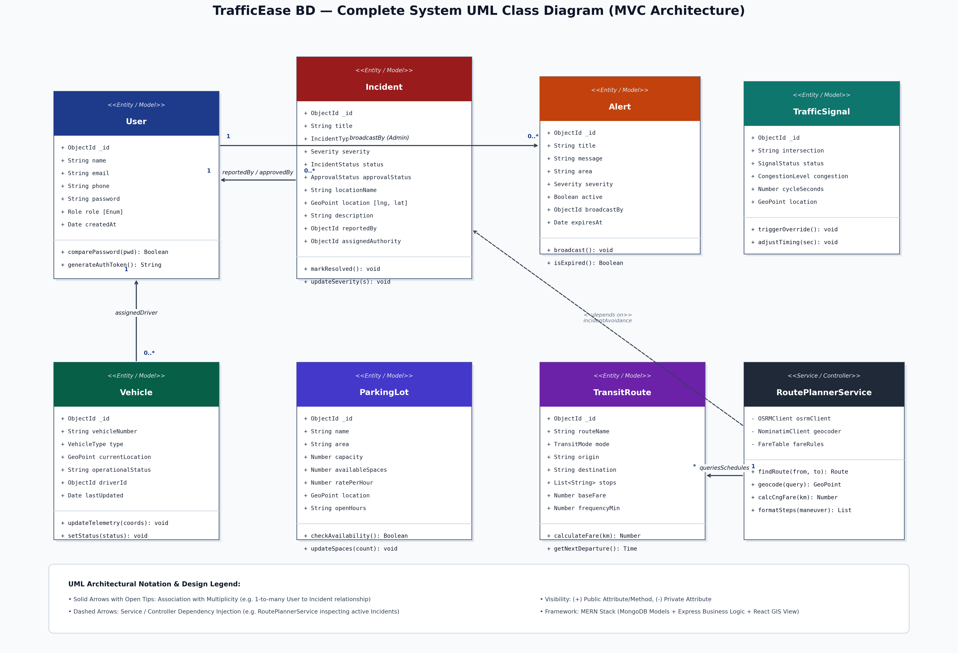
Figure 4.1: TrafficEase BD Complete MVC Class Diagram and Domain Entity Relationships

