**\*\*\*\*\*\*\*\*\*\*\*\*\*Download ,create,extend upload image\*\*\*\*\*\*\*\*\*\*\*\*\*\*\*\*\*\*\*\*\*\***

**docker image ls**

go to Docker Hub to see the versions.If versions not given it will download latest one.

**docker pull nginx:1.11.9** [for official] [**for unofficial use the command given in that page**]

docker image history nginx

docker image inspect nginx

to make our own image:

**docker login**

**cat .docker/config.json**

**docker tag nginx toky/nginx**

**docker push toky/nginx**

**docker tag toky/nginx toky/nginx:testing**

**docker push toky/nginx:testing** //adding new tag testing

//Now if we want it private we have to create a repo manually by specifying public

after done always docker logout.

********Build own image****************

Now we are gonna pull a image from docker hub and cd to that directory .Link is in video description.

**docker build -t customnginx .**

**vim Dockerfile** // here we will expose extra port 8080 and so we will add it and exit

**docker image ls**

**docker build -t customnginx .**

// here we will see from the line of expose port all remaining are built again.So order is important.

Those change less keep them top and those change more keep them bottom

*****************Building image extending official images************************

Download the github repo.

cd dockerfile_sample-2

ll

vim Dockerfile //to check

**docker build -t nginx_with_html .**

**docker run -p 80:80 –rm nginx_with_html**

//now if we go to localhost it’s homepage will change to ours.

**docker -t nginx_with_html:latest toky/nginx_with_html:latest**

**docker push toky/nginx_with_html:latest**

**************************************Assignment********************************

cd dockerfile_assignment_1

**vim Dockerfile**

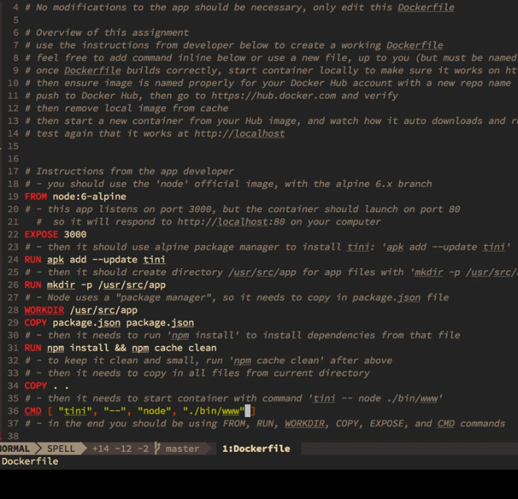

**docker build -t testnode .**

**docker container run –rm -p 80:3000 testnode**

**docker -t testnode toky/testnode**

**docker push toky/testnode**