Bayes’ Rule is a simple way of calculating conditional probabilities. Conditional probabilities are those probabilities whose value depends on the value of another probability. If A and B denote two events, P(A|B) denotes the conditional probability of A occurring, given that B occurs. The two conditional probabilities P(A|B) and P(B|A) are in general different. Bayes theorem gives a relation between P(A|B) and P(B|A).

Bayes’ theorem relates the conditional and marginal probabilities of events A and B:

We know that

P(A∩B) =P(A)P(B|A) …………………………. (I)

P(A∩B) =P(B)P(A|B) …………………………. (II)

From the equation (I) and (II) we get



This is known as Bayes theorem.

Each term in Bayes’ theorem has a conventional name:

• P(A) is the prior probability or marginal probability of A. It is “prior” in the sense that it does not take into account any information about B.

• P(A|B) is the conditional probability of A, given B. It is also called the posterior probability because it is derived from or depends upon the specified value of B.

• The term P (B | A) is called the likelihood function for B given A.

• P(B) is the prior or marginal probability of B.

Let the events $A_{1},$ $A_{2},$ $A_{3}$………. $A_{n}$ are mutually exclusive, then the joint events (B and $A_{1}$), (B and $A_{2}$),,,,,,,,,,,,,,,,,, (B and $A_{n}$) are also mutually exclusive. So we can use the addition rule to obtain

P(B)=P(B and $A_{1}$)+P(B and $A_{2}$)+………………+ P(B and $A_{n}$)

=P($A_{1}$) P(B|)+ P($A_{2}$) P(B|)+…………….+ P($A_{n}$) P(B|)

……………. (iii)

Bayes theorem for class A = $A_{i}$ is



P(|B)= $\frac{P\left(B | A_{i}\right)P(A_{i})}{P(B)}$………………………………………………(iv)

Now from the equation (iii) and (iv) we get Bayes theorem for n classes:

P(|B)= $\frac{P\left(B | A_{i}\right)P(A_{i})}{P\left(A_{1}\right)P\left(B | A_{1}\right)+P\left(A_{2}\right)P\left(B | A_{2}\right)+…………………………+ P(A_{n}) P(B|A_{n})}$

This is Bayes’ Rule for multiple events

**Bayes Rules for extended Format**

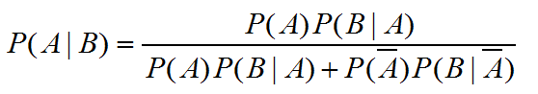

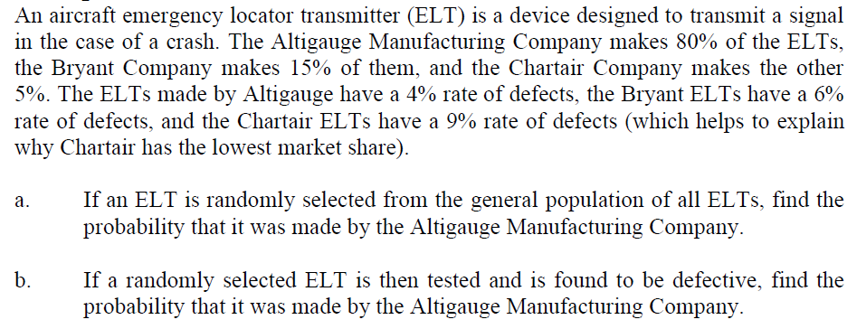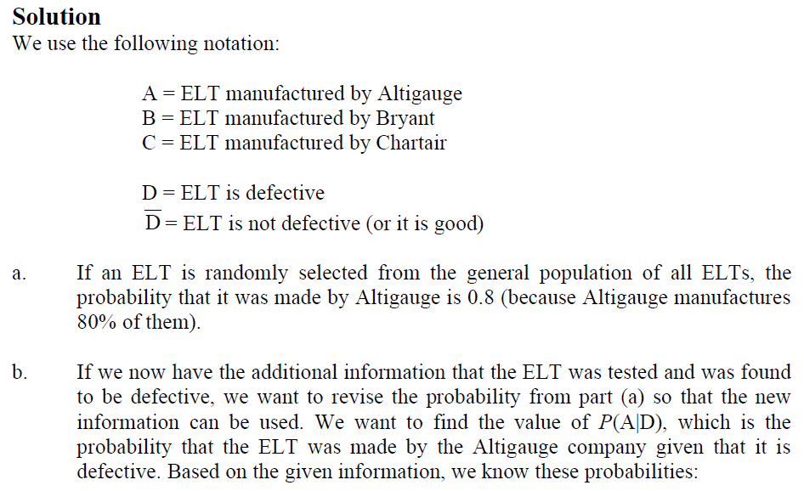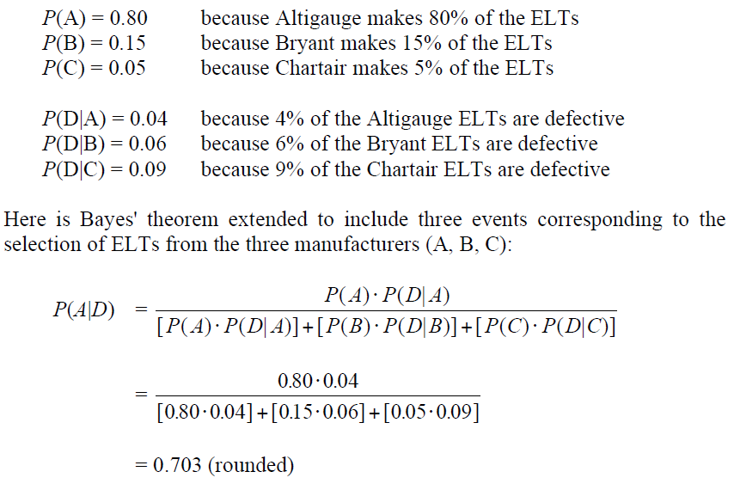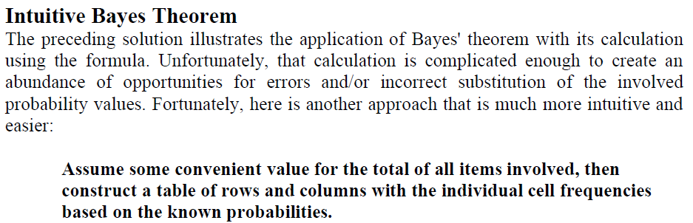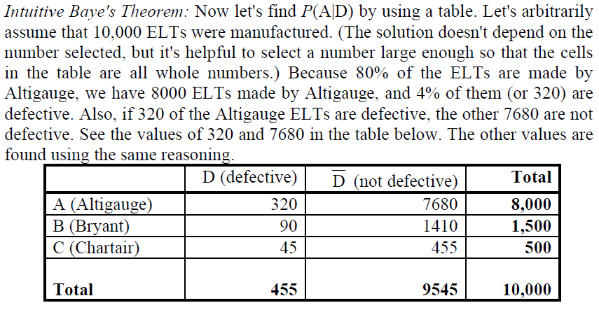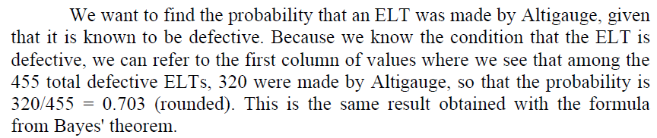

**3.Example**

Stores A, B and C have 50, 75 and 100 employees respectively. and respectively, 50%, 60% and 70% of the employees are women. One employee resigns and this is a woman. What is the probability that she works in store A?

Let W be the event that a woman employee resigns from anywhere, and let A, B and C denote the event that a randomly selected employee works at the respective store. Then Pr[A] = 50/225, Pr[B] = 75/225 and Pr[C] = 100/225. Likewise the probabilities of resignation of a woman from a store is given by the information to be Pr[W|A] = 0.50, Pr[W|B] = 0.60, and Pr[W|C] = 0.70 Then we can use Bayes Theorem:

