
Siddaganga Institute of Technology, Tumkur-572103
Department of Computer Science and Engineering
CRYPTOGRAPHY AND NETWORK SECURITY LAB (7RCSL01)

Student Name: Nitin Krishna H |  | USN:1SI18CS068 |  | Batch No:A4 |  | Date:03/12/2021
Evaluation:
Write Up (10 marks) | Clarity in concepts (10 marks) |  | Implementation and execution of the algorithms (10 marks) |  | Viva (05 marks) |  | Total (35 marks)
Sl.No | Name of the Faculty In-Charge |  |  |  |  |  | Signature
1. | Mr Bhaskar G
2. | Mrs Thejaswini S
Question No: 10
Write a program to generate large random number using BBS random number generator algorithm and check whether the generated number is prime or not using RABIN-MILLER Primality testing algorithm.
Algorithm:
BBS Random Number Generator Algorithm:
First, choose two large prime numbers p and q, that both have a remainder of 3 when divided by 4.
P=Q=3 mod 4
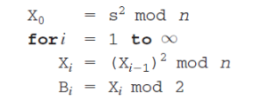
RABIN-MILLER Primality testing algorithm:
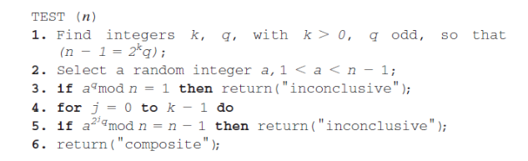

PROGRAM

#include<bits/stdc++.h>
using namespace std;

int randInRange(int low,int high)
{
return (rand()%(high-low+1))+(low+1);
}

bool isprime(int num)
{
for(int i=2 ; i<=sqrt(num) ; i++)
if(num%i==0)
return false;
return true;
}

int genPrime3mod4()
{
while(true)
{
int num = randInRange(10000,100000);

if(num%4!=3)
continue;

if(isprime(num))
return num;
}
}

int bbs(int p,int q)
{
cout<<"BlumBlumShub"<<endl<<"--------------"<<endl;
cout<<"p="<<p<<"\nq="<<q<<endl;

long long n=(long long)p*q;//step 1 : n=p*q
cout<<"n="<<n<<endl;

//step 2 : CALCULATING s
//s should be relatively prime to n
//s should not be divisible by both p and q
long long s;
do{ s = rand(); }while( s%p==0 || s%q==0 || s==0);
cout<<"s="<<s<<endl;

//BBS algo
int B=0;
long long x=(s*s)%n;
for(int i=0;i<10;i++)
{
x = (x*x)%n;
B = B<<1|(x&1);
}
return B;
}

int powModN(int a,int b,int n)
{
int res=1;
for(int i=0;i<b;i++)
res = (res*a)%n;
return res;
}

string rabinMiller(int n)
{
cout<<"\nRabinMiller("<<n<<")\n-----------------"<<endl;
//step 1: choosing k and q
//k>0 and q is odd such that n-1 = 2 ^ k * q
int k=0;
int q=n-1;
while(q%2==0)
{
q=q/2;
k++;
}
cout<<n-1<<"=2^"<<k<<"*"<<q<<endl;
cout<<"k="<<k<<"\nq="<<q<<endl;

//step 2 : select random a
int a = randInRange(1,n-1);
cout<<"a="<<a<<endl;

//step 3 : if a^q mod n = 1 then inconclusive
if(powModN(a,q,n)==1)
return "inconclusive";

//step 4
for(int j=0;j<k;j++)
if(powModN(a,pow(2,j)*q,n)==n-1)
return "inconclusive";

//step 5
return "composite";
}

int main()
{
srand(time(NULL));

//generate two primes
int p = genPrime3mod4();
int q = genPrime3mod4();

//generate random number using bbs algo
int randNum = bbs(p,q);
cout<<"Random number generated by BBS= "<<randNum<<endl;

//test primality using rabin miller algo
cout<<rabinMiller(randNum)<<endl;

return 0;
}

OUTPUT

