Siddaganga Institute of Technology, Tumakuru
(An Autonomous institution affiliated to Visvesvaraya Technological University, Belagavi, Approved by AICTE, New Delhi, Accredited by NAAC and ISO 9001:2015 certified)

Technical Seminar Report

on
“DevOps for IOT Systems”

submitted
in the partial fulfillment of the requirements VII semester
Bachelor of Engineering
In
Computer Science and Engineering

by

Mohammed Sayeed 1SI18CS057



Department of Computer Science & Engineering
(Program Accredited by NBA)

Siddaganga Institute of Technology
B.H Road, Tumakuru-572 103, Karnataka, India. Web: www.sit.ac.in
January, 2021-22

Siddaganga Institute of Technology, Tumakuru
(An Autonomous institution affiliated to Visvesvaraya Technological University, Belagavi, Approved by AICTE, New Delhi, Accredited by NAAC and ISO 9001:2015 certified)

Department of Computer Science and Engineering
(Program Accredited by NBA)



CERTIFICATE

This is to certify that technical seminar work entitled “DevOps for IOT Systems” is a bonafide work carried out by Mohammed Sayeed (1SI18CS057) of VII semester Bachelor of Engineering in Computer Science and Engineering of the SIDDAGANGA INSTITUTE OF TECHNOLOGY (An Autonomous Institution, Affiliated to VTU, Belagavi, Approved by AICTE, New Delhi, Accredited by NAAC and ISO 9001:2015 certified) during the academic year 2021-2022.

Name of the Panel Members Signature witDate

1. Mrs. Kavitha M
2.

Abstract

Current Internet of Things (IoT) systems are highly distributed systems, which integrate cloud, fog, and edge computing approaches. Accelerating their maintenance and continuous improvement, while ensuring their availability, is complex. DevOps promotes fast and continuous feedback from operations to development to detect problems before customers are impacted, among other benefits. However, there is not any formal definition about how to do this. The “fast and continuous monitoring feedback of system availability” activity (F&CF availability) that supports automatic and continuous monitoring feedback from operations to development of IoT system availability. This activity has been formalized through the software and systems process engineering metamodel (SPEM). Its implementation is demonstrated in a real scenario that provides evidence that the formalization of the F&CF availability activity helps teams in better diagnosing and fixing outage problems. The result is a distributed and configurable monitoring component developed through code (Monitoring as Code, MaC). This component is embedded in the IoT infrastructure. MaC enables DevOps team to configure their own metrics and indicators at run time, i.e. monitoring on demand. The formalization of this activity, based on a MaC technique, enables the automation, versioning, and replication of monitoring elements.

Table of Contents
Introduction 1-2
Literature Survey 3-4
Problem Statement 5
Implementation 6-11
Results and Analysis 12-21
Conclusion 22-23
References 24-27

Introduction

Nowadays, it is a fact that there are a multitude of IoT applications in nearly all fields (especially in industry, utility management, health, transportation, sports, etc.). Many of them are deployed in environments, such as smart cities, manufacturing plants, energy distribution sites, hospitals, etc. [1] [2]. Many of those applications are actually IoT systems that integrate sensors, actuators, computing resources, and communication components to control physical processes or monitor critical tasks [3]. IoT system scan be understood as the integration of: a hardware infrastructure (a set of connected physical devices, such as servers, physical objects, sensors, actuators, etc., and communication networks) a software infrastructure.

Many IoT systems provide very important services, sometimes critical services that require uninterrupted operation or very high levels of availability (in e-health or energy for instance), but their complexity make them difficult to monitor in depth in order to prevent anomalies and failures [4]. In addition, rapid and continuous feedback to instrument maintenance, updates, and ultimately, meet customer satisfaction requires a multidisciplinary collaboration between development and operations teams, which have to test the systems in production, build new releases, and deploy them [5].

DevOps promotes fast and continuous feedback from operations to development to detect problems long before customers are impacted [9]. However, continuous monitoring is not an easy task and is even more complex for IoT. Some researchers [10] [11]. In this work, the “fast and continuous monitoring feedback of system availability” activity (F&CF availability activity) is formally specified. The objective of this activity is early monitoring and detecting of the availability of IoT systems working in production and to continuously inform about it (feedback) to the DevOps teams—feedback from operations to development One important feature of the “F&CF availability” activity is that it defines the use of a versioned and repeatable configuration of an IoT software infrastructure that we named “monitoring as code” (MaC). MaC is defined as a specialization of infrastructure as code (IaC) for monitoring purposes, that enables the implementation, deployment, and execution of customized pieces of code. With this MaC infrastructure DevOps teams are able to configure their own metrics and indicators at runtime and receive detailed information about the availability of an IoT system in execution, in other words, monitoring on demand.

The “F&CF availability” activity is specified while conforming to the fundamentals of DevOps [13] [14] and enables the quick detection of availability problems and obtains the information to fix them, ideally long before customers are impacted.
.
IT Operations monitoring is an essential activity to guarantee reliable and compelling IoT systems. So far, the teams that develop IoT systems and IT Operations work in silos, i.e., each one has its own objectives (usually different of business objectives), processes, methodology, tools, managers, etc. These silos and the lack of collaboration hamper rapid and continuous feedback to instrument maintenance, updates, and ultimately, meet customer satisfaction and impact on the business. In 2008, P. Debois was one of the first voices on highlighting the need of resolving the conflict between development and operations teams when they have to collaborate to provide quick response time to customer demands [27]. As response to this need, DevOps emerged as a cultural approach that promotes the development team to work closely and efficiently with the operations team [7]. To create this culture, specific practices are needed. This means to create short feedback loops that enable detect errors or weaknesses of systems in production and correct them quickly in a continuous improvement cycle [28] [29].

Balaile et al. [30] identifies “continuous monitoring” as a critical DevOps practice that provides developers with performance-related feedback and facilitates detecting any operational anomalies. This helps to bridge the gap between development and operations and change the team structures [30]. In a previous work [31] we focused on self-service cybersecurity monitoring as an enabler to introduce security practices in a DevOps environment. However, continuous monitoring is not an easy task and is even more complex for IoT. Some researchers [10] [11] applied systematic literature review and multiple-case study, respectively, to identify the main challenges to adopt DevOps to the embedded systems domain, in contrast to its widespread use in the web domain. One the one hand, there are technical challenges as the highly distribution of IoT systems (cloud, fog, and edge approaches). On the other hand, people who are not used to work together have to do it, being necessary to define new processes, activities, and automate them

Literature Survey

Recently, some works approach the development of IoT systems based on DevOps practices. Most of them focuses on automating the deployment and delivery of systems. For example, [33] describes a system for automated lifecycle management of IoT applications requiring cellular network access. This system supports DevOps by automating the deployment pipeline of IoT applications, in other words, the system automates allocation and deallocation of network and cloud resources based on the information provided by a monitoring infrastructure of the network, CPU, and memory status. Similarly, [34] describes a system for data operation visibility. The same authors in [35] focus on automated continuous integration and deployment of IoT cloud services using containers. [36] describes a cloud/fog ecosystem to support both IoT and DevOps in the automated management of infrastructure but not explicitly together.
As far as we know, only [33] and [34] address monitoring infrastructures for IoT systems to convey feedback from operations to development. Nevertheless, our contribution differs from these previous ones in some aspects: (i) the monitoring infrastructure is created and configured automatically, it is versioned and repeatable, and easily adaptable to changes in production (monitoring as code, or MaC); and (ii) we introduce the concept of custom monitoring on demand (managed as MaC components) as pieces of code for monitoring purposes that can be coded, deployed, and executed in the IoT system in production to improve the feedback from operations to development.
1. A Systematic Review on the Use of DevOps in Internet of Things Software Systems 2021
Development and operation teams have opposite goals and incentives. The goal of development teams is to respond to business needs quickly. On the other hand, the goal of the operation teams is to provide a stable, reliable, and secure service to the customer. To address these conflicts, organizations adopt a culture of collaboration between development and operations teams (DevOps). DevOps allows companies to integrate their workflow completed, increasing the frequency of deployments and the stability and robustness of the production environment Internet of Things (IoT) solutions share these conflicts, as they require changes in known ways of construction and maintenance. IoT solutions are composed of addressable objects (things) that interact with each other and with users, detecting and processing data to achieve specific goals. IoT solutions have different software components, such as clients and servers, with their frontend and backend. They also include the essential software to the hardware (e.g., firmware), gateway, and edge computing.
2. An Exploratory Study of DevOps Extending the Dimensions of DevOps with Practices 2016
Innovative online companies, such as Amazon, Google and Facebook, have fueled customers’ expectations for great services at fast speed due to their quick response times to customer demands. Consequently, more companies from most fields are learning and emulating their capabilities in order to cope with competition and technological changes in the field of IT [1]. Today’s technology landscape and advances, such as cloud computing, have changed the ways in which software products are developed and delivered to customers. For instance, in the cloud environment, providers of Software-as-a Service (SaaS) applications are expected to update software frequently and in much faster release cycles to customers
3. Microservices Architecture Enables DevOps: An Experience Report on Migration to a Cloud-Native Architecture 2016
DevOps is a set of practices which not only aims to decrease the time between applying a change to a system and the change being transferred to the production environment, but also insists on keeping the software quality in terms of both code and the delivery mechanism as one of the key elements in the development process. Any techniques that enable the mentioned goal is considered as a DevOps practice. Continuous Delivery (CD) is a DevOps practice that enables on-demand deployment of a software to any environment through the automated machinery. CD is an essential counterpart for microservices as the number of deployable units increases. Yet another critical DevOps practice is the Continuous Monitoring (CM) which not only provides developers with performance-related feedbacks but also facilitates detecting any operational anomalies Although DevOps practices can also be used for monoliths, but microservices enables an effective implementation of the DevOps through promoting the importance of small teams [1]. Microservices architecture is a cloud-native architecture that aims to realize software systems as a package of small services, each independently deployable on a potentially different platform and technological stack, and running in its own process while communicating through lightweight mechanisms like RESTful or RPC-based APIs (e.g., Finagle). capability that can utilize various programming.
Problem Statement

Design A Fast & Continuous Monitoring Feedback of System Availability Using DevOps for IoT Systems:

DevOps brings fast and continuous feedback from operations to development to detect problems before customers are impacted, among other benefits. However, there is not any formal definition about how to do this. This defines the “fast and continuous monitoring feedback of system availability” activity (F&CF availability) that supports automatic and continuous monitoring feedback from operations to development of IoT system availability. This activity has been formalized through the software and systems process engineering metamodel (SPEM). Its implementation is demonstrated in a real scenario that provides evidence that the formalization of the F&CF availability activity helps teams in better diagnosing and fixing outage problems. The result is a distributed and configurable monitoring component developed through code (Monitoring as Code, MaC).

Objectives

- To promote the practice “fast and continuous feedback from operations to development”
- DevOps stages with tools and methods to improve the quality of the produced software and the underpinning delivery methodology.
- Reduce Implementation Failure, Reflections and Recovery Time in the existing systems
- To bridge the gap between the raw code and the challenges that the business has to face everyday
- The objective of this activity is early monitoring and detecting of the availability of IoT systems working in production and to continuously inform about it (feedback) to the DevOps teams—feedback from operations to development.

Implementation
A key practice in DevOps is the fast and continuous feedback from operations to development. In this work, we have promoted this practice in large IoT systems in production for availability monitoring. For this purpose, we provide a formal specification of the F&CF availability activity using SPEM 2.0 [12] (see some SPEM 2.0 graphical notations in Fig. 2). Fig. 3 shows the SPEM specification for the activity of the principle “fast and continuous feedback from operations to development” and the instantiation for the case of system availability monitoring. The activity specification is composed of three Task Use elements, each of which is described in its corresponding Task Definition. Each Task Definition, as a method content element, provides step-by-step explanations that describe how specific development goals are achieved independent of the placement of these steps within a development lifecycle. Each Task Use, as a process element, takes these method content elements and relates them to partially ordered sequences that are customized to specific types of projects. The specification of the “F&CF availability” activity defines the following set of Task Definition elements (see Fig. 3)
Fig. 3. Specification (SPEM 2.0) of the “F&CF availability” activity

1.TaskDefinition “create telemetry”: This task reads the values of the monitoring metrics specified in the Work Product Definition “target telemetry” and generates a new Work Product Definition named “telemetry” with the collected data. Table I shows the summarized formal description of this task in SPEM 2.0.
2. Task Definition “analyse telemetry”: This task is responsible for detecting anomalies and failures from the values of the metrics that the Work Product Definition “telemetry” collects. The set of detected anomalies are sent to the “anomalies” artifact.
3. Task Definition “supervision”: The function of this task is to diagnose problems (from the “anomalies” artifact) and send the feedback to the development team with details of the anomalies and possible solutions to fix them (e.g., deploying a new version of the software for some of the monitored elements). This task will generate the appropriate events and messages to help plan corrective actions. These events are described in the “activity log” artifact.

The main input for the “F&CF availability” activity through the Task Definition “create telemetry” is the Work Product Definition called “target telemetry,” which contains a complete definition of the elements of the IoT system that must be monitored and how to accomplish this. The artifact “target telemetry” is defined as associations of several “metric” elements
(Environment metrics, application metrics, pipeline metrics, etc.) (Fig. 3). Table II shows a summary of the “environment metrics” specification in SPEM 2.0.

The “F&CF availability” activity is carried out by the DevOps Team, which performs both development and operation works. This role has been specified as an instance of Composite Role whose main responsibility in this case is the generation of the Work Product Use "script availability" that implements the MaC in this proposal. Finally, the SPEM specification (Fig. 3) outlines a set of tools that support the Task Definition elements. These tools are part of a monitoring infrastructure (Tool Definition) that is flexible enough so that DevOps teams can develop their own monitoring and alerting services according to their criteria (monitoring on demand). In order to automatize the deployment of the monitoring tools and the monitoring on demand components (management of code and configurations of monitoring, alarms, and alerts/events), we have defined a set of configurable scripts which we call monitoring as code (MaC) as a specialization of the well-known infrastructure as code (IaC). All those code and configuration components are versioned and configured, and they are repeatable. Virtualization and containerization technologies are used for the automation of the monitoring infrastructure. This automation is described in detail in the implementation of the “F&CF availability” activity.

distributed and light, enables deployment and monitoring in both cloud, edge, and virtualized environments, and supports monitoring and event management as code (MaC).

Fig. 2. SPEM 2.0 graphical notation

Attribute | Value
name  (from UML 2 Infrastructure) | Create Telemetry
presentation Name  (from Describable  Element.ContentDescription) | create telemetry
Kind  (from Extensible Element.Kind) | Discipline: feedback Ops2Dev
brief Description (from Describable  Element.Content Description) | This task defines how to get the metrics, and how these metrics are stored.
main Description (from Describable  Element. Content Description) | This task is responsible for reading the values of those elements that have to be monitored and that are indicated in the Work Product Definition target telemetry. It generates a new telemetry artifact in which the read values appear (at the indicated intervals).
purpose  (from Describable  Element.ContentDescription) | To gather metrics from elements of an IoT system.
ownedTaskDefinitionParameter  (Default_TaskDefinitionParameter) | This is a composition association that references the  WorkProductDefinitions related with this task. In this case, target telemetry (mandatory, input) and telemetry (mandatory, output).
usedTool: ToolDefinition | event&data collector tool
/step: Step | 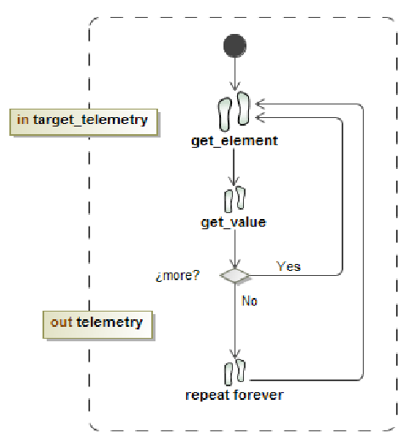
Precondition  (from Work Definition) | “target telemetry” artifact exists
Postcondition  (from Work Definition) | “telemetry” artifact has been created
Attribute | Value
name | environment metrics
presentationName | Environment Metrics
Kind | Metric
briefDescription (from Describable  Element.ContentDescription) | Defines the family of metrics related to the IoT physical infrastructure on which the system is deployed.
mainDescription (from Describable  Element.ContentDescription) | The taxonomy of environment metrics and their measures follow the schema:  - Infrastructure metrics: refer to hardware and data links:  - CPU Metrics: o CPU Usage (%) o …  - Memory Metrics: o RAM usage (Gb) o …  - Data Network Metrics: o Physical Network Interfaces  Aggregated Bandwidth (Kb/s) o Bandwidth (Kb/s) o Packets (packets/s) o Interface Errors (errors/s) o Interface Drops (drops/s) o …  - Disk Metrics:  o I/O operations (operations/s): o Space usage (bytes) o I/O bandwidth/s (Kb/s) o Utilization (%) o …  - IoT service metrics: the IoT infrastructure is designed as an architecture of microservices, all of them encapsulated in containers:  - http.server.requests (#)  - process.start.time (s)  - process.uptime (s)  - process.cpu.usage (%)  - process.files.open (#)  - system.load.average.1m (#)  - system.cpu.count (#)  - system.cpu.usage (%)  - …  - Device metrics:  - Device status (On/Off)  - Device error (Error Code)

Table I Table II

The instantiation of “F&CF availability” activity includes the following elements:

- Service measures: It defines the availability metrics to be collected in the instantiated scenario (IoT system). This instance defines the “environment metrics” related to availability in three scopes: infrastructure metrics, IoT service metrics, and device metrics
- Availability measures: This Task Use collects the measures related to the availability specified in “service measures” and calculates availability indicators by means of functions that combine sets of measures applying predefined logic. It leaves the value of those measures and indicators in the Work Product Use “availability indicator”. The steps are
- Develop monitoring components (code in the Net data plugin files) that collect the measures defined in “service measures” following the design model defined by the monitoring tool
- Configure the monitoring components in the monitoring tool by editing and modifying the configuration file netdata.conf defined for this purpose
- Restart the monitoring tool services (warm restart)
- Availability indicator: This Work Product Use receives and stores the entire set of values of the measures and indicators
- Evaluate availability: This Task Use receives the values of measures and indicators stored in the Work Product Use “availability indicator” and applies a set of rules and logic that define the grade of availability of the IoT system, generates availability alerts and events, and produces the detailed information that will be sent to the DevOps team. This detailed information will be the feedback of the availability status of the IoT system in production (measures and indicator values, alerts and events generated, and their severity levels) to be sent to the DevOps team to anticipate anomalies and fix failures. The results of this task are sent to the “availability alarm” Work Product Use. The steps are
- Develop the alarm components (code in the Netdata alarm definition files) that evaluate the IoT system availability, following the design model defined by the monitoring tool
- Configure the alarm components in the monitoring tool by editing and modifying the configuration file netdata.conf. Restart the monitoring tool services (warm restart)
- Restart the monitoring tool services (warm restart).
- availability alarm: This Work Product Use is the repository that receives detailed information (indicators and evaluation results) from the “evaluate availability” task.
- generate dashboard: This Task Use implements two actions: generate the dashboard web application retrieving measures, indicators and their analysis stored in “availability indicator” and “availability alarm” respectively, and send detailed feedback to the DevOps team through direct messages (e-mail, instant messaging, etc.) and/or as tickets to other event monitoring systems (third-party applications). The steps are:
- Configure the dashboard in the monitoring tool by editing and modifying the configuration file defined for this purpose. This configuration includes the URL to show the dashboard in a web browser
- Configure the event management in the monitoring tool by editing and modifying the configuration file netdata.conf or programming ad-hoc components to send messages and events that are called from the alarm components
- Restart the monitoring tool services (warm restart).

- Data presentation: This Work Product Use is the web application generated by the monitoring tool that shows the IoT system availability dashboard. This application is accessible through a web browser in a specific URL previously configured in the tool.

Result and Analysis
Implementation of “F&CF Availability” Activity
The SPEM specification of the “F&CF availability” activity has been validated by implementing it in a real IoT scenario. The activity implementation and the results of the case study are detailed below
The scenario for the case study was a drinkable water supply system. This system consisted of three flow meters that could be opened/closed on demand and that send the state of the current metering to the IoT Platform.
The flow meters were installed in the water entry points of three different sets of buildings. Each set of buildings was a closed workplace where all the workers had everything they needed to work and live. The workplace consisted of offices, factories, canteens, houses, and warehouses, and could be seen as a sort of small smart city, where systems such as the drinkable water supply could be monitored using IoT capabilities. The IoT capabilities of the system helped the facility management team to provide a quality service, since they had fine-grained information in real time. With the information provided by the system, they could forecast system failures even before they happened and act in advance to avoid supply interruptions among other benefits.
The flow meters measured the amount of water flowing through them and sent this data to third-party applications through the IoT infrastructure. The flow meters also had the capability to stop and start the water flow and report this status in conjunction with the water flow measures
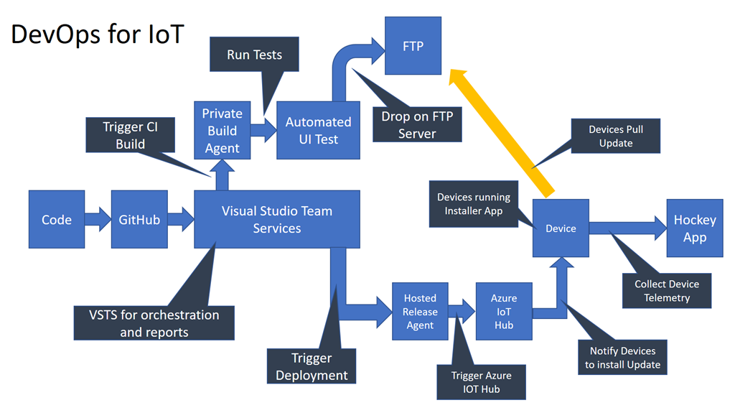
For the development of this case study, we deployed RECAP’s SAT-IoT platform [37]. This platform was designed and built using a distributed microservice architecture composed of multiple small components working together.
The flow meter devices were configured to send their data to the SAT-IoT collector (one of the main entities of the platform built as a microservice and deployed in a container) using the MQTT protocol over TCP. This IoT collector also provided an endpoint where the user could obtain metrics, such as data received, errors in the data, and data acquisition performance.

This case study focused on the monitoring of the availability of this IoT system. The availability was studied from the hardware infrastructure level, that includes the status of servers and devices, going through the IoT software infrastructure level, to the application level. To perform this study, the Netdata monitoring tool was chosen as an implementation of the “event data collector,” “anomalies detection,” and “supervision” tools defined in the “F&CF availability” activity specification (Fig. 3). This tool was designed as highly modular software to perform all-in-one metrics analysis. The Netdata configurations, plugins and event/alarm managers can be created, extended, or modified to fit the DevOps team needs since almost behaviour in Netdata can be coded. This is key for enabling Monitoring as Code (MaC) and supporting the automation that the F&CF activity aims. These plugins and configurations are managed via a version control system and are deployed using an automation tool like Ansible16 among others. Fig. 4 shows an overview of the IoT distributed system that was deployed in this case study, in which the SAT-IoT collector, Netdata plugins, alarm managers, and event managers were deployed in an edge node, while the Netdata core and the other IoT software infrastructure components were in cloud servers.

Implementation of “F&CF Availability”
Once the IoT infrastructure was deployed, the next step was the development of the “F&CF availability” activity and its deployment and execution on the IoT system. To that end, the Task Use elements specified in Section IV.B were implemented ad-hoc as MaC components and configured to be installed and executed in Netdata. The implementation consists of a set of configuration files, scripts, and python code files, all of them under GitLab17 CI/CD pipeline, configuration, and version control. The management of deployments and executions is carried out using playbooks that Ansible executes in the selected servers. All this is the Work Product Use "script availability" generated by DevOps team to implement the MaC. Fig. 5 shows the sequence of steps performed by “script availability”
Since this case study aimed to evaluate the availability of the IoT system, it was necessary to provide a set of indicators needed to calculate the availability. The calculation of these indicators was coded and deployed in the same way as the plugins, and they were also managed as MaC components.

System availability indicators combined CPU, RAM, disk, and network usage metrics of hardware infrastructure. In addition, multiple indicators related to devices and data sent from them were developed to reflect availability.

The first one was the error indicator. This indicator was used to raise an alarm if a valve was supposed to be closed, but the water was flowing through the flow meter. The second one was a requests indicator to alert that the number of responses sent from de device is less than the number of requests received. The last one was the flow threshold, which indicates that the current water flow is exceeding the manufacturer’s recommended limits

Software infrastructure (Sat-IoT platform) availability indicators relied on the responses (or the lack of them if a component was down) from the IoT software infrastructure.

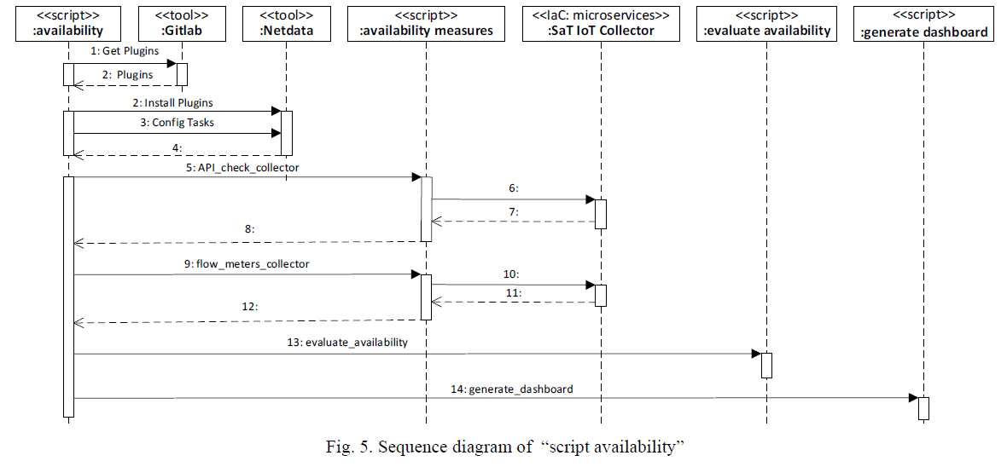

TaskUse “evaluate availability”
This Task Use examines indicators, calculates the availability at different levels, generates feedback about the behaviour of the system and raise alarms.
In this case study the availability is calculated at two levels: component level (system environment, SW infrastructure and data/device) and indicator level (for example, error, request and threshold are the indicators of data/device component).
Code 1 shows an excerpt from the configurations file. When the Netdata tool was configured and was running, custom plugins were coded using Python programming language. In this case two ad-hoc plugins were developed (flow_meters_collector.py and API_check_collector.py) to retrieve information from the SAT-IoT collector [37] via the API REST endpoint. The information retrieved included the flow meter measures, the state of the valve, the amount of data sent, etc. Some code sequences of the plugins implemented are shown in Code 2 and Code 3. The availability AI,(Ci, Ij), where Ij is an indicator that belongs to the component Ci, is calculated as in (1), the availability of each component AC (Ci) is calculated as in (2) and the availability of the system Asystem(Ci) is calculated as in (3). This model, expresses the percentage of time that a component/system is working properly and it is computed by well-known equation which relates Mean Time to Repair (MTTR) and Mean Time to Failure (MTTF) [38].

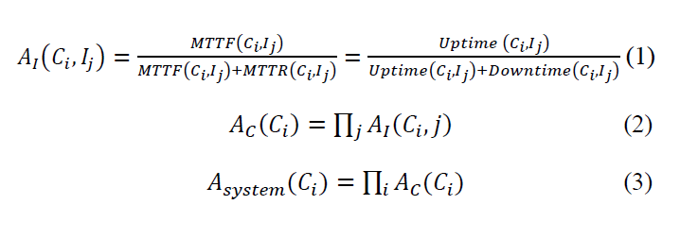
This TaskUse was coded in Netdata using the graphic alarm configuration system This system provides a programable rule system that enables make calculations, define rules to raise alarms, set the alarm severity and also execute a process associate to the alarm—In this use case a feedback generator that sends detailed information about indicators and behavior of the system.

TaskUse “generate dashboard”
This Task Use is the key piece of the activity for de DevOps Team since this Task Use provides a rich and tailored feedback from the system in production including measures, indicators, alarms, and detailed notification messages about the behavior of the system. The Task Use “generate dashboard” is the customized configuration of the dashboard and feedback system in this case study. This customization was made using the Netdata configuration file which contained the charts definition and location, the order of the elements, the scale of the data, and all the parameters that are shown in the dashboard. The notification actions were also defined through the alarm configuration system described in the configuration of “evaluate availability”. The customization of the dashboard is specified and deigned by the DevOps team, so that it is adapted to the specific environment monitored and helps team to interpret the information shown and to take the necessary actions in case of system anomalies or failures. Code 4 shows a fragment of the configuration code for generating the dashboard.

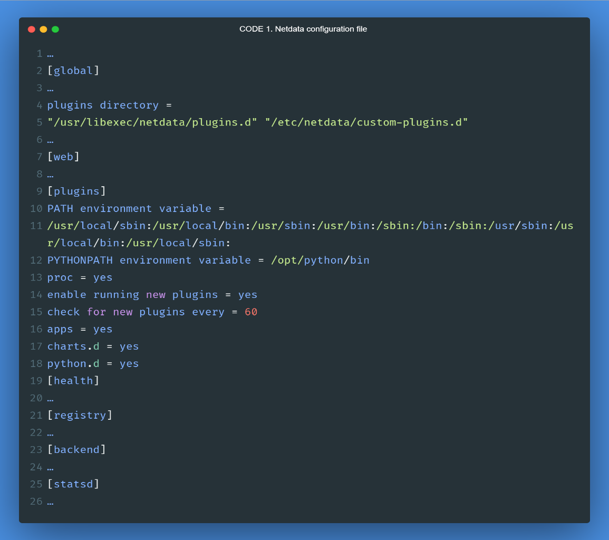
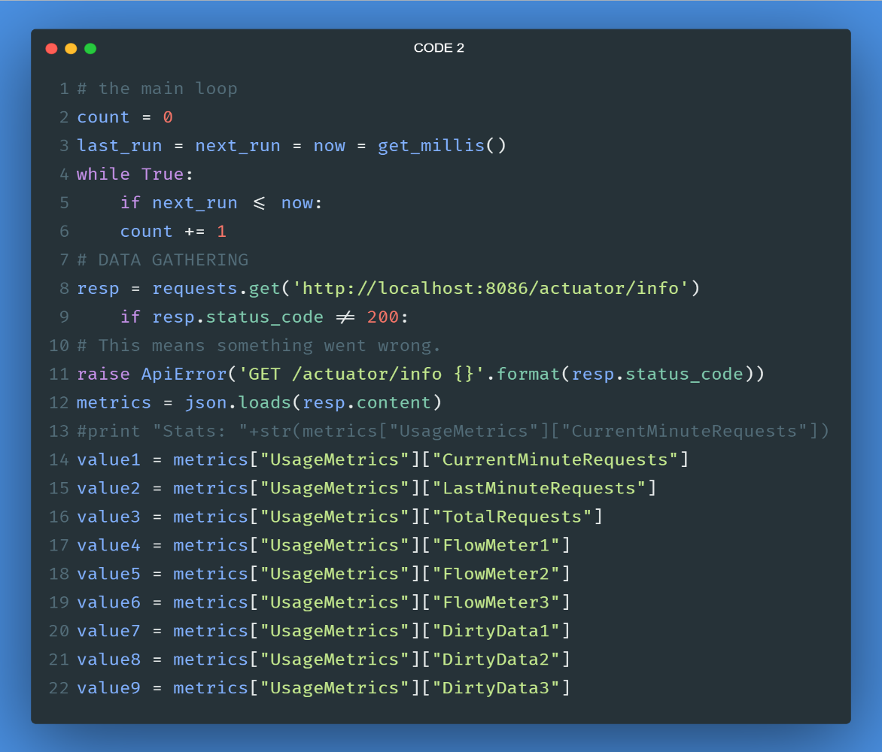

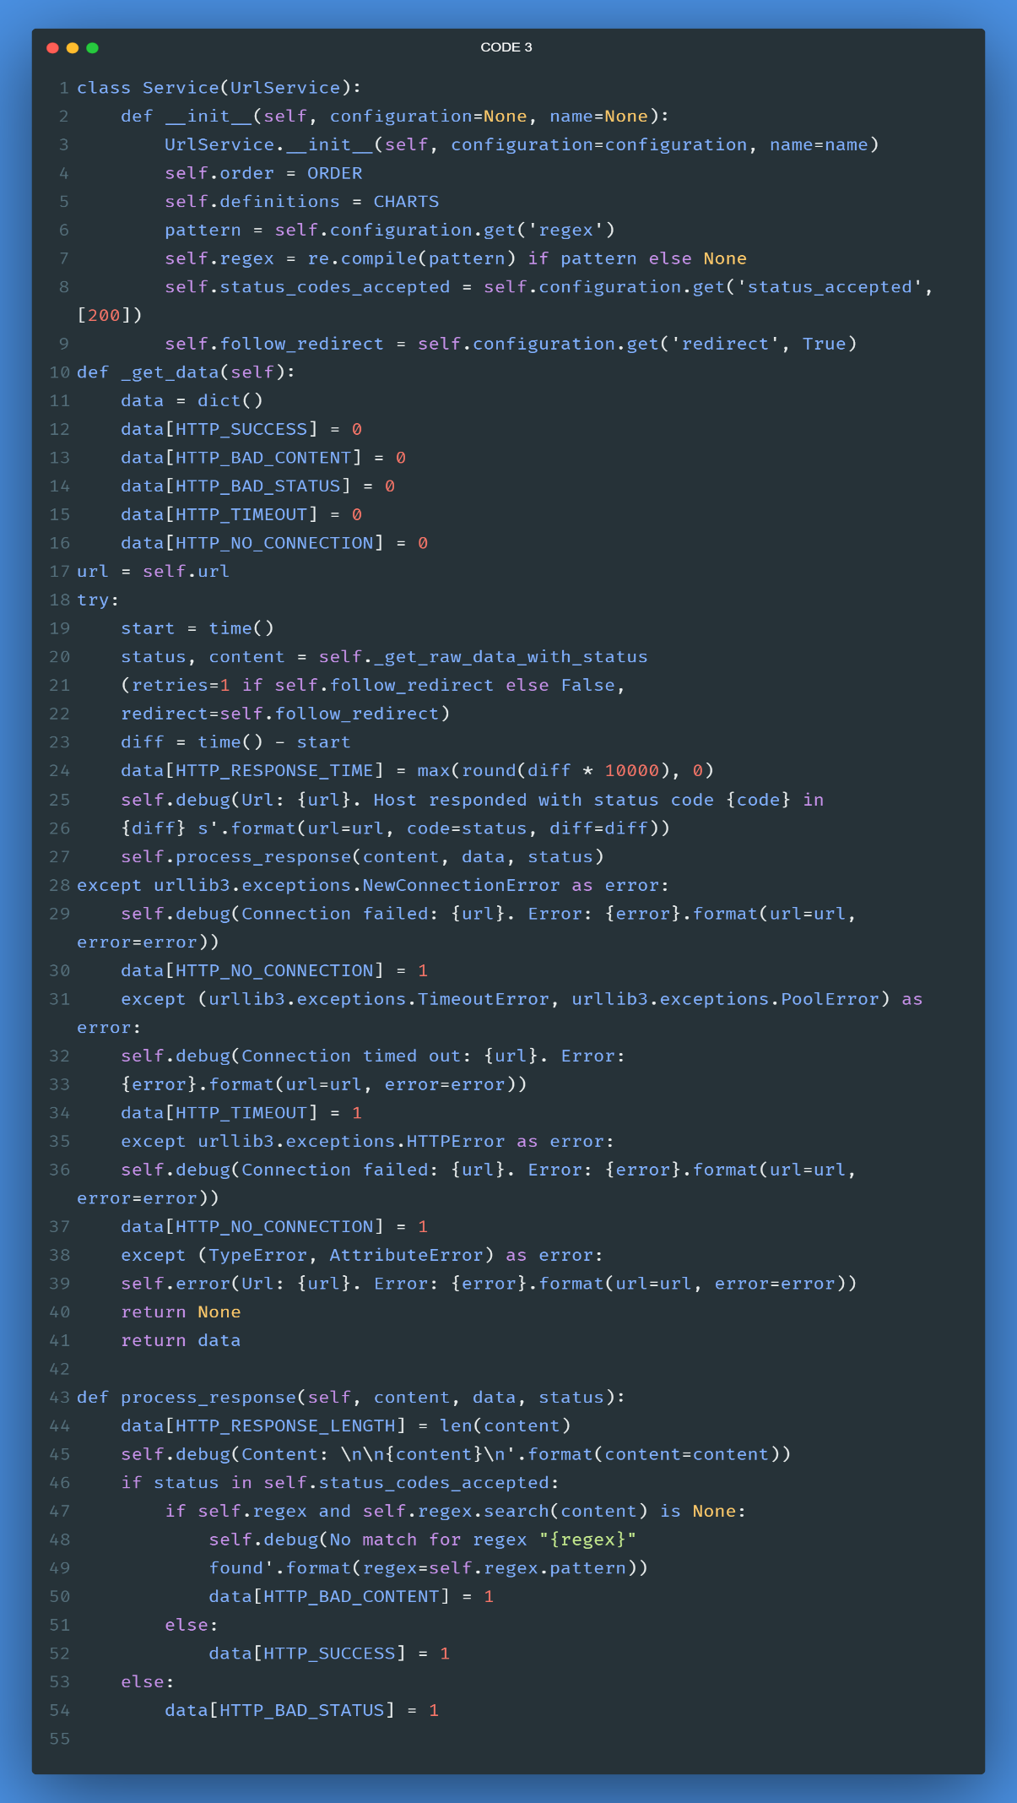
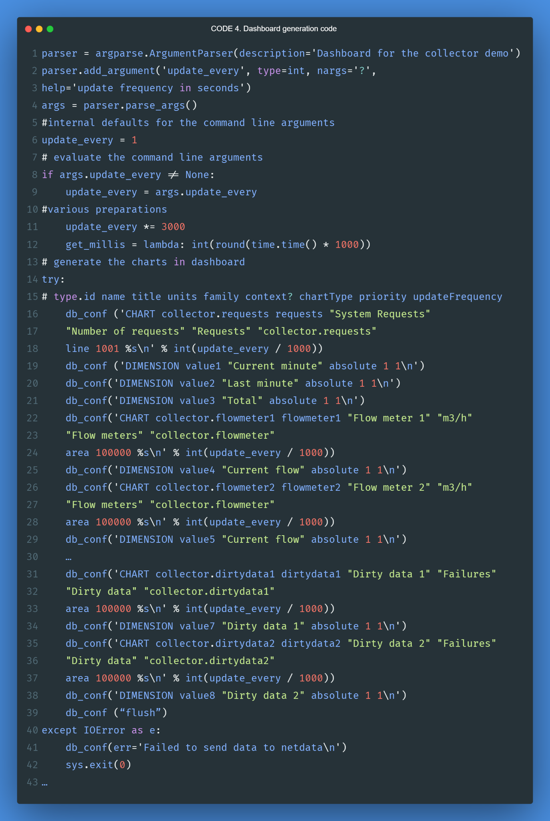

Case Study Results

The result of this case study is a complete implementation of the F&CF availability activity that support DevOps team in the process of continuous improvement. DevOps Team manage both monitoring infrastructure and monitoring components under a CI/CD model and the deploy of new versions are fully automated.

This implementation is an example of MaC that consists of both the installation of the tool (Netdata) and a set of configurations and customized pieces of code that were developed specifically for the IoT system to be monitored. All these components are controlled, tested and versioned under a CI/CD by the DevOps team, which is able to change them throughout the IoT application life-cycle. In addition, any new version of the whole monitoring system can be deployed and run automatically through virtualization and containerization technology as it is specified in "script availability" component in the “F&CF availability” activity specification.
Fig. 7, Fig. 8 and Fig. 9 show only some views of the very large and detailed dashboard designed. For example, Fig. 7 is a view of the panel that show the time series of water flows through the flowmeters and the threshold indicator (green) normal conditions an red when the evaluation of this indicator raises an alarm). Fig. 8 shows a real-time detailed graph with current (green line) and cumulative values (red line) of requests sent from system to the flowmeters, with which the monitoring system calculates request indicators and raises the corresponding alarms. Fig. 9 displays one of the views of the dashboard panel that monitors the flowmeters error indicator, this panel use three graphical gauges that change their color to red when the evaluation of the error level raises an alarm In addition to the graphical dashboard, the monitoring system sends detailed feedback messages systematically
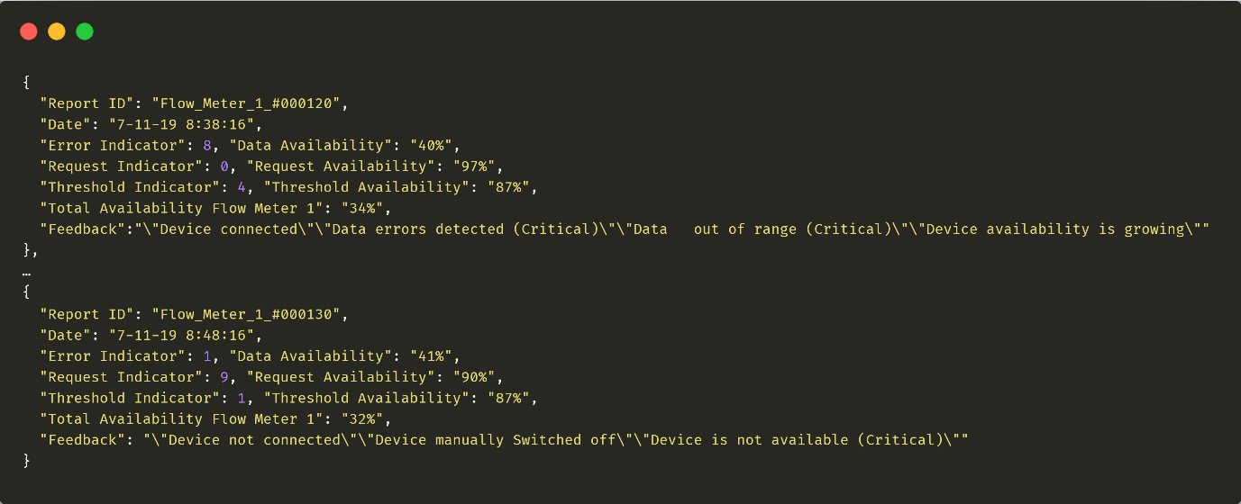

Fig. 6. IoT software infrastructure alarm
Fig. 7. Dashboard panel with flows and threshold indicators.
Fig. 8. Request indicator graph.
Fig. 9. Flowmeter error indicator panel in the dashboard
Conclusion

This work is focused on the need of apply DevOps in the development of reliable and compelling IoT systems. The Systems formalized through SPEM 2.0 a key activity named "F&CF availability" that supports feedback from operations to development in the process of maintenance and continuous improvement for IoT systems in operation. The formal specification provides reusability and flexibility by separating good practices (method content) from their use in different modalities of software development (process). The “F&CF availability” activity has been designed to allow DevOps teams to receive detailed feedback from operations.

This monitoring is based on the detection of anomalies or failures of availability from IoT hardware infrastructure, devices, IoT software infrastructure, and IoT applications. The feedback obtained from the detection of availability anomalies allows DevOps members in operations to make more informed decisions to fix problems or support IoT system evolution. The monitoring system and the monitoring on demand components were developed using the techniques IaC and MaC, which enables two DevOps good practices: all the components of the monitoring infrastructure are versioned (GitLab CI) and repeatable as their deployment had been automated through virtualization and containerization technology.

The case study provides evidence of how this monitoring infrastructure for a potable water supply system enabled the detection of system availability status and helped to better anticipate anomalies that could produce unavailability in the mid-term when a production deployment was performed. The validity of the approach was performed through a case study. The case study is qualitative in nature. That is, they are, in general terms, very difficult to judge objectively [39].

However, they are often used in software engineering due to the difficulty in producing multiple experiments or experiments with large populations. In fact, the major limitation in case study research concerns external validity, “the generality of the results with respect to a specific population” [40], in that only one case is studied.

In our examination, though only one case was studied, in the humble opinion of the authors, it was sufficient to validate the contributions claimed. In fact, this case study allowed the research team to evaluate the designed activity and the process practices in a real setting. This is an important aspect in software engineering, in which a multitude of external factors may affect the validation results

References

[1] L. Atzori, A. Iera and G. Morabito, "Understanding the Internet of Things: definition, potentials, and societal role of a fast-evolving paradigm," Ad Hoc Networks, vol. 56, pp. 122-140, 2017.
[2] T. Kramp, R. Kranenburg and S. Lange, Introduction to the Internet of Things. In Enabling Things to Talk: Designing IoT solutions with the IoT Architectural Reference Model, Springer Berlin Heidelberg, 2013, pp. 1-10
[3] E. Lee, "Cyber Physical Systems: Design Challenges," in 11th IEEE International Symposium on Object Oriented Real-Time Distributed Computing, Orlando, FL, USA, 2008.
[4] J. Reason and A. Hobbs, Managing maintenance error: a practical guide, CRC Press, 2017
[5] G. Casale et al., "Current and future challenges of software engineering for services and applications.," Procedia Computer Science, vol. 97, pp. 34-42, 2016
[6] L. Lwakatare, P. Kuvaja and M. Oivo, "Relationship of DevOps to Agile, Lean and Continuous Deployment," in 17th International Conference, PROFES 2016, 2016
[7] L. Lwakatare, P. Kuvaja and M. Oivo, "An Exploratory Study of DevOps Extending the Dimensions of DevOps with Practices," in Proc. The Eleventh International Conference on Software Engineering Advances, 2016
[8] A. Dyck, R. Penners and H. Lichter, "Towards definitions for release engineering and devops," in Proceedings of the IEEE/ACM 3rd International Workshop on Release Engineering, 2015
[9] G. Kim, J. Willis, P. Debois and J. Humble, The DevOps Handbook: How to Create World-Class Agility, Reliability, and Security in Technology Organizations, IT Revolution Press, 2016
[10] L. Lwakatare, T. Karvonen, T. Sauvola, P. Kuvaja and et-al, "Towards DevOps in the embedded systems domain: Why is it so hard?"," in Proc. 49th Hawaii Int. Conf. Syst. Sci. (HICSS), 2016
[11] D. Mattos, J. Bosch and H. Holmstrom, Agile Processes: Challenges and Strategies for Undertaking Continuous Experimentation to Embedded Systems: Industry and Research Perspectives, vol. Agile Processes, 2018
[12] OMG, "About the Software & Systems Process Engineering Metamodel Specification (SPEM) Version 2.0," 2008. [Online]. Available: http://www.omg.org/spec/SPEM/.
[13] F. Erich, C. Amrit and M. Daneva, "A Qualitative Study of DevOps Usage in Practice," Journal of Software: Evolution and Process, vol. 29, no. 6, January 2017
[14] W. Van Gremberen and S. De Haes, "Introduction to the Minitrack on IT Governance and its Mechanisms," in Proceedings of the 51st Hawaii International Conference on System Sciences, Hawai, 2018
[15] ISO/IEC, "International Standard 20924 “Information technology - Internet of Things - Definition and Vocabulary"," 2018
[16] ISO/IEC, "International Standard 30141. "Internet of Things (IoT) - Reference Architecture"," 2018
[17] H. Derhamy et al., "A survey of commercial frameworks for the internet of things," in IEEE 20th Conference on Emerging Technologies & Factory Automation (ETFA), 2015
[18] P. Ray, "A survey of IoT cloud platforms," Future Computing and Informatics Journal, vol. 1, no. 1-2, pp. 35-46, 2016
[19] Industrial Internet Consortium (IIC), [Online]. Available: https://www.iiconsortium.org
[20] Y. Chao Hu et al., "Mobile edge computing—A key technology towards 5G," ETSI White Paper, vol. 11, no. 11, pp. 1-16, 2015
[21] P. Fremantle, "A Reference Architecture for the Internet of Things (white paper)," 2015. [Online]. Available: https://wso2.com/whitepapers/a-reference-architecture-for-the-internet-of-things
[22] F. Bonomi and et-al, "Fog Computing and Its Role in the Internet of Things Characterization of Fog Computing," in 1st MCC workshop on Mobile cloud computing, 2012.
[23] R. Khan Suk, R. Zaheer and S. Khan, "Future Internet: The Internet of Things Architecture, Possible Applications and Key Challenges," in 10th International Conference on Frontiers of Information Technology, 2012.
[24] Y. Shanhe, H. Zijiang, Q. Zhengrui and L. Qun, "Fog Computing: Platform and Applications," in Third IEEE Workshop on Hot Topics in Web Systems and Technologies (HotWeb), 2015
[25] A. Munir, P. Kansakar and S. U. Khan, "IFCIoT: Integrated Fog Cloud IoT: A novel architectural paradigm for the future Internet of Things," IEEE Consumer Electronics Magazine, vol. 6, no. 3, pp. 74-82, 2017
[26] S. Shekhar et al., "INDICES: Exploiting Edge Resources for Performance-Aware Cloud-Hosted Services," in IEEE 1st International Conference on Fog and Edge Computing (ICFEC), 2017
[27] P. Debois, "Agile infrastructure and operations: how infra-gile are you?," in Agile 2008 Conference proceedings, Toronto, 2008
[28] A. Wahaballa et al., "Toward unified DevOps model," in 6th IEEE International Conference on Software Engineering and Service Science (ICSESS), Beijing, China, 2015.
[29] O. Krancher, P. Luther and M. Jost, "Key affordances of platform-as-a-service: Self-organization and continuous feedback," Journal of Management Information Systems, vol. 35, no. 3, pp. 776-812, 2018
[30] A. Balalaie, H. Abbas and P. Jamshidi, "Microservices architecture enables devops: Migration to a cloud-native architecture," Ieee Software, vol. 33, no. 3, pp. 42-52, 2016.
[31] J. Díaz, J. Pérez, M. A. López-Peña, G. Mena and A. Yagüe, "Self-Service Cybersecurity Monitoring as Enabler for DevSecOps," IEEE Access. Special Section on Advanced Software and Data Engineering for Secure Societies, vol. 7, pp. 100283-100295, 2019.
[32] N. Ferry et al, "Enact: Development, operation, and quality assurance of trustworthy smart iot systems," in DEVOPS: Software Engineering Aspects of Continuous Development and New Paradigms of Software Production and Deployment, 2018
[33] A. Karapantelakis et al., "DevOps for IoT applications using cellular networks and cloud," in IEEE 4th International Conference on Future Internet of Things and Cloud (FiCloud), 2016
[34] S. Kim and J. Kim, "Enabling operation data visibility for SmartX-mini IoT-cloud playground," in IEEE NetSoft Conference and Workshops (NetSoft), 2016
[35] J. Bae, C. Kim and J. Kim, "Automated deployment of SmartX IoT-cloud services based on continuous integration," in International Conference on Information and Communication Technology Convergence (ICTC), 2016
[36] M. Syed and E. Fernandez, "Cloud Ecosystems Support for Internet of Things and DevOps Using Patterns," in IEEE First International Conference on Internet-of-Things Design and Implementation (IoTDI), 2016
[37] M. A. Lopez-Peña and I. Muñoz Fernández, "SAT-IoT: An Architectural Model for a High-Performance Fog/Edge/Cloud IoT Platform," Limerick, 2019
[38] I. Silva, L. A. Guedes, P. Portugal and F. Vasques, "Reliability and availability evaluation of wireless sensor networks for industrial applications," Sensors, vol. 12, no. 1, pp. 806-838, 2012
[39] R. K. Yin, Case Study Research: Design and Methods. (Fourth Edition), London: SAGE, 2009
[40] U. Van Heesch, P. Avgeriou and R. Hilliard, "A documentation framework for architecture decisions," Journal of Systems and Software, vol. 85, no. 4, pp. 795-820, 2012
[41] C. B. Seaman, "Qualitative methods in empirical studies of software engineering," IEEE Transactions on software engineering, vol. 25, no. 4, pp. 557-572, 1999

Complete Referred journal/ conference paper

DevOps for IoT Systems: Fast & Continuous Monitoring Feedback of System Availability

Links:
https://www.researchgate.net/publication/343316168_DevOps_for_IoT_Systems_Fast_Continuous_Monitoring_Feedback_of_System_Availability
https://ieeexplore.ieee.org/document/9151987

