**DCR V4 CLIENT - FUNCTIONAL SPECIFICATION**

**Revision History:**

|  |  |  |  |
| --- | --- | --- | --- |
| **Version #** | **Date** | **Author** | **Remarks** |
| 1.0 | 19-09-2013 | M. Ganesh Pandian | Document is created |

**Objective:**

We have given the screen design (UI) to the vendor and this document will provide the detailed explanation for the entire screen. Please keep the UI document (i.e. DCR_V4_UI_V1.xlsx) with you before get into this document further.

**Introduction:**

We tried to explain the functionality of each and every control in various scenarios in the following categories.

***Prefill Source:***

We have to prefill the data from some source in order to make the user to submit the DCR without entering the data again. To prefill the we have the following scenarios

1. Fresh mode
2. Temp save mode

***Validations:***

We have classified the validations as follows.

1. Privilege validations
2. General validations

***Save/Edit:***

Once all the validations are passed the user will save the new data or will the save the modified data.

**Left side doctor panel:**

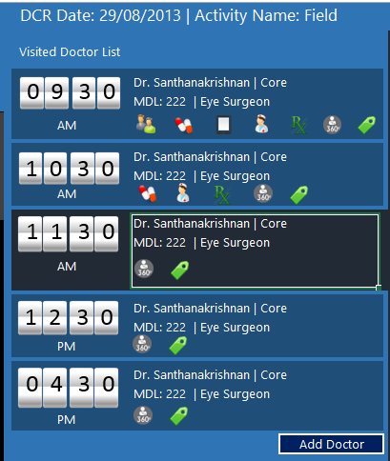

We just name the above image as “Left side doctor panel” for our better understanding. In this section we are going to see only about the above image.

**DCR Date:**



***Prefill Source:***

Always show the device’s date. The date should be displayed as per the config settings. Use the config value for the config key DATE_DISPLAY_FORMAT. This key and value are available in the tbl_DCR_Config_Settings table. The date should be displayed as per the config value. If the key is not found in the above mentioned table use the default format (i.e. dd/MM/yyyy). We have to show the date based on this settings only throughout the application.

***Validations:***

N/A

**Activity Name:**



***Prefill Source:***

Always show the selected activity name. If the user has selected field then show it as Field if the user has selected attendance, then show it as Attendance.

***Validations:***

N/A

**Visited Doctor List:**

We name the below image as “Visited Doctor List”.

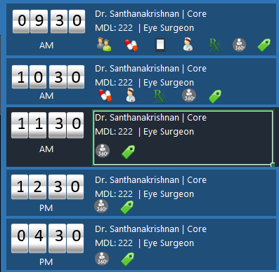

***Prefill Source:***

The source of this section is the union of the following three things

1. WA analytics
   1. SELECT cm.Customer_Name, ana.Doctor_Code, ana.Doctor_Region_Code FROM tbl_Analytics_Doctor_Visit ana INNER JOIN tbl_Customer_Master cm ON ana.Doctor_Code = cm.Customer_Code AND ana.Doctor_Region_Code = cm.Region_Code AND cm.Customer_Entity_Type = ‘DOCTOR’ WHERE ana.DCR_Actual_Date = ‘2013-09-25’
2. TP doctors for that date
   1. SELECT cm.Customer_Name, tpd.Doctor_Code, tpd.Doctor_Region_Code FROM tbl_TP_Doctors tpd INNER JOIN tbl_Customer_Master cm ON tpd.Doctor_Code = cm.Customer_Code AND tpd.Doctor_Region_Code = cm.Region_Code AND cm.Customer_Entity_Type = ‘DOCTOR’ INNER JOIN tbl_TP_Header tph ON tpd.TP_Id = tph.TP_Id WHERE tph.TP_Date = ‘2013-09-25’
3. Temp save doctors
   1. SELECT dv.Doctor_Name, dv.Doctor_Code, dv.Doctor_Region_Code FROM tbl_DCR_Doctor_Visit dv INNER JOIN tbl_DCR_Header dcr ON dv.DCR_Code = dcr.DCR_Code WHERE dcr.DCR_Actual_Date = ‘2013-09-25’ AND dcr.Flag = ‘F’

***Validations:***

N/A

***Icon details:***

Each icon gives some information or action to the user. Please find the detailed description for all the icons.

*Accompanist Icon:*

This is the first icon. This icon should be displayed if any one of the following condition is true.

1. WA analytics has at least one accompanist for this doctor visit
2. If the user is already entered accompanist name for this doctor visit (i.e. data available in the tbl_DCR_Doctor_Accompanist table for this Doctor_Visit_Code)

*Input Icon:*

This is the first icon. This icon should be displayed if the following condition is true.

1. If the user is already entered input details for this doctor visit (i.e. data available in the tbl_DCR_Product_Details table for this Doctor_Visit_Code)

*WA Icon:*

This is the third icon. This icon should be displayed if the following condition is true.

1. If the doctor data is available in WA analytics for this date.

*Chemist Icon:*

This is the fourth icon. This icon should be displayed if the following condition is true.

1. If the user is already entered chemist for this doctor visit (i.e. if data available in the tbl_DCR_Chemist_Visit table for this Doctor_Visit_Code)

*RCPA Icon:*

This is the fifth icon. This icon should be displayed if the following condition is true.

1. If the user has already entered at least one RCPA for this doctor visit (i.e. if data available in the tbl_DCR_RCPA_Details table for this Doctor_Visit_Code)

*Doctor 360 Icon:*

This is the sixth icon. This icon should be displayed always. If the user clicks this icon, it has to show the doctor 360 report in a pop up.

*Doctor Tag Icon:*

This is the seventh icon. This icon should be displayed always. Ganesh will add more info on this after the discussion with Vijay and Kamaraj.

**Points to remember:**

1. If the user clicks the “Update DCR” button once he completed detailing through WA, it has to prefill all the relevant data like visit time, accompanist, inputs, detailed products.
2. In the left side doctor panel, we are showing doctor visit time. The time should be displayed based on the following scenarios.
   1. In order to show the doctor visit time, we have to check a privilege called DCR_DOCTOR_VISIT_MODE
   2. If the value of the above mentioned privilege is AM_PM or the privilege is not mapped, we have to show only AM or PM. Do not show visit time. For other privilege values, see the below points
   3. If the user comes through the WA detailing it has to show the visit time from WA analytics.
   4. If the user has already entered the doctor visit data, then show it from the tbl_DCR_Doctor_Visit table
3. The doctor category is a non-mandatory field in doctor master. Hence you should not use inner join with doctor master instead you have to user left join. Please make sure you are taking care of this point throughout the project.
4. If the doctor is prefilled through WA, then the user can’t delete the doctor

**Doctor entry section:**



We just name the above box as “Doctor Entry section” for our better understanding.

**Doctor Name:**

As per the above image, SanthanaKrishnan | Core | 222 | Eye Surgeon is the doctor name.

***Prefill Source:***

The doctor name can be prefilled either from the “Left side doctor panel” or from the “Add Doctor” pop up.

***Validations:***

N/A

**Speciality name:**

It means the speciality label and text box. It has to show all the speciality names in the auto complete list. If the doctor is not a flexi doctor, do not show this label and text box. Show this label and text box only for flexi doctors.

***Prefill Source:***

N/A

***Validations:***

1. If the doctor is a flexi doctor (i.e. the doctor is not chosen from the doctor master), then this field is a mandatory field. You have to show the alert message to the user when the user saves the doctor.

**Visit Time:**

***Prefill Source:***

1. If the value for the privilege DCR_DOCTOR_VISIT_MODE is AM_PM, then two radio button should be shown as AM and PM. And AM option should be pre-selected by default.
2. If the privilege value is VISIT_TIME and no config value is found in tbl_DCR_Config_Settings for the key DCR_DOCTOR_VISIT_TIME_ENTRY_MODE, then a text box with time picker should be shown.
3. If the privilege value is VISIT_TIME and the config value in tbl_DCR_Config_Settings for the key DCR_DOCTOR_VISIT_TIME_ENTRY_MODE is equal to MANUAL, then a text box with time picker should be shown.
4. If the privilege value is VISIT_TIME and the config value in tbl_Config_Settings for the key DCR_DOCTOR_VISIT_TIME_ENTRY_MODE is equal to SERVER_TIME, then show the server time in a label. The time shown in label should be saved when we save the doctor data.
5. If the privilege value is VISIT_TIME_MANDATORY and no config value is found in tbl_Config_Settings for the key DCR_DOCTOR_VISIT_TIME_ENTRY_MODE, then a text box with time picker should be shown.
6. If the privilege value is VISIT_TIME_MANDATORY and the config value in tbl_Config_Settings for the key DCR_DOCTOR_VISIT_TIME_ENTRY_MODE is equal to MANUAL, then a text box with time picker should be shown.
7. If the privilege value is VISIT_TIME_MANDATORY and the config value in tbl_Config_Settings for the key DCR_DOCTOR_VISIT_TIME_ENTRY_MODE is equal to SERVER_TIME, then show the server time in a label. The time shown in label should be saved when we save the doctor data.

***Validations:***

1. If the value of the privilege DCR_DOCTOR_VISIT_MODE is VISIT_TIME_MANDATORY, then the user must enter the doctor visit time. We have to show the alert message when the user saves the doctor data.
2. The user must enter the valid time
3. Though the doctor visit time is prefilled through WA, the user can edit the visit time.

**Note:**

1. For fresh entry, please take the doctor_visit_time from tbl_Analytics_Doctor_Visit table if all the necessary privileges are satisfied.

**POB:**

It means the label “POB” and a text box. If the value of the privilege DCR_DOCTOR_POB_AMOUNT is YES show the label as POB and a text box. If the privilege is not mapped or the privilege value is NO, do not show the label and text box

***Prefill Source:***

If the user has already entered data for this doctor in DCR, show the POB amount from tbl_DCR_Doctor_Visit table

***Validations:***

1. This is a non-mandatory field.
2. The user can enter only numeric value
3. It should accept float value
4. It should not accept any alphabet or special character.
5. It should not allow negative values

**Accompanist Details:**

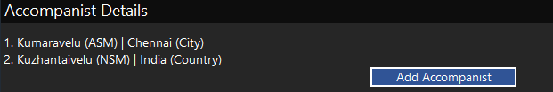

***Note:***

There are two changes in the UI

1. Show a check box with the text as “Only for doctor”.
2. Show a remove (delete) icon to remove the particular accompanist name from the UI

***Prefill Source:***

1. If the WA analytics has accompanist info prefill it
   1. SELECT Accompanist_Name FROM tbl_Analytics_Doctor_Visit WHERE DCR_Actual_Date = ‘XXX’ AND Doctor_Code = ‘XXX’ AND Doctor_Region_Code = ‘XXX’
2. If the user has already entered accompanist information for this doctor (i.e. if data available in the tbl_DCR_Doctor_Accompanist for this Doctor_Visit_Code)

***Validations:***

1. If the accompanist name is prefilled through WA, do not show the delete icon for that accompanist. The user should not delete the accompanist info that comes from the WA.
2. Though the accompanist name is prefilled through WA, the user can check/uncheck the “Only for doctor” check box.
3. The user can’t enter more than 4 accompanists for that DCR date (The distinct accompanist count should not exceed 4 for all the doctors entered for that DCR date)
4. The user can’t enter an accompanist name more than one time for that doctor visit

**Input Details:**

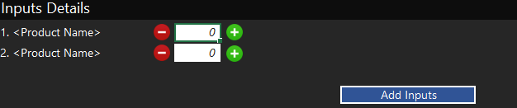

***Prefill Source:***

1. If the user has already entered input details for this doctor, prefill it. (i.e. if data is available in the tbl_DCR_Product_Details for this Doctor_Visit_Code)

***Validations:***

1. In the “Add Inputs” pop up, we have to show text box, there the product names should appear in the auto complete list.
2. The user can’t choose a product name apart from the auto complete. (i.e. the user can enter only valid product names)
3. We have a restriction in showing the product names in the auto complete list.
4. SELECT Privilege_Value FROM tbl_Privileges WHERE Privilege_Name = ‘DCR_PRODUCTS_BRING_TYPE’
5. For example if the value of the privilege is SAMPLE,GIFT,INPUT, then we have to use the following query to fetch the product names
6. SELECT up.Product_Code,pm.Product_Name FROM tbl_User_Product_Mapping up INNER JOIN tbl_Product_Master pm ON up.Product_Code = pm.Product_Code WHERE pm.Product_Type_Name IN (‘SAMPLE’,’GIFT’,’INPUT’)
7. The quantity text box should accept only integer value
8. The quantity text box should not accept float value or alphabet or special characters
9. The quantity text box should not accept negative values
10. The quantity text box can accept zero value
11. The no. of inputs entered should be validated based on a privilege.
12. If the value of the privilege DCR_INPUT_MANDATORY_NUMBER is 2 mean, the user should enter at least 2 inputs for every doctor visit.
13. If the value of the above mentioned privilege is 0(zero), then we should not force the user to enter inputs.

**List of Detailed Products:**

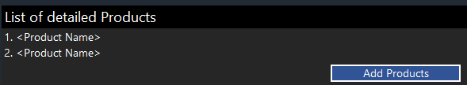

***Prefill Source:***

1. If the WA analytics has the detailed products info, prefill it
   1. SELECT pm.Product_Name FROM tbl_Anlytics_Detailed_Products ana INNER JOIN tbl_Product_Master pm ON ana.Product_Code = pm.Product_Code WHERE ana.DCR_Actual_Date = ‘XXX’ AND ana.Doctor_Code = ‘XXX’ AND ana.Doctor_Region_Code = ‘XXX’
2. If the user has already entered the detailed products info for this doctor visit. (i.e. if the tbl_DCR_Product_Detailing table for this Doctor_Visit_Code)

***Validations:***

1. In the “Add Products” pop up we have to show only the SALES type products from product master table.
2. The user can’t enter a product name apart from the product auto complete. (i.e. the user must enter a valid product name only)
3. If the detailed product information comes from the WA analytics, the user can’t delete those product info.

**Chemist Visits:**

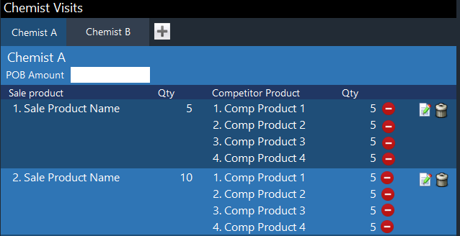

**Chemist Name Text Box:**

***Prefill Source:***

1. If the user has already entered chemist details for this doctor visit.

***Validations:***

1. The chemist auto complete should contain the chemists of mine and my accompanists chemists
2. Showing the accompanists chemist names should work based on a privilege
3. If the value of the privilege SHOW_ACCOMPANIST_DATA contains the value as CHEMIST we should show the accompanists chemist names in the chemist auto complete. Otherwise we should show only the chemists of mine.
4. If the above mentioned privilege contains CHEMIST, then we should consider only the accompanists that are entered for this doctor. We should not bring all the accompanists’ chemists.
5. The user can enter a chemist name from the chemist auto complete or he can enter a flexi chemist name also
6. The no. of chemists entered should be validated based on a privilege.
7. If the value of the privilege DCR_CHEMIST_MANDATORY_NUMBER is 2 mean the user must enter at least 2 chemists for that doctor visit.
8. If the value of the privilege is 0(zero), then we should not force the user to enter chemists

***POB Amount Text Box:***

1. The user has already entered data for this chemist.

***Validations:***

1. The user can enter a numeric value
2. The value can be integer or float
3. The user can’t enter alphabet or special character
4. The user can’t enter negative values

**RCPA Grid:**

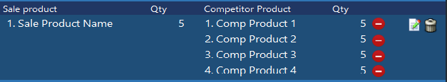

***Prefill Source:***

1. If the user has already entered RCPA data

***Validations:***

1. In the “Add Products” pop up, the user can choose a single sales type product and multiple competitor product names
2. Once the user has selected the sale type product name, the competitor product text box should show only the competitor product names that are mapped to that sales type products.
3. The user can choose a competitor product name from the auto complete or he can enter any product names on his own.
4. But he can enter only valid sales type product names
5. The quantity text box should accept only numeric values
6. The quantity text box should accept integer or float values
7. The quantity text box should not accept alphabet or special characters
8. The quantity text box should not accept negative values
9. The user can able to delete a single competitor product names (Actually the UI shows minus icon for delete, please show delete icon. If the user clicks that, it has to delete from the UI
10. The user can able to delete a single sale product and all the competitor product names in a single click
11. The user must enter at least one RCPA entry for every doctor entries. This should be validated based on a privilege.
12. If the value of the privilege, “RCPA_MANDATORY_DOCTOR_CATEGORY” is Core, Non Core mean, the user must enter at least one RCPA entry if the doctor is core doctor or non core doctor, the user must enter at least one RCPA entry.

**General Notes:**

1. The user can do up sync only once for a DCR actual date. If the user tries to do up sync for the date second time, the API will return an error message. Please show that error message to the user.
2. While up sync please push the data from tbl_Analytics_Doctor_Visit and tbl_Anlytics_Detailed_Products tables also.
3. Once the up sync is successfully completed, please delete all the data from DCR related tables.