

American International University-Bangladesh (AIUB)  
Department of Computer Science  
Faculty of Science &Technology (FST)  
Fall 22 23

Section: C  
Software Quality Assurance and Testing

**Pick Up**

A Report submitted

By

|  |  |  |
| --- | --- | --- |
| SN | Student Name | Student ID |
| 1 | MD ROKON ISLAM EMON | 19-41117-2 |
| 2 | MD. BAKHTIAR AZIM NILOY | 19-41011-2 |
| 3 | H.M. JAYED CHOWDHURY RABBY | 19-40893-2 |
| 4 | EASINUL ABEDIN SAYEM | 19-40291-1 |

Under the supervision of

**ABHIJIT BHOWMIK**

Associate Professor

**Checked By Industry Personnel**

Name:

Designation:

Company:

Sign:

Date:

**Software Test Plan**for  
**Pick Up**

Version 1.0 approved  
Prepared by

MD ROKON ISLAM EMON

EASINUL ABEDIN SAYEM

MD. BAKHTIAR AZIM NILOY

H.M. JAYED CHOWDHURY RABBY

American International University-Bangladesh (AIUB)  
10.12.2022

**Checked By Industry Personnel**

Name:

Designation:

Company:

Sign:

Date:

**Table of Contents**

Revision History 1

1. TEST PLAN IDENTIFIER: RS-MTP01.3 2

2. REFERENCES 2

3. INTRODUCTION 2

Background to the Problem 2

Solution to the Problem 3

4. REQUEIREMNT SPECIFICATION 3

4.1 System Features 3

4.2 System Quality Attributes 5

4.3 System Interface 6

4.4 Project Requirements 10

5. FEATURES NOT TO BE TESTED 11

6. TESTING APPROACH 11

6.1 Testing Levels 11

6.2 Test Tools 12

6.3 Meetings 14

7. TEST CASES/TEST ITEMS 15

8. ITEM PASS/FAIL CRITERIA 26

9. TEST DELIVERABLES 27

10. STAFFING AND TRAINING NEEDS 27

11. RESPONSIBILITIES 28

12. TESTING SCHEDULE 30

13. PLANNING RISKS AND CONTINGENCIES 31

14. APPROVALS 32

**REVISION HISTORY**

**1**

|  |  |  |  |
| --- | --- | --- | --- |
| **Revision** | **Date** | **Updated By** | **Updated Comment** |
| 0.1 | 05-12-22 | Rokon | 1st Draft |
| 0.2 | 05-12-22 | Niloy | 2nd Draft |
| 0.3 | 06-12-22 | Sayem | 3rd Draft |
| 0.4 | 07-12-22 | Rabby | 4th Draft |
| 0.5 | 08-12-22 | Rokon | 5th Draft |
| 0.6 | 09-12-22 | Rabby | 6th Draft |
| 0.7 | 09-12-22 | Niloy | 7th Draft |
| 0.8 | 18-12-22 | Sayem | 8th Draft |

**1.** **TEST PLAN IDENTIFIER:RS-MTP01.3**

**2. REFERENCES**

● Software Requirement Engineering Document  
● Software Quality And Testing Course PowerPoint Slides  
● Selenium tool  
● Postman Software

**3. INTRODUCTION**

**3.1 Background to the Program**

Many popular e-commerce websites are available. But the problem is when customers want a product that is not available in any e-commerce platform. Customers are not able to purchase those products sitting at home. Our system has two individual ways to purchase the product. One is as, like the other, sellers add their products customers can choose and buy. Another one is if customers can’t find their expected product. They can purchase through the service provider. According to the product location, customers can send a request order to the service provider with details of the product. And Customers can get here products through the service provider. We are doing this project for helping people and many of us want products from a place where we have no familiar person to help. There is a high risk of an unknown person that they can deceive. So, through this system we can make it possible with enough credibility for the people.

**3.2 Solution to the Program**

This project is one that allows people to buy and sell physical goods, services, and digital products over the internet rather than at a brick-and-mortar location. Through this project, clients sell products and provide customer service properly and customers are able to buy their products. Using this website, user can pay their payments or they are able to pay cash on delivery (COD). And the purpose of this project is to maintain a business platform so peoples get their needed products by using this website in a few moments. And also, by using this project, people can easily interact with service providers and get products as soon as possible. By using this project, customer can easily do their shopping, clients can easily sell their products, and the company can earn money.

**4. REQUIREMENT SPECIFICATION**

**4.1 System Features**

|  |  |  |  |
| --- | --- | --- | --- |
| **Requirement ID** | **Requirement Description** | **Dependencies** | **Originator** |
| FR-01 | Two types of users: customer and client; store their credentials in the database. | Users need to have valid and unique email address, strong password as well as other valid information. | Junior Developer |
| FR-02 | Authenticate validly of the users of the system and log them in. | Must be a registered user. | Junior Developer |
| FR-03 | Users can edit their profile. | Must be a registered user. | Junior Developer |
| FR-04 | Products can be added, edited, and deleted by the client. | Must be a valid products. | Junior Developer |
| FR-05 | Clients are able to track which customers have purchased their products. | Must be a valid client. | Senior Developer |
| FR-06 | Customers can see all the products that have been added to the cart. | Must be a valid customer. | Junior Developer |
| FR-07 | Customers can purchase products. | Customers must have valid payment details. | Senior Developer |
| FR-08 | Customers can see which products were bought from which client. | Database | Senior Developer |
| FR-09 | Customers can review the products on their experience. | Must have bought the product they are reviewing. | Junior Developer |
| FR-10 | Admin can create client and customer. | Must be an authenticated admin. | Junior Developer |
| FR-11 | Admin can see the statistical data of users, purchases | Must be an authenticated admin. | Senior Developer |
| FR-12 | Admins can delete posts; block customers and clients. | Must be an authenticated admin. | Senior Developer |

**4.2 System Quality Attributes**

|  |  |  |  |  |
| --- | --- | --- | --- | --- |
| **Requirement ID** | **Date** | **Requirement Description** | **Dependencies** | **Originator** |
| NF-0.R1 | 05-12-22 | Security | Program | Software Engineer |
| NF-0.R2 | 06-12-22 | Usability | Program | Junior Developer |
| NF-0.R3 | 07-12-22 | Maintainability | Program | Senior Developer |
| NF-0.R4 | 08-12-22 | Scalability | Program | Software Engineer |
| NF-0.R5 | 09-12-22 | Performance | Program | Senior Developer |
| NF-0.R6 | 10-12-22 | Reliability | Program | Senior Developer |

**4.3 System Interface**

4.3.1 Login Page

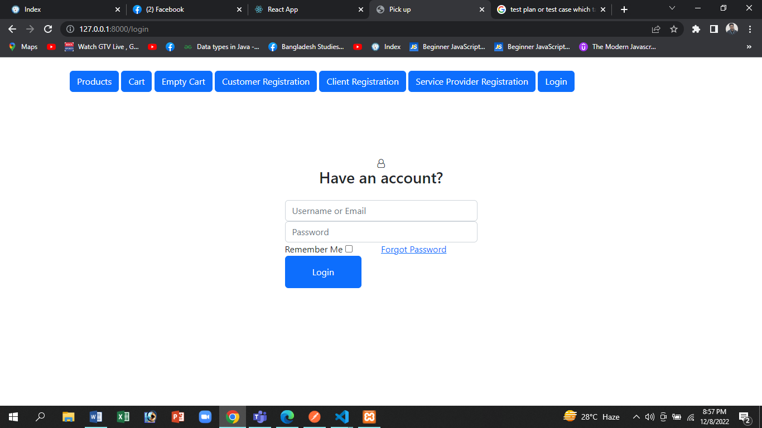

4.3.2 Registration Form of Client

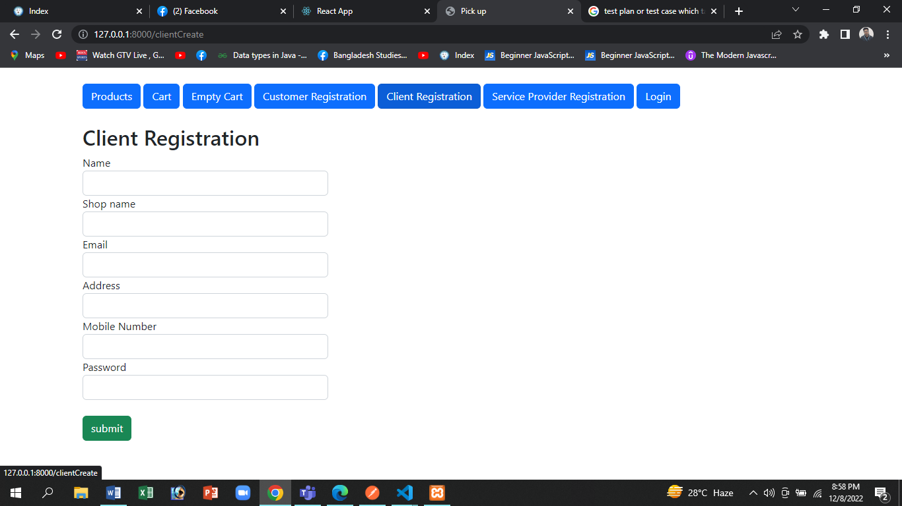

4.3.3 Registration Form of Customer

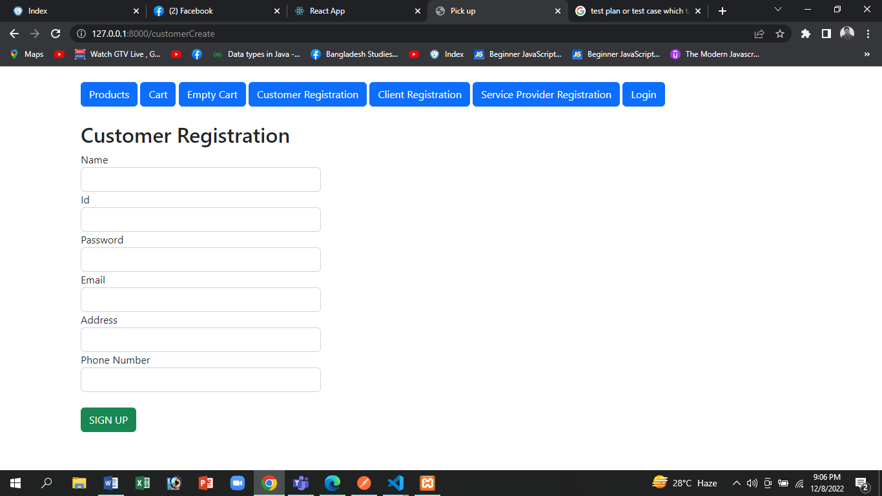

4.3.4 Product List

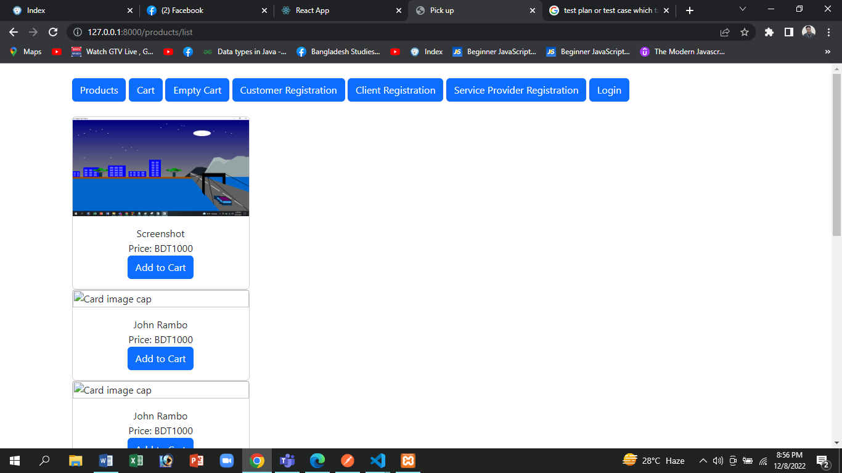

4.3.5 My Orders

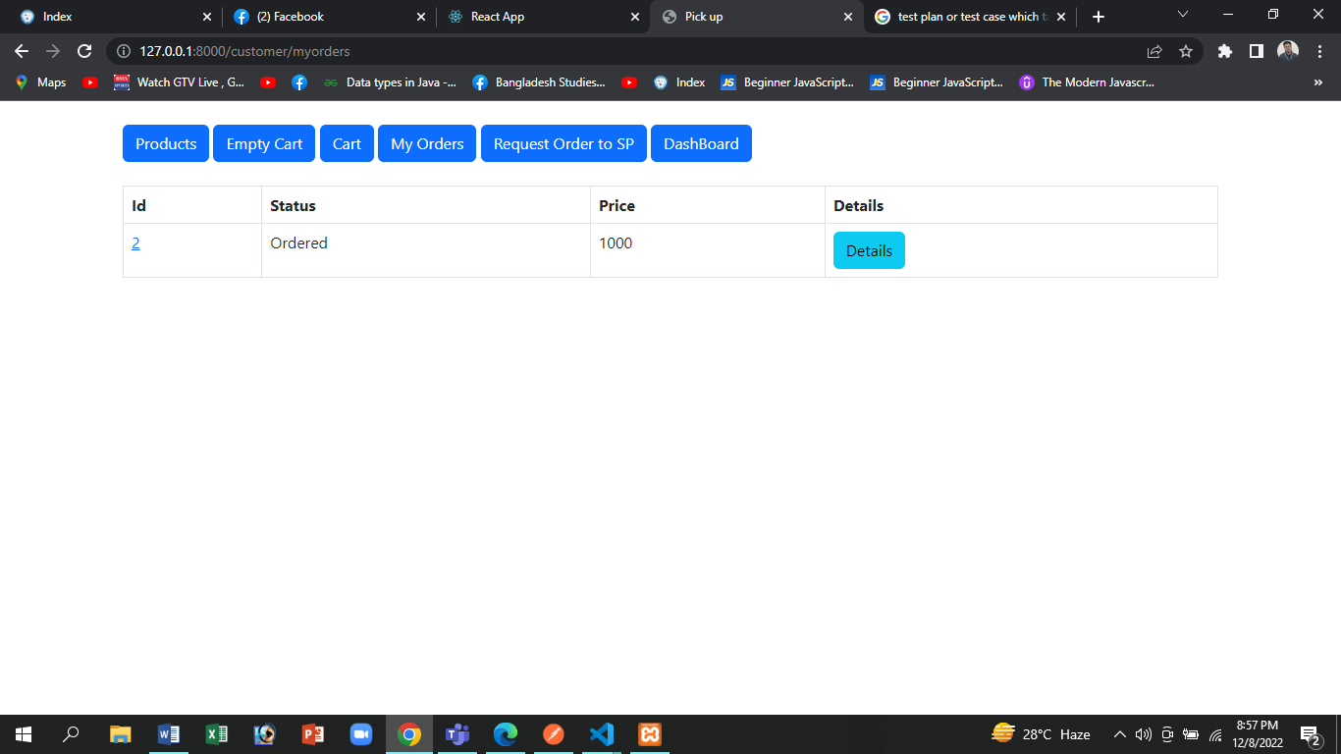

4.3.6 Order Details

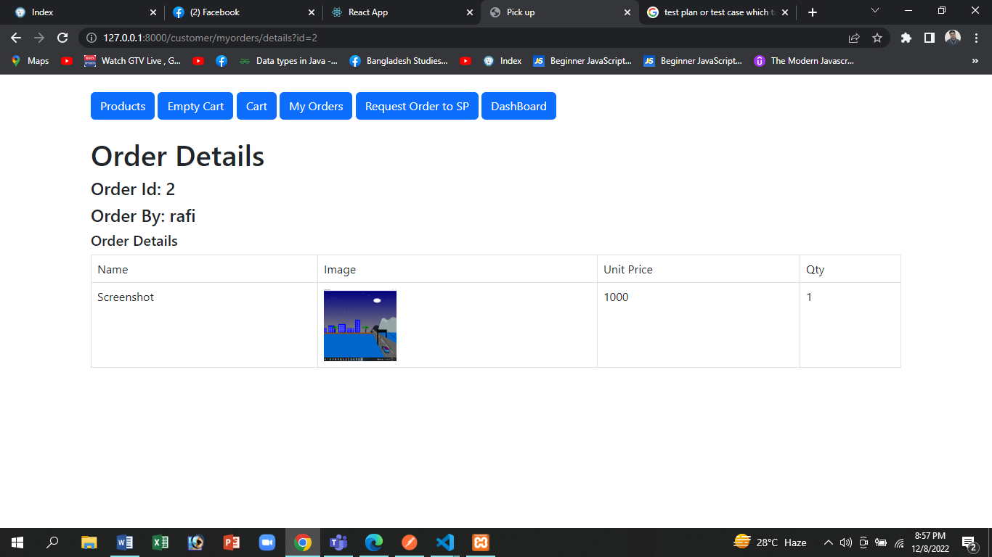

4.3.7 Request Order to Service Provider

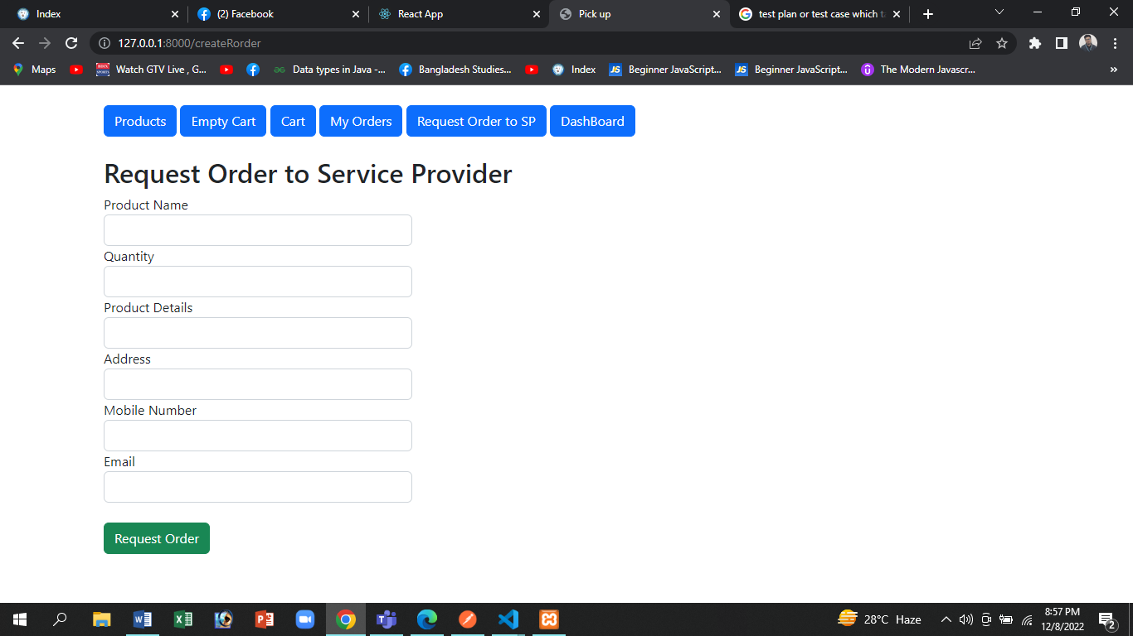

**4.4 Project Budgets**

**Effort Estimation**

**Constructive Cost Model**

Project Type: Organic

Coefficient<Effort Factor>: 2.4[p=1.05; T=0.38]

SLOC: 10,000

Effort=PM={2.4*(10000/1000)1.02}=26.92

Development Time=DM=(2.5 * 26.920.38)=9 months=1584 Working Hours[1 month=22 Working Days | 198 Working Days | Daily 8 Hours]

Required number of people, ST=PM/DM=26.92/8.74=3.08=3

**Budgeting:**  
Developer Salary in 9 months: Pre-Developer Salary Per Working  
Hours = 1000 Taka  
Total Developer salary = 1000 x 1584 = 1,584,000 Taka

**Requirement Analysis:**  
**Time Needed:** 1month (22working Days = 176 Working Hours)  
Requirement Analysis Person's Hourly wage = 400 Taka  
Total Requirement Analysis Expense = 400 x 176 = 70,400  
Transportation Cost Estimation: 14,000 Taka  
Training & Hardware Expenses Estimation: 150,000 Taka  
**Rent Expenses:**  
Room per Month = 20,000 Taka  
Total in 9 Months = 180,000 Taka  
Total Utilities in 9 Months: 40,000 Taka  
Maintenance (Till 6 Months after Delivery):  
Expense Per Hour = 1000 Taka  
Total Estimated Time Needed for Maintenance = 60Hours  
Total Estimated Maintenance Expense = 60 * 1000 - 60,000 Taka

**Other Human Resources cost:**  
Project Manager: 1*30,000*9= 270,000 Taka

Accountant: 1*20,000*9=180,000 Taka  
Technical Staff: 2*15,000*9= 270,000 Taka  
Total HR cost: 270,000+180,000+270,000  
=720,000 Taka  
Total Estimated Expense: 15,84,000+ 70,000+ 14,000+  
150,000+ 180,000+40,000+ 60,000+ 720,000  
=2,818,000 Taka  
**Profit:**  
30% of Total Estimated Expenses = 2,818,000* 30% = 845,400 Taka  
Final Project Budget= 2,818,000+845,400= 3,663,400 Taka

# 5. FEATURES NOT TO BE TESTED

● Edit Admin Profile (Personal Information)

● Statistical data of users, purchases

● Networking Testing

● Language (Default language is English

**6. TESTING APPROACH**

**6.1 Testing Levels**

**Unit Testing:** This level of testing is done by the developers to ensure that the functionality developed by the developers is working correctly according to the expectation. At this level, the lead developer approves the module, integrates it with the system level, and passes it to the SQA team. In this process, it only finds the defects for this particular unit and needs to work around them to make the unit functional and meet the expectation.

**System/ Integration Testing:** At this level, all the modules are integrated and a system-level test will be conducted by the test manager and SQA engineers to find out the existing bugs which were not able to detect on unit testing. This level of testing is time-consuming and expensive. By this level of testing, most of the major defects have been detected, and need to work around the application to remove the bug and make the system properly functional.

**Acceptance Testing:** This level of testing is done by some of the potential users, business personnel of the department, and the project lead to ensure that the application meets the stockholders' expectations. This testing is conducted only to find defects rather than ensure that the application meets the acceptance criteria. After the System/Integration test is completed, the acceptance test will run in parallel with the existing creating user manuals and instructions processes for one month.

**6.2 Test Tool**

**6.2.1 Postman**

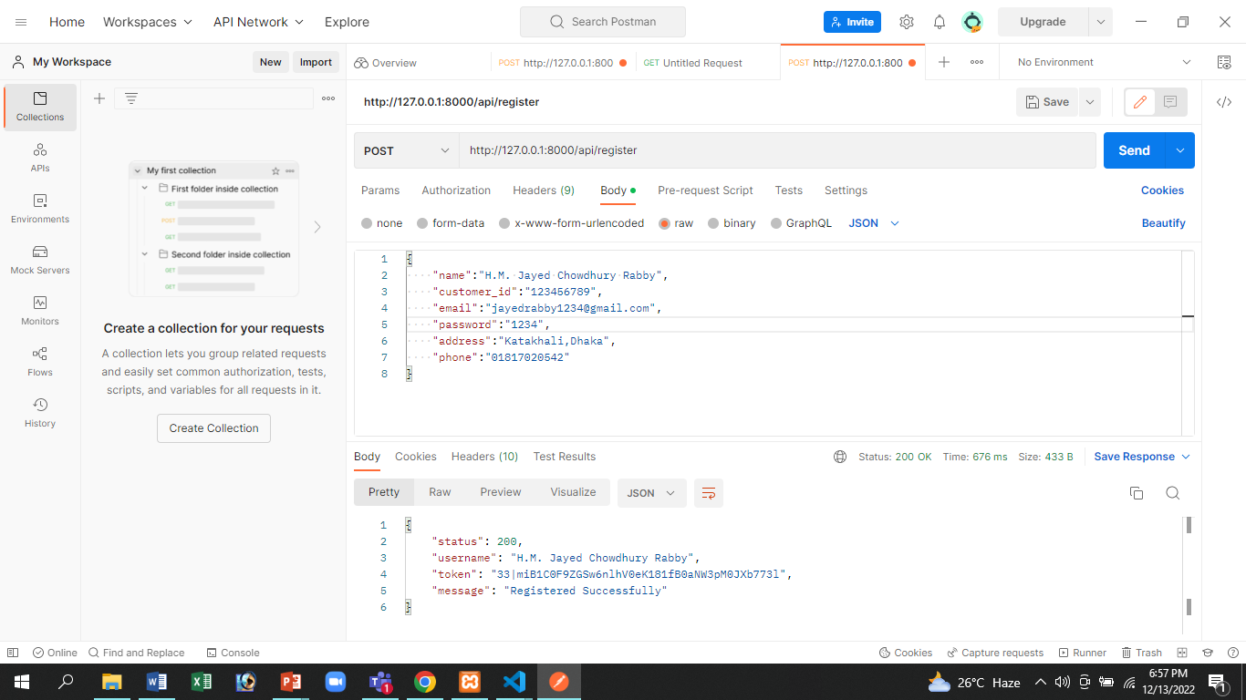

**6.2.1 Selenium**

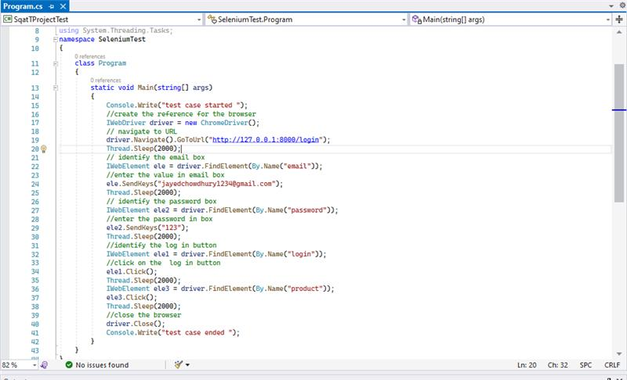

**6.3 Meetings**

|  |  |  |
| --- | --- | --- |
| Meeting Date | Meeting Criteria | Object |
| 01.12.2022 | Checking of system features and quality attributes | ● Check the Functional &           Nonfunctional requirements  ● System’s working process |
| 05.12.2022 | Error & Bug Solving | ● After detecting bugs list them down  ● Solve the bugs  ● Preparation for safety |
| 10.12.2022 | Conclusive | ● Check the listed documentation  ● Recheck the requirements  ● Run the full system |

# 

# 7. TEST CASES/TEST ITEMS

**Test Case 1: Client Registration**

|  |  |  |  |  |  |
| --- | --- | --- | --- | --- | --- |
| **Project Name:** Pick Up | | **Test Designed by:** Easinul Abedin Sayem | | | |
| **Test Case ID:** Registration Client_01 | | **Test Designed date:** 08-12-2022 | | | |
| **Test Priority (Low, Medium, High): High** | | **Test Executed by:** Easinul Abedin Sayem | | | |
| **Module Name:** Registration | | **Test Execution date:** 08-12-2022 | | | |
| **Test Title:** Verifying  registration client module | |  | | | |
| **Description:** Test the Pick Up Registration Client website registration session | |  | | | |
| **Precondition (If any):** 1. Need to use a username,shopname,email,address,phone number,password (Doesn’t present in the system Database) | | | | | |
| **Test Steps** | **Test Data** | | **Expected Results** | **Actual Results** | **Status (Pass/Fail)** |
| 1.Go to the site registration page.  2.Fill up the information.  3. Click on the “Sign Up” button. | Uname:Easnul  shopname:SK  Email: abc@gmail.com  Address: Dhaka  PhoneNumber:  Password:12345 | | Successful Registration | Pass registration for valid email | Pass |
|  |  | |  |  |  |
|  |  | |  |  |  |
| **Post Condition:** User will go back to the login page. | | | | | |

**Test Case 2: Customer Registration**

|  |  |  |  |  |  |
| --- | --- | --- | --- | --- | --- |
| **Project Name:** Pick Up | | | **Test Designed by:** Easinul Abedin Sayem | | |
| **Test Case ID:** Registration Customer_02 | | | **Test Designed date:** 08-12-2022 | | |
| **Test Priority (Low, Medium, High): High** | | | **Test Executed by:** Easinul Abedin Sayem | | |
| **Module Name:** Registration Customer | | | **Test Execution date:** 08-12-2022 | | |
| **Test Title:** Verifying  registration Customer module | | |  | | |
| **Description:** Test the Pick Up Registration Customer website registration session | | |  | | |
| **Precondition (If any):** 1 Need to use a username, id,password,email,address,phone number (Doesn’t present in the system Database) | | | | | |
| **Test Steps** | **Test Data** | **Expected Results** | | **Actual Results** | **Status (Pass/Fail)** |
| 3.Go to the site registration page    4.Fill up the information | Uname:eufi  Id:123  Password:1234  Email: abc@  gmail.com  Address: Dhaka  Phone: 01856894644 | Successful Registration | | Pass registration for valid email | Pass |
| 3. Click on the “Sign Up”  button |  |  | |  |  |
|  |  |  | |  |  |
| **Post Condition:** User will go back to the login page. | | | | | |

**Test Case 3: Login**

|  |  |  |  |  |  |
| --- | --- | --- | --- | --- | --- |
| **Project Name:** Pick Up | | | **Test Designed by:** Easinul Abedin Sayem | | |
| **Test Case ID:** Login_01 | | | **Test Designed date:** 08-12-2022 | | |
| **Test Priority (Low, Medium, High): High** | | | **Test Executed by:** Easinul Abedin Sayem | | |
| **Module Name:** Login | | | **Test Execution date:** 08-12-2022 | | |
| **Test Title:** Verifying  login  module | | |  | | |
| **Description:** Test the Pick Up Customer website login session | | |  | | |
| **Precondition (If any):** 1. User need to register into the system | | | | | |
| **Test Steps** | **Test Data** | **Expected Results** | | **Actual Results** | **Status (Pass/Fail)** |
| 1. Go to the site login page | Uname:Easnul Pass: 123456 | Successful Login | | Successful | Pass |
| 2. Fill up the information |  |  | |  |  |
| 3. Click on the “login” button. |  |  | |  |  |
| **Post Condition:** User will go into the Home page. | | | | | |

**Test Case 4: Logout**

|  |  |  |  |  |  |
| --- | --- | --- | --- | --- | --- |
| **Project Name:** Pick Up | | | **Test Designed by:** Easinul Abedin Sayem | | |
| **Test Case ID:** Logout_01 | | | **Test Designed date:** 08-12-2022 | | |
| **Test Priority (Low, Medium, High): High** | | | **Test Executed by:** Easinul Abedin Sayem | | |
| **Module Name:** Logout | | | **Test Execution date:** 08-12-2022 | | |
| **Test Title:** Verifying  logout  module | | |  | | |
| **Description:** Test the Pick Up website logout session. | | |  | | |
| **Precondition (If any):** 1. User need to login into the system | | | | | |
| **Test Steps** | **Test Data** | **Expected Results** | | **Actual Results** | **Status (Pass/Fail)** |
| 1. Go to the site's | N/A | Successful | | Successful | Pass |
| Dashboard page. |  | Logout | |  |  |
| 2. Click on the |  |  | |  |  |
| “logout” button. |  |  | |  |  |
| **Post Condition:** User will go back to the login page. | | | | | |

**Test Case 5: Add Product**

|  |  |  |  |  |  |
| --- | --- | --- | --- | --- | --- |
| **Project Name:** Pick Up | | | **Test Designed by:** Easinul Abedin Sayem | | |
| **Test Case ID:** Add Product_01 | | | **Test Designed date:** 08-12-2022 | | |
| **Test Priority (Low, Medium, High): Medium** | | | **Test Executed by:** Easinul Abedin Sayem | | |
| **Module Name:** Add Product | | | **Test Execution date:** 08-12-2022 | | |
| **Test Title:** Verifying Add Product module | | |  | | |
| **Description:** Test the Pick Up website Add Productsession | | |  | | |
| **Precondition (If any):** 1. User need to login as a client into the system. | | | | | |
| **Test Steps** | **Test Data** | **Expected Results** | | **Actual Results** | **Status (Pass/Fail)** |
| 1.Go to the site add product page | Product Name: Chips  Price:100  Image:xyz.jpg | Successful Update Profile | | Successful | Pass |
| 2.Input product name as well as product price and picture of A product |  |  | |  |  |
| 3.Press on “Upload” button |  |  | |  |  |
|  |  |  | |  |  |
| **Post Condition:** User will go into the product list page. | | | | | |

**Test Case 6: Add Product to cart**

|  |  |  |  |  |  |
| --- | --- | --- | --- | --- | --- |
| **Project Name:** Pick Up | | | **Test Designed by:** Easinul Abedin Sayem | | |
| **Test Case ID:** Add Product to Cart_01 | | | **Test Designed date:** 08-12-2022 | | |
| **Test Priority (Low, Medium, High): Medium** | | | **Test Executed by:** Easinul Abedin Sayem | | |
| **Module Name:** Add Product to Cart | | | **Test Execution date:** 08-12-2022 | | |
| **Test Title:** Verifying Add Product to Cart module | | |  | | |
| **Description:** Test the Pick Up website Add Productto Cartsession | | |  | | |
| **Precondition (If any):** 1. User need to login into the system | | | | | |
| **Test Steps** | **Test Data** | **Expected Results** | | **Actual Results** | **Status (Pass/Fail)** |
| 1. Go to the site list of  product page | N/A | Successful  Add to cart | | Successful | Pass |
| 2.Click on the “add to cart” button |  |  | |  |  |
|  |  |  | |  |  |
|  |  |  | |  |  |
| **Post Condition:** User will go into the Home page. | | | | | |

**Test Case 7: Product Buy**

|  |  |  |  |  |  |
| --- | --- | --- | --- | --- | --- |
| **Project Name:** Pick Up | | | **Test Designed by:** Easinul Abedin Sayem | | |
| **Test Case ID:** Product Buy_01 | | | **Test Designed date:** 08-12-2022 | | |
| **Test Priority (Low, Medium, High): Medium** | | | **Test Executed by:** Easinul Abedin Sayem | | |
| **Module Name:** Product Buy | | | **Test Execution date:** 08-12-2022 | | |
| **Test Title:** Verifying  Product Buy module | | |  | | |
| **Description:** Test the Pick Up website  ProductBuy session | | |  | | |
| **Precondition (If any):** 1. User need to login and add to cart into the system. | | | | | |
| **Test Steps** | **Test Data** | **Expected Results** | | **Actual Results** | **Status (Pass/Fail)** |
| 1.Go to the site cart  page | N/A | Successful  product buy | | Successful | Pass |
| 2.Click on the “checkout” button |  |  | |  |  |
|  |  |  | |  |  |
|  |  |  | |  |  |
| **Post Condition:** User will go into the page and show the confirm message | | | | | |

**Test Case 8: Delete Product**

|  |  |  |  |  |  |
| --- | --- | --- | --- | --- | --- |
| **Project Name:** Pick Up | | | **Test Designed by:** Easinul Abedin Sayem | | |
| **Test Case ID:** Delete Product_01 | | | **Test Designed date:** 08-12-2022 | | |
| **Test Priority (Low, Medium, High): Medium** | | | **Test Executed by:** Easinul Abedin Sayem | | |
| **Module Name:** Delete Product | | | **Test Execution date:** 08-12-2022 | | |
| **Test Title:** Verifying  Delete Productmodule | | |  | | |
| **Description:** Test the Pick Up website  Delete Productsession | | |  | | |
| **Precondition (If any):** 1. User need to login as a client into the system. | | | | | |
| **Test Steps** | **Test Data** | **Expected Results** | | **Actual Results** | **Status (Pass/Fail)** |
| 1.Go to the site products list page | N/A | Successful  Delete product | | Successful | Pass |
| 2.Click on the “delete” button |  |  | |  |  |
|  |  |  | |  |  |
|  |  |  | |  |  |
| **Post Condition:** User will stay in products list  page. | | | | | |

**Test Case 9: View Product**

|  |  |  |  |  |  |
| --- | --- | --- | --- | --- | --- |
| **Project Name:** Pick Up | | | **Test Designed by:** Easinul Abedin Sayem | | |
| **Test Case ID:** View Product_01 | | | **Test Designed date:** 08-12-2022 | | |
| **Test Priority (Low, Medium, High): Medium** | | | **Test Executed by:** Easinul Abedin Sayem | | |
| **Module Name:** View Product | | | **Test Execution date:** 08-12-2022 | | |
| **Test Title:** Verifying  View Productmodule | | |  | | |
| **Description:** Test the Pick Up website  View Productsession | | |  | | |
| **Precondition (If any):**N/A | | | | | |
| **Test Steps** | **Test Data** | **Expected Results** | | **Actual Results** | **Status (Pass/Fail)** |
| 1.Go to the site | N/A | Successful  View product | | Successful | Pass |
| 2.Go to the product list |  |  | |  |  |
|  |  |  | |  |  |
|  |  |  | |  |  |
| **Post Condition:** User stay in products list page. | | | | | |

# 

# 8. ITEM PASS/FAIL CRITERIA

* With valid information, the registration should be done.
* The user/customers profile, client profile & service provider profile should be created.
* A valid user name and password should be given.
* Users/customers should be add to cart their products and remove their products.
* Clients add products and delete products which is properly done in the system.
* There is no error when a customer order products and confirm products.
* Service Provider accept the request from the customer which functionality smoothly works.
* The test cases should be properly documented.
* All reports should be maintained.
* All problem documents should be viewed by the valid user account.
* Item pass/fail criteria depends on Test Cases. 100% defect free system is not possible.
* If 98% or above 98% test cases are pass then the system is passed.
* If below 98% test cases are passed then the system is failed.

Here we have implemented a total of 9 test cases. At first, when applied the test case to the system, 60% of the test cases were passed successfully and 40% failed. The test cases were failing due to some logical errors and query related issues on the database. When the test case was applied after solving query related problem, all the test cases passed successfully.

**9. TEST DELIVERABLES**

* Test Documentation
* Test Plan
* Test Strategy
* Test Scenario
* Test Designs
* Test Cases
* Test data
* Test Results
* Errors
* Bug report
* Test Summary Report
* Test Status report
* Test Scripts

**10. STAFFING AND TRAINING NEEDS**

Depending on the project, different methods will be used for staffing and training. If this section is a component of a Master Test Plan, it should specify the stages of the project lifecycle at which various staffing levels and skill sets are required. Where one full time tester assigned for the project for the system/integration and acceptance testing phases of the project. If this is an iteration test plan, the primary attention should be on the potential training locations and activities. The EDI interface's fundamental functions will need to be taught to the developers and testers. The project manager assumed that for the project needs the developers and testers are hire and properly give training to done the project.

The test team frequently needs the assistance and expertise of other team members who are not formally a part of the test team. System administrators, database administrators, and developers must be scheduled appropriately in the plan in order to support the testing activities.

**11. RESPONSIBILITIES**

|  |  |  |
| --- | --- | --- |
| Name | Role | Responsibility |
| MD Rokon Islam Emon | Project Manager | 1. Ensure the completion of the Project in due time. 2. Conduct required interactions with customers. 3. Manage the whole project and team. 4. Match the completed project with the requirements. |
| H.M. Jayed Chowdhury Rabby | Senior Developer | 1. Research, design, implement and manage software programs.      1. Write and implement efficient code. 3. Deploy software tools, processes, and metrics. |
| MD Bakhtiar azim niloy | Lead Quality Assurance Engineer | 1. Create test plans, test forms, test cases, and test information. 2. Develop test cases and prioritize testing activities. 3. Prepare all reports related to program testing carried out. |
| Easinul Abedin Sayem | Lead Quality Control Engineer | 1. Characterize the testing activities of test planning. 2. Check if all the tools and fundamental assets are available to execute the test cases.      1. Execute all the test cases and report defects. |

**12. Testing Schedule**

|  |  |  |  |  |  |  |  |  |  |
| --- | --- | --- | --- | --- | --- | --- | --- | --- | --- |
| Task Name | | | Duration (Weeks) | | | | Responsible | | |
| Design | | | 4 | | | | Project Manager & Senior Developer | | |
| Writing Code | | | 10 | | | | Senior Developer | | |
| Test Plan | | | 4 | | | | Lead Quality Assurance Engineer & Project Manager | | |
| Unit testing | | | 3 | | | | Senior Developer, Junior Developer | | |
| Test Case | | | 4 | | | | Lead Quality Control Engineer | | |
| Test Case Report | | | 3 | | | | Test Engineer | | |
| Test/weeks | 1-2 | 3-4 | | 5-6 | 7-8 | 9-10 | | 11-12 | 13-14 |
| 1: Design |  |  | |  |  |  | |  |  |
| 2: Writting Code |  |  | |  |  |  | |  |  |

|  |  |  |  |  |  |  |  |
| --- | --- | --- | --- | --- | --- | --- | --- |
| Test/weeks | 15-16 | 17-18 | 19-20 | 21-22 | 2-24 | 25-26 | 27-28 |
| 3: Test plan |  |  |  |  |  |  |  |
| 4: Unit testing |  |  |  |  |  |  |  |
| 5: Test case |  |  |  |  |  |  |  |
| 6: Test case report |  |  |  |  |  |  |  |

**13. PLANNING RISKS AND CONTINGENCIES**

|  |  |  |  |
| --- | --- | --- | --- |
| **Risk** | **Probability** | **Impact** | **Mitigation** |
| Error in function execution | Medium | Medium | Test the web app frequently and maintain daily backup. |
| Error due to invalid input | High | Low | Train user to use right data type in each input field. |
| Loss of encrypted data(password) | Medium | High | Maintain security check and backup |
| Database query execution error | Low | High | Recheck the queries and logics. |

**14. APPROVALS**

|  |  |
| --- | --- |
| Position | Assigned |
| Project Manager | Development Plan |
| Development Management | Integration test |
| Design Manager | Interface |
| Test Team Lead | Test Plan |
| Test Engineer | Functionality test |
| QA Manager | Review Test Case |
| Client | Acceptance Testing |