SmartPhone QA

It’s a community where users share their experience on latest smartphones. User can ask question, help other users with their questions and share their experience.

Login Page

This is Login Page . Register User can Login with their Email and password. After Login They will Redirect To Home page.

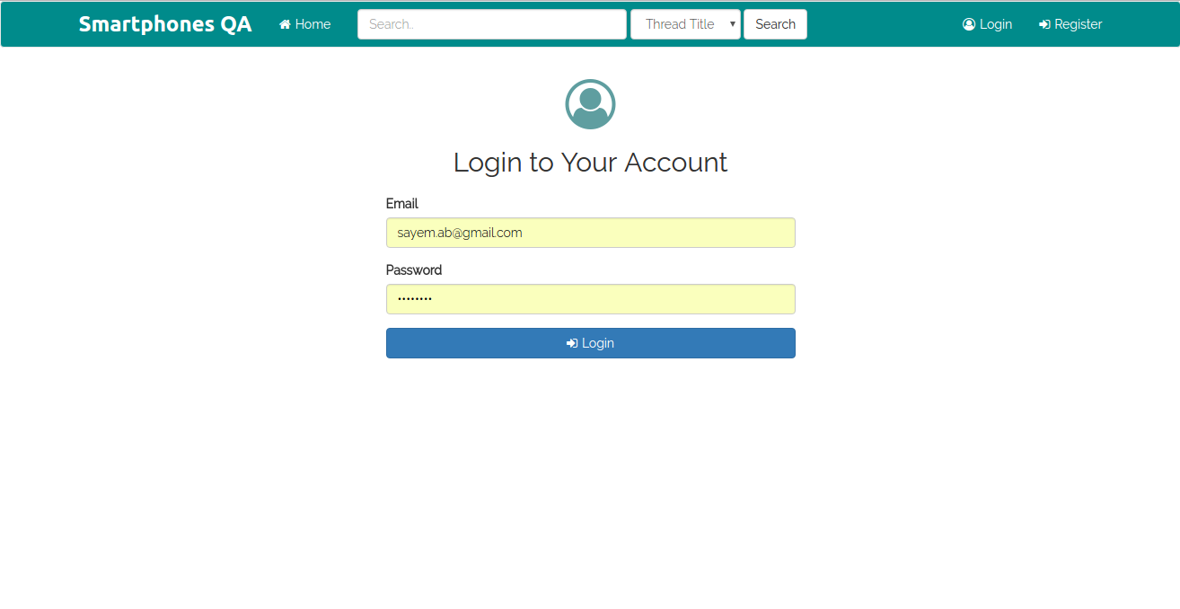

Homepage

- On the left hand side we have topics listed where user can choose a topic of their interest
- On the right hand side we have all threads listed in the default “newest” order where newer posts appear at the top.
- Default sort option can be changed by selection another sort option from the select menu above.

Register

This is Registration Page . New user Can register to the Forum

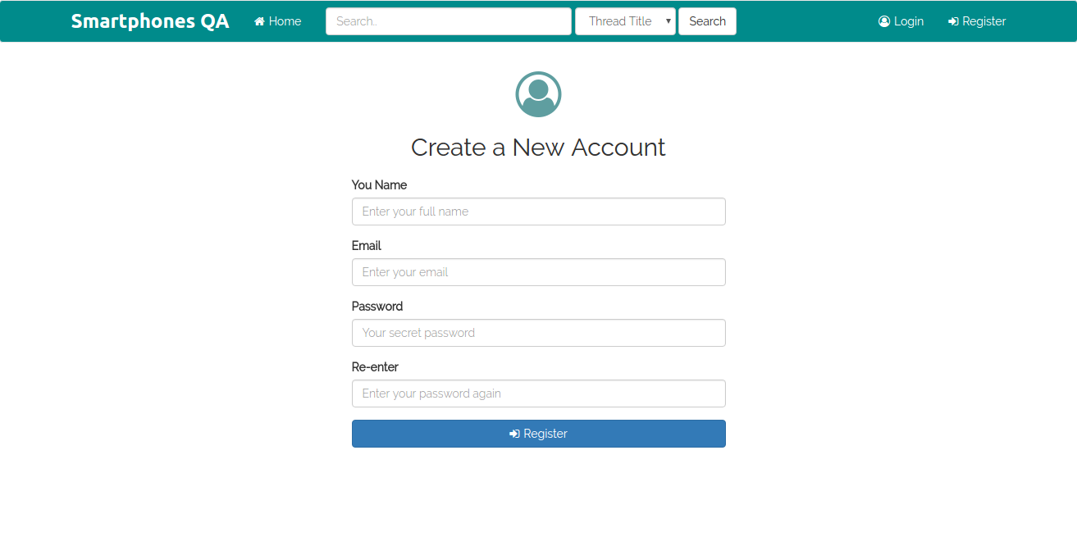

Create New Thread

This is add new thread form . Only Register User Can Add New Thread.

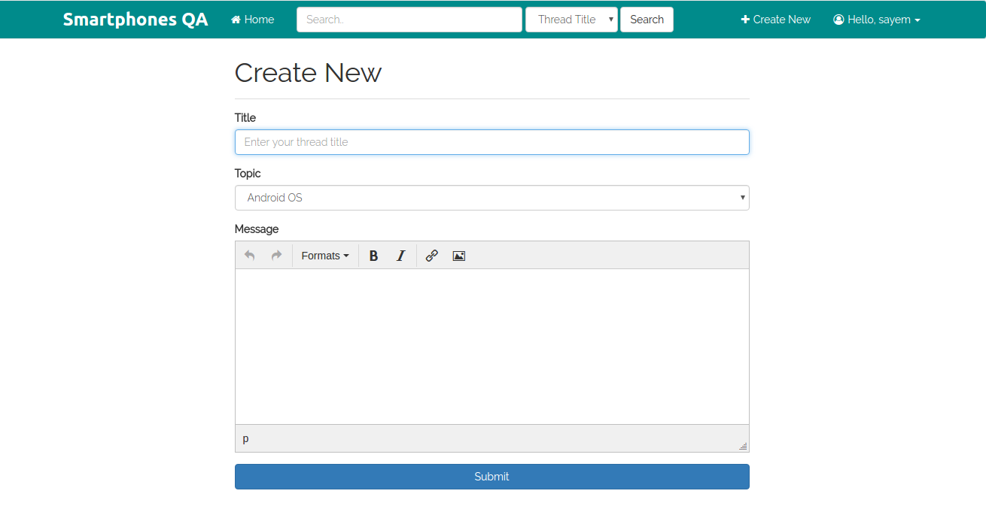

Search Page

This is Search Page . All User Can Search By Thread Title, Post, User.

