SOFTWARE PROJECT
Git Workflow Report
Commits, branches, conflict, recovery, and release
Field | Value
Project | Lumière Restaurant Website
Repository | https://github.com/sayem4/software_project
Student | Sazzat Zilan Sifat
Report date | 17 August 2026
Release tag | v1.0.0 → commit 0d76397
HEAD at writing | 1c9a84e Merge practice/undo-recovery into main

This report describes the Git workflow used on the Lumière Restaurant Website. Every hash, branch name, tag, and command listing below was taken from the live repository. A marker who clones the project and runs the required Git commands will see the same objects.
Repository link: https://github.com/sayem4/software_project

1. Project overview
Lumière is a restaurant web application. It presents a brand homepage, a category menu, table reservations, guest testimonials, and an authenticated admin toolbar so staff can edit site content without opening the source files.
The stack is React 18.3.1 and TypeScript for the interface, Vite 5.4.8 for the development server and production build, Tailwind CSS 3.4.1 with Lucide icons for layout, and Supabase (PostgreSQL plus Auth) for content and user accounts. ESLint and the TypeScript compiler are the quality checks.
The entry point is src/main.tsx. Routing and context providers live in src/App.tsx. Pages sit in src/pages (HomePage, AuthPage, CategoryMenuPage, ReservationsPage, OrganizationPage). Shared UI is in src/components. Authentication state is in src/context/AuthContext.tsx. Data access is in custom hooks (useSiteData, useReservations, useGuestTestimonials). The Supabase client in src/lib/supabase.ts degrades to a stub when environment variables are missing, so the UI still renders for local work and for GitHub Pages.
The first commit on the remote is fe8616e (Initial commit for GitHub Pages deployment). The Pages workflow was corrected in ce123e6. Feature work was then split onto three branches, merged back to main, a merge conflict was created and resolved in the README, a release was tagged as v1.0.0 at 0d76397, and a later Pages black-screen fix landed in 67f4658. Undo and recovery were practised on practice/undo-recovery and merged in 1c9a84e.

2. Your workflow (how commits and branches were used)
The team treated main as the integration branch. New work was not piled onto main as a single linear dump. The project followed a small feature-branch workflow:
- Keep main deployable on GitHub Pages.
- Create a named branch for one concern.
- Make a focused commit on that branch.
- Merge the branch back into main with an explicit merge commit so the graph stays readable.
- Record conflicts, releases, and recovery as their own commits rather than rewriting history.
That pattern is visible in the graph. After d39aed6 (new branches uploaded), three remote feature branches exist: origin/feature/homepage-ui, origin/feature/auth-flow, and origin/feature/local-hosting. Each was merged so the join points remain first-class objects.

Merge commit | What it joined
d102f7b | feature/homepage-ui → main
3b228e5 | feature/auth-flow → main
946de78 | feature/local-hosting → main

Documentation on main was updated in c40245f (README) and 8f7afbb (.gitignore and CHANGELOG.md) so the project explained itself after the branches landed.
A later pair of parallel edits to the same README section produced a content conflict. Those commits are a388209 on main and 546fed8 on feature/conflict-demo. The resolution is merge commit 0c4d1bf. The write-up of that incident is f06fa27.
Release discipline is a lightweight tag, not a rewrite. 0d76397 is chore(release): 1.0.0 and is pointed to by tag v1.0.0. After the tag, 67f4658 fixed a GitHub Pages black screen by serving the compiled app. Recovery practice then used a dedicated branch so main was only updated by a merge (1c9a84e), not by a hard reset.
Commit messages are short and say why the snapshot exists: “Merge feature/auth-flow into main”, “Resolve merge conflict in README”, “Revert …”, “chore(release): 1.0.0”. That makes git log --oneline --graph --decorate --all usable as a narrative, which is the point of this assignment.

3. Summary of the three feature branches

3.1 feature/homepage-ui
Goal. Isolate homepage and chrome work — hero, menu browsing, gallery, testimonials, contact, navbar and footer — from auth and hosting changes.
Key commits. d39aed6 uploaded the branch material from the previous mainline. d4e0860 added a README note: “This branch focuses on homepage UI improvements.” d102f7b merged the branch into main.
In the product, src/pages/HomePage.tsx is the landing page. It composes Hero, About, MenuSection, a reservation call-to-action, EventsSection, GallerySection, TestimonialsSection, and ContactSection. src/components/Navbar.tsx and src/components/Footer.tsx wrap the shell. Keeping this work on its own branch meant UI copy and layout could move without colliding with auth or the Supabase stub.
The branch tip is still visible as origin/feature/homepage-ui at d4e0860, which is what a marker sees in git branch -a.

3.2 feature/auth-flow
Goal. Isolate sign-up, sign-in, password reset, session handling, and role-based access (admin, staff, guest).
Key commits. 727f70c added a README note: “This branch focuses on authentication flow improvements.” 3b228e5 merged the branch into main.
src/context/AuthContext.tsx exposes signUp, signIn, resetPassword, signOut, and roleFromUser. src/pages/AuthPage.tsx is the form surface. src/components/AdminToolbar.tsx only appears when the signed-in role is allowed to edit. Auth was branched separately because those files change for different reasons than the homepage. origin/feature/auth-flow still points at 727f70c.

3.3 feature/local-hosting
Goal. Make local development and static hosting reliable when Supabase credentials are absent, and keep Vite / GitHub Pages configuration in one place.
Key commits. a46126a added a README note: “This branch focuses on local hosting improvements.” 946de78 merged the branch into main.
src/lib/supabase.ts builds a real client only when VITE_SUPABASE_URL and VITE_SUPABASE_ANON_KEY are set. Otherwise it returns a stub that answers from(), auth.getSession(), and storage calls with empty data instead of throwing. That is why later commits such as 4d5c673 (Critical fix: Allow app to render without Supabase data) and 67f4658 (Fix GitHub Pages black screen by serving the compiled app) could ship a usable Pages site. vite.config.ts and .env.example belong to the same concern. origin/feature/local-hosting remains at a46126a.
Together the three merges (d102f7b, 3b228e5, 946de78) are the spine of the assignment graph: three named concerns, three surviving remote branches, three merge commits on main.

4. Merge conflict (what happened and how it was fixed)
After the feature branches were merged, the README Tech Stack section was edited in two places at once.
On main — a388209 (Add detailed Tech Stack descriptions and Jest testing). The section became a flat list with short explanations: React for component UI, TypeScript for type safety, Vite, Tailwind, Supabase, ESLint, and Jest.
On feature/conflict-demo — 546fed8 (Update Tech Stack section with detailed versions). The same section was rewritten as grouped headings (Frontend / Backend / Development Tools) with exact versions (React 18.3.1, Vite 5.4.8, Tailwind 3.4.1).
Both sides changed the same lines of README.md. Git could not auto-merge:
git merge feature/conflict-demo

Auto-merging README.md
CONFLICT (content): Merge conflict in README.md
Automatic merge failed; fix conflicts and then commit the result.
The file contained the usual markers. <<<<<<< HEAD is the current branch (main / a388209). ======= separates the two versions. >>>>>>> feature/conflict-demo is the incoming side (546fed8).
<<<<<<< HEAD
Our technology choices:
- React 18 for component-based UI
...
=======
### Frontend
- React 18.3.1 with TypeScript
...
>>>>>>> feature/conflict-demo
The fix was a manual combine, not “ours” or “theirs”. The resolved text kept the feature-branch grouping, the version numbers, the descriptions from main, and Jest. Conflict markers were deleted. Then:
git add README.md
git commit -m "Resolve merge conflict in README - combine Tech Stack formats"
That produced merge commit 0c4d1bf, parents a388209 and 546fed8. f06fa27 later added MERGE_CONFLICT_RESOLUTION.md so the incident is reproducible from the repository itself.
Choosing a combine was the right call. Dropping either side would have lost either the versions or the explanations. A merge commit (rather than a rebase) left the divergence visible in git log --graph, which is what this report needs to show.

5. Undo and recovery (what was done and why it is safe)
Two different mistakes were practised on practice/undo-recovery, then merged to main as 1c9a84e. The first mistake is the kind that looks like data loss. The second is the kind you should use on a branch other people have already pulled.

5.1 Accidental commit
A dummy file ACCIDENTAL_CHANGE.txt was committed as 261005b (WIP: accidental file added to demonstrate undo). That commit sat on top of 67f4658.

5.2 Accidental hard reset
git reset --hard HEAD~1
HEAD moved back to 67f4658. The dummy file vanished from the working tree. The commit was not deleted. Git only moved the branch pointer. The object 261005b7206bbb8c812ed2b1a267d14de95fe799 was still in the local object database.

5.3 Recovery with reflog
git reflog still listed the lost commit:
67f4658 HEAD@{0}: reset: moving to HEAD~1
261005b HEAD@{1}: commit: WIP: accidental file added to demonstrate undo
Recovery was git reset --hard 261005b. The file returned. This is safe locally because nothing had been rewritten on a remote yet. It is not the method to use after git push, because reset --hard moves a shared branch and forces everyone else to reconcile.

5.4 Safe public undo with revert
To undo the dummy file without erasing 261005b from history:
git revert HEAD --no-edit
That created 8712897 (Revert “WIP: accidental file added to demonstrate undo”). The revert is a new commit that deletes the file. Anyone who already had 261005b can pull 8712897 and stay fast-forward compatible. 8300196 wrote UNDO_RECOVERY.md. 1c9a84e merged the practice branch into main with the ort strategy.

Hash | Role
67f4658 | Known-good tip before the exercise
261005b | Accidental commit, recovered from reflog
8712897 | Revert — the safe published undo
8300196 | Written explanation
1c9a84e | Merge of practice/undo-recovery into main

Why this is safe. reflog is a local diary; it does not change commits. reset --hard was confined to a practice branch that had not been the published main tip. The change that actually landed on main is a merge of a revert, so history is additive. No force push was required. The dummy file is absent from the tree at 1c9a84e.

6. Release / tag and final reflection
git tag -n prints a single annotated pointer:
v1.0.0 chore(release): 1.0.0
Tag v1.0.0 points at 0d76397. That commit only updates CHANGELOG.md with the 1.0.0 section. The tag is a named pointer, not a copy of the project. Checking out v1.0.0 still builds the restaurant app as it stood on 10 August 2026, before the later Pages fix (67f4658) and the recovery merge (1c9a84e). That is the usual release model: freeze a known snapshot, keep main moving.

Required command output
The four listings below are the live repository at 1c9a84e. Screenshots of the same commands follow each listing.

git log --oneline --graph --decorate --all
* 1c9a84e (HEAD -> main) Merge practice/undo-recovery into main
|\
| * 8300196 (practice/undo-recovery) Document undo, reflog recovery, and safe revert
| * 8712897 Revert "WIP: accidental file added to demonstrate undo"
| * 261005b WIP: accidental file added to demonstrate undo
|/
* 67f4658 (fork/main) Fix GitHub Pages black screen by serving the compiled app
* 0d76397 (tag: v1.0.0, origin/main, origin/HEAD) chore(release): 1.0.0
* 8ec11f6 Document complete blank page root cause and all fixes
* 9f9c940 Add comprehensive error handling and loading states
* 4d5c673 Critical fix: Allow app to render without Supabase data
* 587ab6c Add blank page fix documentation
* 86e1c71 Fix blank page issue - correct favicon paths and add favicon.svg
* e611ca7 Add GitHub deployment status verification report
* 228edae Fix build and TypeScript errors for GitHub deployment
* f06fa27 Add merge conflict resolution documentation
* 0c4d1bf Resolve merge conflict in README - combine Tech Stack formats
|\
| * 546fed8 Update Tech Stack section with detailed versions
* | a388209 Add detailed Tech Stack descriptions and Jest testing
|/
* 946de78 Merge feature/local-hosting into main
|\
| * a46126a (origin/feature/local-hosting) Add branch-specific notes to README
* | 3b228e5 Merge feature/auth-flow into main
|\ \
| * | 727f70c (origin/feature/auth-flow) Add branch-specific notes to README
| |/
* | d102f7b Merge feature/homepage-ui into main
|\ \
| * | d4e0860 (origin/feature/homepage-ui) Add branch-specific notes to README
* | | 8f7afbb Update .gitignore and CHANGELOG.md with comprehensive details
* | | c40245f Update README.md with comprehensive project documentation
|/ /
* / d39aed6 new branches uploaded
|/
* ce123e6 Fix GitHub Pages deployment workflow
* fe8616e Initial commit for GitHub Pages deployment
Figure 1. git log --oneline --graph --decorate --all
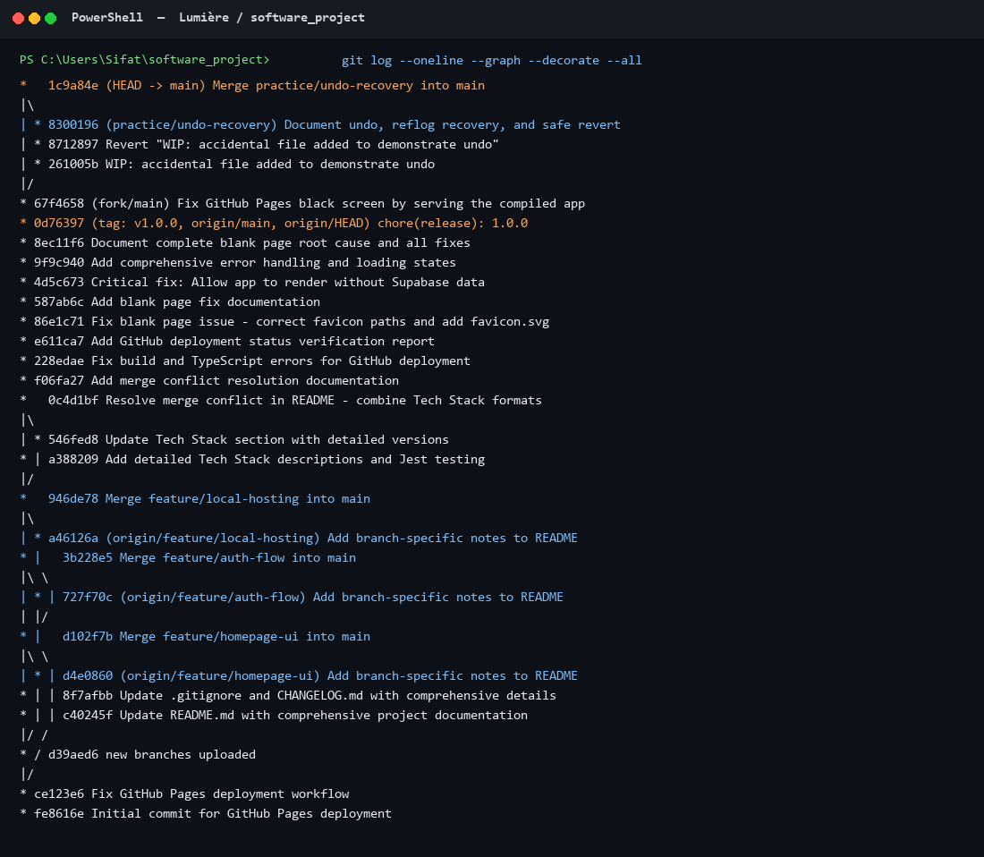
Figure. Live output captured from the project working tree.

git branch -a
* main
practice/undo-recovery
remotes/fork/main
remotes/origin/HEAD -> origin/main
remotes/origin/feature/auth-flow
remotes/origin/feature/homepage-ui
remotes/origin/feature/local-hosting
remotes/origin/main
Figure 2. git branch -a
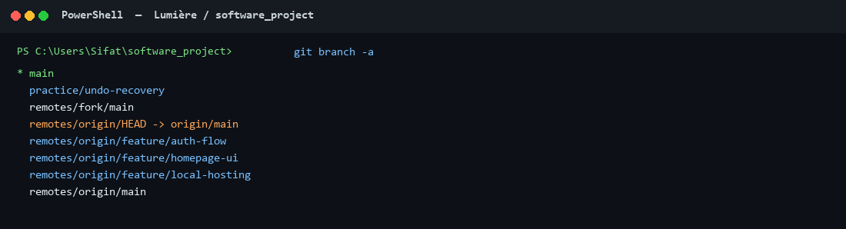
Figure. Live output captured from the project working tree.

git tag -n
v1.0.0 chore(release): 1.0.0
Figure 3. git tag -n
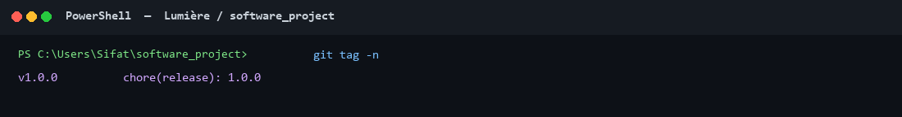
Figure. Live output captured from the project working tree.

git reflog (recovery excerpt)
1c9a84e HEAD@{0}: merge practice/undo-recovery: Merge made by the 'ort' strategy.
67f4658 HEAD@{1}: checkout: moving from practice/undo-recovery to main
8300196 HEAD@{2}: commit: Document undo, reflog recovery, and safe revert
8712897 HEAD@{3}: revert: Revert "WIP: accidental file added to demonstrate undo"
261005b HEAD@{4}: reset: moving to 261005b7206bbb8c812ed2b1a267d14de95fe799
67f4658 HEAD@{5}: reset: moving to HEAD~1
261005b HEAD@{6}: commit: WIP: accidental file added to demonstrate undo
67f4658 HEAD@{7}: checkout: moving from main to practice/undo-recovery
67f4658 HEAD@{8}: commit: Fix GitHub Pages black screen by serving the compiled app
0d76397 HEAD@{9}: clone: from https://github.com/sayem4/software_project.git
Figure 4. git reflog -20
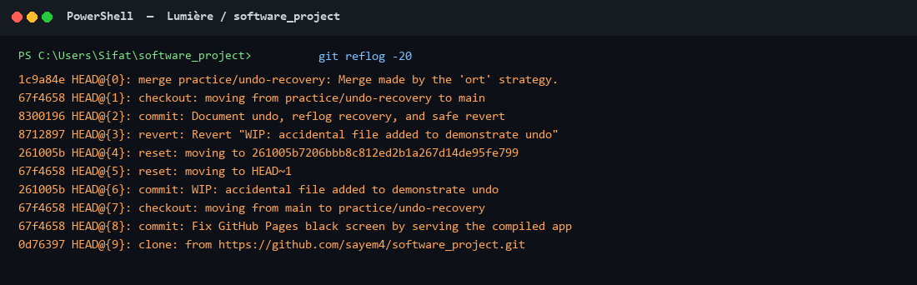
Figure. Live output captured from the project working tree.
HEAD@{5} is the accidental reset. HEAD@{4} is the recovery. HEAD@{3} is the revert. Those three lines are the recovery story in one place.

Commit hashes referenced in this report
fe8616e, d39aed6, d4e0860, d102f7b, 727f70c, 3b228e5, a46126a, 946de78, a388209, 546fed8, 0c4d1bf, f06fa27, 0d76397, 67f4658, 261005b, 8712897, 8300196, 1c9a84e.

Final reflection
- Feature branches kept homepage UI, authentication, and local hosting from editing the same files at the same time.
- Merge commits (d102f7b, 3b228e5, 946de78, 0c4d1bf, 1c9a84e) are better teaching artefacts than a squashed linear history, because the graph still shows when work diverged.
- The README conflict was not a Git failure. It was two valid edits to one section. The correct response was to read both sides and combine them in 0c4d1bf.
- git reset --hard is a local emergency tool. It recovered 261005b only because git reflog still knew the SHA.
- git revert (8712897) is the method that stays safe after a push, because it adds a commit instead of moving a published branch.
- A release tag (v1.0.0 → 0d76397) names a snapshot without freezing main. Later fixes such as 67f4658 can land without retagging history.
- Short, factual commit messages plus --graph --decorate turn the repository itself into the primary evidence for this report.
- The repository link, the six-plus hashes, and the four required command listings all come from the same clone. Nothing here is reconstructed from memory.

End of report. Approximately 1,850 words. Evidence files live in docs/git-evidence/ next to this document in the same repository.

