Steps for executing the project

1. Extract the files from the downloaded “Project.zip” folder in a specific location of your preferences

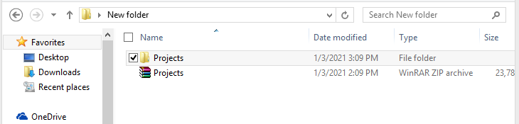

1. In google type 🡪 Google colab



1. Select the Upload option from the appeared window

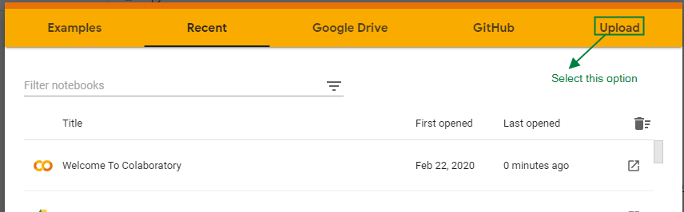

1. Choose (.ipynb) files from any of the five projects of the Project folder

**For example:**

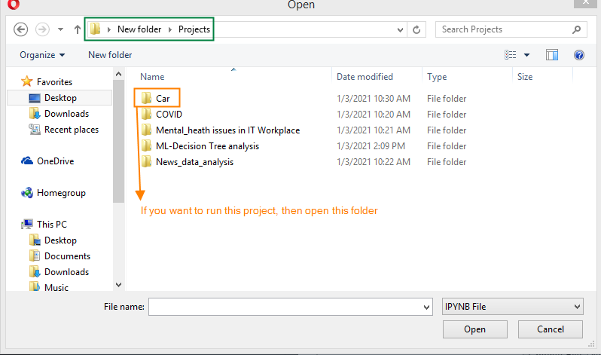

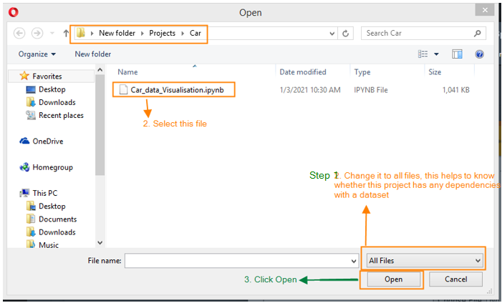

1. The project will be opened
2. For running the project

**Select “Runtime” tab 🡪 select “Run all”**

Steps for executing the project files which has datasets (.csv files)

1. Follow 1, 2, 3, 4 steps which is mentioned above
2. In the fourth step when you see any .csv files, then this project has a dependency with these datasets, so this data set must be added in google colab

**For Example:**

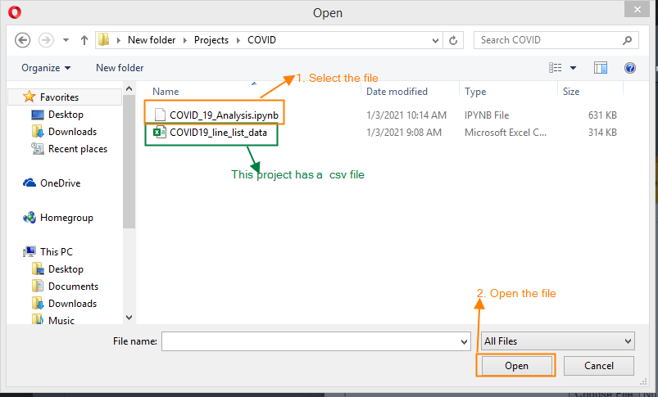

1. Once the project is opened in google colab, follow the below steps for adding the (.csv) in colab

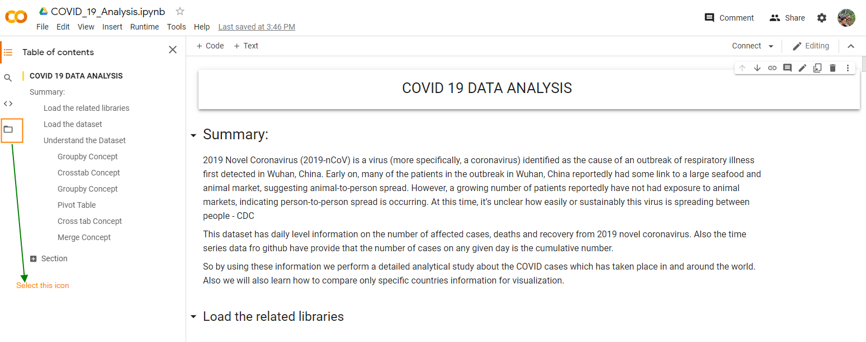

Wait for few seconds 🡪 you will get options like this in the file section of colab

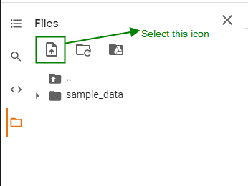

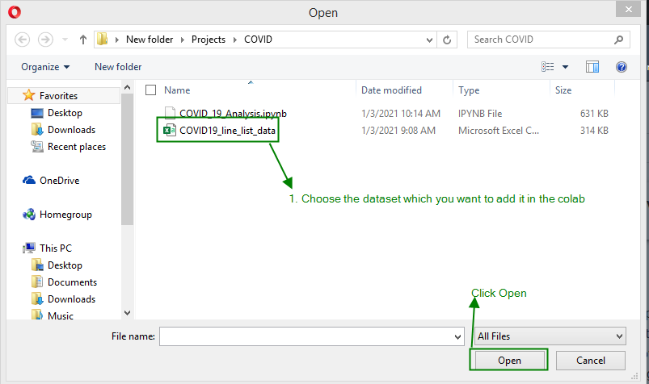

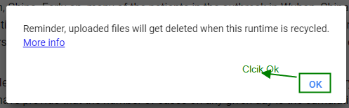

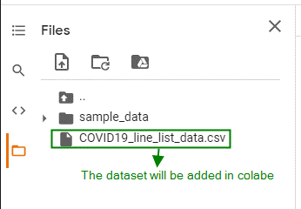

1. For running the project

**Select “Runtime” tab 🡪 select “Run all”**