Alexandria University (CDS) · IEEE IC-FTAI 2026 · Student Project Track
International Conference on Future Telecommunications and Artificial Intelligence (IC-FTAI) · Alexandria, 23–26 Nov 2026
DentalAI — AI-Assisted Diagnostic and Patient History System for Dental Clinics
Assistive decision support: the dentist confirms every finding and treatment.
Team: Seif Ahmed (role: UNVERIFIED) · Abdullah Tarek Habashy (ML Engineer) · 3 names + roles: UNVERIFIED — Backend, Frontend, Integration/QA, Team Lead/Clinical Liaison
Affiliation: Alexandria University (CDS) Advisor: Ashraf Eshta Partner dentist: Mohamed Fatah Duration: 21 Sep – 18 Oct 2026
Partners: partner dentist (clinical liaison); public DENTEX 2023 dataset Repository: github.com/sayfeldinn/dental-xray-ai-assistant
Abstract
Panoramic radiographs are read under time pressure, subtle lesions are missed, and medication-safety checks are often done from memory. DentalAI is an assistive decision-support system that links AI detection to the dentist's decisions in one closed loop. A three-stage pipeline analyses each panoramic X-ray: a YOLOv8n coordinator locates the four quadrants, a YOLOv8 detector finds caries, deep caries, periapical lesions and impacted teeth, and a Random Forest assigns each finding to an FDI tooth number. The dentist confirms, rejects or corrects every finding. A deterministic rule engine then proposes treatments and candidate drugs and checks each one against the patient's allergies, medications, conditions, age and weight using 26 rules drawn from ADA, AHA and AAPD guidance; a flagged drug needs the dentist's acknowledgement or a written override. Decisions are stored in the patient's longitudinal record, and every correction is logged for future retraining. The system is built with React, FastAPI and Supabase (PostgreSQL with row-level security, authentication and private storage). On a held-out benchmark of 23 panoramic images (122 detections), the pipeline gave the correct finding label for 97.54% of detections, the correct tooth for 76.23% and both for 75.41%. The software is complete and covered by 171 backend and 25 frontend automated tests in continuous integration. The clinical rules are source-backed but not yet clinician-validated, and a clinic pilot is the next step. DentalAI proposes; the dentist confirms every finding and treatment.
Keywords: Deep Learning (T5.2) · Computer Vision (T5.4) · Machine Learning (T5.1) · Medical Science (T5.12) · Personalized Health (T7.11)
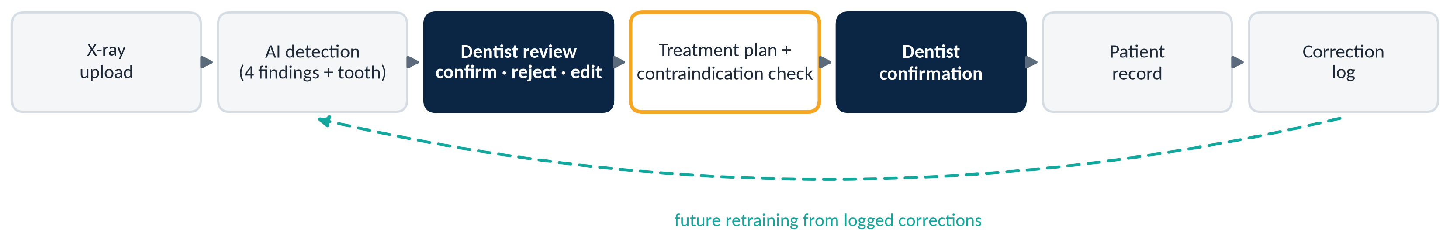
Figure 1. The closed loop. Navy steps are the dentist's decisions; amber marks the drug-safety check; the dashed path is future retraining from logged corrections (not yet run).
Approach & Methodology  • Data: public DENTEX 2023 panoramic X-rays (CC BY-NC-SA). Four findings: caries, deep caries, periapical lesion, impacted tooth; teeth in FDI notation. An earlier Tufts + Loki model was set aside.  • Model: YOLOv8n quadrant coordinator → YOLOv8 disease detector → Random Forest tooth association (300 trees, 15 spatial features). Replaced per-quadrant enumerators that shifted numbering when a tooth was missing.  • System: React (Vite) UI → FastAPI backend → inference microservice; Supabase PostgreSQL with row-level security, Auth and private storage. Every API call is authenticated and scoped to the dentist's own patients.  • Clinical safety: finding → treatment mapping and drug regimens from ADA 2019, AHA 2021 and AAPD; 26 contraindication rules (allergy, interactions, age, weight, daily dose). Antibiotics only when the dentist reports infection. Warnings need acknowledgement; contraindications need a written reason.  • Feedback: every rejection, relabel, missed lesion and override is logged for future retraining (no retraining run yet).  • Limitations: small held-out set; tooth numbering is the weakest output (76.23%); confidences are uncalibrated; trained and tested on public data only, so a real-clinic domain gap is expected. | Results & Status  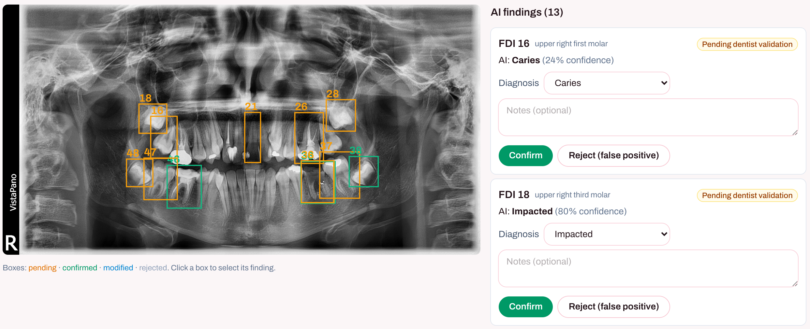  Figure 2. Review screen (synthetic patient, public DENTEX image): AI findings stay “pending” until the dentist acts.  • Status: all six loop steps, login and per-dentist access built and tested end-to-end.  • Testing: 171 backend + 25 frontend automated tests; CI (repo guard, backend, frontend); 6 synthetic profiles; 3 demo branches (no drug / drug, no conflict / drug with conflict).  • Pilot: clinic pilot status: UNVERIFIED — no pilot recorded in the repo. Clinical rules pending clinician validation.
  Shipped pipeline, held-out (23 images, 122 detections)
  Finding label correct | 97.54%
  Tooth number correct | 76.23%
  Finding + tooth correct | 75.41%
  Quadrant coordinator mAP50 (training-set fit) | 0.995
Acknowledgments & References
We thank our advisor Ashraf Eshta and partner dentist Mohamed Fatah. [1] Hamamci et al., DENTEX: dental enumeration and diagnosis on panoramic X-rays, MICCAI 2023 challenge dataset. [2] Jocher et al., Ultralytics YOLOv8, 2023. [3] ADA 2019 antibiotic guideline; AHA 2021 infective-endocarditis prophylaxis statement; AAPD Reference Manual.

