Bilkent University

Department of Computer Engineering

CS 319 - Object Oriented Programming Term Project

RSim: Railway Simulator

Analysis Report

SemahatElifDayı, ZahitSaygınDoğu, Mevlüt Geredeli, GizemUzuner

Instructor: ErtuğrulKartalTabak

Analysis/Final Report

March21, 2015

This report is submitted to the Department of Computer Engineering of Bilkent University inpartial fulfillment of the requirements of the Object Oriented Programming course CS319.

Contents

1 Introduction 1

2 Current System 1

3 Proposed System 2

1.1 Overview 2

1.2 Functional Requirements 2

1.3 Non-functional Requirements 3

1.4 Pseudo Requirements 3

1.5 System Models 3

1.1.1 Scenarios 3

**Use Case Name:** Adding Station 4

**Participating actors:** User ( Ertuğrul) 4

**Entry Conditions:** 4

**Use Case Name:** Creating a new track 4

**Participating actors:** User ( Ertuğrul) 4

**Entry Conditions:** 4

**Use Case Name:** Adding a train 5

**Participating actors:** User ( Ertuğrul) 5

**Entry Conditions:** 5

1.1.2 Use-Case Model 8

1.1.3 Object and Class Model 9

1.1.4 Dynamic Models 10

1.1.5 User Interface 13

4 Glossary 14

5 References 14

Analysis Report

RSim: Railway Simulator

# Introduction

We decided to design and implement a rainway simulator which provides design railway route and simulate the system to observe how system works. This simulator allows user to both create new railway route and edit existing routes. User can add new stations, trains and edit their properties. Eventually, railway system is simulated and user can observe system.

Our aim while creating the idea of this railway simultor is to show how railway system works. User can create different variation of routes and observe what will happen at the desired time. Hence user can recognise what he will encounter at the arranged time and desired route.

This raport contains the overview of the simulator, specifies the simulator's contents and how simulator works. This rapor includes the architectural patterns which will be used in our simultor and current system that is familiar with our project. Moreover, rapor ensures that gives information about functional requirements, non-functional requirements, pseudo functional requirements, use-case models that include scenarios, use-case diagrams, object and class model, dynamic model. At the end of the report, there are samples of user interface of simulator.

.

# Current System

OpenTrack began in the mid-1990s as a research project at the Swiss Federal Institute of Technology. The aim of the project*Object-Oriented Modeling in Railways* was to develop a catalyst for practical economic solutions to complex railway technology problems.

Today, the railway simulation tool OpenTrack is a well-established railway planning software and it is used by railways, the railway supply industry, consultancies and universities in different countries.

OpenTrack allows modeling, simulating and analyzing the following types of rail systems:

* [**High speed rail**](http://en.wikipedia.org/wiki/High-speed_rail)
* [**Heavy rail / Intercity rail**](http://en.wikipedia.org/wiki/Intercity_rail)
* [**Commuter rail**](http://en.wikipedia.org/wiki/Commuter_rail) systems
* [**Heavy haul freight**](http://en.wikipedia.org/wiki/Rail_freight_transport)
* [**Mining**](http://en.wikipedia.org/wiki/Mining) railway systems
* [**Metro**](http://en.wikipedia.org/wiki/Metro_(rapid_transit)) / [**Subway**](http://en.wikipedia.org/wiki/Rapid_transit) / [**Underground**](http://en.wikipedia.org/wiki/London_Underground) systems
* [**Light rail**](http://en.wikipedia.org/wiki/Light_rail) (LRT)
* [**Tram**](http://en.wikipedia.org/wiki/Tram) / [**Streetcar**](http://en.wikipedia.org/wiki/Tram) systems
* [**People mover**](http://en.wikipedia.org/wiki/People_mover) systems
* [**Rack railways**](http://en.wikipedia.org/wiki/Rack_railway) / Mountain railways
* [**Maglev**](http://en.wikipedia.org/wiki/Maglev) (magnetic levitation) systems (e.g. Transrapid)

OpenTrack supports the following kinds of tasks:

* Determining the requirements for a railway network’s infrastructure
* Analyzing the capacity of lines and stations
* Rolling stock studies (for example, future requirements)
* Running time calculation
* Timetable construction; analyzing the robustness of timetables (single or multiple simulation runs, Monte-Carlo simulation)
* Evaluating and designing various signaling systems, such as *discrete block systems*, *short blocks*, *moving blocks*, *LZB*,*CBTC (communication-based train control)*, *ATP*, *ATO*, *ETCS Level 1*, *ETCS Level 2,* *ETCS Level 3* (see also: [***ERTMS***](http://www.ertms-online.com/))
* Analyzing the effects of system failures (such as infrastructure or train failures) and delays
* Calculation of power and energy consumption of train services
* Simulation of railway power supply systems (using [**OpenPowerNet**](http://www.openpowernet.com/))

# Proposed System

This is where you provide the details of the results of your analysis work.

## Overview

The purpose of this project is to simulate a railway system. For simplicity there is only one line with no cross sections. User can add a new station, specify the distance between the stations, edit and remove the stations if necessary. User can also specify the capacity of the trains, the frequency of the trains and number of the trains. User should also specify the average quantity of people coming to a specific station, waiting and times for the trains for that station. After everything is specified user can advance time to see how full the trains, stations and how the system works are. Then user can modify the parameters and observe the system so that the user can achieve optimal operation strategy for the system.

We are planning to realize our design by using Java programming language. We are planning to build a simple GUI for adjusting parameters and showing the state of the system. However, since it will exceed the scope of the course we will not add any animations or graphical representations for the line, stations and trains.

We decided to pick this topic for the project because we see high potential for expanding. If the project won’t satisfy the requirements for the course, we can always add new features.

## Functional Requirements

User should add new stations to the system.

User should define the distances between the stations.

User should define train specifications (such as speed, capacity...)

User can change the station properties at edit time.

User is not allowed to modify the properties of trains and stations during simulation time.

User can save the layout of the stations to a file.

User can see the system state after some defined time by the user.

User can view the simulation as time passes.

Controller won't let trains to be overlapped. This means, in between two adjacent stations there can be only one train at a time instant.

User can log in to system.

User can open and simulate a saved system by any user.

User cannot edit a system saved by other users.

## Non-functional Requirements

A bulleted list is below:

* All user inputs should be acknowledged within 1 second.
* A system crash should not result in long term data loss.
* Any simulation calculation taking more than 1 minute will terminate and result in warning.

## Pseudo Requirements

* The System will be implemented on Java. Because Java is one of the best object oriented programming languages and it provides nice UI API's to make platform independent applications.

## System Models

### Scenarios

Ertuğrul has a childhood dream of creating a virtual train system and simulation its behavior. Ertuğrul finds out there is software called Railway Simulator for this. Ertuğrul gets the program, starts it. Ertuğrul sees the user interface. Ertuğrul first creates an account for the program. After that he logs in to the system and starts editing. He first creates a track by using create track button. He creates a track initially with three stations. He decides he wants to add some more stations and adds them by using add station button. After that he creates a train dispatcher at the beginning of the track. After this he creates 3 trains using add train button. He specifies the destination and the departure hour vector of the trains. After that he is satisfied with the design of the railway system so he decides to simulate it. He pushes the simulate button and watches the simulation for hours. After a while he gets bored and decides to close the program. He stops the simulation and saves state of the railway design. After that he closes the program. After closing the program he gets curious and opens the program with another account to see what happens. He locates the design file to open it. He is able to see the design, simulate it but he notices that he can't change the design. It is because he is not logged in as his original profile.

### Use Case Name: Adding Station

### Participating actors: User ( Ertuğrul)

### Entry Conditions:

* Program is running.
* There is no simulation in progress.
* User is logged in.
* There is a track existing.

Flow of Events:

* Ertuğrul presses the button for adding new station.,
* Ertuğrul specifies the properties of the station.
  + Ertuğrul can specify the name of the station.
  + Ertuğrul can specify the position of the station.
  + Ertuğrul can specify the maximum waggoncapcity of the station.
* If the station is overlapping with another staion, or it is conflicting with the line spesifications, Ertuğrul will see a warning.
* If there is no warning Ertuğtul can confirm the addition of the station.
* The station will be added to the line system.

Exit Condition:

* The station is added, or the station addition process is aborted.

### Use Case Name: Creating a new track

### Participating actors: User ( Ertuğrul)

### Entry Conditions:

Program is running.

There is no simulation in progress.

User is logged in.

There is no track existing.

Flow of Events:

* Ertuğrul presses the button for adding new line.
* Ertuğrul specifies the properties of the line.
  + Ertuğrul can specify the minimum distance between stations.
  + Ertuğrul can specify the maximum length of the track.
  + Ertuğrul can specify the maximum station count in the line.
  + Ertuğrulcan specify the name of the line.
  + Ertuğrul can specify the name of the first station.
  + Ertuğrul can specify names and the positions of the following stations.
* If any station is overlapping with another staion, or it is conflicting with the line spesifications, Ertuğrul will see a warning.
* If there is no warning Ertuğtul can confirm the creation of the line.
* The track will be added to the line.

Exit Condition:

The new trak is added or the track addition process is aborted.

### Use Case Name: Adding a train

### Participating actors: User ( Ertuğrul)

### Entry Conditions:

Program is running.

There is no simulation in progress.

User is logged in.

There is a track existing with at least 2 stations.

Flow of Events:

Ertuğrul presses the button for adding new train.

Ertuğrul specifies the properties of the train.

Ertuğrul can specify which train dispacher the train will start it's service.

Ertuğrul can specify the capacity of the train.

Ertuğrul can specify the count of the waggon.

Ertuğtrul can specify the maximum capcity of each waggon.

Ertuğrul can specify the departure time table for the train.

Ertuğrul can specify the directions which the train will go at each departure time.

If the waggoncoun is more than the stations can handle, the program will give a warning.

If there is no warning Ertuğtul can confirm the addition of the train.

The train will be added to the line system.

Exit Condition:

The train is added to the dispaching queue of the dispaceher.

### Use Case Name: Add Train Dispacher

### Participating actors: User ( Ertuğrul)

### Entry Conditions:

Program is running.

There is no simulation in progress.

User is logged in.

There is a track existing with at least 2 stations.

Flow of Events:

Ertuğrul presses the button for adding new traindispatcher.

If there is a dispatcher on the station, Ertuğrul will see a warning message.

Ertuğrul specifies the properties of the train dispatcher.

Ertuğrulmust specify which station the train dispatcher will work at.

Ertuğtrul can specify which way the train will move initially.

Exit Condition:

The train dispatcher is added to the station, or the existing dispatcher is overridden.

### Use Case Name: Simulate the System

### Participating actors: User ( Ertuğrul)

### Entry Conditions:

Program is running.

There is no simulation in progress.

User is logged in.

There is a track existing with at least 2 stations.

There is at least one train dispatcher on one of the stations.

Flow of Events:

Ertuğrul presses the button for starting the simulation.

Ertuğrul will see the simulation results in the screen.

Ertuğrul can adjust the speed of the simulation.

Ertuğrul can stop the simulation.

After stopping Ertuğrul can save the processsimulated.

Exit Condition:

The simulation process is either saved or nothing happens.

### Use-Case Model

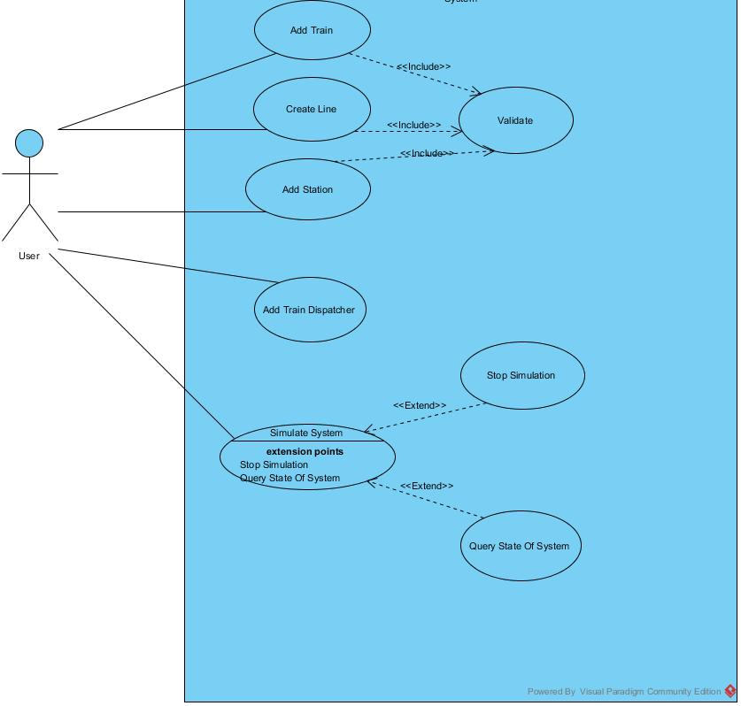

### Object and Class Model

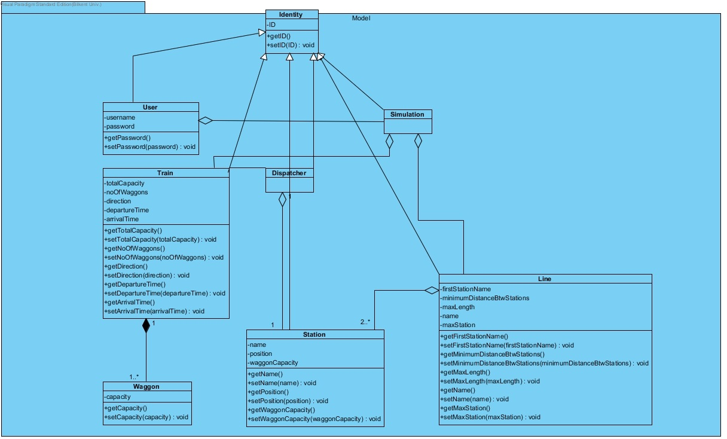

Figure: Model Package

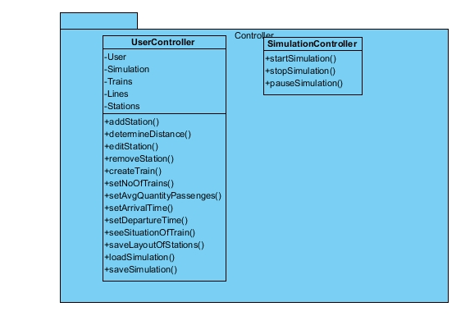

*Figure: Controller Package*

### Dynamic Models

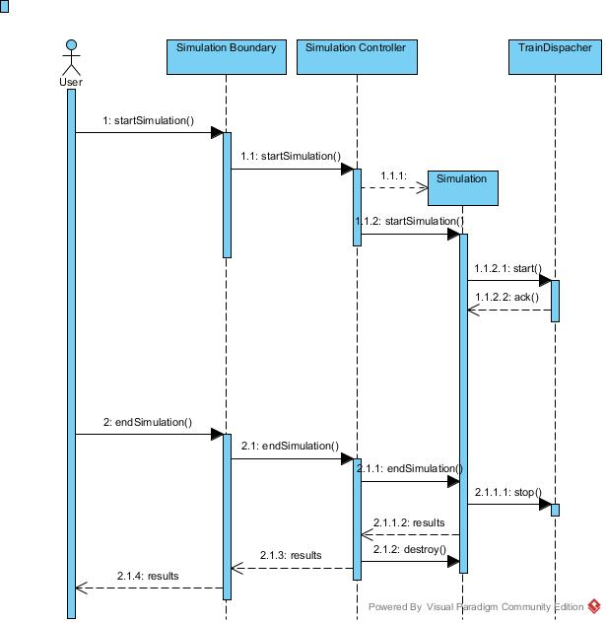

*Figure: Sequence Diagram*

In figure, the sequence diagram of simulating a system is given. The user pushes the button to start simulation, which is on the SimulationBoundary object. SimulationBoundary object is the View object associated with a simulation. When the button is pressed, SimulationBoundary notifies SimulationController which then creates a Simulation instance. After that the calculations are made and shown to the user until the user presses the stop button.

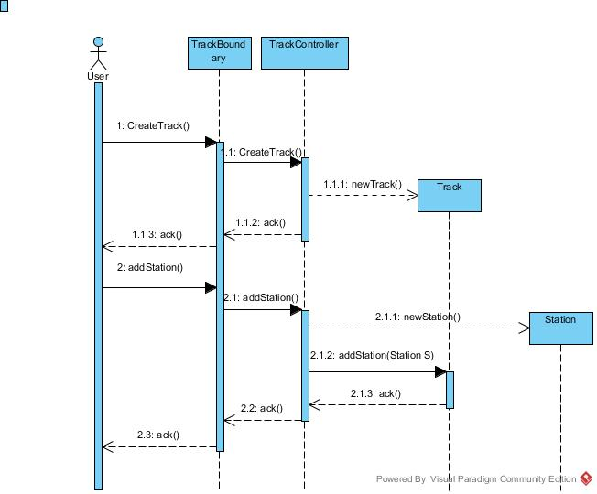

*Figure: Sequence Diagram*

Inthe figure, the sequence diagram of creating and managing a track is given. The user pushes the add new track button which is on TrackBoundary which is a View object associated with the Track. After this, the TrackController is notified and it will create a new Track instance. After this the user clicks the button for adding a station to a track, then the TrackController object then it creates a new Station instance and links it to the associated Track object. The changes in the Track model will be shown by the TrackBoundary object to the user.

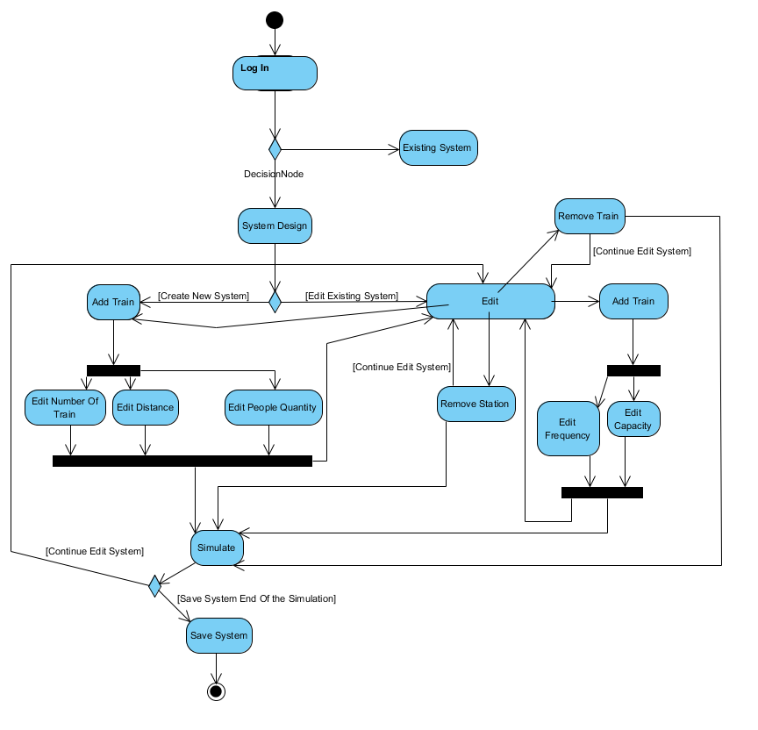

*Figure: Activity Diagram*

### User Interface

### 

Figure: Log on and Adding Station

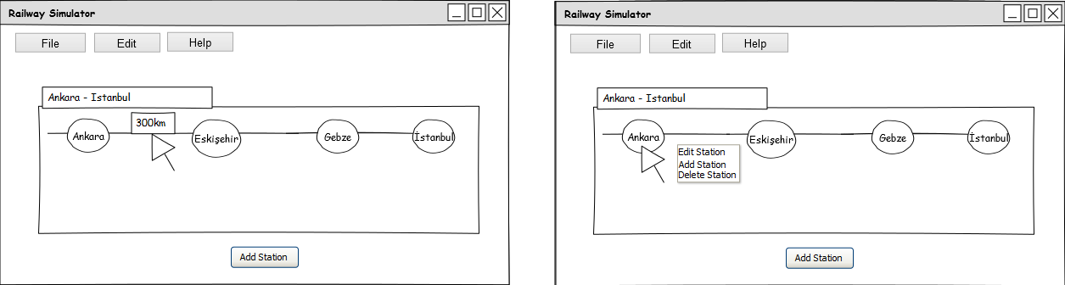

### Figure: Sample Simulation

# Glossary

Glossary for any domain-specific terms you use in your report.

# References

1. Object-Oriented Software Engineering, Using UML, Patterns, and Java, 2nd Edition, by Bernd Bruegge and Allen H. Dutoit, Prentice-Hall, 2004, ISBN: 0-13-047110-0.
2. "OpenTrack Railway Technology." - Railway Simulation. Web. 23 Mar. 2015. <<http://www.opentrack.ch/opentrack/opentrack_e/opentrack_e.html#Events>>.