**<appActivity activityName = ".base.UiDrawerBaseAct" desc = "mainPage">**

1>

<appElement elementrepresentative= "titleTextView" method = "find_element_by_id" locationValue = "android:id/action_bar_title" />

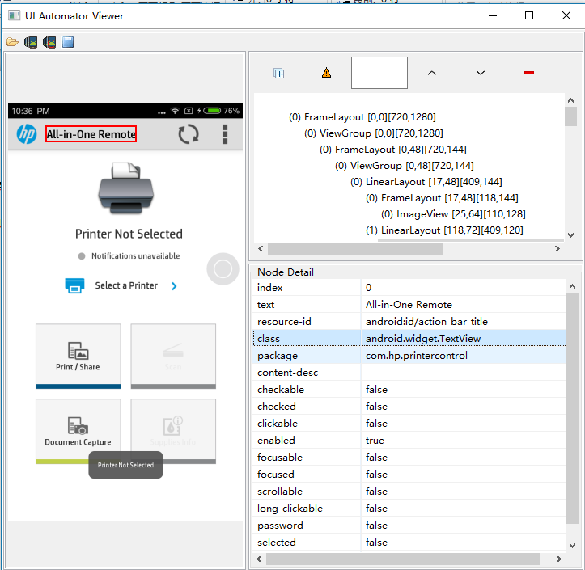

2>

<appElement elementName = "availablePrintersButton" method = "find_element_by_id" locationValue = "com.hp.printercontrol:id/availablePrintersButton" jumpTargetActivity = ".printerselection.UiPrinterSelectionAct"/>

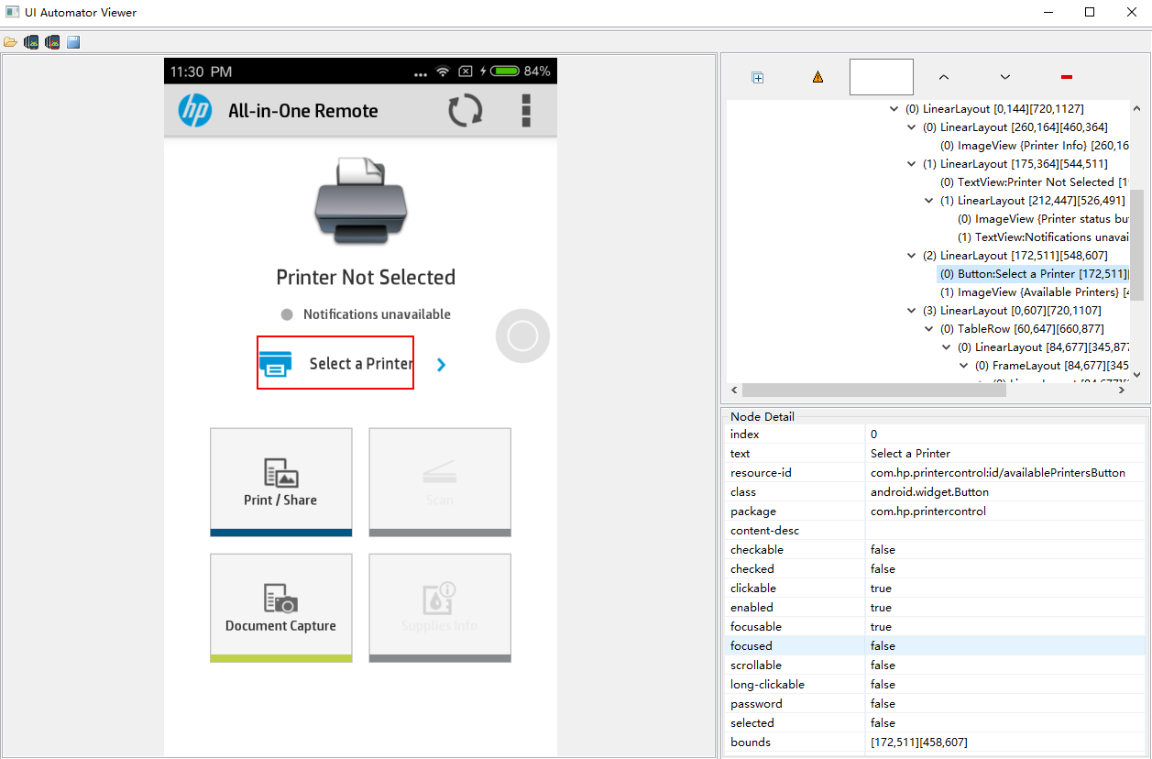s