Create project

1. Create folder

2 .Open cmd

3. npx create-next-app@latest

4. Naming the project

5. Choose the option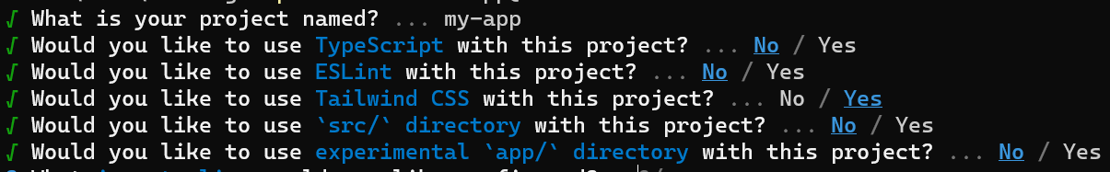

-------------------App had been created! -------------------

Run project

1. cd <name project>

2. npm run dev

3. visti “ <http://localhost:3000> ”

*Note*

**_app.js**

* This file is used to initialize pages and provide layout components that are shared across all pages.
* You can override the default App component by creating a file at ./pages/_app.js and exporting a custom App component.
* The App component receives a pageProps prop that contains the data returned from getStaticProps, getServerSideProps or getInitialProps of the page component.
* The App component also receives a Component prop that contains the page component itself.
* You can use the App component to add global CSS, global state providers, global hooks, etc.

**_document.js**

* This file is used to modify the initial HTML and body tags used to render a page.
* You can override the default Document component by creating a file at ./pages/_document.js and exporting a custom Document component.
* The Document component receives a renderPage prop that contains a function to render the page component inside the App component.
* The Document component should only be used for any <head> code that is common for all pages, such as meta tags, fonts, etc.
* The Document component should include the <Html>, <Head>, <Main> and <NextScript> components as they are required for the page to be properly rendered.
* The Document component is only rendered on the server side and not on the client side, so event handlers like onClick cannot be used in _document.

**index.js**

* This file is used to render the homepage of your Next.js application.
* You can create a file at ./pages/index.js and export a React component that will be rendered as the homepage.
* You can use Next.js data fetching methods like getStaticProps, getServerSideProps or getInitialProps to fetch data for your homepage and pass it as props to your component.
* You can use next/head to add custom <head> code for your homepage, such as title, description, etc.