a**. Project title** -Implement a simple shell or command line interpreter.

b. **Project Description** - Implementation of built in commands with the help of command line interpreter in c programming

c. **Author** - Saylee Raut

d. **Acknowledgment** -I'd like to thank Dr. Unan and the TA'

e. **Getting Started** - Creating executable uab_shell file

i. Prerequisites/dependencies -uab_sh.o: uab_sh.cpp uab_sh.h

$(CC) -c uab_sh.cpp

ii. Instructions for building the software - gcc (GCC) 4.8.5 20150623 (Red Hat 4.8.5-44)

f. **Running the test** - gcc uab_sh.c -lreadline

i. **How to run test cases** -./a.out

ii. **Sample test cases** - hello, help, exit, ls ,cd ,fibonacci ,history

g. **Screenshots/Sample Session**

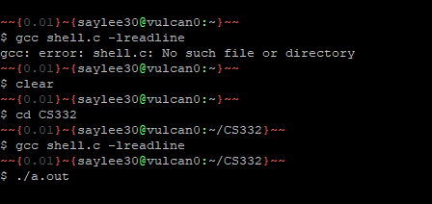

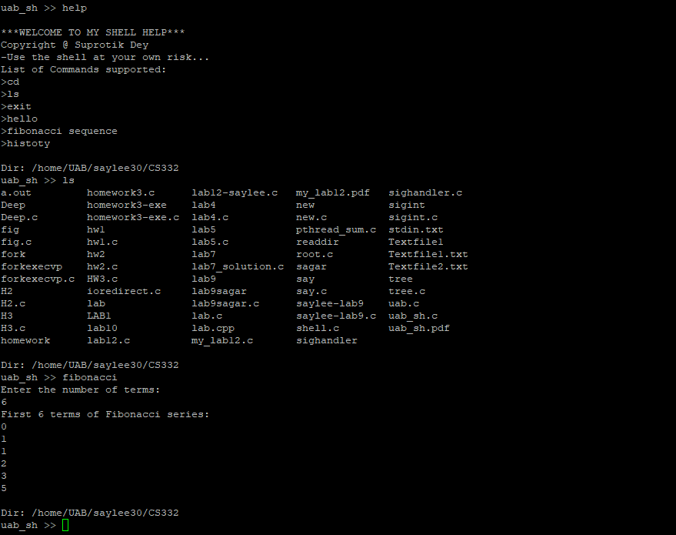

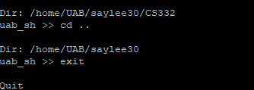

**Reference-**

https://www.geeksforgeeks.org/making-linux-shell-c/

https://beginnersbook.com/2014/06/c-program-to-display-fibonacci-series/

https://github.com/laurakoco/linux-shell/blob/master/shell.c

https://github.com/mohamed-minawi/Unix-Shell-and-History-Feature/blob/master/main.c

https://github.com/deepakavs/Unix-shell-and-history-feature-C/blob/master/shell2.c