Mini Project
On
Cyber Cafe Management System



2010

Submitted in partial fulfilment of the requirement for the award of Bachelor of Technology degree course in Information Technology

By,

Dhanoop Bhaskar
Bibinkumar T
Gopikrishnan A N
Ramesh T R

DEPARTMENT OF INFORMATION TECHNOLOGY

UNIVERSITY COLLEGE OF ENGINEERING
THODUPUZHA-685584

UNIVERSITY COLLEGE OF ENGINEERING
THODUPUZHA
IDUKKI DISTRICT, KERALA-685584

Department of Information Technology

CERTIFICATE

This is to certify that the report of mini project titled CYBER CAFE MANAGEMENT SYSTEM is the bona fide record of the work executed by DHANOOP BHASKAR, BIBINKUMAR T, GOPIKRISHNAN A.N, RAMESH T.R of sixth semester INFORMATION TECHNOLOGY, in partial fulfilment of the requirement for the award of Bachelor of Technology degree course under M.G University during the academic year 2007-2011

Staff in-charge Head of Department

Internal Examiner External Examiner

Thodupuzha

Date……….

ACKNOWLEDGEMENT

On the occasion of presenting this project report, we wish to express our deep and profound feelings of gratitude to a number of persons who have contributed to the completion of this project.
First of all we express our deep gratitude to Almighty, the supreme guide, for bestowing his blessings upon us in our entire endeavor.
We are grateful to our respected Principal Dr. Lathakumari B for providing all facilities for the development of our project.
We also express our heartfelt gratitude to Mrs. Bindu Baby Thomas our Head of the Department for rendering all possible help and support during the development, implementation and presentation of the project.
We are extremely grateful to Mr. Sijo Thomas lecturer-in-charge of our project for his valuable guidance and encouragement throughout our humble endeavor.

TABLE OF CONTENTS
CHAPTER NO. | TITLE | PAGE NO.
 | SYNOPSIS
1. | INTRODUCTION | 2
2. | SOFTWARE ENVIRONMENT | 3
 | 2.1 SOFTWARE SELECTION | 3
3. | SYSTEM ANALYSIS | 5
 | 3.1 EXISTING SYSTEM | 5
 | 3.2 NEED FOR THE SYSTEM | 6
 | 3.3 PROPOSED SYSTEM | 6
 | 3.4 SCOPE OF THE PROJECT | 7
 | 3.5 PROBLEM DEFINITION | 8
 | 3.6 SYSTEM CONFIGURATION | 8
 | 3.7 FEASIBILITY STUDY | 10
4. | DESIGN AND DEVELOPMENT | 11
 | 4.1 LOGIN | 11
 | 4.2 ACCOUNT SETTINGS | 11
 | 4.3 CABIN SETTINGS | 11
 | 4.4 TARIFF SETTINGS | 11
 | 4.5 RECHARGE | 11
 | 4.6 BILLING | 11
 | 4.7 REPORTS | 12
 | 4.8 VIEW ACCOUNTS | 12
5. | SYSTEM TESTING | 14
 | 5.1 Unit Testing | 14
 | 5.2 Integration Testing | 14
 | 5.3 White Box Testing | 15
 | 5.4 Black Box Testing | 15
 | 5.5 Functional Test | 15
 | 5.6 Performance Test | 16
 | 5.7 Stress Test | 17
 | 5.8 Structure Test | 17
 | 5.9 Validation Test | 18
 | 5.10 Output Test | 18
 | 5.11 User Acceptance test | 18
 | 5.12 Change Over Plan | 19
6. | IMPLEMENTATION | 20
 | 6.1 SYSTEM SECURITY MEASURE | 20
 | 6.2 SYSTEM MAINTAINANCE | 21
7. | SCOPE OF THE PROJECT | 23
8. | USER TRAINING | 24
 | 8.1 INTRODUCTION | 24
 | 8.2 USERS MANUAL | 24
9. | CONCLUSION | 25
 | 9.1 Achievement Expected through the project | 25
10. | REFERENCES | 25
11. | APPENDIX I | 26
 | 11.1 LIST OF TABLES | 26
12. | APPENDIX II | 28
 | 12.1 DFD | 28
 | 12.2 IMPLEMENTATION FIGURES | 33
 | 12.2.1 MODULE LIST | 33
13. | APPENDIX III | 35
 | 13.1 SCREEN SHOTS | 35
14. | APPENDIX IV | 43
 | 14.1 OVERVIEW | 43

SYNOPSIS

Computers have become a way of life for today’s high society. Many aspects of modern life that we have come to accept as common place would not be possible if there were no computers. Today computers are use extensively in many areas of business, industry, science, education etc.
The major advantage of computer is its speed that makes it able to give some useful information very quickly. This speed also opens new approaches to problem solving and data processing. Another feature is its accuracy. Though the computers do only what is instructed at every instant, these instructions are taken into account and accurate information’s are produced. Computer can hold data and instruction in an electronic representation in internal memory and this data can be retrieved at any time
The project entitled “Cyber Café Management System” is a software package, which can be used in cyber cafés for managing the clients’ computer efficiently. Now a day’s cyber terrorism, which is mainly undergone through internet cafés, need to be tackled properly. Thereby, it is indeed necessary to store the valid information of the user who comes for internet access. The system being used, the time at which the user logs in and logs out should be recorded systematically.
In this modern era, a number of people access the internet frequently by means of cyber cafes. For such frequent users, a prepaid account shall be maintained and discounted rates may be charged from them. While walkthrough users, who are less frequent, are charged a fixed rate. By using the LAN connections in the cyber cafes we can automate this process very easily. This system comprises of the following modules:

- The Server Module
- The Client Module

The server module, which is handled by the administrator can create new accounts for prepaid users and also store the details of walkthrough customers. While in the client module, which is handled by users themselves, the user should give his/her user-id and password to start browsing. After they are logged out, the time and amount will be automatically generated at the server module and the bill is provided to the user.
This system is developed in JAVA language with My SQL as backend. The system is a menu driven one. User-friendly menus will help both the administrator and the clients to work on it without any operational difficulty.

INTRODUCTION

In this project an attempt is made to design a computer system for the CYBER CAFÉ that makes the management of recording user details, internet usage and billing much easier. The objective of this software is to maintain the details of users, cabins and login history. Through this system we provide facility of prepaid and postpaid accounts respectively for Account Users and Walkthrough Users. It has the features like adding, viewing, editing of user details, cabin details, recharge option for prepaid users, billing, tariff settings, etc.
The Software powered by JAVA assures clear and efficient services to the agency. This easy-to-operate system helps to access and modify user details, provides efficient billing facility. The software is designed to provide Reliable and error free information. The database is driven by My SQL thus providing portability. Anyone having an account with the system can have access to internet by logging into the client machine using a given username and password. Account users can login only if they have sufficient balance in the account. Otherwise they will have to recharge their account using the recharging facility at the administrator side. To ensure enhanced security user account creation, editing, etc are available only at the administrator side.
On successful login the user can load browser and can have access to internet. The login time displayed on the login screen may help the users manage their usage. On logout the internet usage charges and available balance in the account (in case of account users) will be displayed.

2. SOFTWARE ENVIRONMENT

2.1 SOFTWARE SELECTION

The proposed software is designed on the JAVA platform with My SQL backend.
JAVA is special because - first, it is platform-independent. That means that you, as a Java programmer, will need to write your Java code only once. Before Java, programmers had to write their code for each targeted operating system (OS). If you wanted to write a poker game application and then distribute it to customers, you would have to write the program for the Windows operating system and again for the Mac operating system. Java eliminates the problematic scenario above, once and for all. You write your poker application in Java, compile the application, and distribute it. As long as your users have a Java Virtual Machine (JVM) for their particular operating system, then your application will run on a Mac, Windows, UNIX, or any other operating system that has the correct JVM.
Another special feature of Java is that it is object-oriented. Object-oriented programming allows the programmer to create templates (classes) that can be reused over and over. Every time you write a program, you don’t want to reinvent the wheel, and creating well-designed classes will give you a great foundation for writing other programs. Also, Java has a core set of classes that are already provided for you. You can take advantage of these pre-built classes, and you have the ability to create classes from scratch. You can even use many of the pre-existing Java classes as a model to create customized classes of your own.

One of the ideas behind Java's automatic memory management model is that programmers be spared the burden of having to perform manual memory management. In Java, the potential problem of memory leakage is avoided by automatic garbage collection. The programmer determines when objects are created, and the Java runtime is responsible for managing the object's lifecycle.

The program or other objects can reference an object by holding a reference to it (which, from a low-level point of view, is its address on the heap). When no references to an object remain, the unreachable object is eligible for release by the Java garbage collector - it may be freed automatically by the garbage collector at any time. Java does not support pointer arithmetic as is supported in, for example, C++. This is because the garbage collector may relocate referenced objects, invalidating such pointers. Another reason that Java forbids this is that type safety and security can no longer be guaranteed if arbitrary manipulation of pointers is allowed.

My SQL is an open source structured query language. It is platform-independent and hence is portable. The language is easy to understand and use. The queries are very similar to Oracle 8i and can be easily used in java programs. JDBC (java database connector) driver is used to implement Java to My SQL connectivity.

3. SYSTEM ANALYSIS

System analysis is for finding out what happens in existing system deciding on what changes and new features are required and defining exactly what the proposed system must be. The process of system analysis is largely concerned with determining, developing and agreeing to the user’s requirements. It provides prime opportunity to communicate well with the user and conceive a joint understanding of what a system should be doing together with a view of relative importance of the system facilities using interactive techniques.

3.1 EXISTING SYSTEM

Presently, most of the functions in the Cyber cafés are done manually. Even though there are LAN connections and an administrator system, an automated system is not introduced. The owner records the details of the clients, login and logout time, cabin and has to calculate the amount. All these details are written in book. Also there is no special system to allocate cabins efficiently. The owner also has to calculate the total income of a day. The present system has following limitations:
- Limitations in report generations
- Manual recording consumes excess time
- Chances of error
- Difficulty in allocating cabins
- The retrieval of information regarding a client is time consuming
- Lack of billing system and manual calculation of daily income
- Repeated recording of frequent user details

Focusing on the drawbacks and inadequacies of the existing system, the new system is designed which could well replace the existing system.

3.2 NEED FOR THE SYSTEM

In the present scenario the café owner keeps a paper book to keep track of user details. Manual processing of data is always time consuming and may commit more errors. There is much difficulty in allocating cabins to the users. Further reference to the user details is time consuming. Accuracy of such data makes the system unreliable and inefficient. Obviously there is need of an efficient system. The proposed system rectifies the demerits and defects of the existing system to a greater extend.

3.3 PROPOSED SYSTEM

The Cyber Café Management System which we design is in the same line of the existing system. No procedural changes are made to the existing system except the login process done by the customers.
The new system we develop has 2 modules. One module is to be installed in the server computer and the second module is to be installed in every client computers. In server module the staff should login with their username and password. The first entering window contains a flex grid which will display all the cabins. If any customer logs in any client computer, the details of the user including name and address will be displayed in this grid.
If any of the client computers is not in working condition, there is facility to remove it from allocation process. After accomplishing the maintenance it can be added back to the cabin settings.
When a new customer comes for browsing, an account is created for him.

The account can be of two types, “Account user” and “Walkthrough user”. An account user must pay a minimum amount of Rs.50 for the creation of account. While walkthrough users have to pay only after their usage. Account users can use the internet for lower tariffs which can be adjusted from the menu ‘tariff settings’.
The usage amount will be deducted from their account’s balance. In case their credit amount is lower, the customer should recharge their account. Recharge option are available at ‘recharge’ menu.
An account contains information about the user’s name, address, identification etc... They should have a unique user-id and password. Using this user-id and password they can log in from the client computers. In case any user forgets his password, it can be recovered and edited from the edit option in menu named ‘Account setting’.
Different reports are included regarding users, their login time, logout time, used machine etc… In case if any malpractices have occurred from the café, it can be identified by checking the user report. Daily report provides details regarding all the user details of a day. Reports of a specific user can be viewed using their user-id. Similarly machine wise reports are also there, which helps to find all the users who have used a specific computer.
Since information regarding the users is needed for further checking, an account can be deleted only after 5 years from the last login date. That is the information and details regarding usage of a user will be kept for at least 5 years.

3.4 SCOPE OF THE PROJECT

The system we propose has great scope in the current real time situation. The cyber crime monitoring system can be enhanced to an extent by implementing this system. Most of the firms and establishments are being

computerized in order to ease the tasks to be performed. The internet cafés unfortunately are rarely computerized. We aim through this venture, a better reliable solution. In the primary stage of feasibility study itself we received an exquisite response and so we plan to go ahead with our project.

3.5 PROBLEM DEFINITION

The purpose of the project is to automate cyber cafes. The software must include provisions to keep user details and login history. It should help the café owners to retrieve user details when needed and internet usage in the system. It should be capable of allocating cabins automatically. It should help the café owner in calculating daily usage of the systems and income.

3.6 SYSTEM CONFIGURATION
HARDWARE CONFIGURATION:

Processor - Pentium IV
Memory - 512 MB RAM
Keyboard - 105 Keys
Monitor - CRT or LCD
Mouse - USB mouse or PS/2 mouse

SOFTWARE SPECIFICATION:
Operating System : Windows XP/NT,
Front End : CORE JAVA
Back End : MY SQL
Documentation : MS Word

OPERATING SYSTEM - WINDOWS XP

Windows XP is an operating system developed by Microsoft Corporation, which provides a lot of software services to the user. It provides disk allocation, disk management and faster disk access. Windows 2000 combines the user-friendly interface (GUI) and features of Windows 98 wit the file system, networking, power and stability of Windows NT and some new improved features. This combination of features makes Windows 2000 the most power full and easy to use. It supports multitasking that is it can do more then one work at the same time. It includes many useful programs and accessories using a network are easier than ever with Windows 2000.

Various features of Windows -2000 Operating System.

- Improved setup and installation
- Improved internet features
- Improved disk management
- Plug and play
- 32-bit architecture
- Improved memory management and file system

3.7 FEASIBILITY STUDY

During system analysis, the feasibility study of the proposed system is to be carried out. This is to ensure that proposed system is not a burden to the company. This study can be categorized into three types. They are:

ECONOMIC FEASIBILITY STUDY
This study is carried out to check the economic impact that the system will have on the organization. The amount of fund that the company can pour into the research and development of system is limited, the expenditures must be justified. Thus the developed system was well within the budget and this was achieved because most of the technologies used are freely available. Only customized products had to be purchased.

TECHNICAL FEASIBILITY STUDY
This study is carried out to check the technical facility, that is, the technical requirements of the system. Any system developed must not have a high demand on the available technical resources. This developed system has modest technical requirements, as only minimal or null changes are required for implementing this system.

SOCIAL FEASIBILITY STUDY
This aspect of study is to check the level of acceptance of the system by the user. This includes the process of training the system but must accept it as a necessity. The levels of acceptance by the users solely depend on the methods that are employed to educate the user about the system and make him familiar with it. His level of confidence must be raised so that he is also able to make some constructive criticism, which is welcomed, as he is the final user of the system.

4. DESIGN AND DEVELOPMENT

4.1 Login:

In this module a user id and password is provided to the Administrator and user, to provide access control. The Administrator has the rights to make modifications from time to time. The user can make use of the software but does have the rights to make modifications in the way it performs.

4.2 Account Settings:

This module is under the control of administrator. In this module the administrator can create account for the user, edit account and delete account. The user needs to produce some sort of identity proofs to create an account.

4.3 Cabin Settings:

This module is controlled by the administrator. Here he/she can add cabins to the system, edit cabin, and remove a cabin. The system name (host name) should be entered without fail while adding a cabin to the system.

4.4 Tariff Settings:

The administrator controls this module. Here he/she can set tariff rates for both Account Users’ and Walkthrough Users’ account.

4.5 Recharge:
This module is under the control of the administrator. Here recharge of accounts is performed. User shall refill there account on paying respective amount to the administrator.

  - Billing:
This module is controlled by the administrator. Here billing of internet usage by various users is performed.

4.7 Reports:
The administrator controls this module. Here he/she can have a look on usage reports of a particular user, whole usage, usage in a particular machine and daily report.

4.8 View Account:

This module is controlled by the administrator. Here he/she can have a look on account details.

4.9 DATA FLOW DIAGRAM

A data flow diagram or a bubble chart is a graphical tool for future analysis. DFD modules a system by using external entities from which data flows to a process, which transforms the data and creates output data flows which go to other process or external entities or files. Data in files may also flow to processes as inputs.

DFD can be hierarchically organized, which can help in partitioning and analyzing large systems. As a first step one data flow diagram can depict an entire system which gives the system overview.

There are various symbols used in a DFD namely:
“Arrow”:
A data flow is a route, which enables packets of data to travel from one point to another. Data may flow from a source to a processor or from a data store or process. An “Arrow Line” depicts a flow with the arrowhead pointing in the direction of the flow.

“Process”:
A Process represents transformations where incoming data flows are changed into outgoing data flows.

“Data Store”:
A data store represents a repository of data that is to be stored for use by one or more processes may be as simple as buffer or queue or sophisticated as relational database. They should have clear names.

“A Source or Sink”:
A source or sink is a person or part of an organization, which enter or receives information from the system, but is considered to be outside the contest of data flowmodel. .

5. SYSTEM TESTING

System testing involves unit testing, integration testing, white-box testing, black-box testing. Strategies for integration software components into a functional product include the bottom-up strategy, the top-down strategy, and sandwich strategy. Careful planning and scheduling are required to ensure that modules that will be available for integration into evolving software product when needed a serious of testing are performed for the proposed system before the system is ready for user acceptance testing.

5.1 UNIT TESTNG

Instead of testing the system as a whole, Unit testing focuses on the modules that make up the system. Each module is taken up individually and tested for correctness in coding and logic.
The advantages of unit testing are:
- Size of the module is quite small and that errors can easily are located.
- Confusing interactions of multiple errors in wide different parts of the
software is eliminated.
- Modules level testing can be exhaustive.

5.2 INTEGRATION TESTING
It tests for the errors resulting from integration of modules. One specification of integration testing is whether parameters match on both sides of type, permissible ranges and meaning. Integration testing is functional black box test method. It includes testing each module as an impenetrable mechanism for information. The only concern during integration testing is that the modules work together properly.

5.3 WHITE BOX TESTING (CODE TESTING)
The code-testing strategy examines the logic of the program. To follow this testing method, the analyst develops test cases that result in executing every instruction in the program or module so that every path through the program is tested. A path is a specific combination of conditions that is handled by the program. Code testing does not check the range of data that the program will accept.
- Exercises all logical decisions on their true or false sides.
- Executes all loops at their boundaries and within these operational
bounds.

5.4 BLACK BOX TESTING (SPECIFICATION TESTING)
To perform specification testing, the analyst examines the specification, starting from what the program should do and how it should perform under various conditions. Then test cases are developed for each condition or combinations of conditions and submitted for processing. By examining the results, the analyst can determine whether the programs perform according to its specified requirements. This testing strategy sounds exhaustive. If every statement in the program is checked for its validity, there doesn’t seem to be much scope for errors.

5.5 FUNCTIONAL TEST

In this type of testing, the software is tested for the functional requirements. The tests are written in order to check if the application behaves as expected. Although functional testing is often done toward the end of the development cycle, it can—and should, —be started much earlier. Individual components and processes can be tested early on, even before it's possible to do functional testing on the entire system. Functional testing covers how well the system executes the

functions it is supposed to execute—including user commands, data manipulation, searches and business processes, user screens, and integrations. Functional testing covers the obvious surface type of functions, as well as the back-end operations (such as security and how upgrades affect the system).

5.6 PERFOMANCE TEST

In software engineering, performance testing is testing that is performed, from one perspective, to determine how fast some aspect of a system performs under a particular workload. It can also serve to validate and verify other quality attributes of the system, such as scalability, reliability and resource usage. Performance testing is a subset of Performance engineering, an emerging computer science practice which strives to build performance into the design and architecture of a system, prior to the onset of actual coding effort.
Performance testing can serve different purposes. It can demonstrate that the system meets performance criteria. It can compare two systems to find which performs better. Or it can measure what parts of the system or workload cause the system to perform badly. In the diagnostic case, software engineers use tools such as profilers to measure what parts of a device or software contribute most to the poor performance or to establish throughput levels (and thresholds) for maintained acceptable response time. It is critical to the cost performance of a new system; the performance test efforts begin at the inception of the development project and extend through to deployment. The later a performance defect is detected, the higher the cost of remediation. This is true in the case of functional testing, but even more so with performance testing, due to the end-to-end nature of its scope.
In performance testing, it is often crucial (and often difficult to arrange) for the test conditions to be similar to the expected actual use. This is, however, not entirely possible in actual practice. The reason is that production systems have a

random nature of the workload and while the test workloads do their best to mimic what may happen in the production environment, it is impossible to exactly replicate this workload variability - except in the simplest system.

5.7 STRESS TEST

The application is tested against heavy load such as complex numerical values, large number of inputs, large number of queries etc. which checks for the stress/load the applications can withstand. Stress testing deals with the quality of the application in the environment. The idea is to create an environment more demanding of the application than the application would experience under normal work loads. A test environment is established with many testing stations. At each station, a script is exercising the system. These scripts are usually based on the regression suite. More and more stations are added, all simultaneous hammering on the system, until the system breaks. The system is repaired and the stress test is repeated until a level of stress is reached that is higher than expected to be present at a customer site. Race conditions and memory leaks are often found under stress testing. A race condition is a conflict between at least two tests. Each test works correctly when done in isolation. When the two tests are run in parallel, one or both of the tests fail. This is usually due to an incorrectly managed lock. A memory leak happens when a test leaves allocated memory behind and does not correctly return the memory to the memory allocation scheme. The test seems to run correctly, but after being exercised several times, available memory is reduced until the system fails.

5.8 STRUCTURE TEST

White-box testing, on the other hand is concerned with testing the implementation of the program. The intent of this testing is not to exercise all the different input or output conditions but to exercise the different programming

structures and data structures used in the program. White-box testing is also called structural testing and we will use the two terms interchangeably.

5.9 VALIDATION TEST

After the culmination of black box testing, software is completely assembled as a package, interfacing errors have been uncovered and corrected and final series of software validation tests begin. Validation testing can be defined as many, but a single definition is that validation succeeds when the software functions in a manner that can be reasonably expected by the customer. Validation refers to the process of using the software in a live environment to find errors. During the course of validation system may occur and the software will be changed.

5.10 OUTPUT TEST
In this output is tested by entering sample data and checking out for its efficiency.

5.11 USER ACCEPTANCE TEST
In this type of testing, the software is handed over to the user in order to find out if the software meets the user expectations and works as it is expected to. In software development, user acceptance testing (UAT) - also called beta testing, application testing, and end user testing - is a phase of software development in which the software is tested in the "real world" by the intended audience. UAT can be done by in-house testing in which volunteers or paid test subjects use the software or, more typically for widely-distributed software, by making the test version available for downloading and free trial over the Web. The experiences of the early users are forwarded back to the developers who make final changes before releasing the software commercially

5.12 CHANGE OVER PLAN

Testing commences with a test plan and terminates with acceptance testing. A test plan is a general document for the entire project that defines the scope, approach to be taken, and the schedule of testing as well as identifies the test items for the entire testing process and the personnel responsible for the different activities of testing.

6. IMPLEMENTATIONS

Implementation is the stage where the theoretical design is turned into a working system. The system can be implemented only after thorough testing is done and if it is found to work according to the specification. The implementation phase comprises of several activities. The hardware and software requisition is carried out. Implementation of a computer system is by replacing a manual system. The problem encountered are converting files, training users, creating accurate files, and verifying printouts for integrity.
Pre implementation and Post implementation are the two major types in Implementation procedure, pre-implementation is the first stage after testing phase is completed under this stage some types of error may occur at the time of installation. The error are collected and analyzed individually. Each and every step should be taken in rectification of errors, that software should be implemented thoroughly that we call as Post implementation.
A post-implementation review measures the performance against predefined requirements. A post-implementation review determines how well the system continues to meet performance specifications. A post-implementation review is an evaluation of a system in terms of the extent to which the system accomplished stated objectives and actual project costs exceed initial estimates. It is usually a review of major problems that need converting and those that surfaced during the implementation phase.

6.1 SYSTEM SECURITY MEASURES

The improper and ignorant users while using the program can generate the errors. The software was validated using the example data. The example data includes both wrong one and correct one. The validation checks handle the wrong

one by giving proper guidance to the user. Risks due to physical hazards are also handled in the software carefully.
The security check includes user authentications. Only the users having the username and password can enter into system. The username and password will get through the registration in the system. It also includes the option for changes in the account information.
To use the system user should have authorization for that. To get into the system one should enter the username and password provided to them. If anyone types incorrect username or password, error message will be displayed.

6.2 SYSTEM MAINTENANCE

Software maintenance is used to describe the software engineering activities that occur following delivery of the software life cycle is time period in which software performs useful work. It may define by describing fare activities that are undertaken after a program is released for use. During the use of the large programs, error will occur and supported to the developer. The program that includes the diagnosis and correction of one or more errors are called corrective maintenance. The other activities that contribute to the definition of maintenance occur when
There occurs a rapid change that is encountered in every aspects of computing. An activity that modifies software to properly interface with the changing environment is adaptive maintenance.
- It occurs when a software package is successful. As software is used, recommendation for new capabilities, modification to existing functions and general enhancements is received from the user. These maintenance activities are called effective maintenance.
- It occurs when software is changed to improve future reliability or maintainability or provide a basis for future enhancements. These maintenance activities are often called preventive maintenance.

Maintenance covers a wide range of activities including correcting, coding, and design errors, updating documentation and test data and upgrading user support. Maintenance is used for restoring something to its original condition. Activities classified as maintenance are an actually enhancement, which means adding, modifying, redeveloping something to support changes that support user needs and operational environment.

After implementation procedure, the next major activity is maintaining document for operational actions. Either successful or unsuccessful actions of the project has to be documented with care to do further rectification before final implementation. Best documentation leads to better project actions.

7. SCOPE OF THE PROJECT

The current system is an application program that provides a better way of management of internet cafes. Users those who have an account with the system are entertained. Creation of account is however very easy, thereby enhances the reliability of the system. The new system provides the following features

- Eliminate the limitations of existing system
- Efficient storing of user details
- Automatic allocation of available cabins
- Automate billing process by calculating time and amount
- The system can treat frequent customers by giving special tariff rates.
- To prevent cyber crime through cyber café
- The system can provide the daily report including customer details , login time, logout time, amount, cabin and the total collection of a day
- To find the details of users worked in a specific computer, a report is included showing all the users who worked in that system up to this date.
- If an existing computer is not in working condition, there is option to free this cabin from automatic allocation and can be added after repairing
- The system will store the details of every up to 5 years since the last login date

8. USER TRAINING

8.1 INTRODUCTION

The success of a system depends on the efficient training received by the user:
- It was suggested that the required staff should be selected and trained before implementation phase.
- The concepts of the software used should be taught.
- The procedure for the installing of the software should also be taught.

8.2 USERS MANUAL

The user can login to the system with the supplied user name and password. Account users having low balance cannot login successfully; they should refill their account before logging in. On login attempt they will be directed to recharge. On logging in successfully user will be directed to load the browser from within the software itself. Login time will also be displayed on the user screen. While the browser is loading, a message saying that the user cannot logout without closing the browser will be displayed. After browsing, the user may close the browser and logout from the system. The internet usage charge and account balance (in case of account users) will be displayed on the screen when logout button is clicked.

9. CONCLUSION

9.1 ACHIEVEMENTS EXPECTED THROUGH THE PROJECT

- Comparing to existing manual system, it performs at a faster pace.
- System gives better feed back.
- Timely and accurate information are available.
- The system provides greater processing speed consistency.
- Chances of errors are much low.
- Provides high security the system and hence unauthorized user can be prevented
- Time taken for overall process is reduced.
- Forms are very user friendly.
- Ease of operation.

10. REFERENCES

- An Integrated approach to Software Engineering : Pankaj Jalote

- The Complete Reference JAVA 2 : Herbert Schildt

- Software Engineering A practitioner’s approach : Roger S. Pressman

11. APPENDIX I

11.1 LIST OF TABLES

TABLE: ACCOUNT

Attribute Name | Type | Length | Description
userid | varchar | 20 | User’s id
name | varchar | 20 | User’s full name
password | varchar | 20 | User’s password
address | varchar | 20 | User’s address
identification | varchar | 20 | Type of identity proof
identificationnum | varchar | 20 | Identity card number
amount | float |  | Amount in the account
dates | date |  | Date of creation of account
acctype | varchar | 20 | Type of account

TABLE: CABIN

Attribute Name | Type | Length | Description
cabinno | varchar | 20 | Cabin number
cabinname | varchar | 20 | Name of host system
status | varchar | 20 | In use or not

TABLE: TARIFF

Attribute Name | Type | Length | Description
type | varchar | 20 | Type of account
rateperhour | int | 11 | Rate per hour for internet usage
minimum | int | 11 | Minimum internet charge

TABLE: LOGINHISTORY

Attribute Name | Type | Length | Description
billno | int | 11 | Bill number
userid | varchar | 20 | User’s id
acctype | varchar | 20 | Type of account
intime | time |  | Login time
outtime | time |  | Logout time
tottime | float |  | Duration of browsing
amount | float |  | Bill amount
machineno | varchar | 20 | Cabin number used
dates | date |  | Date of browsing

12. APPENDIX II

12.1 DFD

LEVEL0

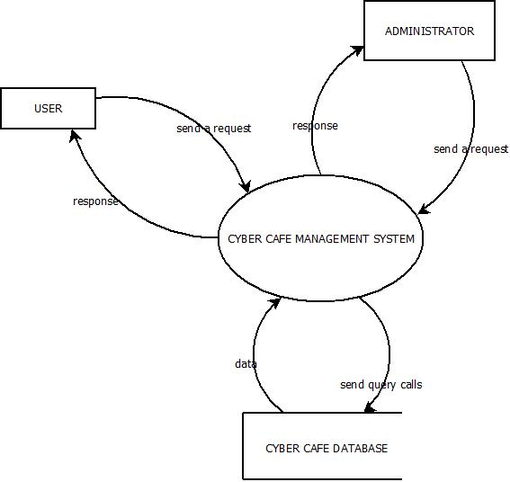

LEVEL 1

USER

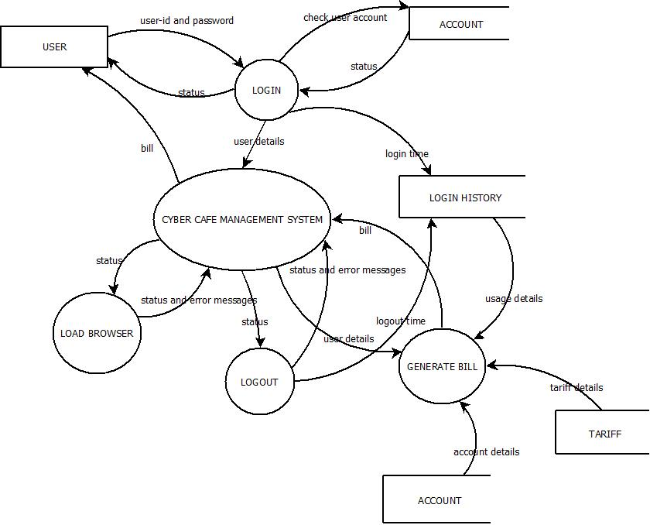

ADMINISTRATOR

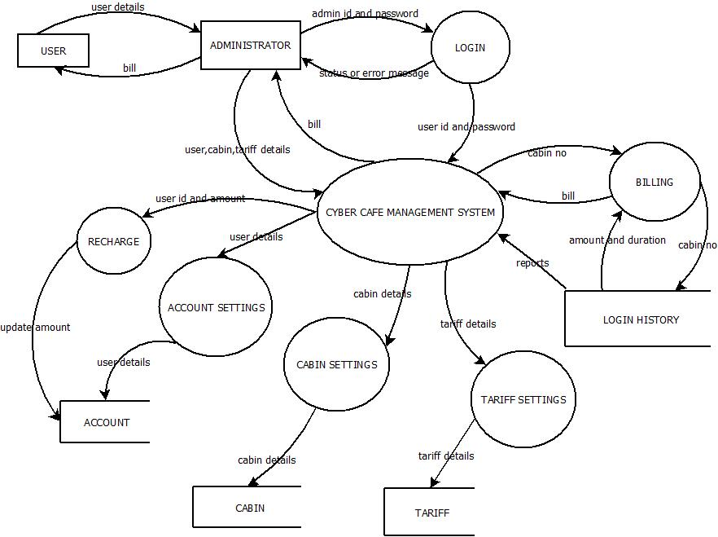

LEVEL2

USER

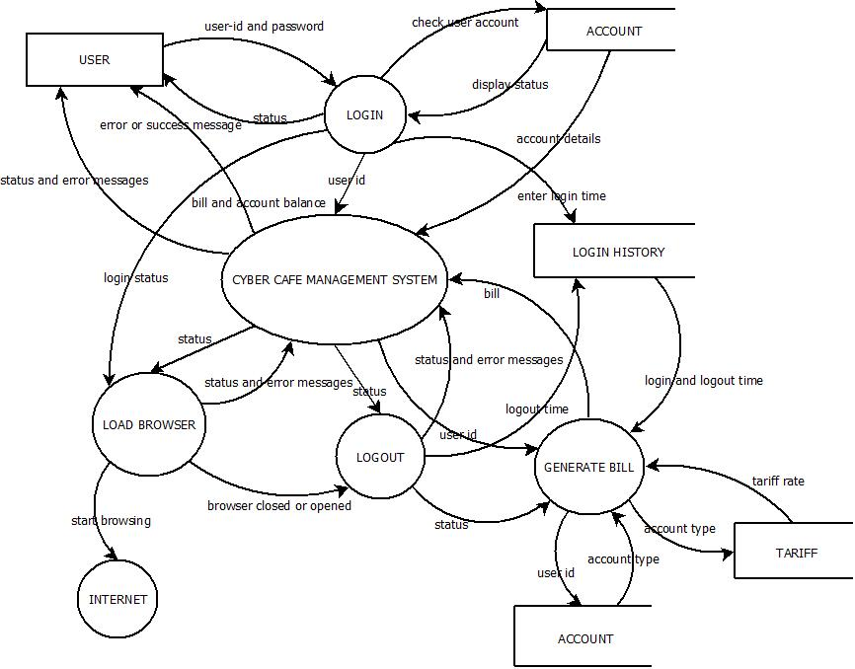

ADMINISTRATOR

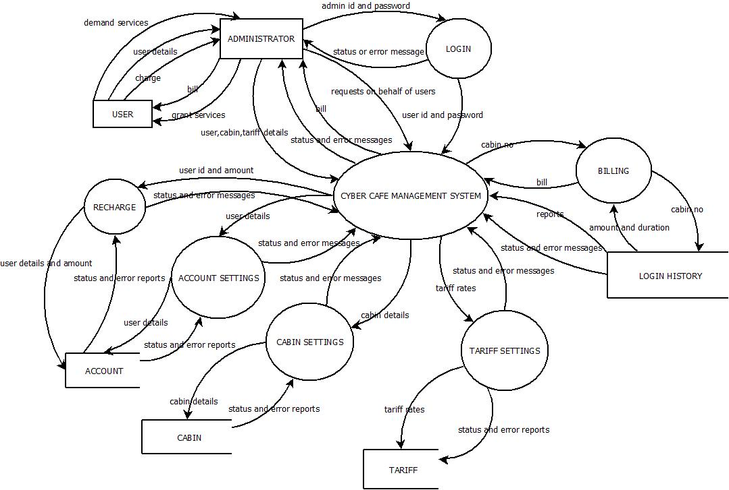

12.3 IMPLEMENTATION FIGURES

12.3.1 MODULE LIST

1. Login:

In this module a user id and password is provided to the Administrator and user, to provide access control. The Administrator has the rights to make modifications from time to time. The user can make use of the software but does have the rights to make modifications in the way it performs.

2. Account Settings:

This module is under the control of administrator. In this module the administrator can create account for the user, edit account and delete account. The user needs to produce some sort of identity proofs to create an account.

3. Cabin Settings:

This module is controlled by the administrator. Here he/she can add cabins to the system, edit cabin, and remove a cabin. The system name (host name) should be entered without fail while adding a cabin to the system.

4. Tariff Settings:

The administrator controls this module. Here he/she can set tariff rates for both Account Users’ and Walkthrough Users’ account.

5. Recharge:
This module is under the control of the administrator. Here recharge of accounts is performed. User shall refill there account on paying respective amount to the administrator.

6. Billing:
This module is controlled by the administrator. Here billing of internet usage by various users is performed.

7. Reports:
The administrator controls this module. Here he/she can have a look on usage reports of a particular user, whole usage, usage in a particular machine and daily report.

8. View Account:

This module is controlled by the administrator. Here he/she can have a look on account details.

13. APPENDIX III

13.1 SCREEN SHOTS

I USER SIDE

(i) USER LOGIN SCREEN

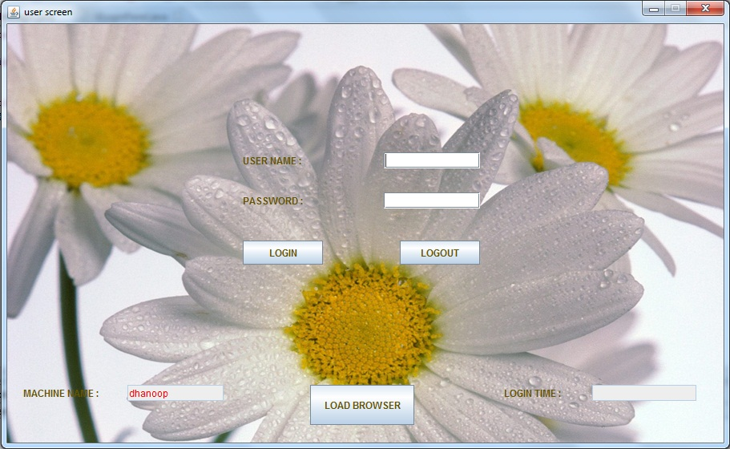

II ADMINISTRATOR SIDE

- LOGIN PAGE

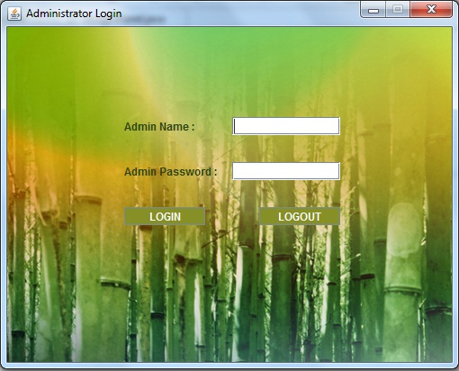

- HOME PAGE

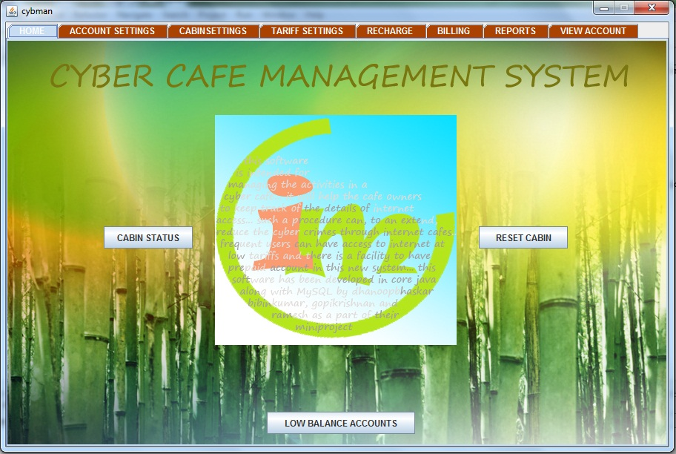

- CREATE ACCOUNT FORM
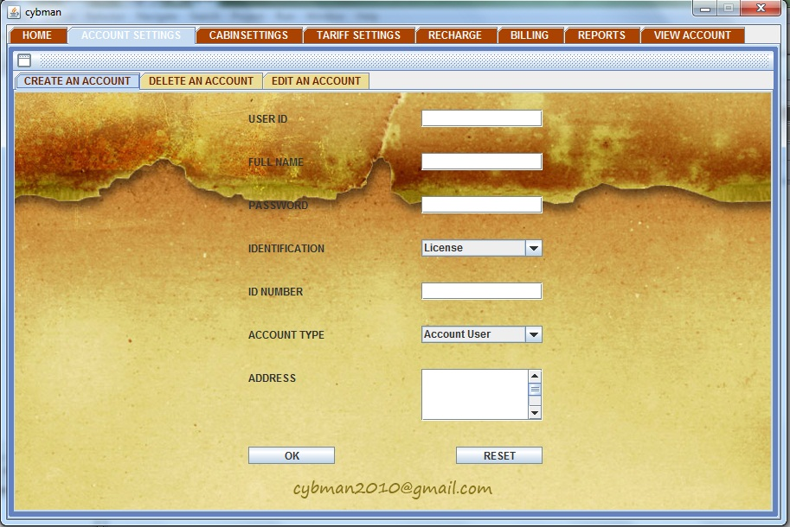

- DELETE ACCOUNT FORM
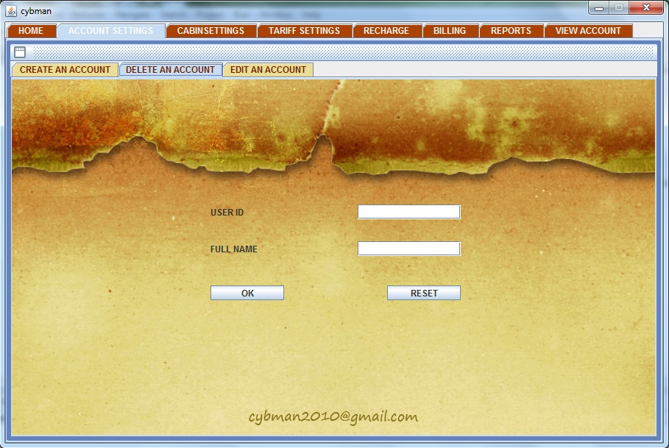

- EDIT ACCOUNT FORM
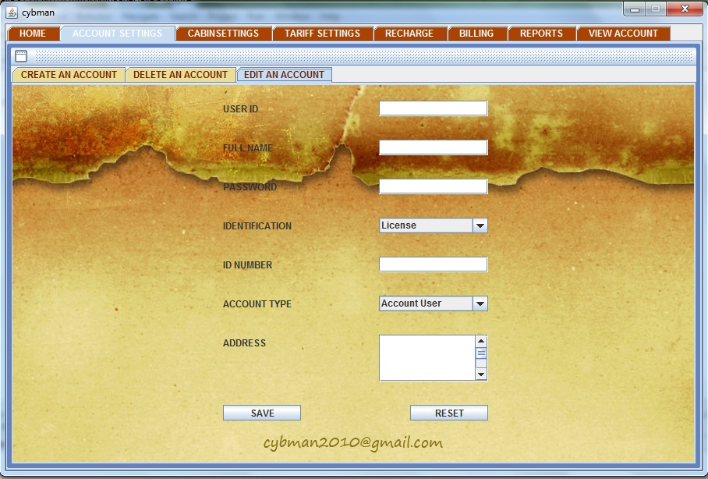

- ADD CABIN FORM
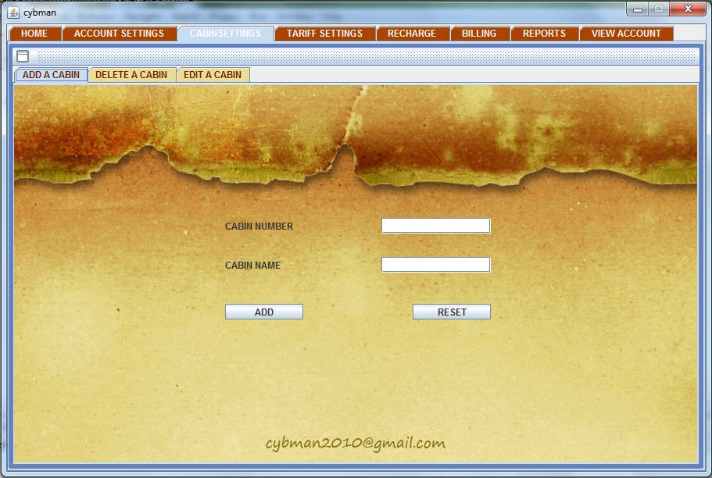

- DELETE CABIN FORM
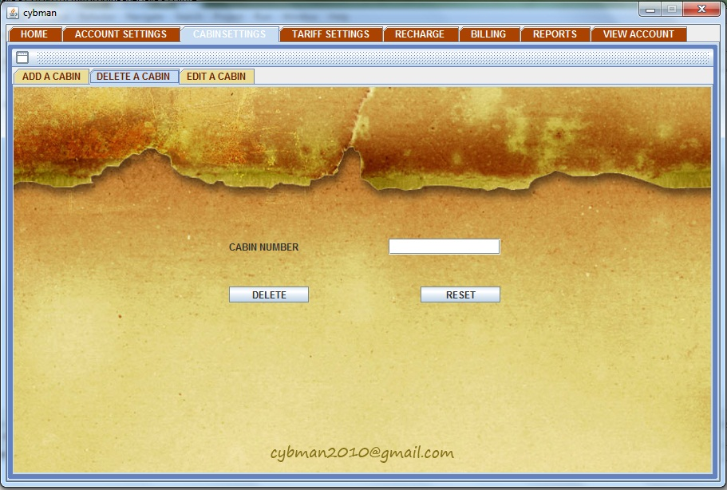

- EDIT CABIN FORM
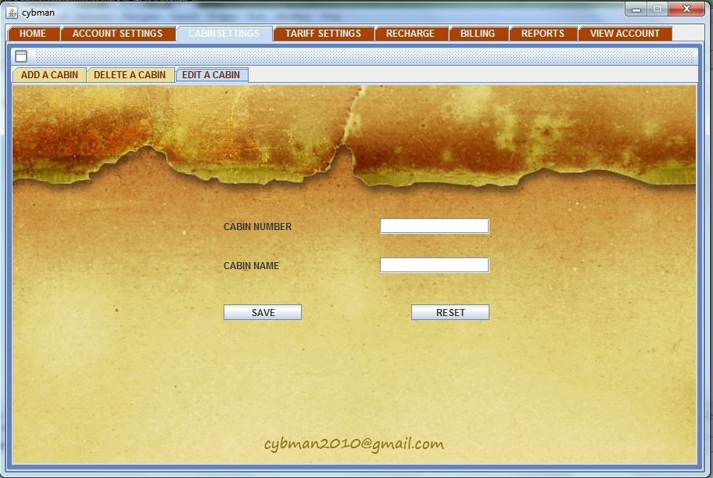

- TARIFF SETTINGS FORM
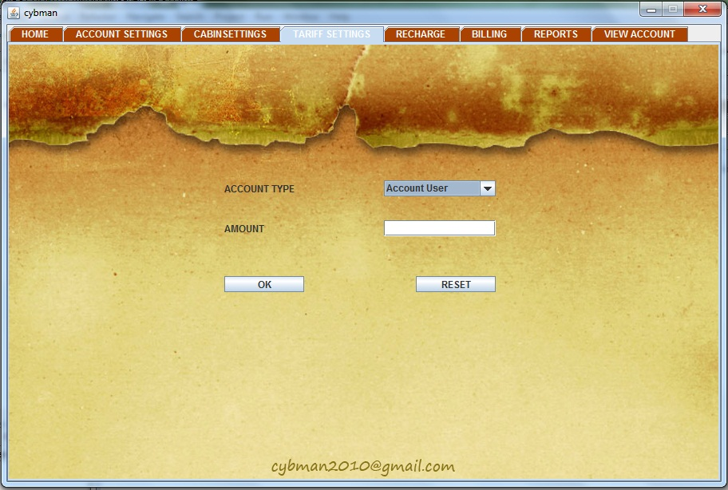

- RECHARGE FORM
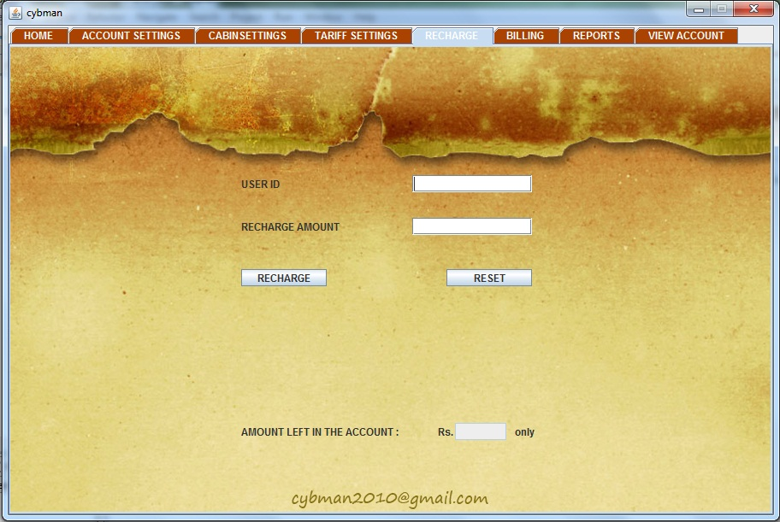

- BILLING FORM
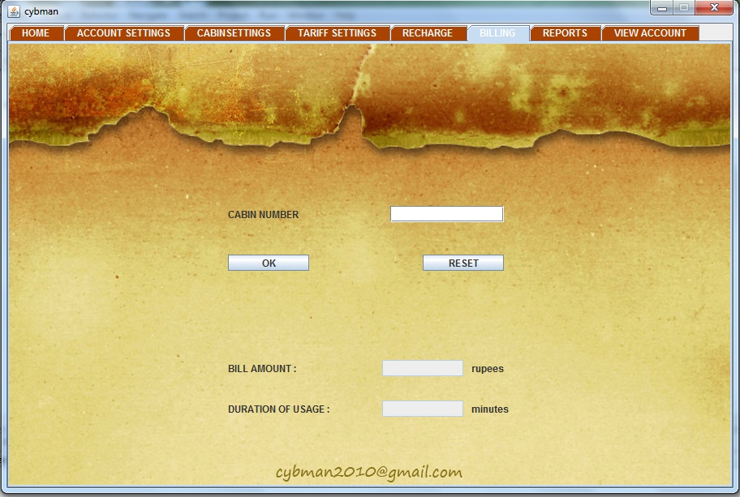
- REPORTS FORM
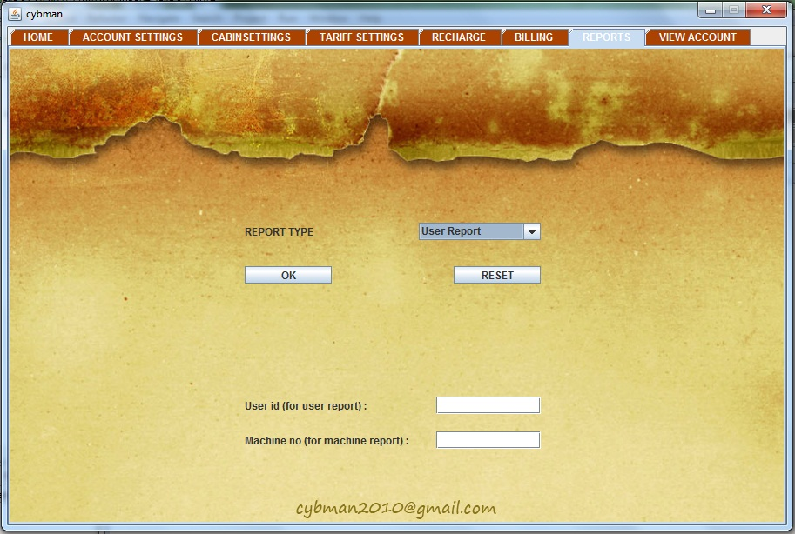

- VIEW ACCOUNT FORM
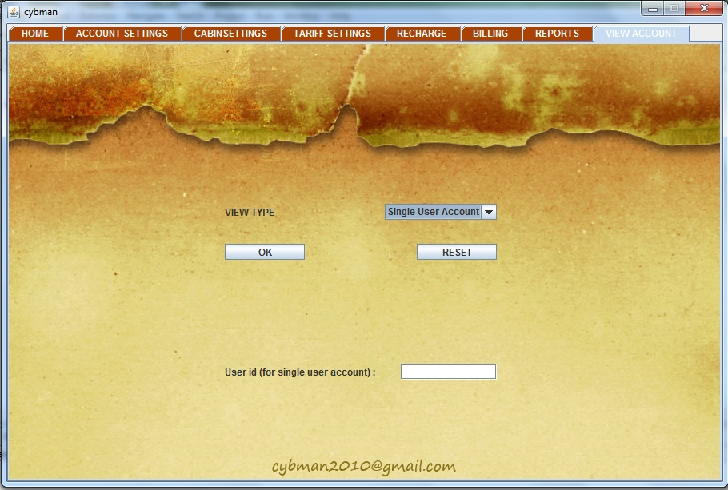

14. APPENDIX IV

  - OVERVIEW

The project entitled “Cyber Café Management System” is a software package, which can be used in cyber cafés for managing the clients’ computer efficiently. Now a day’s cyber terrorism, which is mainly undergone through internet cafés, need to be tackled properly. Thereby, it is indeed necessary to store the valid information of the user who comes for internet access. The system being used, the time at which the user logs in and logs out should be recorded systematically.
In this modern era, a number of people access the internet frequently by means of cyber cafes. For such frequent users, a prepaid account shall be maintained and discounted rates may be charged from them. While walkthrough users, who are less frequent, are charged a fixed rate. By using the LAN connections in the cyber cafes we can automate this process very easily. This system comprises of the following modules:
- The Server Module
- The Client Module
The server module, which is handled by the administrator can create new accounts for prepaid users and also store the details of walkthrough customers. While in the client module, which is handled by users themselves, the user should give his/her user-id and password to start browsing. After they are logged out, the time and amount will be automatically generated at the server module and the bill is provided to the user.
This system is developed in JAVA language with MySQL as backend. The system is a menu driven one. User-friendly menus will help both the administrator and the clients to work on it without any operational difficulty.

THIS IS NOT THE PART OF THIS PROJECT REPORT DELETE IT
