Table creation
Create database college

Use college

Create table StudentRaw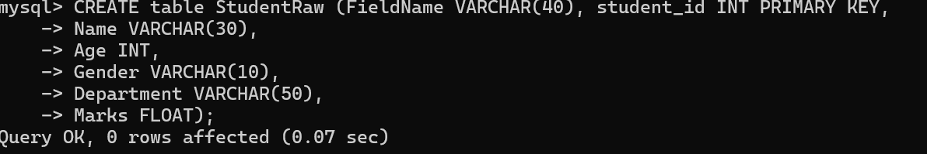
Create another table StudentInfo:
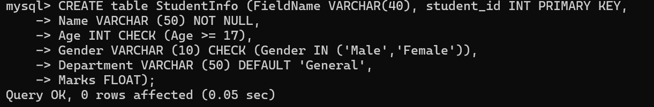

INSERT RECORDS (min 7 row)

Display all records:
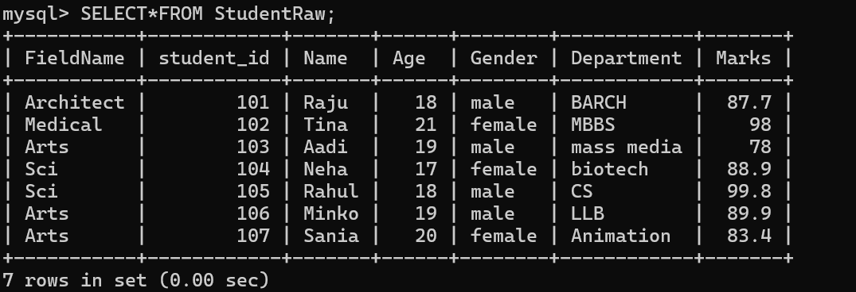

Display only name, Department, and marks
SELECT Name, Department, Marks FROM StudentRaw;
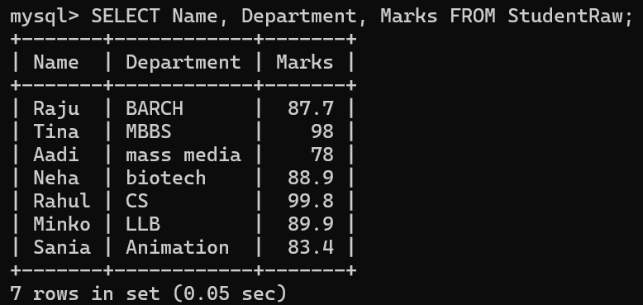

Display students who scored more than 75 marks
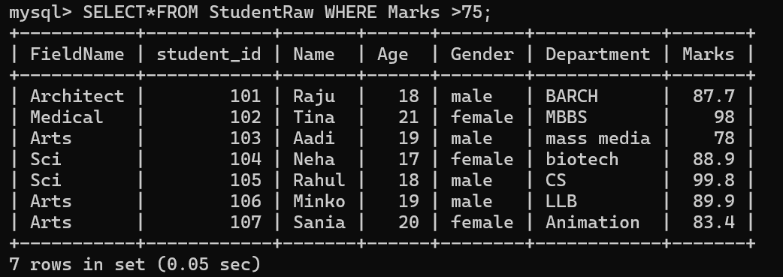

Display names of students from the CS department
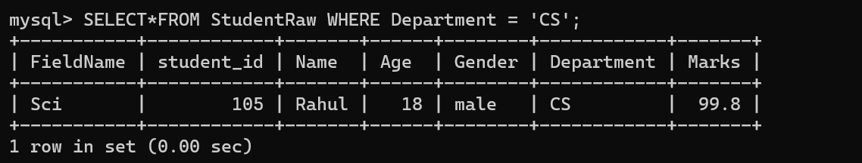

Display students whose name starts with 'A'
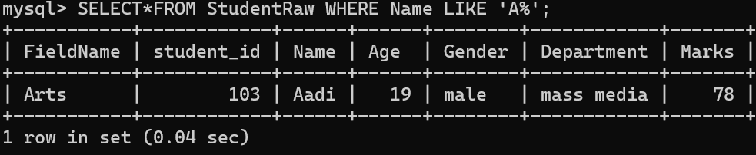

Count total number of students in the table.
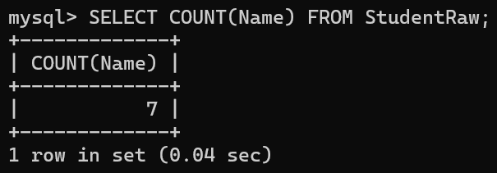
OR
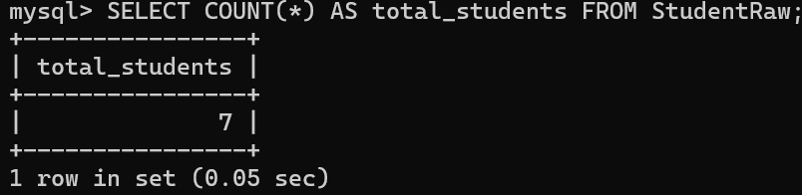

ALTER TABLE COMMANDS
Add a new column EMAIL
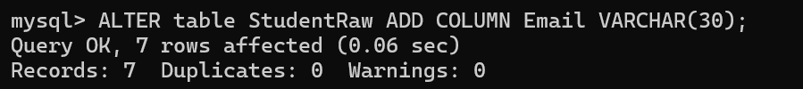

Modify the marks column to DECIMAL(5,2)


Drop the email column from the table
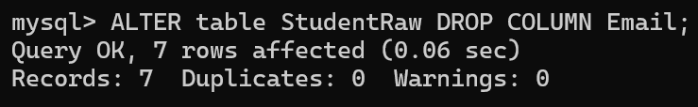

DROP BOTH TABLES


