E-Commerce Management System Backend

Project Name :- E-Commerce Management System Backend

Project Type :- Internship Project
College :- Karmaveer Bhaurao Patil College of Engineering, Satara
Internship :- Symbiosis Powered by Capgemini

1. Team Information
Role | Member Name
Backend Developer | Sayli Shinde
Backend Developer | Anuja Chougule
Backend Developer | Suhana Shaikh
Guide/Mentor |  | Mahajan Mungal

2. Project Overview

Description :-
The E-Commerce Management System Backend is a scalable REST API application developed using Java Spring Boot. The system manages users, companies, products, categories, orders, payments, shipping, reviews, customer support, and organizational hierarchies.
The application follows a layered architecture:
Client
↓
Controller Layer
↓
Service Layer
↓
Service Implementation Layer
↓
Repository Layer
↓
MySQL Database

3. Technology Stack

Backend Technologies
- Java 17
- Spring Boot
- Spring Data JPA
- Hibernate ORM
- REST APIs
- Maven

Database
- MySQL

Development Tools
- IntelliJ IDEA / Eclipse
- Postman
- Git
- GitHub

Additional Libraries
- Lombok
- Jakarta Persistence API
- Spring Web
- Spring Validation

4. Project Statistics
Based on the current project structure:
Component | Count
Entities | 31
Repositories | 31
Service Interfaces | 155
Service Implementations | 155
Controllers | 31
Database Tables | 33
REST APIs | 100+
Relationships | OneToOne, OneToMany, ManyToOne, ManyToMany

5. Layer-wise Architecture

Entity Layer
Purpose:
- Represents database tables.
- Uses JPA annotations.
Examples:
- User
- Product
- Category
- SubCategory
- Order
- Invoice
- Address
- Company
Common Annotations:
@Entity
@Table
@Id
@GeneratedValue
@OneToMany
@ManyToOne

Repository Layer
Purpose:
- Database communication.
- CRUD operations.
Example:
public interface ProductRepository
extends JpaRepository<Product, Long> {
}
Responsibilities:
- Save Data
- Fetch Data
- Update Data
- Delete Data

Service Layer
Purpose:
- Defines business operations.
Each module contains services such as:

Create Service
addData()

Fetch Service
fetchById()

Fetch All Service
fetchAll()

Update Service
updateData()

Delete Service
deleteById()

Service Implementation Layer
Purpose:
- Contains actual business logic.
Example:
@Service
public class ProductCreateServiceImpl
implements ProductCreateService
{
@Autowired
private ProductRepository repository;

@Override
public Product addData(Product product)
{
return repository.save(product);
}
}

Controller Layer & API Testing

Put Swagger Screenshot Here
Use the Swagger UI image (second screenshot).

Heading
REST API Testing using Swagger UI

Points
- POST APIs
- GET APIs
- PUT APIs
- DELETE APIs
- JSON Request/Response Testing
- API Documentation
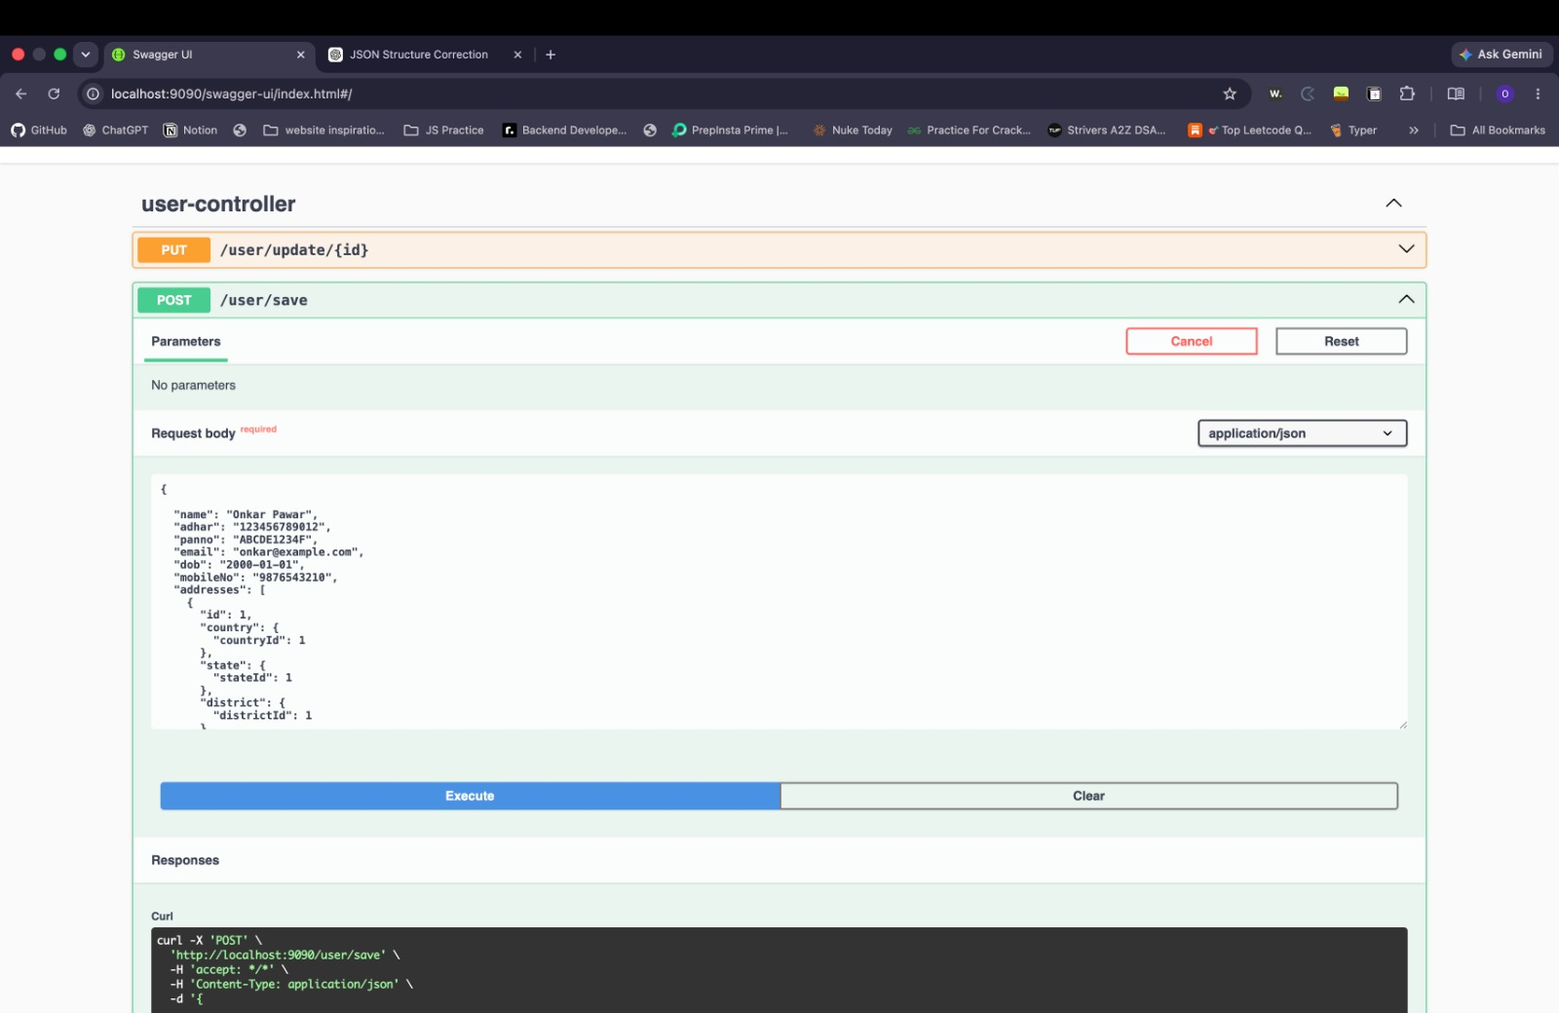
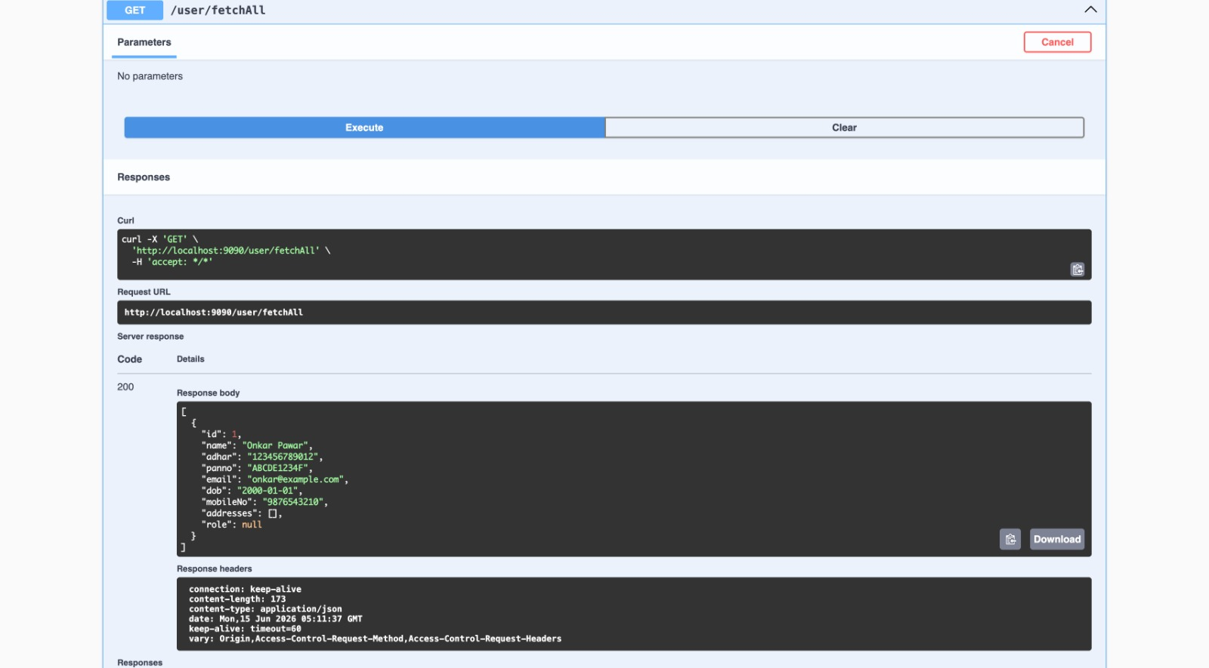

6. Database Modules
The project contains 33 major tables and dependency relationships.

Master Data
- Roles
- Country
- Category
- Company Type
- Owner
- Payment Mode

Location Hierarchy
Country
└── State
└── District
└── Taluka
└── Town

Company Management
Owner
└── Company
├── Manager
├── Department
├── Employee
├── Brand
└── Address

Product Management
Category
└── SubCategory
└── Product
└── ProductReview

Customer Management
User
├── Feedback
├── CustomerQuery
└── Orders

Order Management
Orders
├── Card
├── UPI
├── COD
├── Invoice
├── Tracking
└── ShippingDetails

Support Management
CustomerQuery
└── CompanyResponse
These dependencies are defined in the project design document.
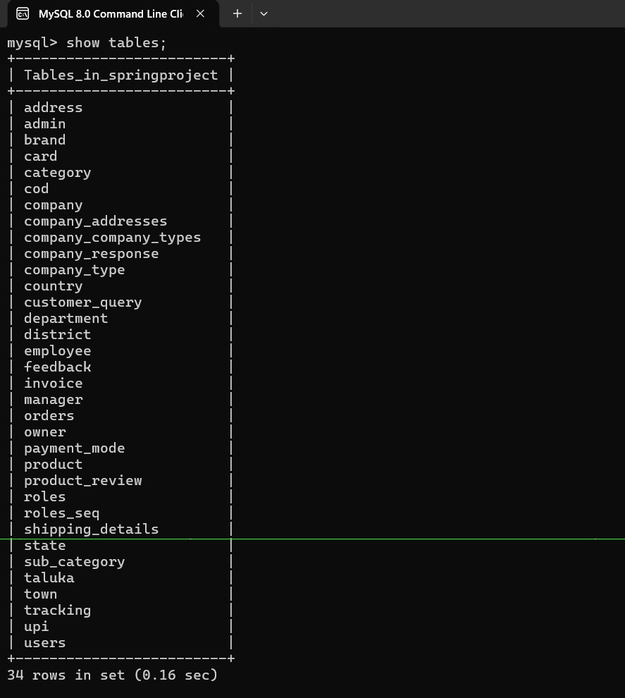

7. Core Functionalities

User Management
- User Registration
- User Login
- Role Assignment
- Address Management

Company Management
- Company Creation
- Company Type Management
- Department Management
- Employee Management

Product Management
- Category Management
- SubCategory Management
- Brand Management
- Product Management
- Product Reviews

Order Management
- Place Orders
- Payment Processing
- Invoice Generation
- Shipping Management
- Order Tracking

Customer Support
- Feedback Submission
- Customer Queries
- Company Responses

8. Key Features
✅ Layered Architecture
✅ RESTful APIs
✅ MySQL Integration
✅ Spring Data JPA
✅ Hibernate ORM
✅ Dependency Injection
✅ Entity Relationships
✅ Modular Service Structure
✅ Scalable Design
✅ Maintainable Codebase

9. Future Enhancements
- Spring Security + JWT Authentication
- Role-Based Access Control (RBAC)
- Email Notifications
- Payment Gateway Integration
- Cloud Deployment (AWS)
- Docker Containerization
- Microservices Architecture
- API Documentation using Swagger

10. Conclusion
The E-Commerce Management System Backend is a comprehensive Spring Boot application designed using industry-standard architecture principles. The project demonstrates expertise in Java, Spring Boot, REST APIs, JPA/Hibernate, MySQL, and enterprise backend development through the implementation of 31 entities, 31 repositories, 155 service interfaces, 155 service implementations, and a complete business workflow from user registration to order tracking.

Updated Architecture (Spring Boot + Factory Pattern)
Application Flow:
Client → Controller → Factory → Service → Repository → Database
Controller:
- Handles REST API requests
Factory Layer:
- Central decision maker using switch-case
- Routes request to appropriate service
Service Layer:
- Contains interfaces:
Create, Update, Delete, GetById, GetAll
Service Implementation:
- Contains business logic
- Uses repository to interact with DB
Repository Layer:
- Extends JpaRepository
- Performs CRUD operations

UPI Module (Example Implementation)
Layers in UPI Module:
1. Repository:
- UpiRepository extends JpaRepository
2. Service Interfaces:
- CreateUpiService
- UpdateUpiService
- DeleteUpiService
- GetUpiByIdService
- GetAllUpiService
3. Service Implementations:
- CreateUpiServiceImpl
- UpdateUpiServiceImpl
- DeleteUpiServiceImpl
- GetUpiByIdServiceImpl
- GetAllUpiServiceImpl
4. Factory:
- UpiFactory with switch-case (1 to 5 operations)
5. Controller:
- /upi/save
- /upi/update
- /upi/delete/{id}
- /upi/{id}
- /upi/all

Key Improvements Added
✔ Factory Pattern for better control
✔ Modular Service Structure
✔ Clean layered separation
✔ Easy scalability for new modules
✔ Consistent CRUD handling

