|  |  |  |
| --- | --- | --- |
| **Name** | **ID** | **STUDENT SIGN** |
| **MOST. SAYMA KHATUN** | **22-47035-1** | **sayma** |

**Class Test 01**

**Hogwarts** is a school of witchcraft and wizardry. To ensure proper management of their data the renowned school has decided to maintain a database system. Out of many bidders your company was hired to accomplish the task. Your job is to create a relational database for Hogwarts from the requirements specified below:

RDBMS- Oracle 10g

Language-SQL

Log in as User System and create a ***user*** Dumbledore who has ***password*** Phoenix. Dumbledore is granted ***unlimited tablespace***. He is also granted the permission to ***create*** tables. After logging in with his username and password Dumbledore creates ***two tables*** i.e. Student and House. ***Student*** table has five columns containing information about students ***Identification Number, Name, CGPA, Blood Status and House Number***. ***House*** table has three columns containing information about ***House Number, House Name and House Points***. Here S_Id, H_Id are the ***primary key columns*** of Student and House table respectively. Student table also has a ***foreign key*** column H_No. Constraint should be applied in such a way that CGPA cannot be greater than 4.00 and House name cannot be NULL. The two tables along with their inserted data are given below:

**Table: Student Table: House**

|  |  |  |  |  |
| --- | --- | --- | --- | --- |
| S_Id | S_Name | S_CGPA | S_BloodStatus | H_No |
| 2 | Harry | 3.45 | Halfblood | 11 |
| 7 | Ron | 3.01 | Pureblood | 11 |
| 12 | Hannah |  | Pureblood | 22 |
| 17 | Cedric | 3.78 | Pureblood | 22 |
| 22 | Cho | 3.55 | Muggleborn | 33 |
| 27 | Luna | 2.89 |  | 33 |
| 32 | Draco | 3.88 | Pureblood | 44 |
| 37 | Goyle | 2.10 | Pureblood | 44 |

|  |  |  |
| --- | --- | --- |
| H_Id | H_Name | H_Points |
| 11 | Gryffindor | 892 |
| 22 | Hufflepuf | 785 |
| 33 | Ravenclaw | 789 |
| 44 | Slytherin | 850 |

After creating the tables and inserting data based on provided requirements write Queries (Write down the question and also the answer. Give screenshot of the result of the query.You can add more Answer Box if required) according to the following specification:

-using **ARITHMETIC** operator

-using **CONCATENATION** operator

-using **COLUMN ALIAS**

-using **LIKE** operator

-using **IS NULL** operator

-using **ORDER BY** clause

-using **SUBSTR** function

-using **NVL** function

-using **MAX** function

-using **SUM** function

-using **GROUP BY** clause

-using **HAVING** claus

Answer:

**1.ARITHMETIC:**

Question: Calculate the total CGPA and House Points for each student. Display the student name, CGPA, House Points, and the total.

Query: SELECT S_Name, S_CGPA, H_Points, (S_CGPA + H_Points) AS Total FROM Student

JOIN House ON Student.H_No = House.H_Id;

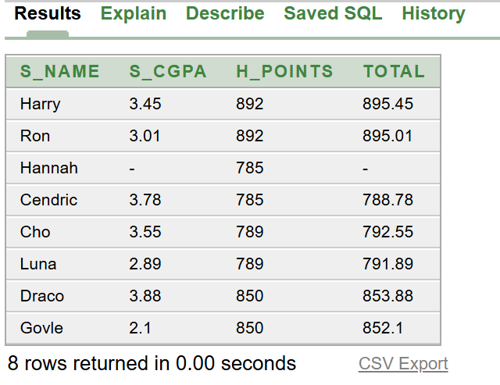

Answer:

1. **CONCATENATION:**

Question: Concatenate the student’s name and blood status in the format 'Name – BloodStatus’.

Query: SELECT S_Name || ' - ' || S_BloodStatus AS Student_Info FROM Student;



Answer:

1. **COLUMN ALIAS**

Question: Display the House Name with an alias 'HouseName' and House Points with an alias 'Points'

Query: SELECT H_Name AS HouseName, H_Points AS Points

FROM House;

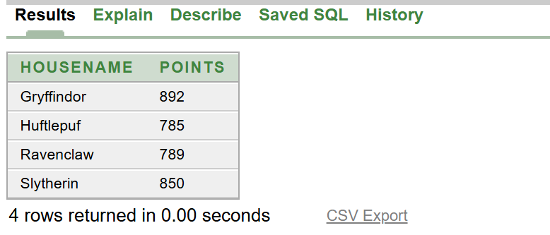

Answer:

1. **LIKE**

Question: Retrieve all students whose names start with 'C'.

Query: SELECT S_Name

FROM Student

WHERE S_Name LIKE 'C%';

Answer:

1. **NULL**

Question: Retrieve all students who do not have a specified blood status.

Query: SELECT S_Name

FROM Student

WHERE S_BloodStatus IS NULL;

Answer:

1. **ORDER BY** clause

Question: Retrieve all students ordered by their CGPA in descending order.

Query: SELECT S_Name, S_CGPA

FROM Student

ORDER BY S_CGPA DESC;

Answer:

**7. SUBSTR** function

Question: Retrieve the first 3 characters of the student names.

Query: SELECT SUBSTR(S_Name, 1, 3) AS Name_Part

FROM Student;

Answer:

**8. NVL** function

Question: Retrieve the student names and their blood status. If the blood status is NULL, replace it with 'Unknown'.

Query: SELECT S_Name, NVL(S_BloodStatus, 'Unknown') AS Blood_Status

FROM Student;

Answer:

**9. MAX** function

Question: Retrieve the highest CGPA among the students.

Query: SELECT MAX(S_CGPA) AS Highest_CGPA

FROM Student;

Answer:

**10. SUM** function

Question: Retrieve the total house points for each house.

Query: SELECT H.H_Name, SUM(H_Points) AS Total_Points

FROM House H

GROUP BY H.H_Name;

Answer:

**12. HAVING** clause

Question: Retrieve houses with an average CGPA greater than 3.5.

Query: SELECT H.H_Name, AVG(S.S_CGPA) AS Average_CGPA

FROM Student S

JOIN House H ON S.H_No = H.H_Id

GROUP BY H.H_Name

HAVING AVG(S.S_CGPA) > 3.5;

Answer:

**11. GROUP BY** clause

Question : Retrieve the average CGPA for each house.

Query: SELECT H.H_Name, AVG(S.S_CGPA) AS Average_CGPA

FROM Student S

JOIN House H ON S.H_No = H.H_Id

GROUP BY H.H_Name;

