**Class Test 04**

**Table: Student_info**

|  |  |  |  |  |  |
| --- | --- | --- | --- | --- | --- |
| S_Id | S_Name | S_CGPA | S_BloodStatus | S_BloodGroup | a_id |
| 1 | Mira | 3.59 | Halfblood | O+ | 11 |
| 2 | Rahman | 3.90 | Pureblood | A+ | 11 |
| 3 | Sharon |  | Pureblood | B+ | 22 |
| 4 | Caprio | 3.21 | Pureblood | AB+ | 22 |
| 5 | Winslet | 3.55 | Muggleborn | AB- | 33 |
| 6 | Khadija | 2.85 |  | O- | 33 |
| 7 | Shekhar | 2.30 | Pureblood | O+ | 44 |
| 8 | Florina | 3.10 | Pureblood | B+ | 44 |

**Table: Address**

|  |  |  |  |
| --- | --- | --- | --- |
| a_id | city | country | Country_code |
| 11 | Dhaka | Bangladesh | 101 |
| 22 | Doha | Qatar | 102 |
| 33 | Washington D.C | USA | 103 |
| 44 | London | UK | 104 |

Write down the queries of the following questions:

Table Creation Query:

Student Info:

CREATE TABLE Student_info (

S_Id NUMBER PRIMARY KEY,

S_Name VARCHAR2(50),

S_CGPA NUMBER(3,2),

S_BloodStatus VARCHAR2(20),

S_BloodGroup VARCHAR2(5),

a_id NUMBER

);

Address:

CREATE TABLE Address (

a_id NUMBER PRIMARY KEY,

city VARCHAR2(50),

country VARCHAR2(50),

country_code NUMBER

);

Data insertion Query:

Address:

INSERT INTO Address VALUES (11, 'Dhaka', 'Bangladesh', 101);

INSERT INTO Address VALUES (22, 'Doha', 'Qatar', 102);

INSERT INTO Address VALUES (33, 'Washington D.C', 'USA', 103);

INSERT INTO Address VALUES (44, 'London', 'UK', 104);

Student Info:

INSERT INTO Student_info VALUES (1, 'Mira', 3.59, 'Halfblood', 'O+', 11);

INSERT INTO Student_info VALUES (2, 'Rahman', 3.90, 'Pureblood', 'A+', 11);

INSERT INTO Student_info VALUES (3, 'Sharon', NULL, 'Pureblood', 'B+', 22);

INSERT INTO Student_info VALUES (4, 'Caprio', 3.21, 'Pureblood', 'AB+', 22);

INSERT INTO Student_info VALUES (5, 'Winslet', 3.55, 'Muggleborn', 'AB-', 33);

INSERT INTO Student_info VALUES (6, 'Khadija', 2.85, NULL, 'O-', 33);

INSERT INTO Student_info VALUES (7, 'Shekhar', 2.30, 'Pureblood', 'O+', 44);

INSERT INTO Student_info VALUES (8, 'Florina', 3.10, 'Pureblood', 'B+', 44);

1. Display the name, CGPA, (CGPA-0.5) of the students from the Student_info table.

**SQL Solution:**

Query: SELECT S_Name, S_CGPA, (S_CGPA - 0.5) AS "CGPA_Minus_0.5"

FROM Student_info;

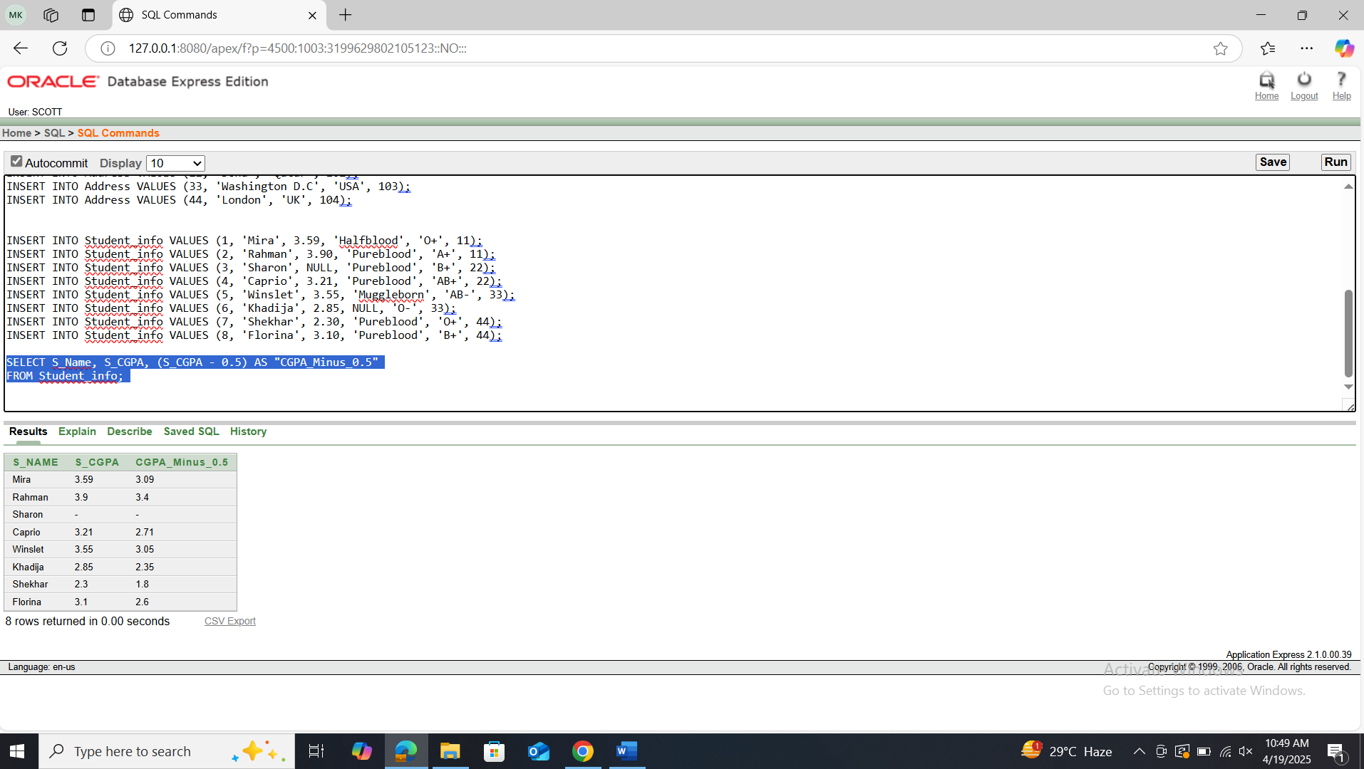

**PL/SQL Solution:**

Query: BEGIN

FOR rec IN (SELECT S_Name, S_CGPA, S_CGPA - 0.5 AS CGPA_Minus

FROM Student_info) LOOP

DBMS_OUTPUT.PUT_LINE('Name: ' || rec.S_Name || ', CGPA: ' || rec.S_CGPA || ', CGPA-0.5: ' || rec.CGPA_Minus);

END LOOP;

END;

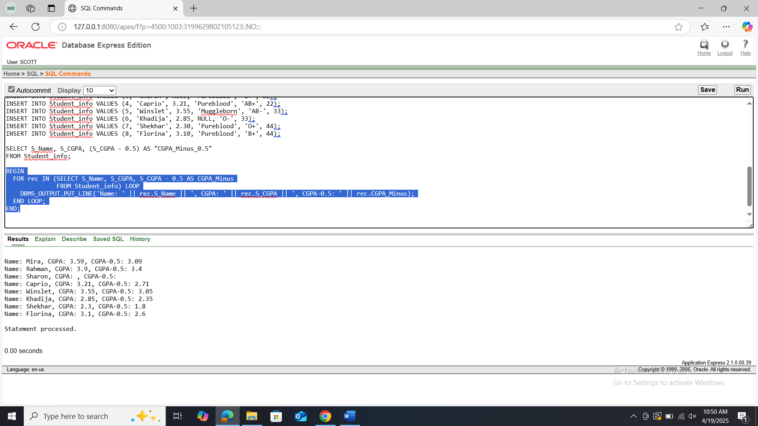

1. Display country and country code together as “Country_info” using concatenation function.

**SQL Solution:**

Query: SELECT country || ' (' || country_code || ')' AS Country_info

FROM Address;

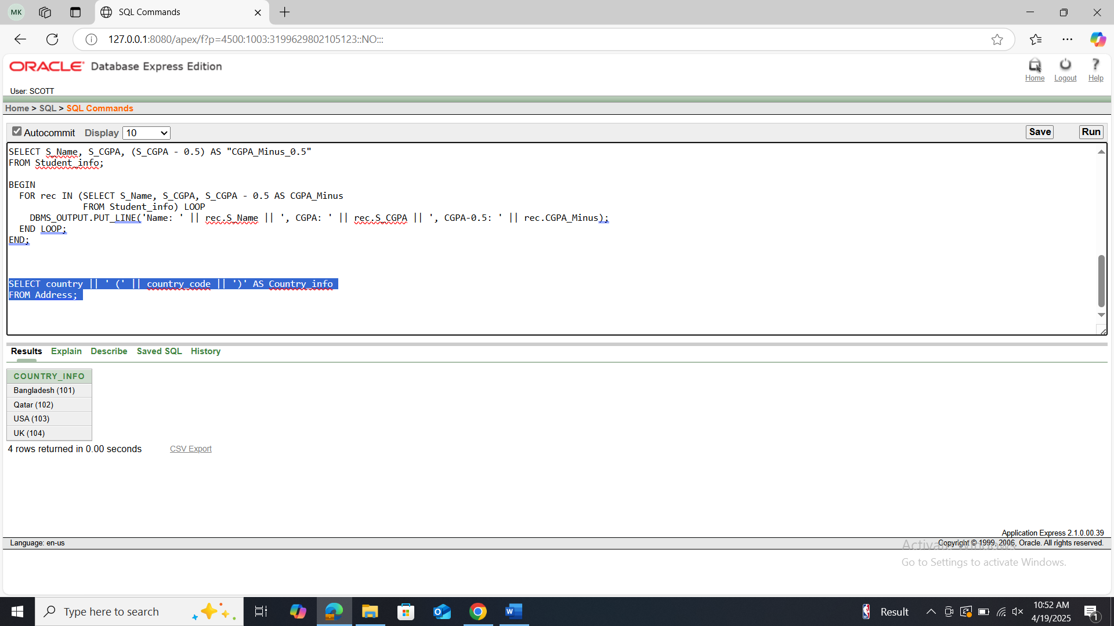

**PL/SQL Solution:**

Query: BEGIN

FOR rec IN (SELECT country || ' (' || country_code || ')' AS Country_info

FROM Address) LOOP

DBMS_OUTPUT.PUT_LINE('Country_info: ' || rec.Country_info);

END LOOP;

END;

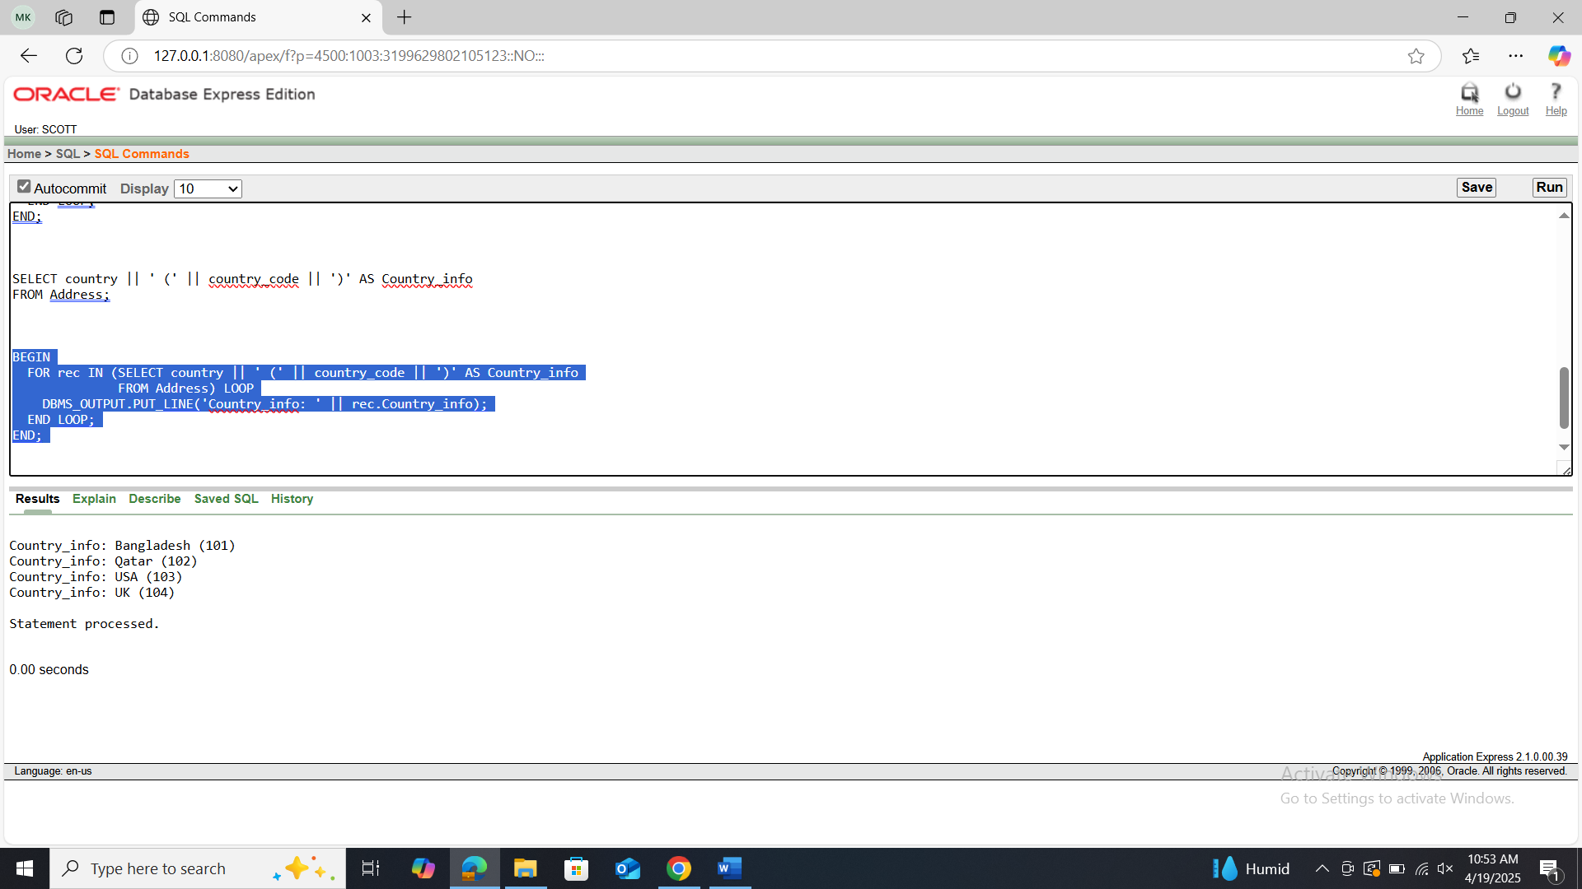

1. Display the student name and student blood status with the column name “Student Name” and “Student Blood Status” from Student_info.

**SQL Solution:**

Query: SELECT S_Name AS "Student Name", S_BloodStatus AS "Student Blood Status"

FROM Student_info;

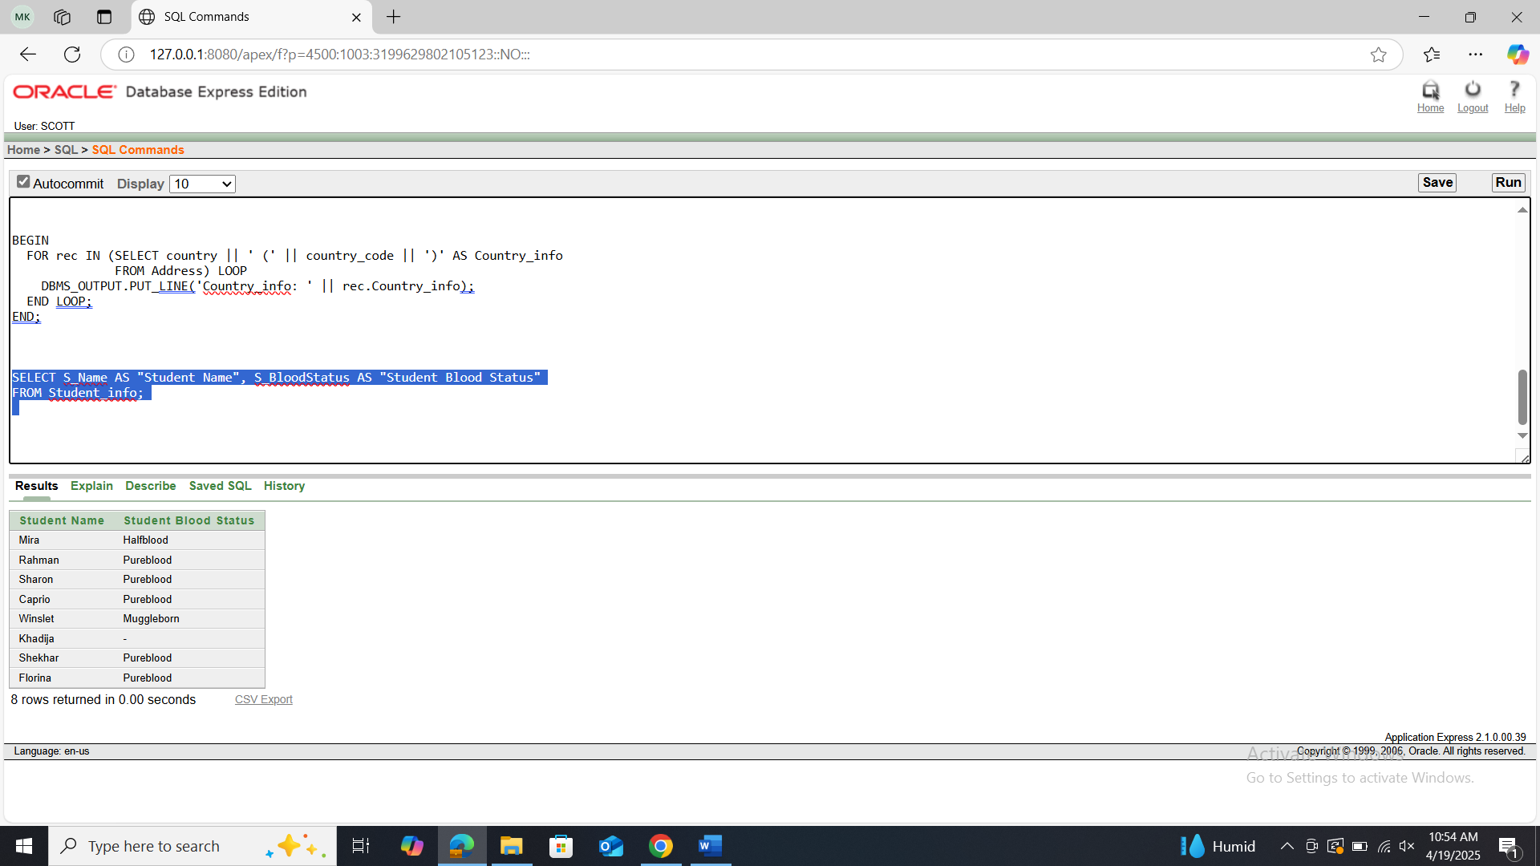

**PL/ SQL Solution:**

Query: BEGIN

FOR rec IN (SELECT S_Name, S_BloodStatus FROM Student_info) LOOP

DBMS_OUTPUT.PUT_LINE('Student Name: ' || rec.S_Name || ', Blood Status: ' || rec.S_BloodStatus);

END LOOP;

END;

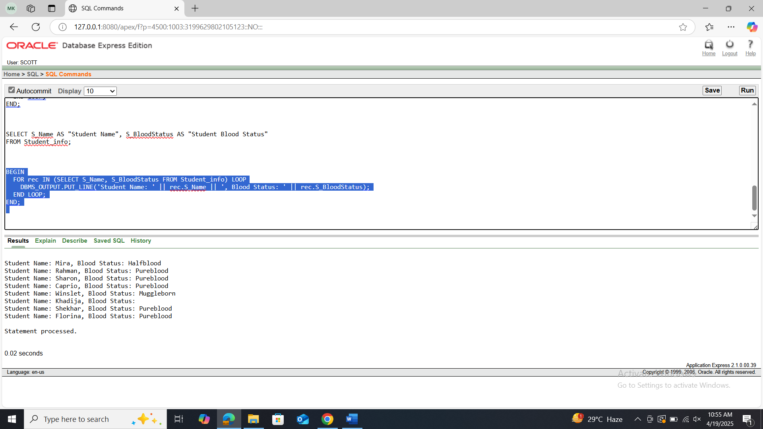

1. Display all students who have only one ‘o’ in their name.

**SQL Solution:**

Query: SELECT S_Name

FROM Student_info

WHERE LENGTH(LOWER(S_Name)) - LENGTH(REPLACE(LOWER(S_Name), 'o', '')) = 1;

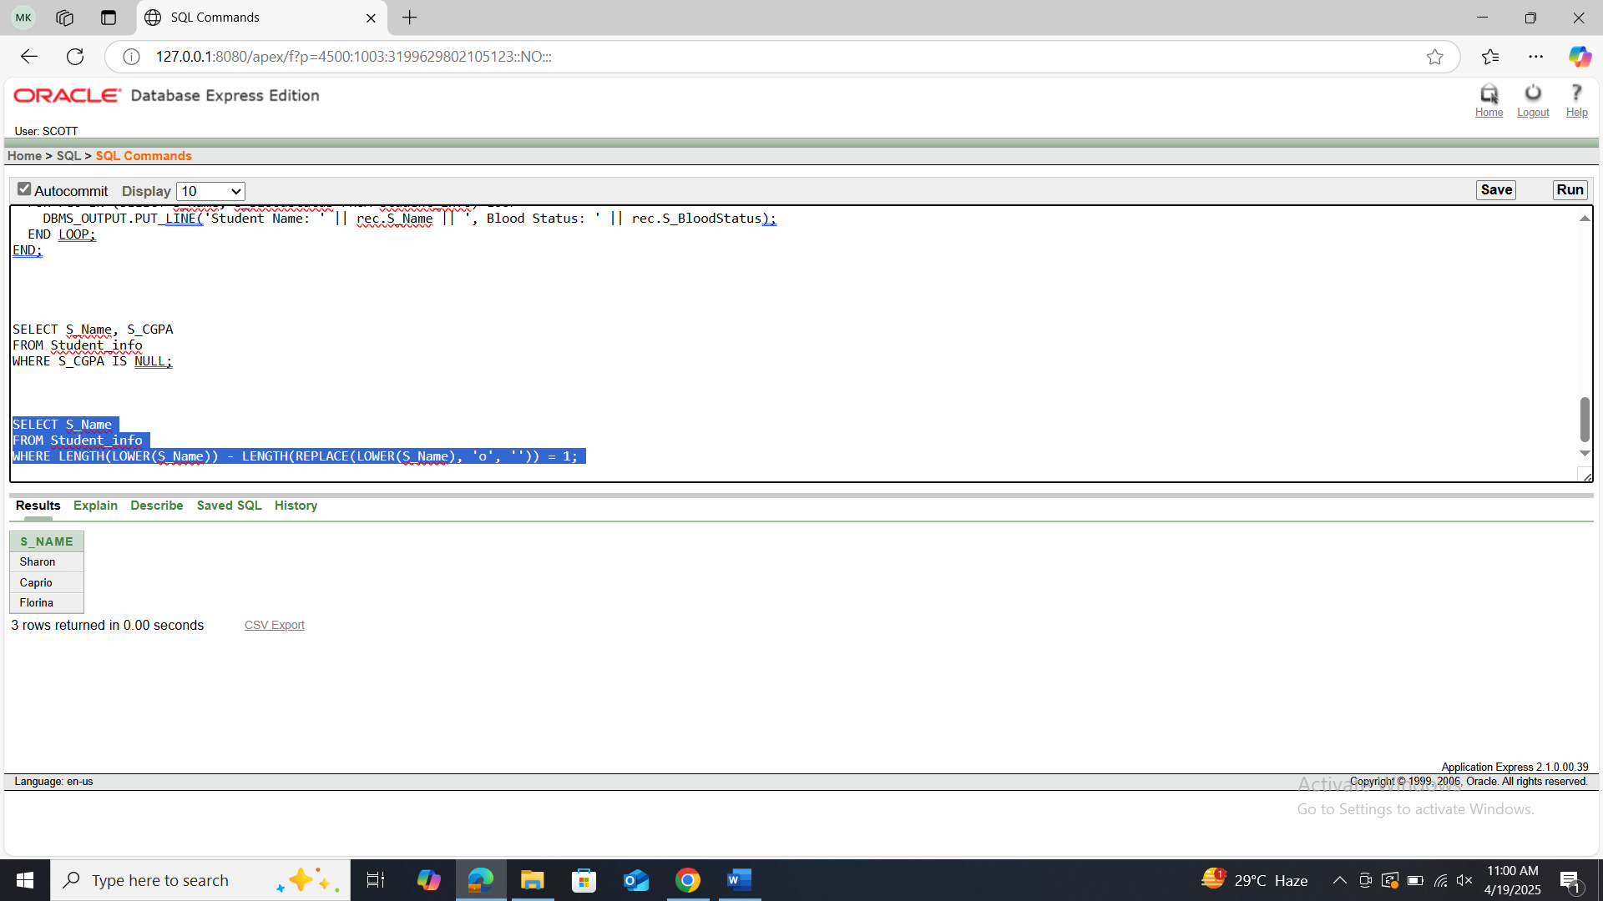

**PL/SQL Solution:**

Query: BEGIN

FOR rec IN (

SELECT S_Name

FROM Student_info

WHERE LENGTH(LOWER(S_Name)) - LENGTH(REPLACE(LOWER(S_Name), 'o', '')) = 1

) LOOP

DBMS_OUTPUT.PUT_LINE('Student with one ''o'': ' || rec.S_Name);

END LOOP;

END;

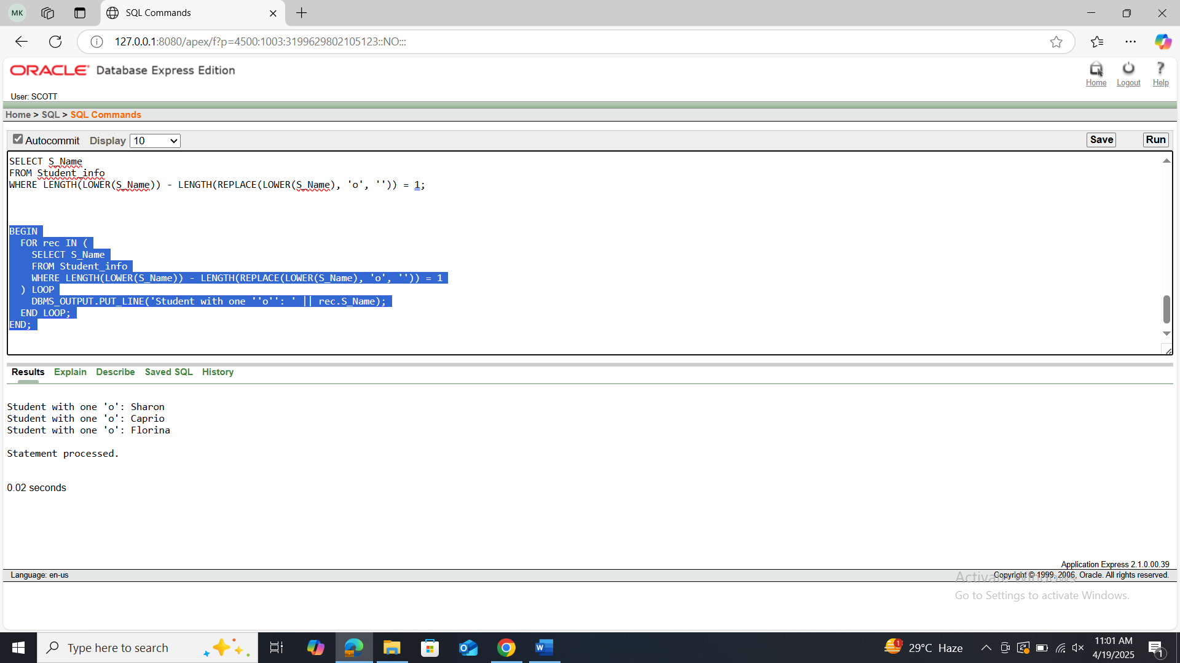

1. Display the student name , CGPA who have null value in their CGPA.

**SQL Solution:**

Query: SELECT S_Name, S_CGPA

FROM Student_info

WHERE S_CGPA IS NULL;

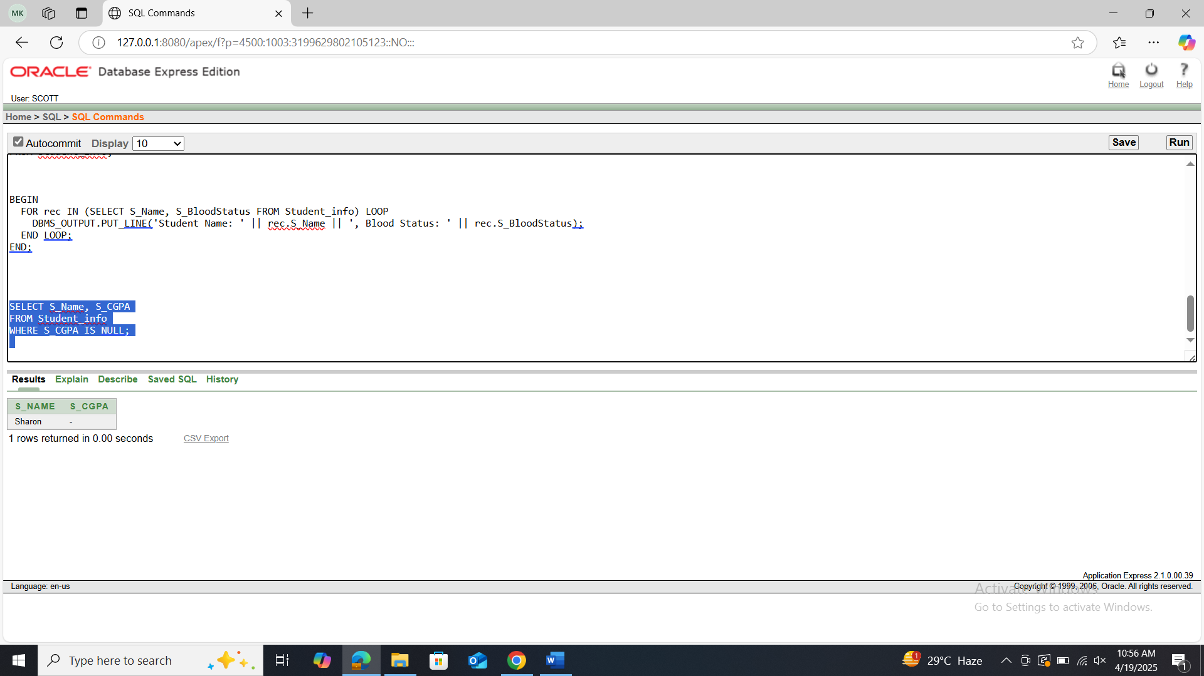

**PL/SQL Solution:**

Query: BEGIN

FOR rec IN (SELECT S_Name, S_CGPA FROM Student_info WHERE S_CGPA IS NULL) LOOP

DBMS_OUTPUT.PUT_LINE('Name: ' || rec.S_Name || ', CGPA: NULL');

END LOOP;

END;

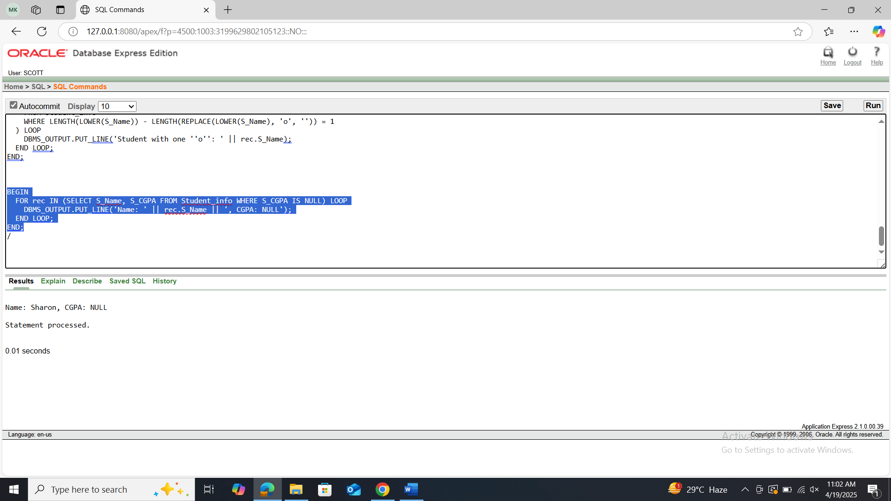

1. Display the city, country, country_code and those must be shown from highest numbered country code to lowest numbered country code.

**SQL Solution:**

Query: SELECT city, country, country_code

FROM Address

ORDER BY country_code DESC;

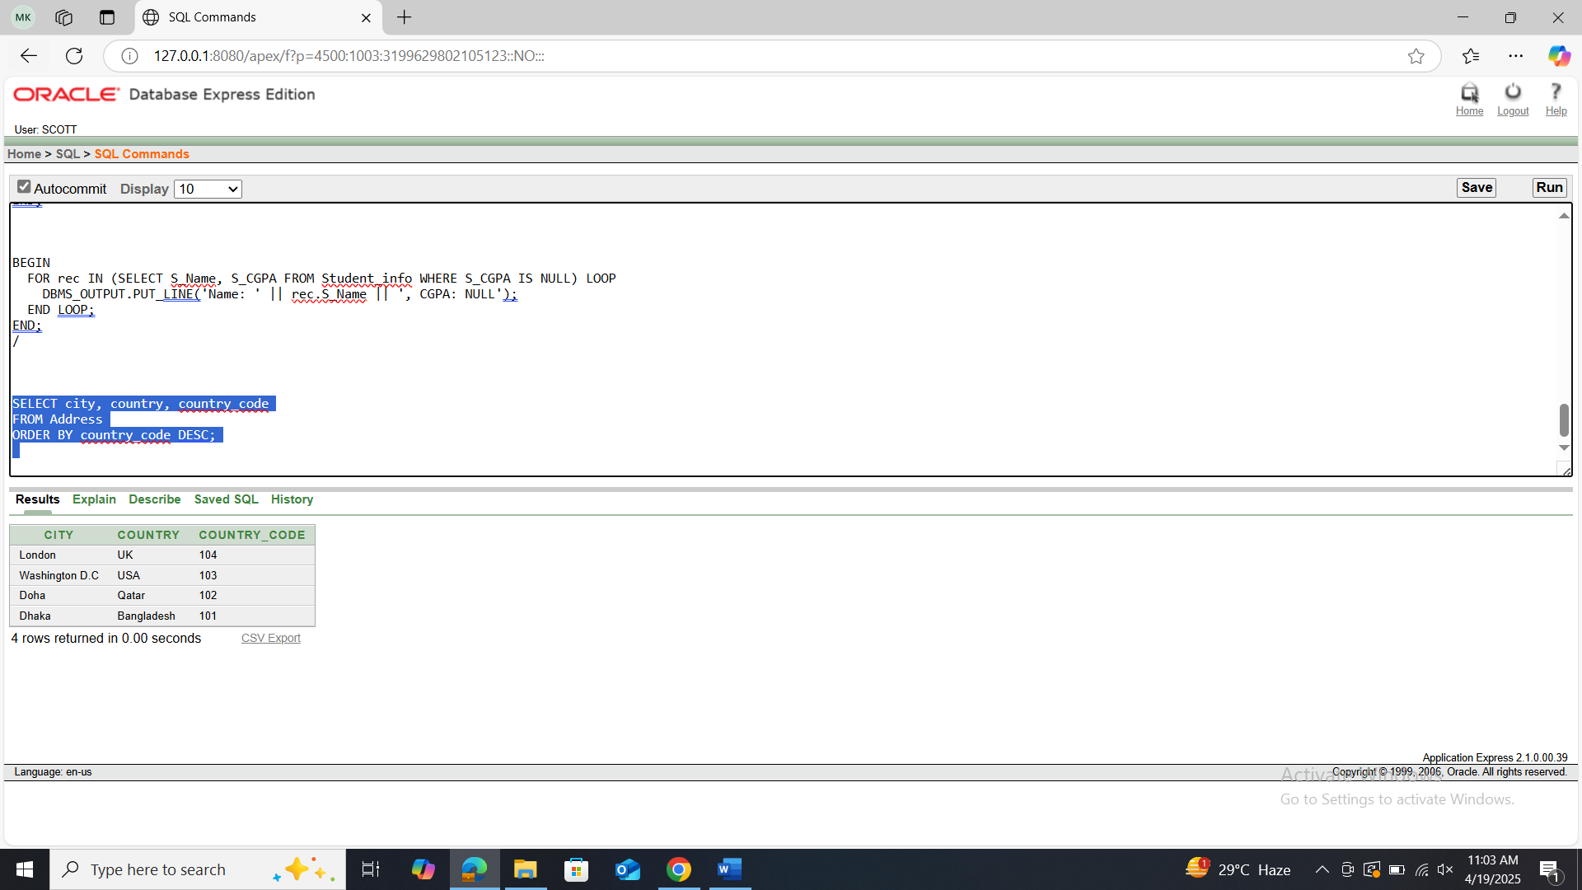

**PL/SQL Solution:**

Query: BEGIN

FOR rec IN (SELECT city, country, country_code FROM Address ORDER BY country_code DESC) LOOP

DBMS_OUTPUT.PUT_LINE('City: ' || rec.city || ', Country: ' || rec.country || ', Code: ' || rec.country_code);

END LOOP;

END;

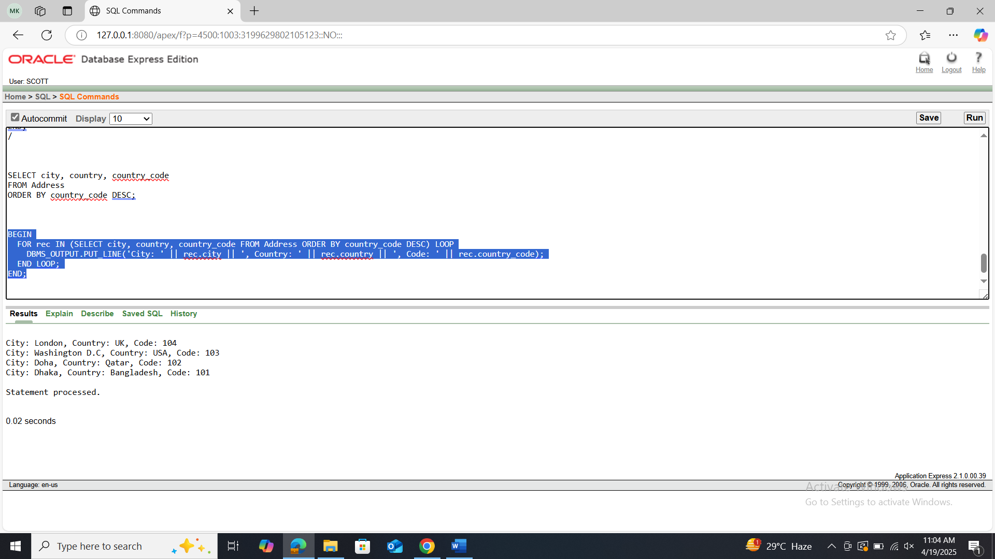

1. Display the student name, student CGPA and student blood status together where the blood status is pureblood using SUBSTR.

**SQL Solution:**

Query: SELECT S_Name, S_CGPA, SUBSTR(S_BloodStatus, 1, LENGTH(S_BloodStatus)) AS "Blood Status"

FROM Student_info

WHERE S_BloodStatus = 'Pureblood';

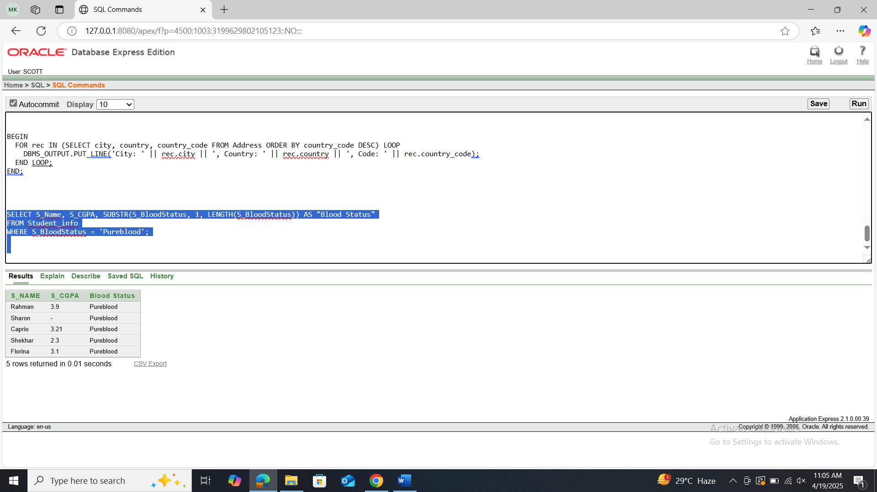

**PL/SQL Solution:**

Query: BEGIN

FOR rec IN (SELECT S_Name, S_CGPA, SUBSTR(S_BloodStatus, 1, LENGTH(S_BloodStatus)) AS BloodStatus

FROM Student_info

WHERE S_BloodStatus = 'Pureblood') LOOP

DBMS_OUTPUT.PUT_LINE('Name: ' || rec.S_Name || ', CGPA: ' || rec.S_CGPA || ', Status: ' || rec.BloodStatus);

END LOOP;

END;

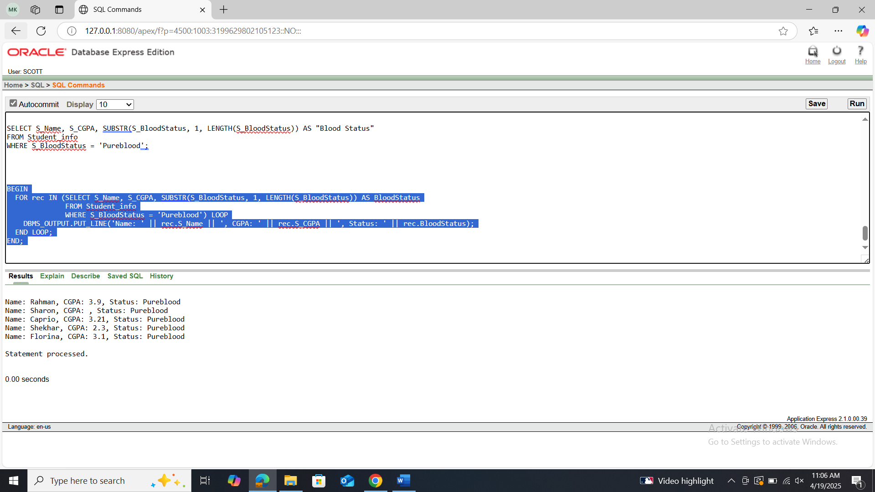

1. Show all the students with their CGPA and blood status. If there is any null value use NVL function.

**SQL Solution:**

Query: SELECT S_Name,

NVL(TO_CHAR(S_CGPA), 'No CGPA') AS CGPA,

NVL(S_BloodStatus, 'Unknown') AS Blood_Status

FROM Student_info;

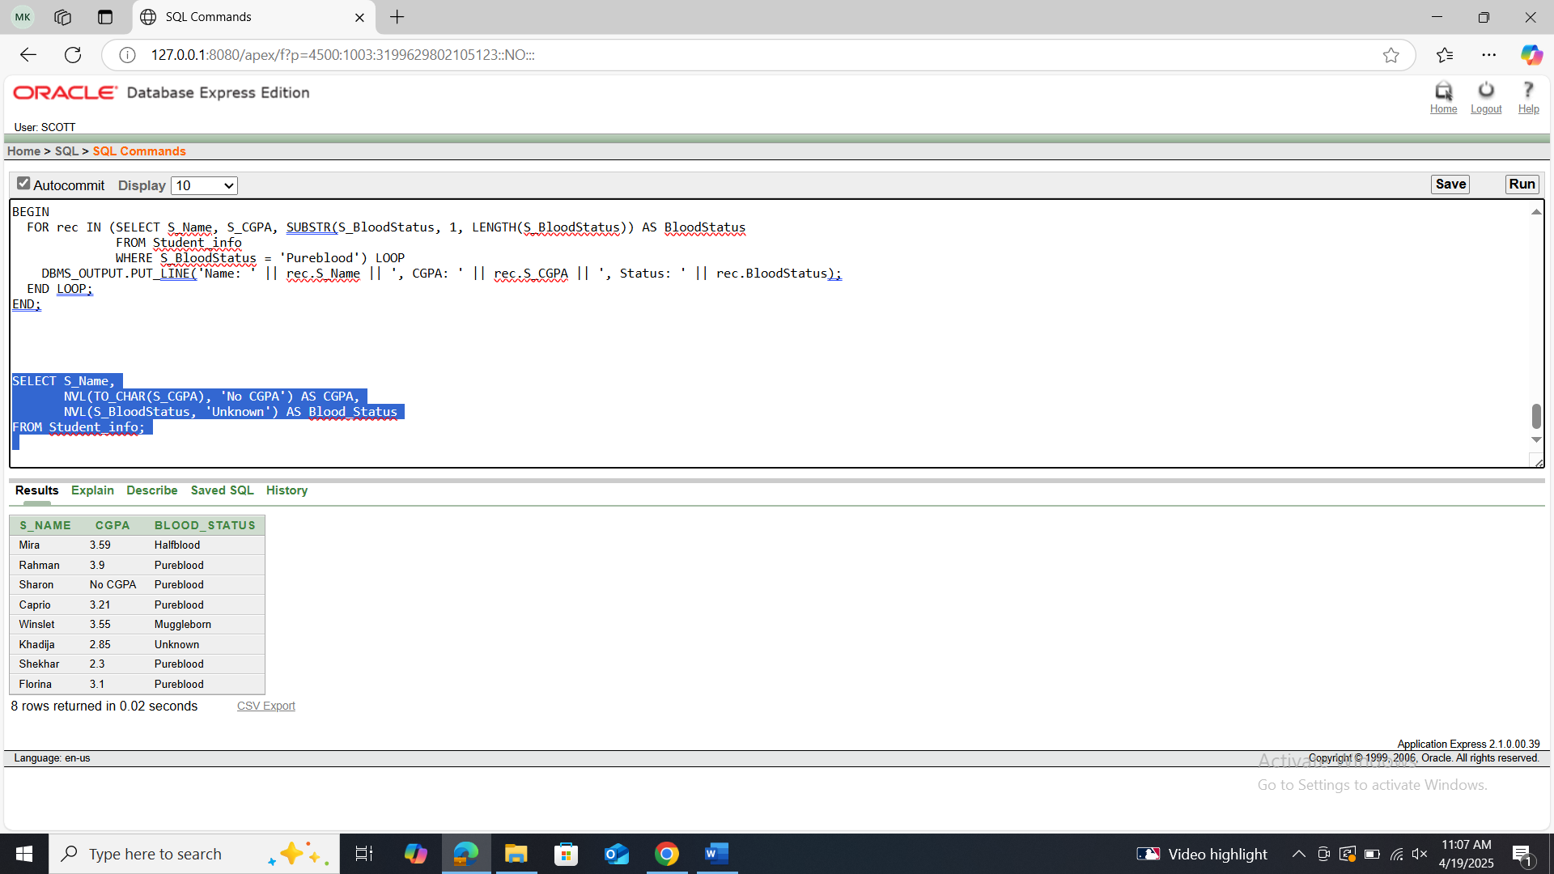

**PL/SQL Solution:**

Query: BEGIN

FOR rec IN (SELECT S_Name,

NVL(TO_CHAR(S_CGPA), 'No CGPA') AS CGPA,

NVL(S_BloodStatus, 'Unknown') AS Blood_Status

FROM Student_info) LOOP

DBMS_OUTPUT.PUT_LINE('Name: ' || rec.S_Name || ', CGPA: ' || rec.CGPA || ', Blood Status: ' || rec.Blood_Status);

END LOOP;

END;

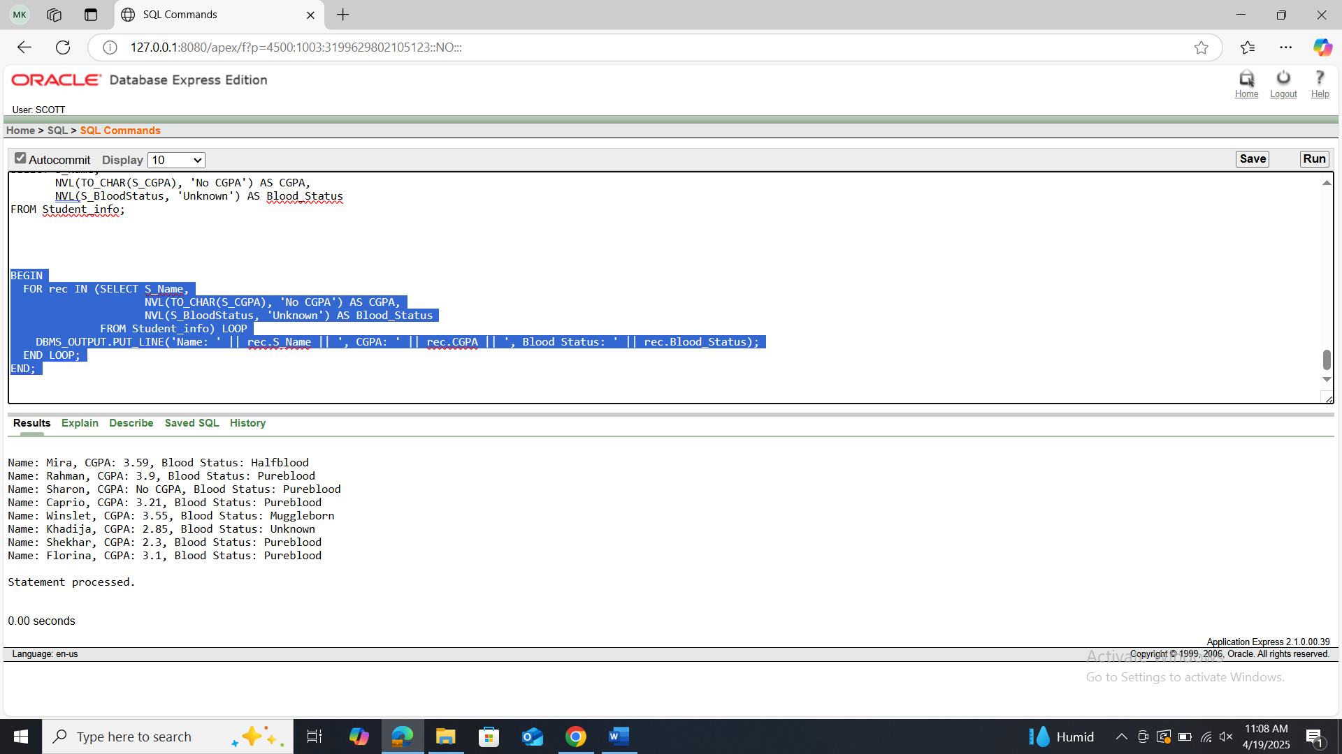

1. Find out the student who is holding maximum CGPA.

**SQL Solution:**

Query: SELECT S_Name, S_CGPA

FROM Student_info

WHERE S_CGPA = (SELECT MAX(S_CGPA) FROM Student_info);

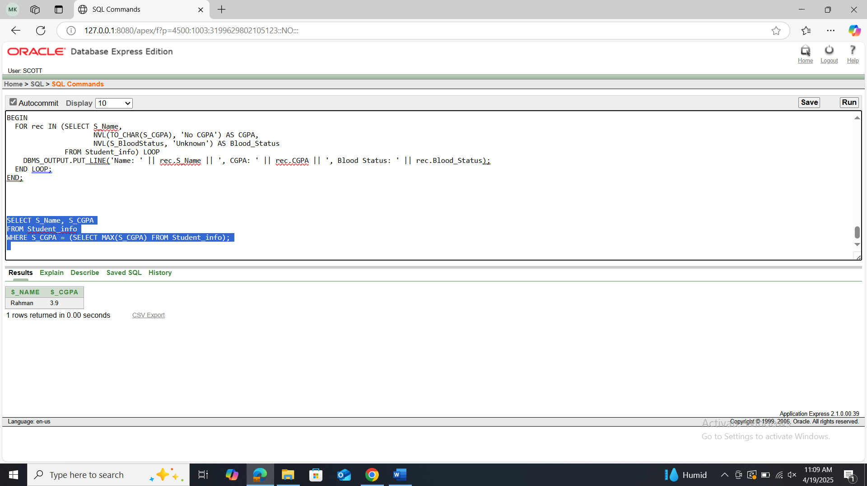

**PL/SQL Solution:**

Query: DECLARE

max_cgpa Student_info.S_CGPA%TYPE;

BEGIN

SELECT MAX(S_CGPA) INTO max_cgpa FROM Student_info;

FOR rec IN (SELECT S_Name, S_CGPA FROM Student_info WHERE S_CGPA = max_cgpa) LOOP

DBMS_OUTPUT.PUT_LINE('Top Student: ' || rec.S_Name || ', CGPA: ' || rec.S_CGPA);

END LOOP;

END;

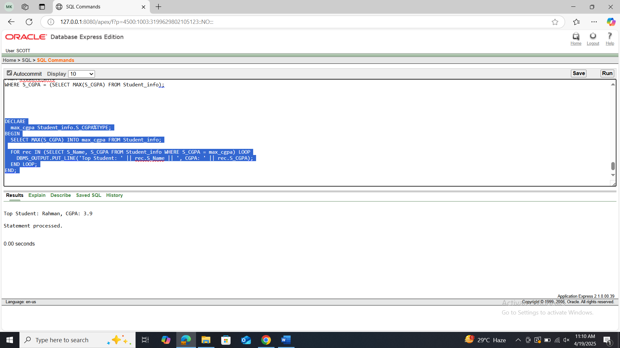

**\*\*Solve the above questions (1 to 9) with SQL. Afterwards solve the same questions with PL/SQL. Write down the answer and give screenshot of the results of the query in a MS Word document. You must use Oracle 10g.The name of the document MUST be your ID (solutions MUST be numbered accordingly) and upload it in the provided link in your VUES account**