**Class Test 05**

**PL/SQL**

*To solve the following use the scott schema*

1. Create a cursor that can output all the data from salgrade table.

Query: DECLARE

CURSOR salgrade_cursor IS

SELECT * FROM salgrade;

salgrade_record salgrade%ROWTYPE;

BEGIN

OPEN salgrade_cursor;

LOOP

FETCH salgrade_cursor INTO salgrade_record;

EXIT WHEN salgrade_cursor%NOTFOUND;

DBMS_OUTPUT.PUT_LINE('Grade: ' || salgrade_record.grade ||

', Losal: ' || salgrade_record.losal ||

', Hisal: ' || salgrade_record.hisal);

END LOOP;

CLOSE salgrade_cursor;

END;

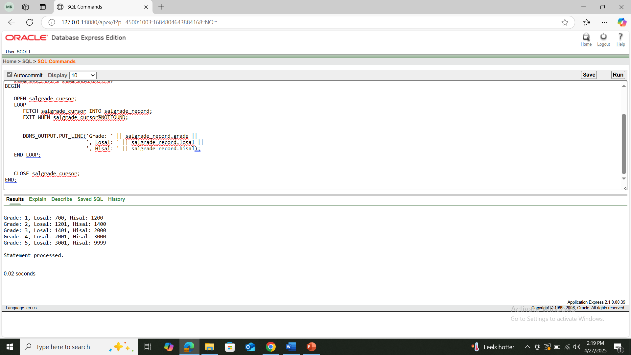

1. Create a record that can output the id, name, job, and hiredate of the employee whose Id is 7654.

Query:

DECLARE

TYPE emp_rec IS RECORD (

empno EMP.EMPNO%TYPE,

ename EMP.ENAME%TYPE,

job EMP.JOB%TYPE,

hiredate EMP.HIREDATE%TYPE

);

emp1 emp_rec;

PROCEDURE printemp(e emp_rec) IS

BEGIN

dbms_output.put_line('Employee ID: ' || e.empno);

dbms_output.put_line('Employee Name: ' || e.ename);

dbms_output.put_line('Employee Job: ' || e.job);

dbms_output.put_line('Employee Hiredate: ' || TO_CHAR(e.hiredate, 'DD-MON-YYYY'));

END;

BEGIN

SELECT empno, ename, job, hiredate

INTO emp1

FROM emp

WHERE empno = 7654;

printemp(emp1);

END;

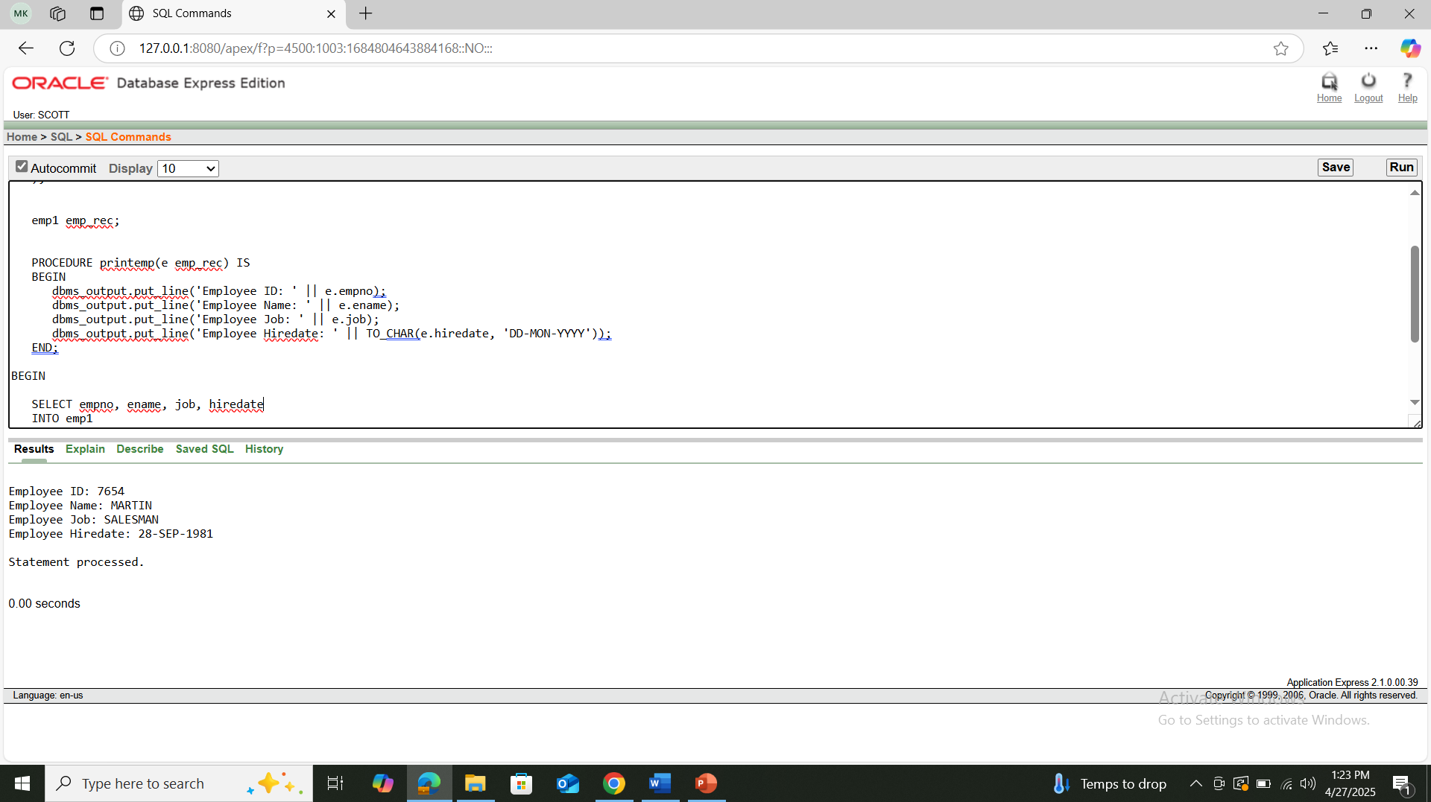

1. Create a trigger in such a way that whenever a new row is inserted into the salgrade table an output ‘New Row Added’ is generated.

Query: CREATE OR REPLACE TRIGGER trg_salgrade_insert

AFTER INSERT ON salgrade

FOR EACH ROW

BEGIN

DBMS_OUTPUT.PUT_LINE('New Row Added');

END;

INSERT INTO salgrade (grade, losal, hisal)

VALUES (6, 5000, 6000);

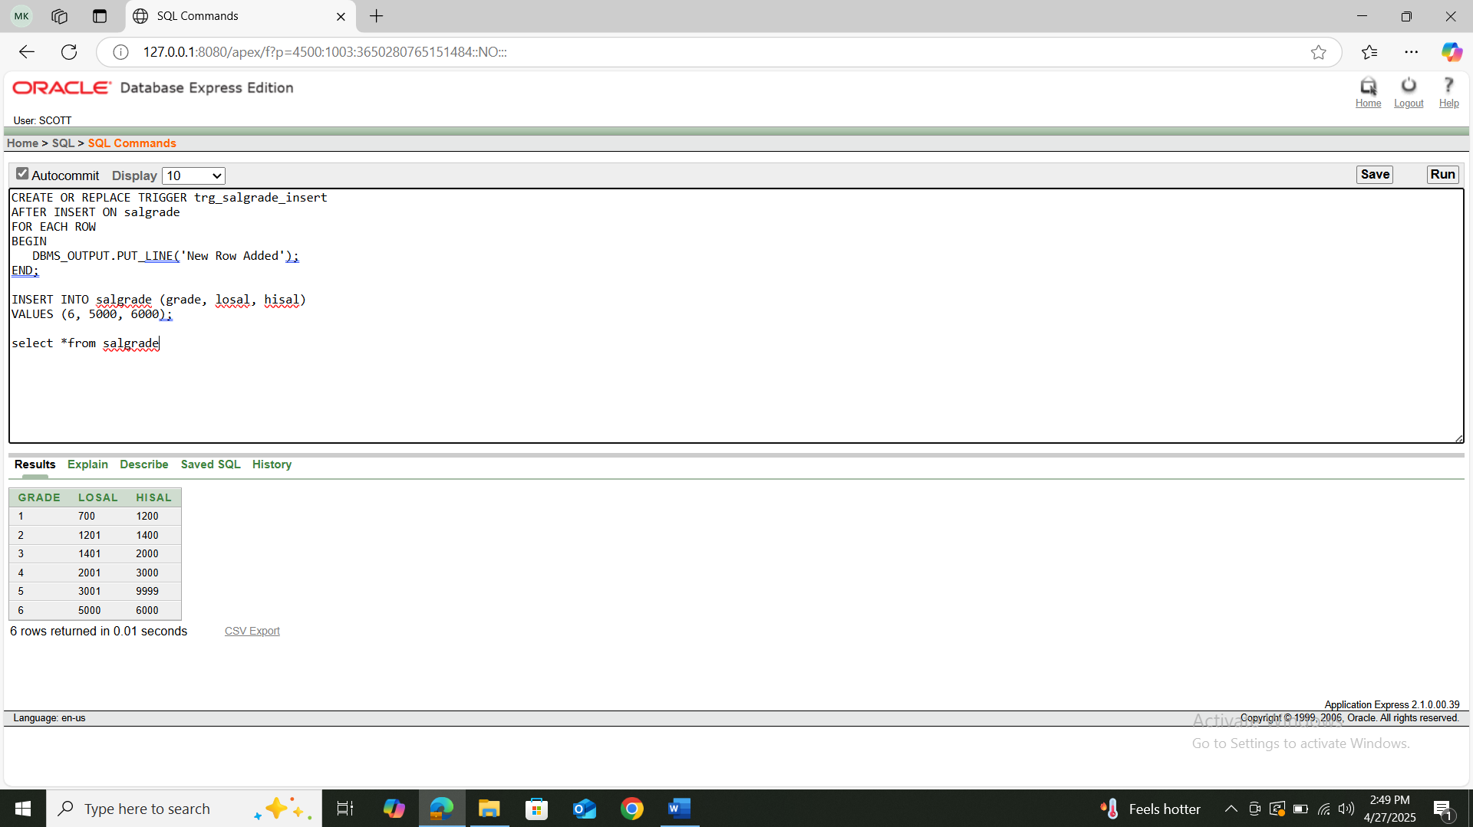

1. Create a package that contains a procedure which can display the grade whose losal and hisal is passed as its parameter.

Query: CREATE OR REPLACE PACKAGE salgrade_pkg IS

PROCEDURE show_grade(p_losal IN NUMBER, p_hisal IN NUMBER);

END salgrade_pkg;

CREATE OR REPLACE PACKAGE BODY salgrade_pkg IS

PROCEDURE show_grade(p_losal IN NUMBER, p_hisal IN NUMBER) IS

v_grade salgrade.grade%TYPE;

BEGIN

SELECT grade

INTO v_grade

FROM salgrade

WHERE losal = p_losal AND hisal = p_hisal;

DBMS_OUTPUT.PUT_LINE('Grade: ' || v_grade);

EXCEPTION

WHEN NO_DATA_FOUND THEN

DBMS_OUTPUT.PUT_LINE('No matching grade found.');

WHEN OTHERS THEN

DBMS_OUTPUT.PUT_LINE('An error occurred: ' || SQLERRM);

END show_grade;

END salgrade_pkg;

BEGIN

salgrade_pkg.show_grade(700, 1200);

END;

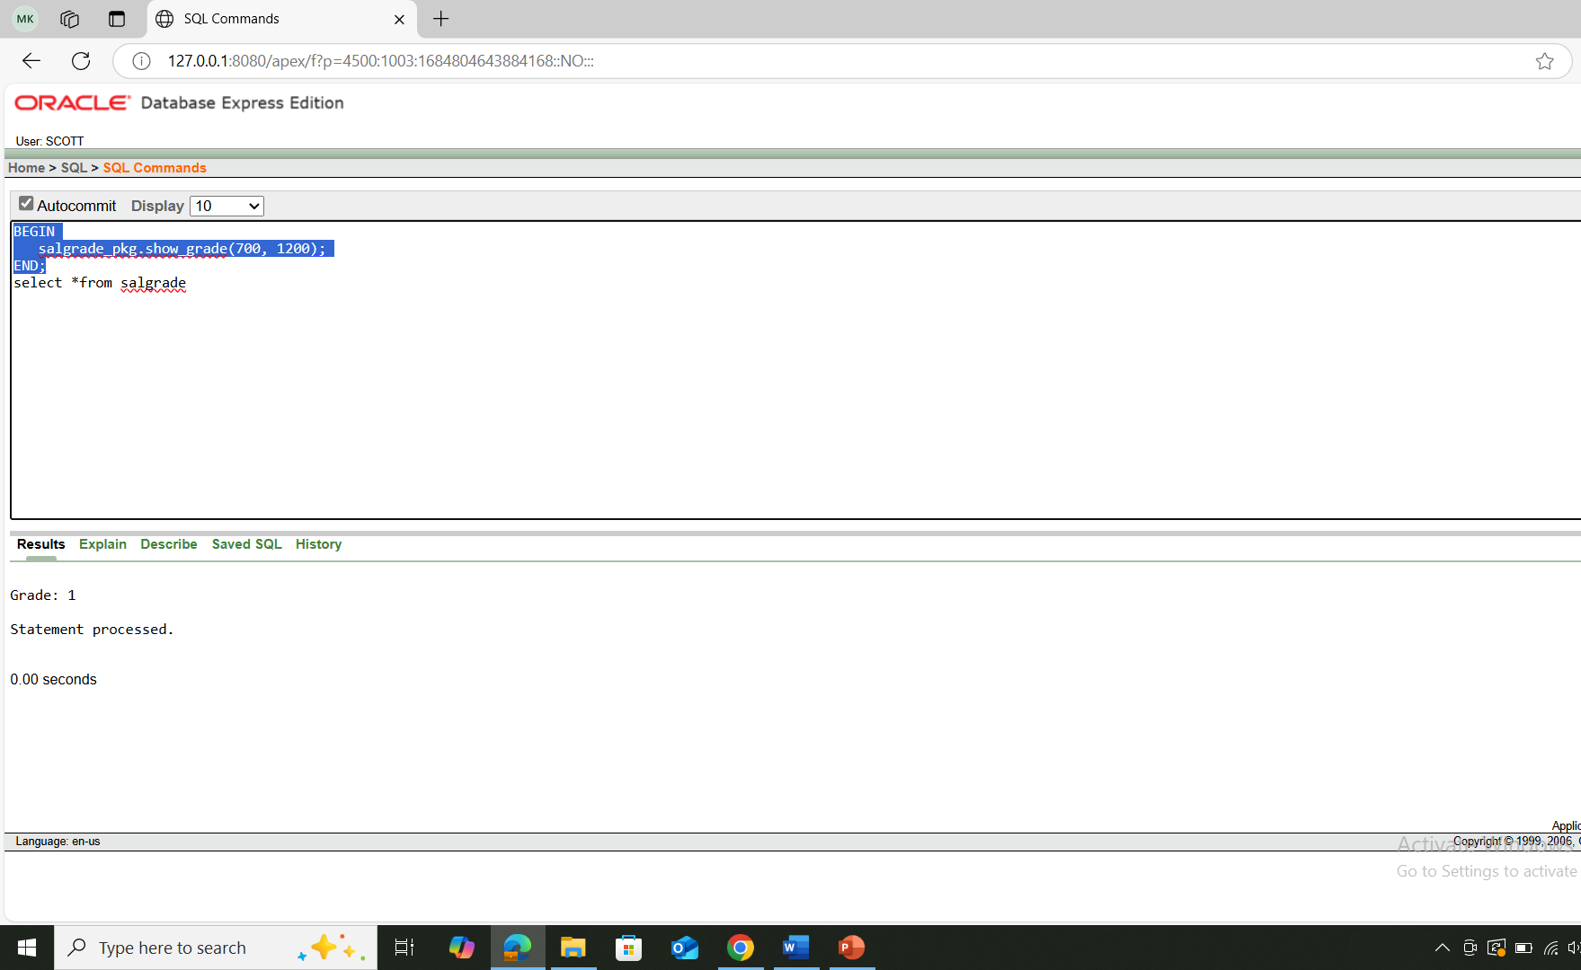

**\*\*After solving the above questions using Oracle 10g, write the PL/SQLs in a MS Word document (Write down the answer and give screenshot of the result of the query. The name of the document MUST be your ID and the PL/SQLs MUST be numbered accordingly) and upload it in the provided link in your VUES account**