|  |  |
| --- | --- |
| Project Title | History based Visual Novel Game |
| Student | Sayma Begum 33565774 |
| Supervisor | Dr Ida Pu |

Contents

Acknowledgements 3

Abstract: 4

Background Research 5

Motivational Research: 5

Questionnaire: 6

Existing applications: 8

Existing Knowledge: 8

New knowledge: 8

Technologies and Materials 9

Languages: 9

Physical Equipment: 9

Software equipment: 9

Other equipment: 10

Techniques: 11

Libraries & Frameworks: 11

Timelines & Milestones: 12

Contingency planning: 12

Gantt Chart: 13

References: 14

# Acknowledgements

# Abstract:

The idea is to create a historical visual novel game. The game is for secondary and college/sixth form school students who are learning about the Russian Revolution in school. Games are a good way to learn as it is an interactive experience for both student and teacher as it is an enjoyable experience thus stimulating memorisation and cooperation (Noonoo, 2019). A mix of reading through some of the history curriculum written by the department of Education, a student questionnaire and various interviews, a period in history was picked so it would be well catered for their education (Department of Education, 2013). Therefore, the conclusion was made for the game to be set just before and during the Russian revolution. Users will act as a solider trying to survive in 19th century Russia. Features in the game will include: Choice based role play, mini games, hand crafted artwork, music, easy to use UI and an enticing storyline.

# Background Research

## Business & Motivational Research: The case behind the Idea

Stories dedicated to the retelling of history has always been a popular genre for many things like books, TV and movies. Since Games are another form of storytelling in many ways, it is no surprise that games can be historical too. The idea to pin point the game during the Russian revolution has been because of a video which sparked an interest in that time period. A YouTube video which explained the state of Russia and the rise of the soviet nation had been extremely popular due to its comedic approach. (Oversimplified, 2020). Watching this video motivated the creation for a historical based game.

Universities UK states that there are over 2.38 million studying in higher education institutions alone (Universities UK, n.d.). It is also said that History as a degree has recovered up to 4% it’s drop after the introduction of fees. This is said to be because of the familiarity students feel when they studied it in A level. A level plays an important reason why the subject of Russia was chosen as this topic is often brought up and is a module in the curriculum. Tsarist Russia is also brought up into topics like the First world war as well. Therefore, this game can be used to top up their knowledge on key themes and dates for their next lesson or even during their revision for their exams. For this reason, this game can be seen as very commercial as it has an extremely large audience. One of the key target audience therefore must be the student population.

However, students are not the only population in the world who have an interest in History. There is a huge rise of history based YouTube channels that are growing in subscribers. For example, we have mentioned the channel Oversimplified above, this channel has over 4.52 million subscribers and the video which related to the Russian Revolution has almost 12 million views. A lot of the views are students yes, but they are also teachers and hobbyists. Those who have a desire to learn historical knowledge will naturally peak an interest to this game because they are a fan of the genre.

As mentioned above, games are a great way to educate students and non-students alike. Students stuck in the classroom will be able to play this game at home or even at school if they wish. Since it is a visual novel, it can have both a personal and a group experience. A personal experience will be the user reading along and playing the game alone, since it is just themselves and the game it is a quite intimate experience, it’s sort of like when you read a book alone. However, if the game is being played in the classroom, perhaps for a fun lesson, the game can be played with the entire class. The teacher can pick out students who want to read and can also pick students to play the mini games. Since the game will also be choice based, they can debate what choice would be best for them. This makes the game very interactive.

A lot of historical research has been done for the game in order to get historical accuracy. It’s extremely important that the dates and the facts are accurate as this game should be an educational experience. It would be erroneous if there was to be a historical flaw in the game. Most of the research done came from the Oversimplified mentioned before and a British educational website which covers everything about the Russian revolution in the national curriculum for schools (BBC Bitesize, n.d.). The website covers the precursor to the revolution, the state of the country, WW1, and the revolution itself.

In terms of coding, research has also been done in order to learn the new coding languages, Renpy and Sonic pi. This was done mainly through checking the documentation, doing extremely small tasks and learning the basics, just enough so that core functions for example, dialogue can be done. The complex coding will be tackled after a grasp of the basics has been achieved.

## Questionnaire:

I’ve also created a questionnaire researching trends amongst games and education.

When questioned why they did not like their lessons:

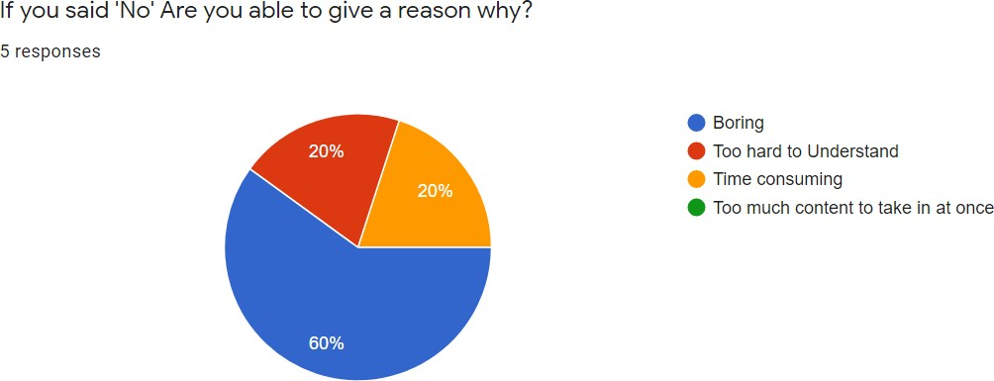

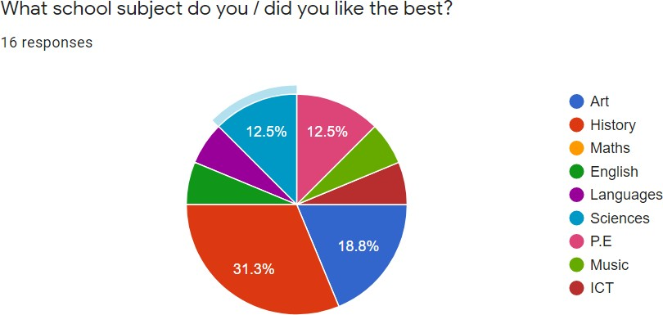

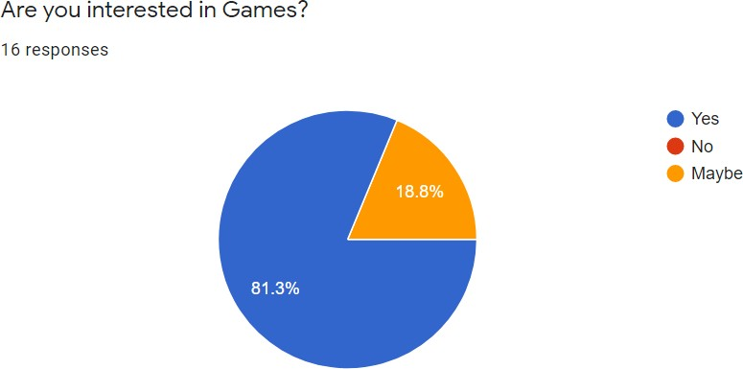

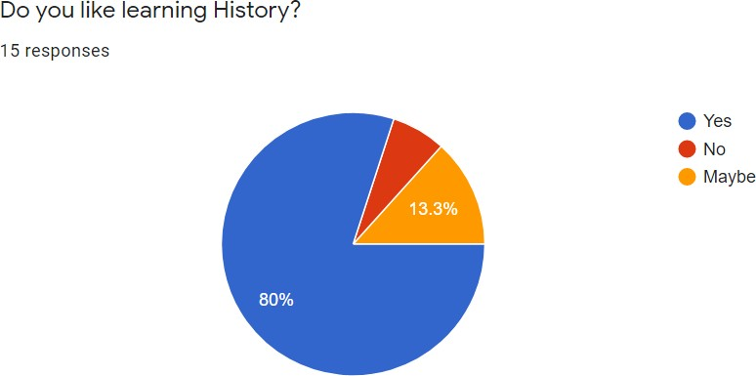

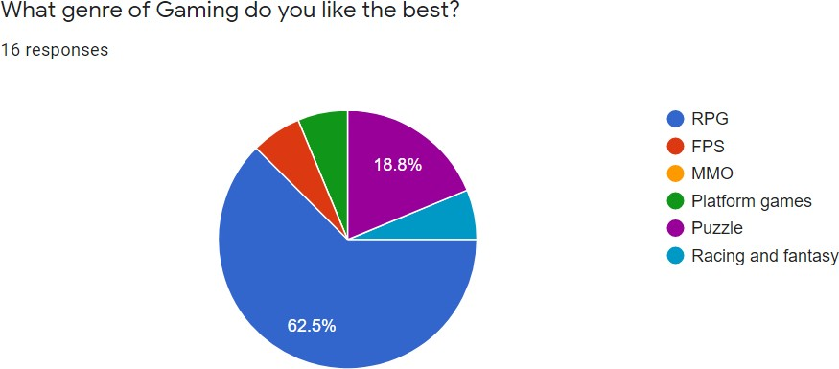

Many participants stated they find their lessons boring, I think my game will help a lot of students to learn in a really interesting way.

Around 31% also said History was their favourite subject, so this means my project will naturally draw in many students just by the historical genre alone.

These pin point why this game is needed amongst students. 80% of students have said they like learning about History, 80% also said they like games. I think this a clear sign that a historical game would be perfect to create.

62.5% Also said Role playing games were their favourite type of game. This is also aligned well with my project.

## Existing applications:

There actually isn’t a lot of extremely similar games out there in the visual novel community. Many visual novel games tend to favour the fantasy and romance genres. However, I will list visual novel games that I’m taking inspiration from.

* Therapy with Dr. Albert Krueger - (dino999z, 2020)
* STEINS; GATE Steam Trailer- (MAGES., 2016)

## Existing Knowledge:

This project will include knowledge which I attained from past and current modules at University.

In my first year of University I did a module called ‘Introduction to Programming.’ This taught me the basics of programming and a lot of fundamentals about coding which could be transferred to any language. We also coded in p5.js which is the language I will be using for some of the project.

I am currently doing a module called ‘Introduction to Modelling and Animation,’ this module was taught with a software called Autodesk Maya. I now know how to model and animate 3d objects. This will be very useful for when I animate scenes in the game.

Interaction design is also a module I am doing this year, this is all about UX design and how to design a good interface. I will use this knowledge to help me design the buttons and other GUI in the game.

## New knowledge:

Although I have some experience working with the game engine, coding complex mini games in Python will be a new challenge for me as I will have to do more research in the coding language. However, I’ve seen some tutorials for this online. There is also extensive documentation on their website. (Elaine, 2017), (Renpy, 2004a).

Sonic pi is a completely new coding language which I will have to get to grips with too to code the music for the game. However, there is a lot of documentation on the Sonic Pi website and I have taken a look at the software itself and found it quite easy to experiment with (Aaron, 2012.

# Technologies and Materials

## Languages:

There has been a lot of thought into deciding what game engine would be right for this game. Unity and Unreal engine has been the typical engines used for games, however they specialise in 3d games and 2d platform games. The genre of game in this project is a visual novel therefore these two game engines were not the ideal platform. Many visual novels are in fact made using another game engine altogether called **Renpy**. Therefore, the game engine that is planned to be of use for this project is Renpy, it’s a popular option for creating visual novel games. The engine itself uses their own language called Renpy. It’s based on Python and Cython (a mixture of python and C) (Renpy, 2004).

The project initially lacked the use of complex coding since Renpy is a relatively simple language when it comes to a basic prototype of the game. It was then decided that as well as coding the game, there will be code for the music too using a coding language called **Sonic Pi**. When people think of creating music, they think of using a DAW (Digital audio workstation), you wouldn’t think of coding your own music. However, Sonic pi does just that. Sonic pi is a language created by Dr Sam Aaron which helps to get people into computing. The language is primarily based in Ruby and is written on a ruby file unlike Renpy which is written in its own file called a .rpy file. The language allows you to code your own music using a plethora of instruments (Aaron, 2012).

For most games the visual element is key as it is the first thing that a user will see when they play. Visual novel games are no different as the game is heavily dependent on the background to give a sort of realism in the experience. Therefore, it was decided for some scenes images will be created using **p5.js**. The language allows you to create buttons to save the images you create. This will be mostly generative drawings which will be used as the background in some parts of the game, for example when a characters reaches a stage of confusion, it would be better if that emotion is displayed by abstract art, as confusion is an abstract feeling. Generative drawing is great for creating abstract art as it can use random shapes to create artwork.

## Physical Equipment:

The main physical equipment which will be needed is a graphics tablet. This will help to stylise the game as well as creating a lot of game assets. A graphics tablet can be used to draw mainly artwork such as Game characters, backgrounds, and the Graphical User Interface(GUI). There will be no need for the purchase of a graphics tablet as it has already been purchased for other projects. A graphics tablet is the standard equipment digital artists use in the world of digital art. The tablet replicates how you would draw traditionally using a pen and paper so it gives the very real feeling that your drawing. Drawing using a mouse would be almost impossible to do with the amount of work that is needed to make this game.

## Software equipment:

Renpy Game Engine – This was mentioned before when talking about coding languages. It will be used in the development stage to code for the visual novel. The game engine is quite easy to use, it comes with an example/ demo code for you to try and experiment with as well as a tutorial which covers all of the basics of how the language works and how to use it. The game engine also comes ready with a full set of UI. Although the UI is very simple and basic, it is perfect for a first prototype. You are given the option to change the UI to suit the game design, which will be planned in the later stages accordingly. The game engine reads all the files as if they are in one big document, this makes it easier, unlike in other languages such as java, where there are very strict rules in importing files. Renpy makes this process very simple, and it is one of the reasons why it was chosen for this project.

Sonic pi portable software – Although Sonic pi is a coding language, you have to download their application in order to use it correctly. The application is similar to an IDE where you are able to input, edit and delete code however you are able to play the music you just coded. If the code wasn’t 100% what you imagined, you could change the code and the music will change in real time as well. This is such a great feature especially if you are new to the language (which is the case in this scenario). Since the learning is very practical, you will know whether or not you made a mistake much faster. After you tested the code and you are happy with it, the software has a record feature where you can record the music for a chosen amount of time and then it will save as a .wav file.

Band lab/ Cakewalk DAW (Digital audio workstation) – This piece of software is a downloadable or online application where you can create your own music. Unlike Sonic pi you cannot code. It works like a traditional DAW where you can create your own music using notes and different instruments. I prefer using this DAW because even though it is free to use it has a lot of features which are not included in even paid DAWs. For example, it has a huge library of loops, which are sections of music which are completely copyright free to use. The DAW will be used as an addition to the Sonic pi code, because for some music there will be overlapping sound effects. Band lab makes it incredibly easy to combine tracks and download them.

Autodesk Maya –This software will be used to animate some scenes in the game and to model some 3d game assets. There may be some assets which will be needed to create in 3d, this might be because it is much easier to get images using 3d models since you don’t have to redraw the same drawing/ painting if you want a particular image in a different angle. 3d models allow you to spin, rotate, scale the model and you can capture the image. The models will then be combined and edited in an image editing software to be incorporated in the final image. It’s important that the 3d model in the editing process looks very 2d because the game itself is a 2d game so it has to look uniform.

Krita – There was a mention above about image editing software. Krita is a drawing software which acts a lot like photoshop. This application will be used instead of Photoshop purely because of the ease of use. Photoshop is quite complex, and since this project will only be used for drawing/ painting and very light editing Krita will suffice. The program is free to use too. One can use custom brushes; the overall range of brushes is on par with Photoshop so Krita as a whole is a very good software to use. Krita will used in order to create drawings/paintings as well as editing the images for the project.

## Other equipment:

Stock images – Since the project will become available to the public, it’s very important to make sure that the artwork used completely copyright free. The previous decision was to create all the artwork 100% by hand, however that would take an extremely long amount of time and as this is a solo project it will be very hard to maintain a balance of time, from the code and the artwork creation. Therefore, the project will be using stock image photos which will be edited using Krita in order to make it in to the style of an oil painting. This is so that it could be aesthetically pleasing. The stock images will be obtained using sites such as Pixabay and Pexels since they are free, copyright free and in many cases attribution free. However, there will be a separate source file which references every image anyway.

Stock free sounds – In gameplay, sound is extremely important. Since the game is mainly based on warfare, sound effects are vital in order to keep realism intact. The project will use sounds from sound libraries such as Sound bites which has copyright free sounds available for use. Though each sound does require attribution, which I will include in the same file as mentioned above in the stock images section. The sounds which will be needed are mostly gun sounds and generic game sounds like clicking sounds etc.

## Techniques:

A number of techniques will need to be used for this project.

Audio programming- Using Sonic Pi for the Music.

Generative Drawing- Creating background art in the game.

3D modelling & Animation- Creating Game assets

2D collision detection for mini games.

## Libraries & Frameworks:

p5.JS will be used which is a JavaScript library, it is mostly used for creative projects (p5.js, 2008).

# Timelines & Milestones:

|  |  |
| --- | --- |
| **Milestones** | **Dates** |
| Research for the Game | 01/11/2020-05/11/2020 |
| Art/asset creation | 04/11/2020-12/11/2020 |
| Game script writing | 06/11/2020-05/12/2020 |
| Basic prototype / base Template (no mini games  just story line) | 05/12/2020-20/02/2020 |
| Interim Report | 12/12/2020-11/01/2021 |
| Coding Mini games for the game (mostly will  be puzzle games) | 20/02/2021-10/03/2021 |
| Coding background music | 05/12/2021-20/03/2021 |
| Testing | 12/03/2021-05/04/2021 |
| Submit draft report | 01/03/2021-26/03/2021 |
| Bug Fixing | 12/04/2021-05/05/2021 |
| Final Report | 12/03/2021-14/05/2021 |

## Contingency planning:

If issues arise in the game, then the **minimum product** I will deliver will be:

* A game which allows includes choice selection, each choice will have an effect on the outcome of the game.
* A game which has background music, made with Sonic pi.
* Backgrounds to the game will be all complete, some of them will be made using P5.js.
* User sprites and art work will be all completed.
* There will be at least one mini game which can be played.
* A very simple inventory system is implemented in the game.

## Gantt Chart:

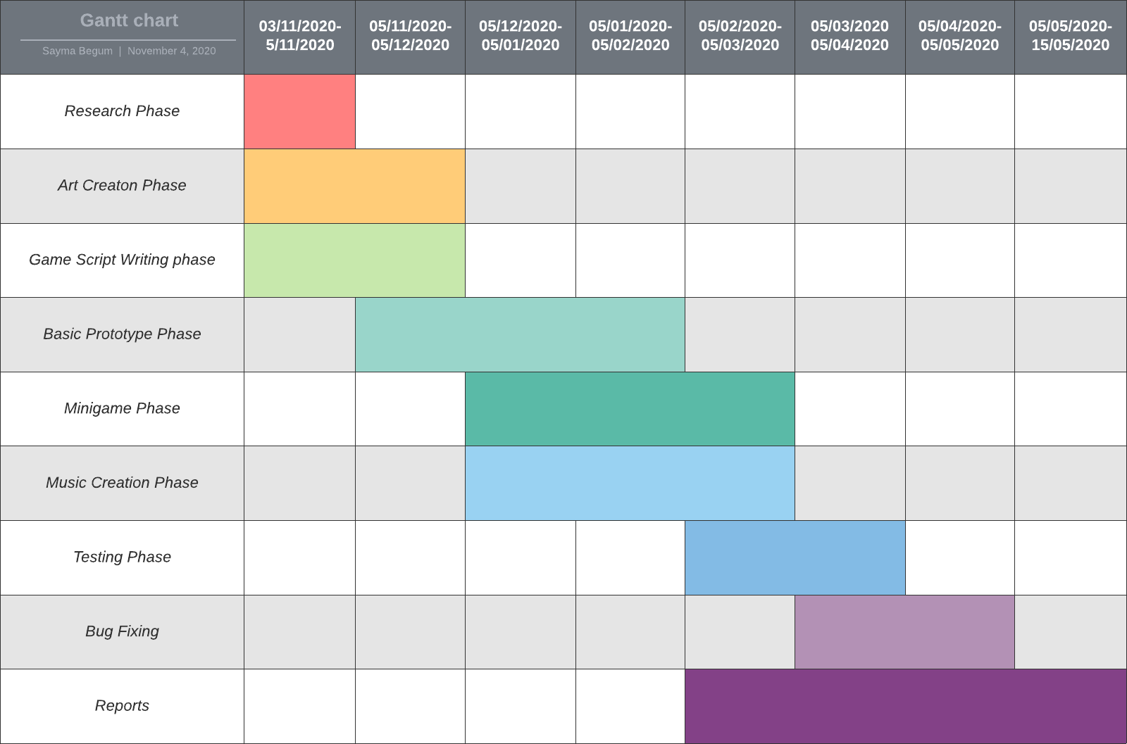

# References:

* Marco Antonio Ferreira Randi and Hernandes Faustino de Carvalho. Learning through role-playing games: an approach for active learning and teaching. Revista Brasileira de Educa¸c˜ao M´edica, 37(1):80–88, 2013
* Noonoo, S. (2019, February 12). *Playing Games Can Build 21st-Century Skills. Research Explains How.* EdSurge. <https://www.edsurge.com/news/2019-02-12-playing-games-can-build-21st-century-skills-research-explains-how>
* Department of Education. (2013). *History programmes of study: key stage 3*. Gov.Uk. [https://assets.publishing.service.gov.uk/government/uploads/system/uploads/attachme](https://assets.publishing.service.gov.uk/government/uploads/system/uploads/attachment_data/file/239075/SECONDARY_national_curriculum_-_History.pdf)
* [nt_data/file/239075/SECONDARY_national_curriculum_-_History.pdf](https://assets.publishing.service.gov.uk/government/uploads/system/uploads/attachment_data/file/239075/SECONDARY_national_curriculum_-_History.pdf)
* Renpy. (2004, August 24). *The Ren’Py Visual Novel Engine*. What Is Ren’Py?<https://www.renpy.org/>
* Aaron, D. S. (2012). Sonic Pi - The Live Coding Music Synth for Everyone. Sonic Pi.<https://sonic-pi.net/>
* Elaine. (2017, November 18). *Renpy Tutorial: RPG Inventory Part 1*. YouTube.<https://www.youtube.com/watch?v=leEiOzuVpTc&t=1031s>
* Renpy. (2004a, August 24). *Screens and Screen Language — Ren’Py Documentation*.<https://www.renpy.org/doc/html/screens.html>
* OverSimplified. (2020, August 17). *The Russian Revolution - OverSimplified (Part 1)*.
* YouTube. <https://www.youtube.com/watch?v=Cqbleas1mmo>
* dino999z. (2020, September 22). *Therapy with Dr. Albert Krueger - Launch Trailer*.
* YouTube. <https://www.youtube.com/watch?v=30B7fGbe7d8&feature=emb_title> MAGES. (2016, September 9). *STEINS; GATE Steam Trailer*. YouTube.
* Universities UK. (n.d.). Higher education in numbers. Retrieved 22 March 2021, from <https://www.universitiesuk.ac.uk/facts-and-stats/Pages/higher-education-data.aspx>
* McGhee, P. (2015, April 13). What are the most popular degree courses? BBC News. <https://www.bbc.co.uk/news/education-32230793>
* BBC Bitesize. (n.d.). Reasons for the February Revolution, 1917. Retrieved 19 January 2021, from <https://www.bbc.co.uk/bitesize/guides/ztyk87h/revision/4>