|  |  |
| --- | --- |
| Project Title | History based Visual Novel Game |
| Student | Sayma Begum 33565774 |
| Supervisor | Dr Ida Pu |

Contents

Acknowledgements 3

Abstract: 4

Background Research 5

Business & Motivational Research: The case behind the Idea 5

Questionnaire: 6

Existing applications: 8

Existing Knowledge: 8

New knowledge: 8

Technologies and Materials 9

Languages: 9

Physical Equipment: 9

Software equipment: 9

Other equipment: 10

Techniques: 11

Libraries & Frameworks: 11

Timelines & Milestones: 12

Contingency planning: 12

Gantt Chart: 13

References: 14

# Acknowledgements

# Abstract:

The idea is to create a historical visual novel game. The game is for secondary and college/sixth form school students who are learning about the Russian Revolution in school. Games are a good way to learn as it is an interactive experience for both student and teacher as it is an enjoyable experience thus stimulating memorisation and cooperation (Noonoo, 2019). A mix of reading through some of the history curriculum written by the department of Education, a student questionnaire and various interviews, a period in history was picked so it would be well catered for their education (Department of Education, 2013). Therefore, the conclusion was made for the game to be set just before and during the Russian revolution. Users will act as a solider trying to survive in 19th century Russia. Features in the game will include: Choice based role play, mini games, hand crafted artwork, music, easy to use UI and an enticing storyline.

# Background Research

## Business & Motivational Research: The case behind the Idea

Stories dedicated to the retelling of history has always been a popular genre for many things like books, TV and movies. Since Games are another form of storytelling in many ways, it is no surprise that games can be historical too. The idea to pin point the game during the Russian revolution has been because of a video which sparked an interest in that time period. A YouTube video which explained the state of Russia and the rise of the soviet nation had been extremely popular due to its comedic approach. (Oversimplified, 2020). Watching this video motivated the creation for a historical based game.

Universities UK states that there are over 2.38 million studying in higher education institutions alone (Universities UK, n.d.). It is also said that History as a degree has recovered up to 4% it’s drop after the introduction of fees. This is said to be because of the familiarity students feel when they studied it in A level. A level plays an important reason why the subject of Russia was chosen as this topic is often brought up and is a module in the curriculum. Tsarist Russia is also brought up into topics like the First world war as well. Therefore, this game can be used to top up their knowledge on key themes and dates for their next lesson or even during their revision for their exams. For this reason, this game can be seen as very commercial as it has an extremely large audience. One of the key target audience therefore must be the student population.

However, students are not the only population in the world who have an interest in History. There is a huge rise of history based YouTube channels that are growing in subscribers. For example, we have mentioned the channel Oversimplified above, this channel has over 4.52 million subscribers and the video which related to the Russian Revolution has almost 12 million views. A lot of the views are students yes, but they are also teachers and hobbyists. Those who have a desire to learn historical knowledge will naturally peak an interest to this game because they are a fan of the genre.

As mentioned above, games are a great way to educate students and non-students alike. Students stuck in the classroom will be able to play this game at home or even at school if they wish. Since it is a visual novel, it can have both a personal and a group experience. A personal experience will be the user reading along and playing the game alone, since it is just themselves and the game it is a quite intimate experience, it’s sort of like when you read a book alone. However, if the game is being played in the classroom, perhaps for a fun lesson, the game can be played with the entire class. The teacher can pick out students who want to read and can also pick students to play the mini games. Since the game will also be choice based, they can debate what choice would be best for them. This makes the game very interactive.

A lot of historical research has been done for the game in order to get historical accuracy. It’s extremely important that the dates and the facts are accurate as this game should be an educational experience. It would be erroneous if there was to be a historical flaw in the game. Most of the research done came from the Oversimplified mentioned before and a British educational website which covers everything about the Russian revolution in the national curriculum for schools (BBC Bitesize, n.d.). The website covers the precursor to the revolution, the state of the country, WW1, and the revolution itself.

In terms of coding, research has also been done in order to learn the new coding languages that will be used (explained in Technologies - Languages), Renpy and Sonic pi. This was done mainly through checking the documentation, doing extremely small tasks and learning the basics, just enough so that core functions for example, dialogue can be done. The complex coding will be tackled after a grasp of the basics has been achieved.

## Questionnaire:

Although we have studies proving how games are very useful in educational terms, we need to prove it from the students themselves. There are several methods on how you can go about asking for the opinions of students. Due to the corona virus situation, interviewing face to face has been proven extremely difficult to do. The decision has been made that the easiest and fastest option would be to ask students and history hobbyists through a questionnaire, and a short online interview. Since the demographic are students, they’d be quite busy especially this time of year so it’s important that enough students are able to have time on their hands to complete the questionnaire. The questionnaire has a total of 17 responses spanning from the ages of mid teenager to middle age, the participants also span across the UK so there is a proven range of answers. There are a total of 20 questions, some of which will be analysed here and others will be in the appendix.

One of the first questions asked was if they were in education or not. This is crucial because one of the main target audiences are students. It is important to ask the main demographics because the game is partly made for them. As you can see here more than half of the participants – 70\% are in education. The rest of the participants are a mixture of people who are interested in history and others who are not.

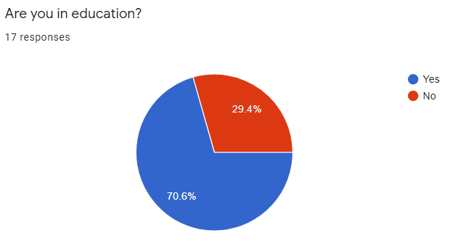

Students will have to enjoy their lessons in order to thrive in school. The question here asked if they enjoy their lessons or not, this is to work out the percentage that said no. The students who said no, in this case 30\% means that there is a reason why they don't like it. This might be because it's boring or it's too hard for them. This gives the case to make the game because if students are finding the lesson boring, you will have to then make it fun, for example through games. The game that is going to be created will create a fun environment, a fun method which students may choose to learn and revise, thus changing their attitude to learning.

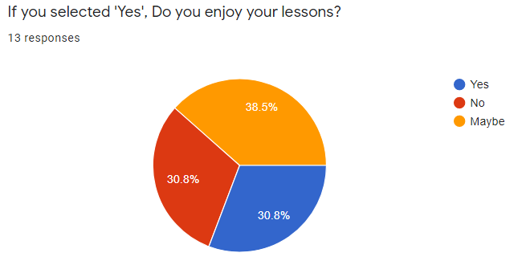

Students will have to enjoy their lessons in order to thrive in school. The question here asked if they enjoy their lessons or not, this is to work out the percentage that said no. The students who said no, in this case 30\% means that there is a reason why they don't like it. This might be because it's boring or it's too hard for them. This gives the case to make the game because if students are finding the lesson boring, you will have to then make it fun, for example through games. The game that is going to be created will create a fun environment, a fun method which students may choose to learn and revise, thus changing their attitude to learning.

The question which came directly after was asked, saying if you selected 'No' why? This is important because we need to know why a student does not enjoy their lesson. The choices were listed in the chart, a massive 60\% had said that they found it boring. This proves that games like this are needed in the classroom to liven up the class and for them to really get stuck in, in the class. The other percentages are shared between the subject is too hard and it’s too time consuming. This as well proves that games are a good way to tackle this issue because even though games might be seen as 'time consuming' initially, the traditional way of teaching already has been classed as too boring, students are not able to understand the content. It is worth trying to learn by gaming because it won't make the subject as boring, and it might even help them understand the topic, because they'll be motivated to learn because of the game. Again, there is proof that games and education can go hand in hand.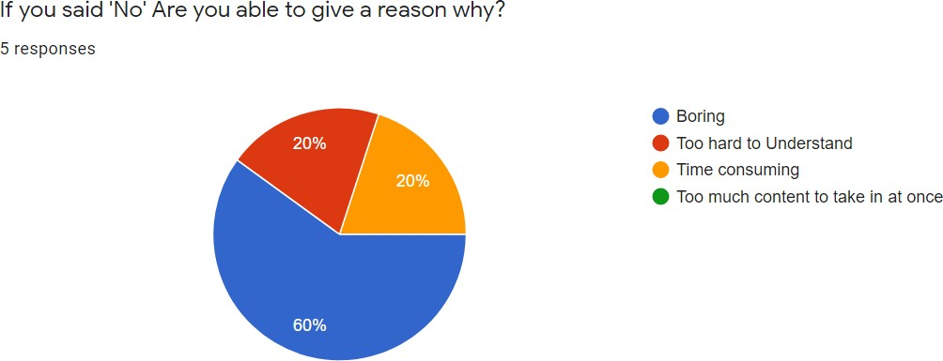

The next question is their favourite subject. Bearing in mind the participants were chosen blindly, not knowing what subject they like or what subject they study, this is an amazing result. The majority of the participants have chosen History as their favourite subject closely followed by art.

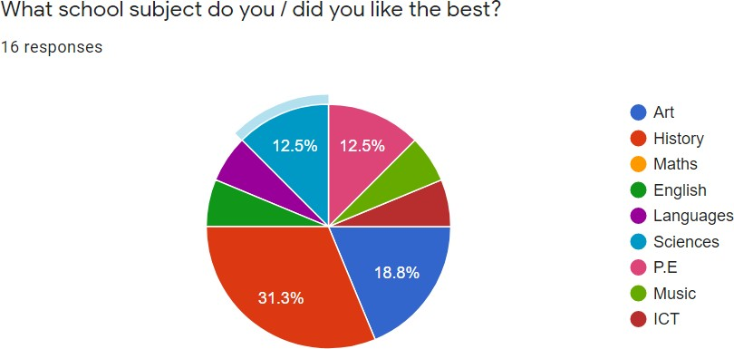

The next question is their favourite subject. Bearing in mind the participants were chosen blindly, not knowing what subject they like or what subject they study, this is an amazing result. The majority of the participants have chosen History as their favourite subject closely followed by art. This is perfect because it proves a game in history will be popular for students. Not only will they be able to enjoy playing the game but they will also enjoy learning the history aspect of the game. It's a win-win scenario.

Since the 2nd subject they picked was art, that's a bonus since the visual novel is known for it's art. The creative aspects of the game will be great for art lovers as they can see aesthetically please art work created.

This question asked what period of history did they like the best. A number of feasible time periods were listed and the participants had to pick from them. The time periods ranged from ancient, to medieval to modern history. This was really important because it's great if there were advantages in creating historical games but that does not mean the specific time period was proven to be a great fit. As you can see from the results which had the most support was the Islamic golden age. This was a very early contender when choosing a time period, however the Russian revolution was chosen instead because the Islamic Golden age, although a fascinating period and underappreciated, it's quite niche topic and not many will not have heard about it. The concept of creating the game was to entice people to play what they know as familiar but in a new medium. Most of the other options had equal weight, the Russian revolution ended up being the final choice as that was mostly on the school curriculum.

Now that we have proven why a historical based game is great, let's move onto the topic of games. The first question which was asked regarding games was if they were into games or not. This was so that we can link a correlation between those who like history and those who play games. Here it shows that roughly 80\% of the participants like playing games. This is very interesting because compared to those who like learning about history, it's almost exactly the same amount. This means that the target demographic lines up extremely well as both gamers and history lovers are seen to be liking the same thing.

One question which was asked in regarding to gaming was how often they play. It is beneficial if you know the approximate the amount because it gives you a sense of how long they will be playing your game for and how often. The range begins from not playing at all to daily. As you can see in the results, the range leans towards 2 and 3 which suggests that they play sometimes - often. This is great because it means they will definitely have time to play this visual novel game since it's quite a small game due to the time constraints.

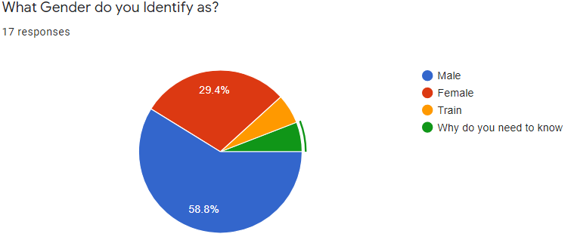

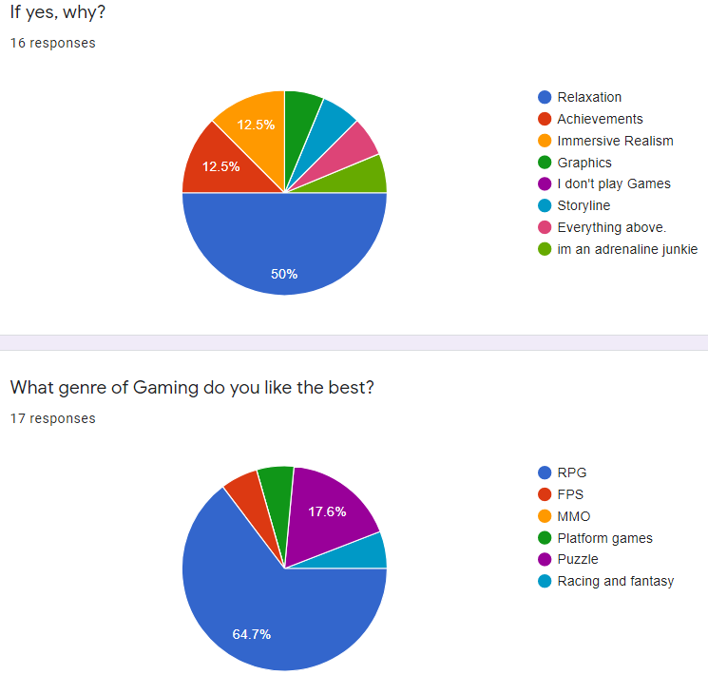

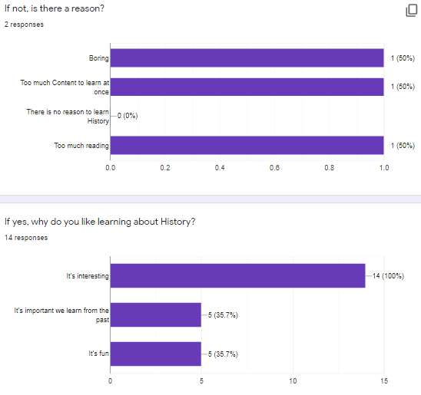

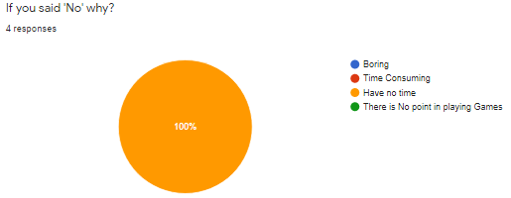

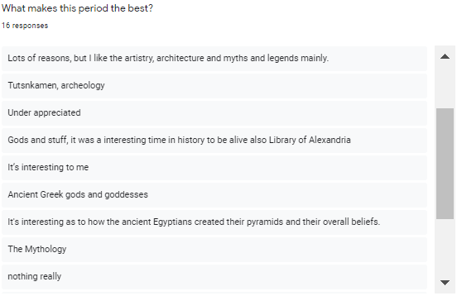

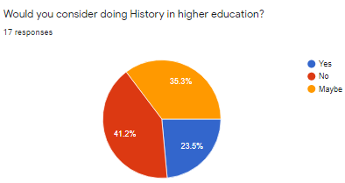

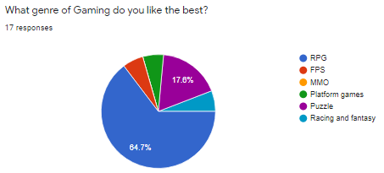

## Existing applications:

There actually isn’t a lot of extremely similar games out there in the visual novel community. Many visual novel games tend to favour the fantasy and romance genres. However, I will list visual novel games that I’m taking inspiration from.

* Therapy with Dr. Albert Krueger - (dino999z, 2020)
* STEINS; GATE Steam Trailer- (MAGES., 2016)

## Existing Knowledge:

This project will include knowledge which I attained from past and current modules at University.

In my first year of University I did a module called ‘Introduction to Programming.’ This taught me the basics of programming and a lot of fundamentals about coding which could be transferred to any language. We also coded in p5.js which is the language I will be using for some of the project.

I am currently doing a module called ‘Introduction to Modelling and Animation,’ this module was taught with a software called Autodesk Maya. I now know how to model and animate 3d objects. This will be very useful for when I animate scenes in the game.

Interaction design is also a module I am doing this year, this is all about UX design and how to design a good interface. I will use this knowledge to help me design the buttons and other GUI in the game.

## New knowledge:

Although I have some experience working with the game engine, coding complex mini games in Python will be a new challenge for me as I will have to do more research in the coding language. However, I’ve seen some tutorials for this online. There is also extensive documentation on their website. (Elaine, 2017), (Renpy, 2004a).

Sonic pi is a completely new coding language which I will have to get to grips with too to code the music for the game. However, there is a lot of documentation on the Sonic Pi website and I have taken a look at the software itself and found it quite easy to experiment with (Aaron, 2012.

# Technologies and Materials

## Languages:

There has been a lot of thought into deciding what game engine would be right for this game. Unity and Unreal engine has been the typical engines used for games, however they specialise in 3d games and 2d platform games. The genre of game in this project is a visual novel therefore these two game engines were not the ideal platform. Many visual novels are in fact made using another game engine altogether called **Renpy**. Therefore, the game engine that is planned to be of use for this project is Renpy, it’s a popular option for creating visual novel games. The engine itself uses their own language called Renpy. It’s based on Python and Cython (a mixture of python and C) (Renpy, 2004).

The project initially lacked the use of complex coding since Renpy is a relatively simple language when it comes to a basic prototype of the game. It was then decided that as well as coding the game, there will be code for the music too using a coding language called **Sonic Pi**. When people think of creating music, they think of using a DAW (Digital audio workstation), you wouldn’t think of coding your own music. However, Sonic pi does just that. Sonic pi is a language created by Dr Sam Aaron which helps to get people into computing. The language is primarily based in Ruby and is written on a ruby file unlike Renpy which is written in its own file called a .rpy file. The language allows you to code your own music using a plethora of instruments (Aaron, 2012).

For most games the visual element is key as it is the first thing that a user will see when they play. Visual novel games are no different as the game is heavily dependent on the background to give a sort of realism in the experience. Therefore, it was decided for some scenes images will be created using **p5.js**. The language allows you to create buttons to save the images you create. This will be mostly generative drawings which will be used as the background in some parts of the game, for example when a characters reaches a stage of confusion, it would be better if that emotion is displayed by abstract art, as confusion is an abstract feeling. Generative drawing is great for creating abstract art as it can use random shapes to create artwork.

## Physical Equipment:

The main physical equipment which will be needed is a graphics tablet. This will help to stylise the game as well as creating a lot of game assets. A graphics tablet can be used to draw mainly artwork such as Game characters, backgrounds, and the Graphical User Interface(GUI). There will be no need for the purchase of a graphics tablet as it has already been purchased for other projects. A graphics tablet is the standard equipment digital artists use in the world of digital art. The tablet replicates how you would draw traditionally using a pen and paper so it gives the very real feeling that your drawing. Drawing using a mouse would be almost impossible to do with the amount of work that is needed to make this game.

## Software equipment:

Renpy Game Engine – This was mentioned before when talking about coding languages. It will be used in the development stage to code for the visual novel. The game engine is quite easy to use, it comes with an example/ demo code for you to try and experiment with as well as a tutorial which covers all of the basics of how the language works and how to use it. The game engine also comes ready with a full set of UI. Although the UI is very simple and basic, it is perfect for a first prototype. You are given the option to change the UI to suit the game design, which will be planned in the later stages accordingly. The game engine reads all the files as if they are in one big document, this makes it easier, unlike in other languages such as java, where there are very strict rules in importing files. Renpy makes this process very simple, and it is one of the reasons why it was chosen for this project.

Sonic pi portable software – Although Sonic pi is a coding language, you have to download their application in order to use it correctly. The application is similar to an IDE where you are able to input, edit and delete code however you are able to play the music you just coded. If the code wasn’t 100% what you imagined, you could change the code and the music will change in real time as well. This is such a great feature especially if you are new to the language (which is the case in this scenario). Since the learning is very practical, you will know whether or not you made a mistake much faster. After you tested the code and you are happy with it, the software has a record feature where you can record the music for a chosen amount of time and then it will save as a .wav file.

Band lab/ Cakewalk DAW (Digital audio workstation) – This piece of software is a downloadable or online application where you can create your own music. Unlike Sonic pi you cannot code. It works like a traditional DAW where you can create your own music using notes and different instruments. I prefer using this DAW because even though it is free to use it has a lot of features which are not included in even paid DAWs. For example, it has a huge library of loops, which are sections of music which are completely copyright free to use. The DAW will be used as an addition to the Sonic pi code, because for some music there will be overlapping sound effects. Band lab makes it incredibly easy to combine tracks and download them.

Autodesk Maya –This software will be used to animate some scenes in the game and to model some 3d game assets. There may be some assets which will be needed to create in 3d, this might be because it is much easier to get images using 3d models since you don’t have to redraw the same drawing/ painting if you want a particular image in a different angle. 3d models allow you to spin, rotate, scale the model and you can capture the image. The models will then be combined and edited in an image editing software to be incorporated in the final image. It’s important that the 3d model in the editing process looks very 2d because the game itself is a 2d game so it has to look uniform.

Krita – There was a mention above about image editing software. Krita is a drawing software which acts a lot like photoshop. This application will be used instead of Photoshop purely because of the ease of use. Photoshop is quite complex, and since this project will only be used for drawing/ painting and very light editing Krita will suffice. The program is free to use too. One can use custom brushes; the overall range of brushes is on par with Photoshop so Krita as a whole is a very good software to use. Krita will used in order to create drawings/paintings as well as editing the images for the project.

## Other equipment:

Stock images – Since the project will become available to the public, it’s very important to make sure that the artwork used completely copyright free. The previous decision was to create all the artwork 100% by hand, however that would take an extremely long amount of time and as this is a solo project it will be very hard to maintain a balance of time, from the code and the artwork creation. Therefore, the project will be using stock image photos which will be edited using Krita in order to make it in to the style of an oil painting. This is so that it could be aesthetically pleasing. The stock images will be obtained using sites such as Pixabay and Pexels since they are free, copyright free and in many cases attribution free. However, there will be a separate source file which references every image anyway.

Stock free sounds – In gameplay, sound is extremely important. Since the game is mainly based on warfare, sound effects are vital in order to keep realism intact. The project will use sounds from sound libraries such as Sound bites which has copyright free sounds available for use. Though each sound does require attribution, which I will include in the same file as mentioned above in the stock images section. The sounds which will be needed are mostly gun sounds and generic game sounds like clicking sounds etc.

## Techniques:

A number of techniques will need to be used for this project.

Audio programming- Using Sonic Pi for the Music. Audio programming languages are languages which help enable you to create music using code. The language itself covers sound synthesis, sound production and algorithmic composition. The source labelled shows the list of languages one could use when programming sounds, and Sonic Pi is one that is listed. This is one of the main techniques which will be used in the project since throughout the whole game there will be background music. Not only that but there are sounds effects which a player will hear whilst doing certain activities, for example there will be mini games which will involve the use of guns, a gun sound effect will therefore be heard, other sounds like clicks will also be included.

Generative Drawing- Creating background art in the game. Generative drawing is when art is made via an autonomous system. The system is usually computer/ AI based as the art is created using algorithms using mathematics, geometry and data mapping. The generative drawings will be in p5.js and will form some of the backgrounds for some scenes in the game. The code in P5.js will have a save button so everything in the canvas can be saved without the need for screen clipping, as this method would lessen the quality of the picture. The art will generally be consisted of random patterns and shapes.

3D modelling & Animation --- Creating Game assets. 3d modelling was a module that was available in the 3rd year of university. Therefore, there is some experience in software such as Autodesk Maya. The 3d modelling will take the form of low poly models, these will be included in the games as clickables in mini games, or very important structures which will reoccur through the game. The advantage of 3d modelling is that you only have to create one model and then you have access to the object from all angles, which makes it a lot faster to obtain the images compared to 2d where you have to create the images separately which can be very time consuming. The models will have some animation done in the same software.

Interaction design --- This was a module in university which has also been completed. Interaction design is exploring the ways in which a user might interact with a product. Similar topics include UX/UI design. It is crucial to create a game which is user friendly to its target audience. Although the student population and gamers are becoming increasingly tech savvy, we must not forget the other demographic, people who are interested in history, which can include a range of people, some may not be so tech savvy. The fact that gamers will play this game, it must be up to standard, this includes with the UI as players will have to be able to know what to press at any given time, especially for the mini games. If people are not able to interact with the game, or if it has a poor design then people will not be able to play and the point of the project will be futile.

## Libraries & Frameworks:

p5.JS will be used which is a JavaScript library, it is mostly used for creative projects (p5.js, 2008).

A study was done to find that two out of three high school students said they were feeling bored in the classroom every single day. When cited why they were bored, 30\% had said it was due to the lack of interaction and the other 70\% said it was simply not interesting. There is a real problem with disengagement within the classroom, it's concern because disengagement means that there is no room for learning as students feel they are cut off from their teachers and peers.

One of the key ways to create a fun and engaging environment is through Gamification. Not only is it a social experience, it also gives the student better control over their learning. Students can compare and talk about the game, develop their emotional intelligence through characters within the game and increase their critical analysis skills. These are just some of the benefits however, more is discussed here:

# Timelines & Milestones:

|  |  |
| --- | --- |
| **Milestones** | **Dates** |
| Research for the Game | 01/11/2020-05/11/2020 |
| Art/asset creation | 04/11/2020-12/11/2020 |
| Game script writing | 06/11/2020-05/12/2020 |
| Basic prototype / base Template (no mini games  just story line) | 05/12/2020-20/02/2020 |
| Interim Report | 12/12/2020-11/01/2021 |
| Coding Mini games for the game (mostly will  be puzzle games) | 20/02/2021-10/03/2021 |
| Coding background music | 05/12/2021-20/03/2021 |
| Testing | 12/03/2021-05/04/2021 |
| Submit draft report | 01/03/2021-26/03/2021 |
| Bug Fixing | 12/04/2021-05/05/2021 |
| Final Report | 12/03/2021-14/05/2021 |

## Contingency planning:

If issues arise in the game, then the **minimum product** I will deliver will be:

* A game which allows includes choice selection, each choice will have an effect on the outcome of the game.
* A game which has background music, made with Sonic pi.
* Backgrounds to the game will be all complete, some of them will be made using P5.js.
* User sprites and art work will be all completed.
* There will be at least one mini game which can be played.
* A very simple inventory system is implemented in the game.

## Gantt Chart:

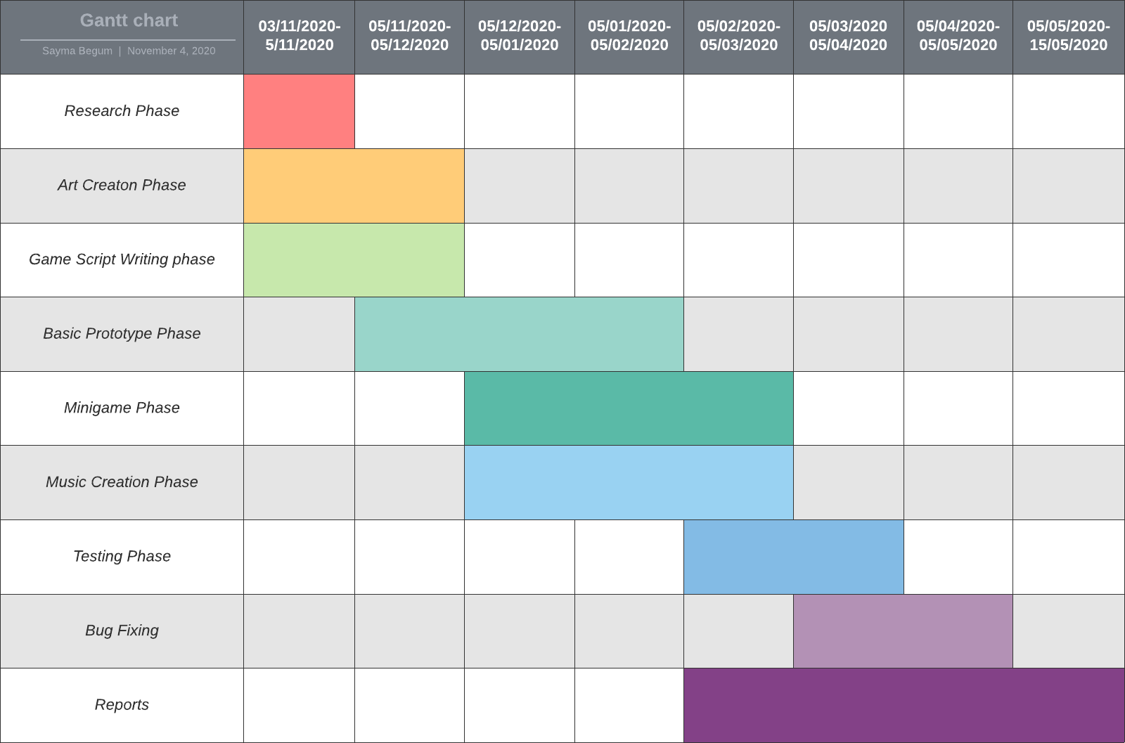

# References

* Marco Antonio Ferreira Randi and Hernandes Faustino de Carvalho. Learning through role-playing games: an approach for active learning and teaching. Revista Brasileira de Educa¸c˜ao M´edica, 37(1):80–88, 2013
* Noonoo, S. (2019, February 12). *Playing Games Can Build 21st-Century Skills. Research Explains How.* EdSurge. <https://www.edsurge.com/news/2019-02-12-playing-games-can-build-21st-century-skills-research-explains-how>
* Department of Education. (2013). *History programmes of study: key stage 3*. Gov.Uk. [https://assets.publishing.service.gov.uk/government/uploads/system/uploads/attachme](https://assets.publishing.service.gov.uk/government/uploads/system/uploads/attachment_data/file/239075/SECONDARY_national_curriculum_-_History.pdf)
* [nt_data/file/239075/SECONDARY_national_curriculum_-_History.pdf](https://assets.publishing.service.gov.uk/government/uploads/system/uploads/attachment_data/file/239075/SECONDARY_national_curriculum_-_History.pdf)
* Renpy. (2004, August 24). *The Ren’Py Visual Novel Engine*. What Is Ren’Py?<https://www.renpy.org/>
* Aaron, D. S. (2012). Sonic Pi - The Live Coding Music Synth for Everyone. Sonic Pi.<https://sonic-pi.net/>
* Elaine. (2017, November 18). *Renpy Tutorial: RPG Inventory Part 1*. YouTube.<https://www.youtube.com/watch?v=leEiOzuVpTc&t=1031s>
* Renpy. (2004a, August 24). *Screens and Screen Language — Ren’Py Documentation*.<https://www.renpy.org/doc/html/screens.html>
* OverSimplified. (2020, August 17). *The Russian Revolution - OverSimplified (Part 1)*.
* YouTube. <https://www.youtube.com/watch?v=Cqbleas1mmo>
* dino999z. (2020, September 22). *Therapy with Dr. Albert Krueger - Launch Trailer*.
* YouTube.<https://www.youtube.com/watch?v=30B7fGbe7d8&feature=emb_title> MAGES. (2016, September 9). *STEINS; GATE Steam Trailer*. YouTube.
* Universities UK. (n.d.). Higher education in numbers. Retrieved 22 March 2021, from <https://www.universitiesuk.ac.uk/facts-and-stats/Pages/higher-education-data.aspx>
* McGhee, P. (2015, April 13). What are the most popular degree courses? BBC News. <https://www.bbc.co.uk/news/education-32230793>
* BBC Bitesize. (n.d.). Reasons for the February Revolution, 1917. Retrieved 19 January 2021, from <https://www.bbc.co.uk/bitesize/guides/ztyk87h/revision/4>

# Appendix