Placement Management System

Project Overview
The Placement Management System is a backend application developed using Node.js, Express.js, MongoDB, and Mongoose. It is designed to manage Students, Departments, Staff, and Companies through REST APIs. CRUD operations were tested using Postman.

Technologies Used
- Node.js
- Express.js
- MongoDB
- Mongoose
- Postman

Modules Implemented
1. Student Module
- Create Student
- View Students
- Update Student
- Delete Student
2. Department Module
- Create Department
- View Departments
- Update Department
- Delete Department
3. Staff Module
- Create Staff
- View Staff
- Update Staff
- Delete Staff
4. Company Module
- Create Company
- View Companies
- Update Company
- Delete Company

Relationships Implemented
One-to-Many Relationship
One Department → Many Students
Many-to-Many Relationship
Many Students ↔ Many Companies

API Testing
All APIs were tested successfully using Postman.
Student APIs
- POST /api/students
- GET /api/students
- PUT /api/students/:id
- DELETE /api/students/:id
Department APIs
- POST /api/departments
- GET /api/departments
- PUT /api/departments/:id
- DELETE /api/departments/:id
Staff APIs
- POST /api/staff
- GET /api/staff
- PUT /api/staff/:id
- DELETE /api/staff/:id
Company APIs
- POST /api/companies
- GET /api/companies
- PUT /api/companies/:id
- DELETE /api/companies/:id

Screenshots
All the Project screenshots are available in the “Project Screenshots” folder.
Final Project Structure :-
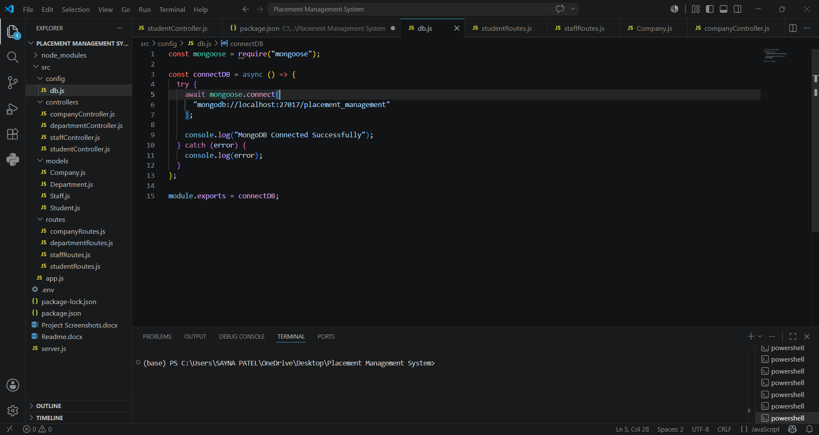
MongoDB Connected :-
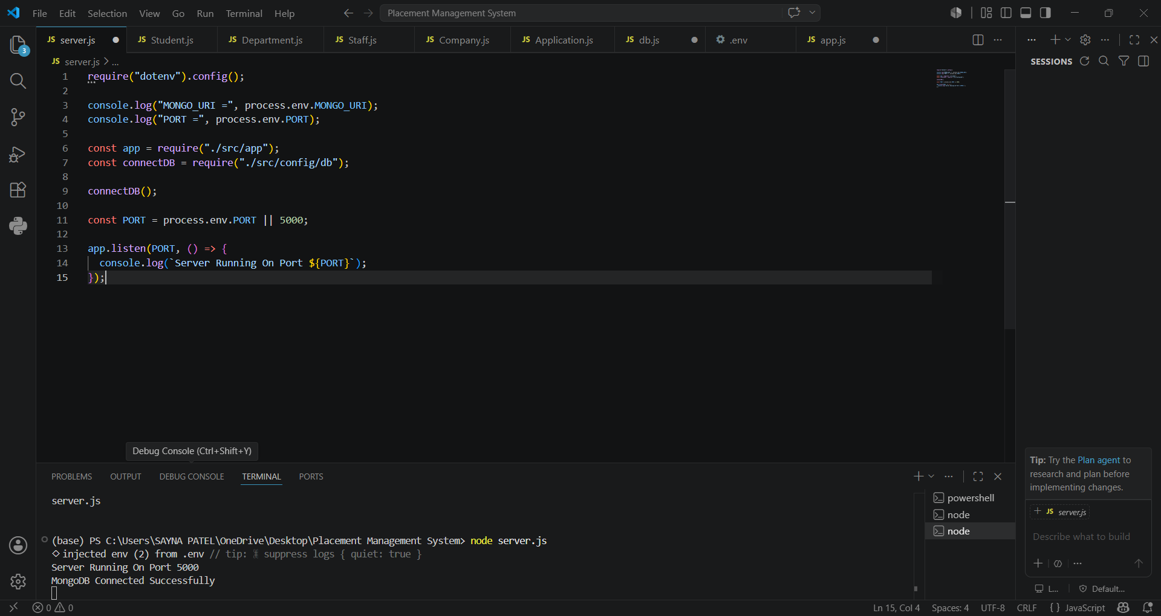
Student (POST)
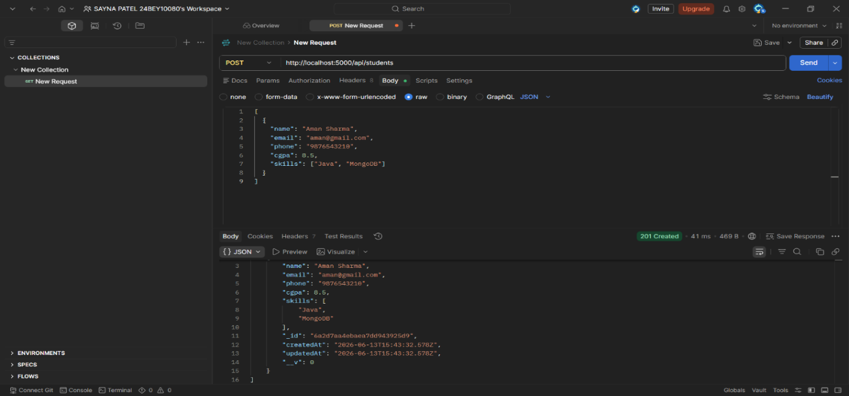
Student (GET)
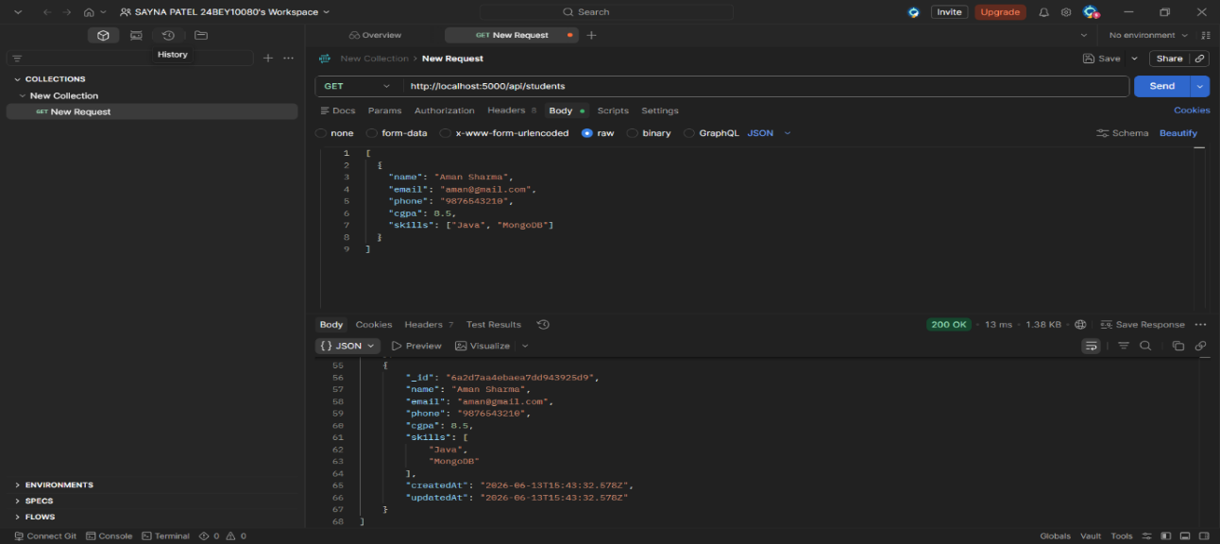
-Similarly, API testing for Staff, Department, and Company modules was successfully completed using POST, GET, PUT, and DELETE operations..
MongoDB Collections :-
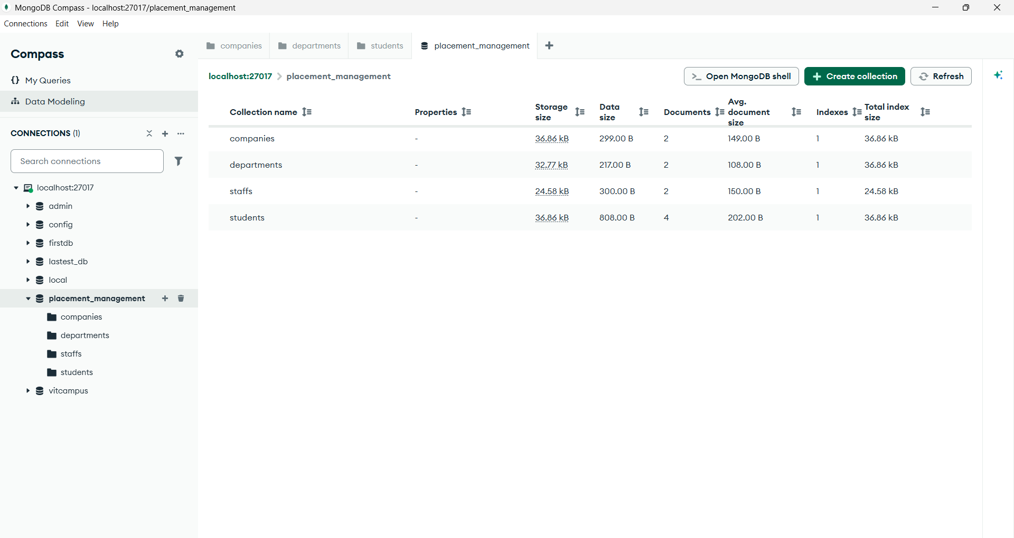

Conclusion
This project demonstrates CRUD operations, REST API development, MongoDB integration, and implementation of One-to-Many, Many-to-One, and Many-to-Many relationships using Mongoose ObjectId references and populate().

