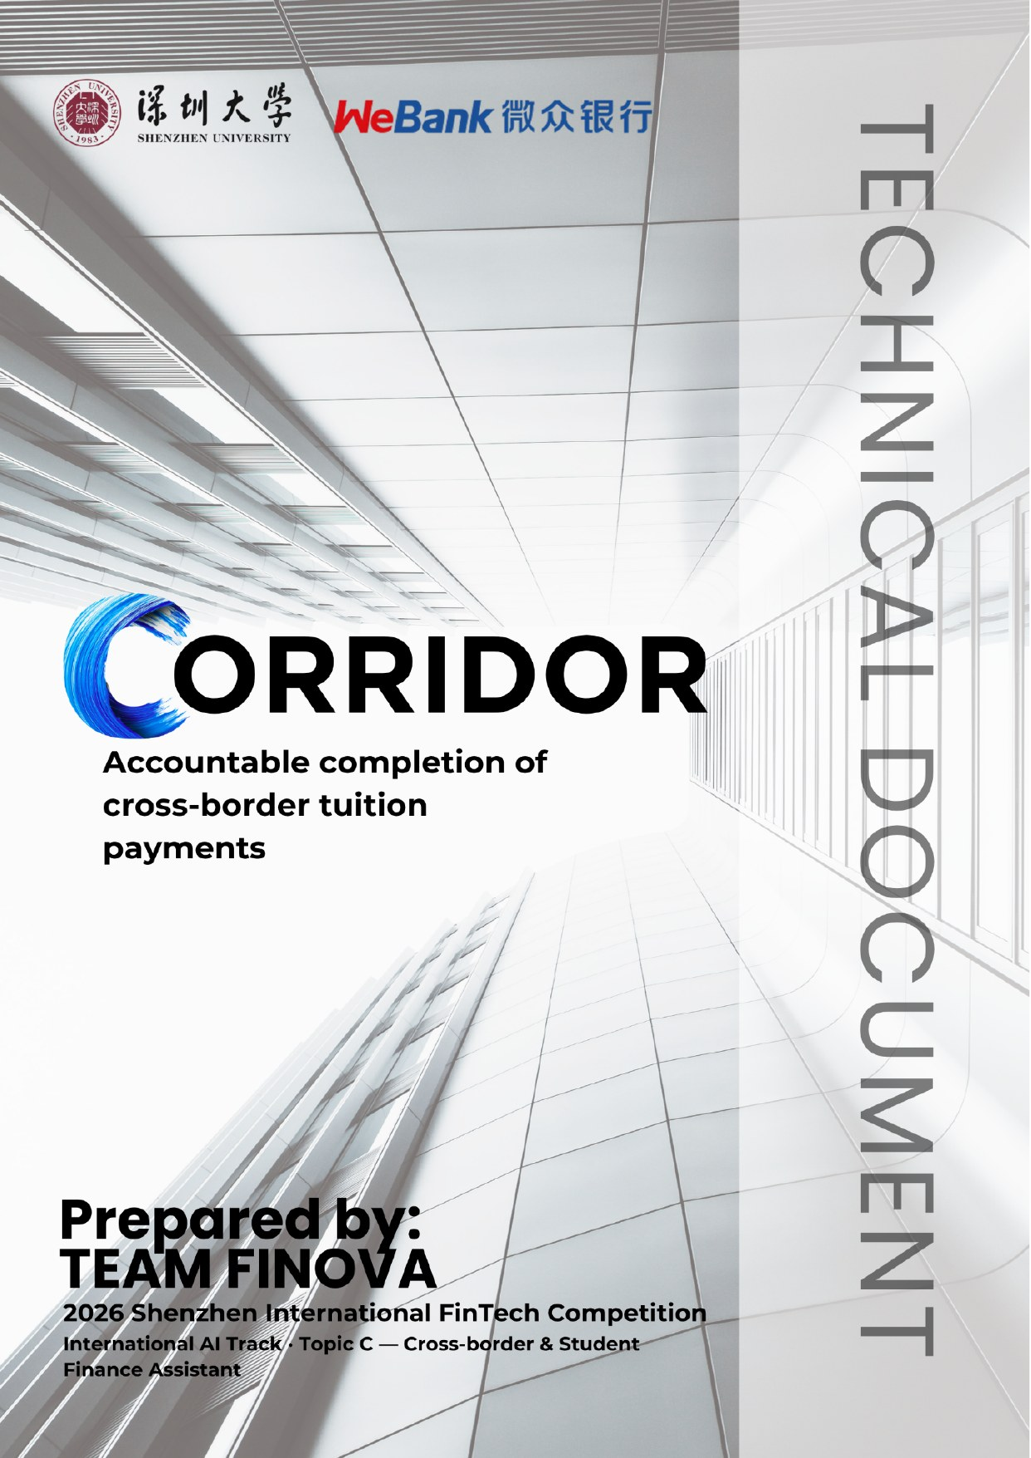

Team name | FINOVA
Competition track | International AI Track · Topic C — Cross-border & Student Finance Assistant
Submission date | 19 October 2026

A. PROJECT OVERVIEW
1. Problem, Target Users and Selected Topic
Corridor helps international students and their families complete a tuition obligation across currencies, with the right amount reaching the right university account on time while preserving the student’s living-cost reserve. It connects the payment decision, the authority to act and the evidence of completion in one accountable workflow.
A student may receive the tuition bill while a parent controls part of the funding and the university controls the final account posting. The student must connect these decisions before the deadline. At NUS, outstanding fees can restrict course enrollment and access to examination results; a GIRO debit can take two to three working days to appear in the student account, and partial GIRO deductions are not processed [1]. These are institution-specific examples of why timing, funding and confirmation matter.
The evidence supports this coordination problem. UNESCO reports nearly 7.3 million students studying abroad in 2023 [2]. Flywire’s 2025 report covers 1,072 international students at six business schools in France and Spain, surveyed in October 2024: parents made 54% of tuition payments, nearly 84% used the institution’s website for payment guidance, and 53% emailed their institution for clarification [3]. These findings establish a substantial role for families and institutional information, while remaining specific to that sample.
Our initial users are students whose tuition depends on both local funds and a family payer abroad. Family members need control over their own accounts; students need to protect living expenses; university finance teams need accurate references and evidence when a payment cannot be matched. The working prototype uses a fictional institution, Lion City University in Singapore, and an IDR–SGD scenario under Topic C, Cross-border & Student Finance Assistant: Putri, a student in Singapore, and her father Budi, who pays from Jakarta in Indonesian rupiah.
2. Core Value and Innovation
Corridor’s contribution is a coordinated decision and execution process for a specific obligation. A plan is eligible only when it satisfies funding, account ownership, institution policy, net receipt, timing and consent together. Each decision retains the evidence on which it depends; uncertainty remains visible until an authorized source resolves it.
The prototype implements this end to end: a source-verified invoice, a funding plan that protects the living reserve, a route chosen by deadline and family budget, approval by each owner of each debit, idempotent execution, and university posting tracked separately from the transfer. A multilingual agent explains every step and every rejected option.
Stakeholder | Decision Corridor supports | Value to validate
Student | How much can I contribute without using protected living funds? | Fewer funding errors and a clear next action.
Family payer | What will my account be charged, and what exactly am I approving? | Control over debit, beneficiary and purpose.
University finance team | Which obligation does this payment satisfy, and what evidence supports that status? | More complete enquiries and less reconciliation effort.
3. Position Within The Existing Payment Ecosystem
Established providers already support a broad payment journey. Flywire describes student-information-system integration, account posting and reconciliation, with regional product differences [4]. Convera describes payment tracking, reconciliation, institution integration and fraud support [5]. NUS offers third-party payer requests [1]. Corridor’s differentiation hypothesis is the explicit coordination of household contributions, protected living funds and owner-specific authority around those existing services.
Alternative | Established value | Corridor must demonstrate
Official guidance and checklist | Trusted instructions and clear payment steps. | A correct next action with fewer clarification steps in ambiguous cases.
Institution payment portal | Payment methods, tracking and, where integrated, posting and reconciliation. | Better coordination of household constraints without duplicating the portal.
Structured form and rules | Exact calculations and repeatable eligibility checks. | Useful extraction and clarification beyond the same planner without an LLM.
Finance support staff | Human resolution of exceptions and unmatched payments. | A more complete case record and less avoidable investigation.
These are comparison questions, not claims that a competitor lacks a feature. Our position is an institution-connected coordination service. Its value must be demonstrated on the same task, with equivalent data and a credible alternative.
4. Relevance To Cross-Boundary Data Validation
HKMA documents the use of the Shenzhen, Hong Kong Data Validation Platform to verify university offer letters for cross-boundary remittance checks [7]. WeBank Technology Services documents its role in operating the platform [8]. This is relevant prior art: document validation already has an education-payment use case. Corridor implements an application workflow, on simulated issuer and verifier services, that connects a validated claim to an eligible plan, owner approval and an independently confirmed outcome.
The design therefore separates document integrity, issuer authority, current obligation and payment status. An authentic offer letter does not establish a current tuition balance or authorize a debit. The IDR–SGD prototype uses a local issuer and verifier (Ed25519 signatures and a trust registry) and simulated verification events; it does not assume DVP access or support for that corridor.
5. A Focused Expression Of The Original Product
The six original features remain connected to one journey: smart routing chooses a feasible funding path; tuition autopilot sequences approval and payment; the wallet distinguishes available, reserved and pending balances; language support (English, Bahasa Indonesia, Russian, Kazakh, Chinese and Vietnamese) clarifies instructions; the scam shield checks recipients and suspicious changes; and credit coaching explains host-country financial information. Rate-watch alerts cannot initiate a transfer. Credit-coaching progress records learning steps, not an official credit score.
The transaction scope supports student payment, direct family payment, or a family top-up followed by one accepted university payment. Split campus payments are allowed only when the institution explicitly supports them. Credit coaching is an informational extension; lending, custody, investments and automated refunds are outside the prototype.
6. How The Prototype Demonstrates Competition Value
Official criterion | Corridor evidence (implemented)
Task completion 40% | The SGD 2,000 obligation reaches signed university posting (POSTED); the SGD 1,500 reserve remains intact; every leg carries an idempotency key. Covered by 20 agent tasks and 37 tuition-case tests.
Security and compliance 30% | Owner-specific authority holds under prompt injection, forged sessions, lost provider responses and model outage: 14 chat attacks, 13 direct policy attacks, 7 role-session tests, 5 outage tests and 6 audit-chain tests.
Innovation and interaction 30% | A guided step-by-step tuition flow; follow-up questions and corrections in six languages; reasons for every rejected route; a labelled simplified mode when the model is down. The LLM’s own contribution is evaluated separately (C.3c).
B. SYSTEM ARCHITECTURE
1. Architecture Diagram And Component Responsibilities
Corridor is one Next.js application with separated modules. The language model interprets requests and explains decisions. Deterministic services calculate amounts, enforce authority and manage payment state. This division keeps the implementation compact while making each sensitive action inspectable.
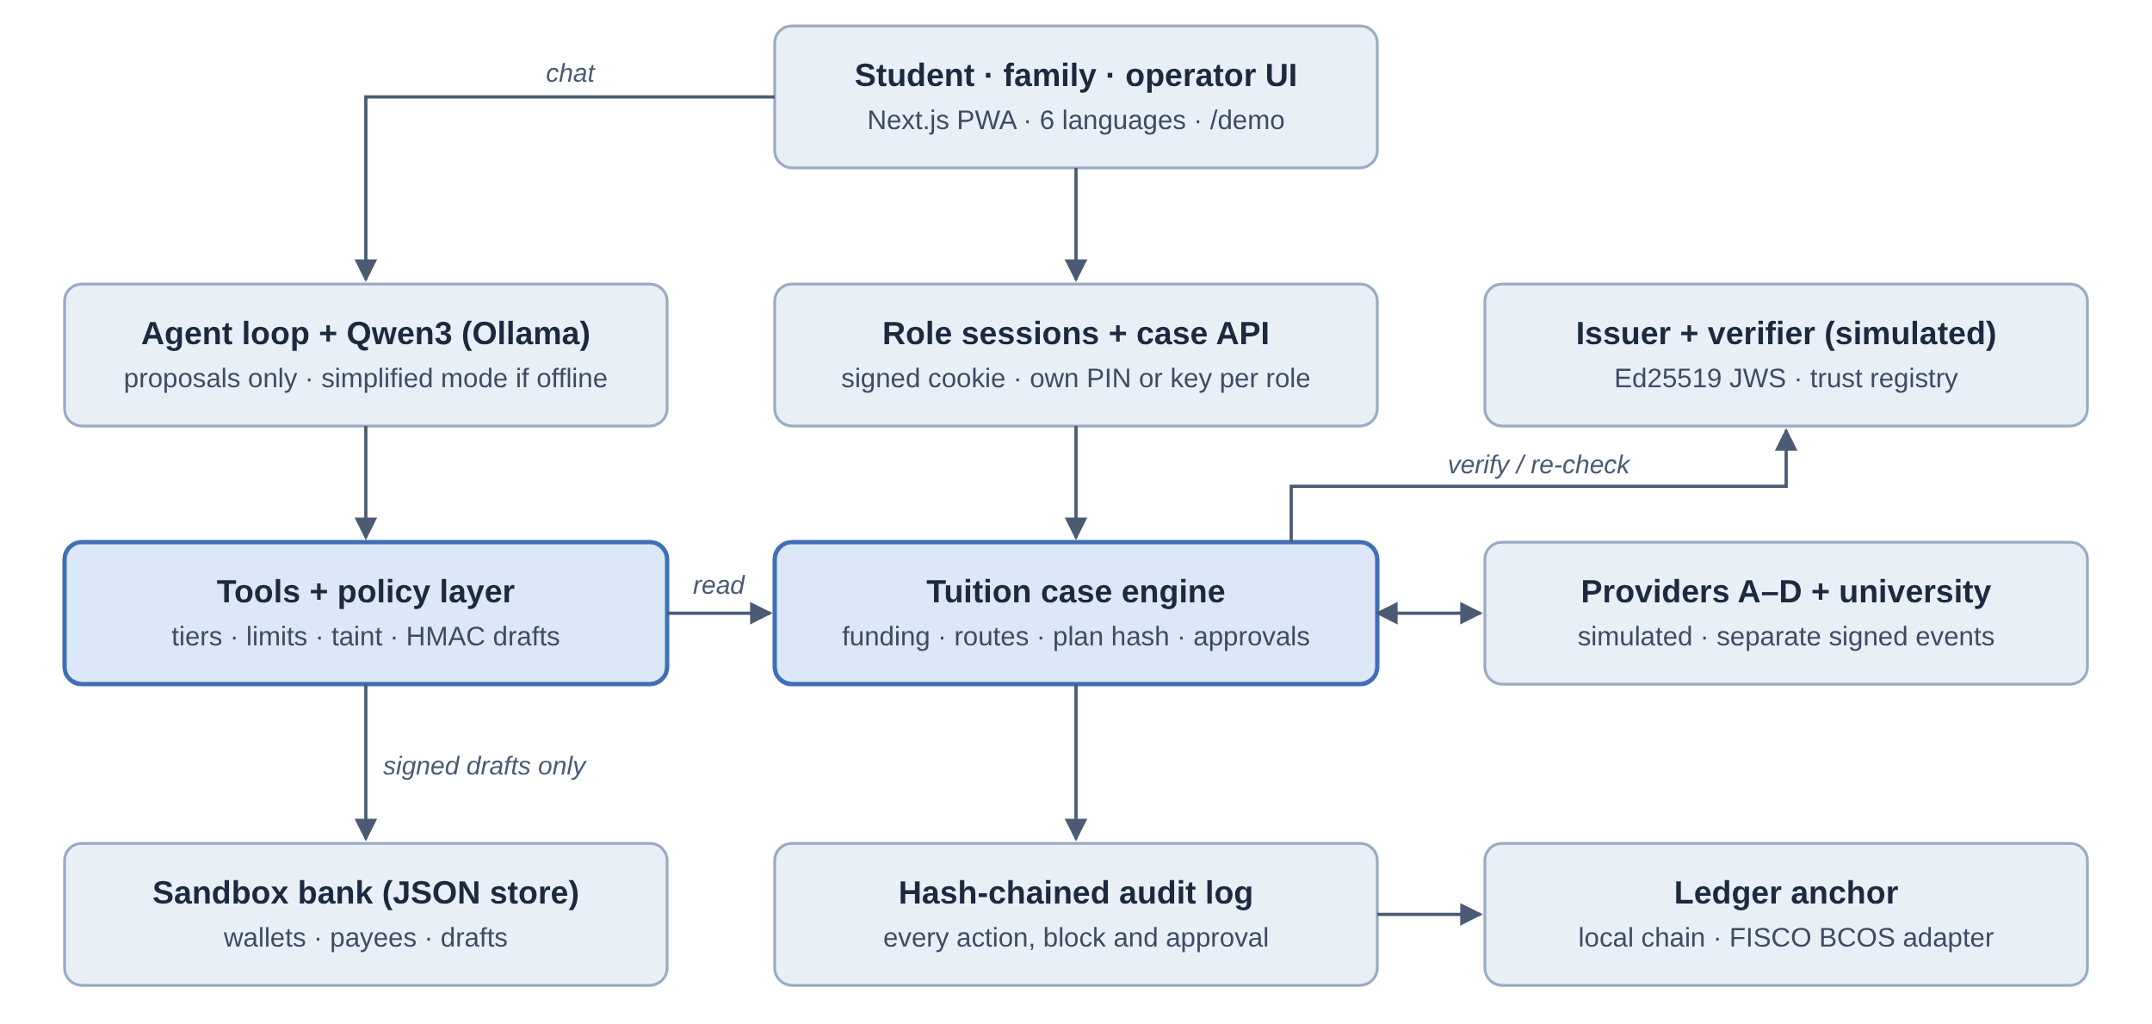
Figure 1. Implemented prototype architecture. The model has no payment credentials or execution path. Provider and university events remain separate even though both come from the simulator.
Component | Responsibility and boundary
Interface (Next.js PWA) | Overview, step-by-step Tuition flow, Funds, Help (agent), Shield, operator Console and a 16:9 /demo mode; six languages.
Role sessions and case API | Student by default; family payer and operator sign in with their own PIN or key. HMAC-signed HttpOnly session, 8-hour lifetime, lockout after 5 failures.
Agent and tools | Qwen3 tool calling over 14 tools; read and draft only. No privileged writes; falls back to a rule-based simplified mode if the model is unavailable.
Policy layer | Permission tiers, limits, cooling-off, saved payees, taint from untrusted content, HMAC-signed drafts and re-checks at execution.
Tuition case engine | Documents, consent, verification, funding, route quotes, immutable plan hash, per-owner approvals, idempotent execution, reconciliation, posting and support pack.
Issuer and verifier (simulated) | Ed25519 JWS over the SHA-256 of the exact invoice file; trust registry; revocation, new versions and expiry.
Providers and university (simulated) | Routes A–D, transfer outcomes and signed posting events; the operator console injects failures.
Store and audit | JSON files for sandbox state; hash-chained audit log; chain head anchored to a ledger.
2. Models, Tools, Data Sources And External Services
The prototype is built with Next.js 15 (App Router), React 19 and TypeScript for both the interface and the API. Sandbox state is stored in JSON files under data/; the prototype has no separate worker or database. The language model is Qwen3 8B served locally by Ollama (Qwen3 4B in the Docker setup); any OpenAI-compatible endpoint can be configured without code changes. Fields are extracted from the PDF text layer and shown beside the original for user confirmation; OCR is not used. No proprietary model training or federated learning is required for this scope.
Input or service | Use | Provenance or control
Tuition document | Amount, currency, reference, due date, student ID, university and payee account. | Synthetic PDF from the simulated issuer; SHA-256 of the exact bytes; fields must be confirmed; the plan uses issuer-signed values.
University rules | Accepted methods, payee account, reference format, 15:00 SGT cutoff, no partial payments, 1-business-day buffer. | Versioned rule set of the fictional institution.
Balance snapshot | Available contribution, protected reserve, holds; pending incoming funds are not counted. | Source and observation time recorded in the case.
Payment quote | All-in IDR debit, fees, net SGD, posting date, 15-minute expiry. | Synthetic routes A–D; the quote ID is bound into the plan hash.
FX rates (wallet) | Conversions, comparisons and rate alerts. | Live mid-market rates from open.er-api.com; labelled sample rates when offline.
Model endpoint | Intent, tool calls, clarification and explanation. | Local by default; system prompt and tool schemas versioned in the repository; 60-second per-call timeout.
Evidence verifier | Issuer, subject, obligation and status of a specific invoice. | Simulated local issuer and verifier; external DVP integration is a future dependency.
3. Evidence Is Attached To A Claim
Each state is a separate assertion with its own source, not a single confidence score. Matching a PDF to a policy does not authenticate the PDF; a document hash alone does not identify a trustworthy issuer. The case tracks:
• Invoice verification: VALID, MISMATCH, EXPIRED, REVOKED, UNKNOWN_ISSUER or UNAVAILABLE; extracted fields stay unconfirmed until the student confirms them.
• Plan: DRAFT, NEEDS_INFORMATION, READY, APPROVED, BLOCKED, EXPIRED or SUPERSEDED, with a reason code when blocked.
• Transfer: PROCESSING, SETTLED, FAILED or UNKNOWN (reconciled with the original idempotency key).
• University posting: NOT_OBSERVED, PENDING, PARTIAL or POSTED, each from a signed event.
Each proof records the issuer and key ID, document hash, subject reference, obligation ID and invoice version, issue and expiry times, status reference, audience, purpose, nonce and the consent reference.
Future DVP connectivity belongs behind this verification interface, subject to access, supported issuers, document types and jurisdictions. The interface must not infer current payment status from document authenticity or claim that sending a document to an external model preserves data locality.
4. Records Needed For Reproducibility
The payment case holds the obligation and its documents. The balance snapshot, constraints (reserve, family limit) and quotes preserve the decision inputs. The plan stores an immutable version and SHA-256 hash. An approval binds a role to the plan ID, version, hash and owned steps. A payment attempt stores the stable idempotency key, status and provider reference. Case events and the hash-chained audit log preserve sources, timestamps and reason codes. Uploaded files are stored separately from logs.
5. Tool And API Contracts
Contract | Typed result and execution boundary
POST /api/cases/:id/documents | Stores the file and its SHA-256; extracts draft fields. Critical fields require confirmation; extraction grants no authority.
POST .../verification-consents, .../verifications | Records consent, then verifies issuer signature, subject, obligation and status.
PUT .../funding-constraints, POST .../calculate | Reserve and family limit; funding split, schemes and quotes for routes A–D with reason codes.
POST /api/cases/:id/plans | Eligible route and immutable plan hash. A deterministic decision; the model cannot call it.
POST /api/plans/:id/approvals | Authenticated owner approval of that owner’s steps, bound to the plan version and hash. A chat message cannot substitute for this endpoint.
POST /api/plans/:id/execute | Re-checks proof, quote, approvals and reserve; persists attempts before dispatch. Repeated requests return the existing attempts.
GET /api/cases/:id/status, .../support-packs | Separate funding, transfer and posting states; support pack without personal fields by default.
Agent tools (14) | get_balances, get_bills, list_payees, get_recent_transactions, get_fx_quote, compare_routes, check_message_risk, get_credit_plan, get_tuition_case, what_if_reserve, present_plan, set_rate_alert, propose_conversion, propose_payment. No tool approves, executes, adds payees or changes limits.
C. AGENT DESIGN
1. Intent Understanding, Planning, Tool Use And State Management
Every user message passes through a multilingual risk scan before it reaches the model. A high-risk message (injection, changed bank account, urgency, credential requests) taints the turn: the policy layer refuses any payment draft in it, whatever the model does. The message, the last ten turns and the system prompt then go to Qwen3, which may call tools for up to eight steps. A guard stops repeated identical calls. Tool results become cards in the interface; the reply stays short.
The agent understands intent, amounts, currencies and deadlines in six languages and replies in the user’s language. Its behaviour is defined by explicit rules:
• Facts come from tools. Balances, rates, payees and invoice numbers are never invented.
• One follow-up when something essential is missing. "Send money to my dad" leads to a question about the amount; the next answer is combined with the original request.
• Corrections replace drafts. "Sorry, I meant 300" produces a new proposal; the earlier draft simply expires unconfirmed.
• Tuition goes only through the verified case. The agent reads the case and can run what-if calculations, but it never pays the university directly and never says tuition is paid before POSTED.
• Rejected options are explained with reason codes, such as DEADLINE_INFEASIBLE or SHORTFALL.
• Graceful failure. If the model is unreachable or exceeds the 60-second timeout, a labelled simplified mode answers balance, rate, bill and tuition-status questions without the model and drafts no payments; a 60-second circuit breaker avoids waiting on a dead model.
2. Separate The Plan From Each Payment Attempt
The plan is a decision; an attempt is an action. The plan records the obligation, funding split, chosen quote and owners, and is sealed by a SHA-256 hash. Each approval refers to that hash, and any material change (amount, payee, quote, reserve, invoice version or a new hold) supersedes the plan and cancels its approvals. Each executed leg is a separate attempt with its own idempotency key, so a failed tuition leg can be re-planned while a settled family top-up is kept.
3. Core Algorithms And Evaluation Approach
a. Funding Is Calculated Before Currency Is Converted
Money is stored as integer minor units with an explicit currency exponent. For each account, spendable funds equal ledger balance minus protected reserve and active holds, floored at zero. The usable contribution is also capped by the owner’s permitted contribution.
For a local onward payment, the required top-up is the unpaid tuition amount plus any uncovered onward fees, less the permitted local contribution, floored at zero. The worked fixture below has no existing holds, no prior campus payment and zero onward fees. All figures are synthetic.
Fixture item | SGD
Student ledger balance | 3,120.40
Protected living-cost reserve | 1,500.00
Permitted spendable contribution | 1,620.40
Tuition obligation | 2,000.00
Required net top-up | 379.60
Three funding schemes are checked: the student pays everything (rejected, RESERVE_BREACH), the family pays the university directly (rejected, METHOD_UNSUPPORTED: an international IDR wire is not an accepted method) and the family tops up the student, who pays locally (chosen). A lower family debit caused by using more student money is not a like-for-like saving.
In the successful fixture, the settled top-up increases the student balance to SGD 3,500.00. One SGD 2,000.00 campus payment leaves SGD 1,500.00. Until that top-up is available, the onward payment cannot reserve SGD 2,000.00. The SGD 379.60 is a funding requirement, not measured savings.
b. Feasibility Precedes Price Ranking
A candidate must satisfy payer and method eligibility, accepted beneficiary and reference, current evidence and quote, the family limit (IDR 4,800,000 in the fixture), net delivery and the deadline. Business days are counted in Singapore time with a 15:00 cutoff, and the institution’s 1-business-day buffer is kept. Unknown material fees produce UNKNOWN_FEE; if every route fails, the plan is BLOCKED with explicit reasons.
Route | Family debit IDR | Net SGD | Days to posting | Decision
A · Bank wire | 4,680,000 | 379.60 | 5 | DEADLINE_INFEASIBLE
B · Partner network | 4,725,000 | 379.60 | 2 | Eligible (keeps the 1-day buffer)
C · Card top-up | 4,640,000 | 374.60 | 1 | SHORTFALL (SGD 5.00 fee)
D · P2P marketplace | 4,593,000 | unknown | 1 | UNKNOWN_FEE
The planner also checks existing holds and active attempts for the same obligation. The time calculation advances from the effective start (after the cutoff) through business days, then checks the posting date against the due date minus the buffer. A displayed exchange rate alone is insufficient to authorize a payment.
c. Evaluation Separates Control Correctness From AI Usefulness
The planner ranks only eligible routes under the same contribution policy. Amounts in different currencies are never compared as bare numbers. For route B the explanation is specific: A misses the deadline, C arrives SGD 5.00 short, D does not disclose its fee, and B fits the family limit and posts on the last business day that keeps the buffer. Lowering the family limit below IDR 4,725,000 makes the plan BLOCKED with BUDGET_EXCEEDED.
Evaluation uses deterministic fixtures for financial correctness, adversarial cases for authority and privacy, and agent scenarios for interaction. A planned ablation compares full Corridor with the same planner and structured forms but no language model, to isolate whether conversational extraction and clarification add value.
Claim to evaluate | Measure | Status
The obligation is completed correctly | Net institution posting, reference match, timeliness and reserve preservation. | Implemented: tuition-case tests C01–C30 on fixed fixtures.
Controls contain unsafe actions | Unauthorized debits, duplicate debits and false completion claims. | Implemented: attacks A01–A14, policy P01–P13, roles C31–C37, plus two invariants after every scenario.
AI interprets the task reliably | Correct tool use, clarification behaviour, corrections, language coverage. | Implemented: agent tasks T01–T20, run with the rule-based test model; re-runnable on any configured model.
The workflow reduces user effort | Time to a correct next action or approved plan; critical errors. | Planned: user study (E.5).
AI adds value to the workflow | Task time, corrections and completeness of captured constraints. | Planned: ablation against the same planner without an LLM.
Operation is economically plausible | Model and hosting cost, support effort per resolved case. | Planned: measure on the pilot build.
d. Interpretable Outcomes
A safe refusal is a successful control outcome for an infeasible or unauthorized request. It is not counted as a completed tuition payment. Likewise, an uncertain payment remains unresolved until evidence arrives. Reporting these categories separately prevents attractive completion figures from concealing unsafe approvals or excessive blocking.
The evaluation report counts each suite separately; an execution test checks exact ledger values, and an agent test checks tool calls, drafts and the absence of forbidden actions. Participant findings remain to be produced in the pilot.
D. SECURITY DESIGN
1. Tiered Permissions And Confirmation For Sensitive Actions
Corridor’s security objective is to keep every debit within the authority of its account owner and every completion claim within the evidence available. Controls run in the application and payment services, not in the prompt. This follows OWASP’s guidance to limit agent capability and enforce authorization in downstream systems [6].
Tier | Permitted activity | Required control
T0 | Read balances, rates, bills, history, risk scan and tuition status. | Authenticated access and minimum necessary data; no financial writes.
T1 | Create plans and user-requested rate alerts. | Validated inputs; a plan or alert grants no debit authority.
T2 | Convert the student’s own funds between wallets. | One-tap owner confirmation; daily limit S$5,000; fresh balance and quote checks.
T3 | Pay a saved, verified payee or execute an approved funding leg. | PIN or biometric of that owner; invoice match; S$3,000 single and S$6,000 monthly limits; 24-hour cooling-off for new payees.
Never | Add payees, change limits, approve for someone else, reveal PIN, tokens or the system prompt. | No tool or endpoint exists for the agent; impossible by construction.
Adding a payee, linking an account or raising a spending ceiling is a separate administrative operation requiring independent verification; the agent has no endpoint for it. The model cannot promote its own tier. A family-to-student transfer requires the family owner’s own approval even though the destination belongs to the student.
Roles are enforced by HMAC-signed, HttpOnly, SameSite=Strict sessions. The student and the family payer have different PINs, the operator console needs a separate key, and five failed attempts lock sign-in for five minutes. A plain or edited role cookie is ignored.
2. Approval Is Transaction Specific
Approval binds the owner, the steps that debit that owner’s account, and the plan version and hash, which cover amounts, currencies, fees, net delivery, reference, quote, reserve and invoice version. The student cannot approve the family debit. A family payer cannot change the student’s protected reserve. Relevant changes invalidate approval for the affected plan.
Before every leg, the service checks approval, proof status, quote validity, beneficiary and available funds again, including the protected reserve. If a quote expires while waiting, the owner reviews a newly priced plan; the system does not silently accept a higher debit.
3. Duplicate Prevention Survives An Uncertain Response
Under a per-case execution lock, the case engine validates authority, reserves funds and stores the payment attempt with a stable idempotency key before dispatching it to the (simulated) provider. Identical retries return the original attempt.
The provider adapter also enforces idempotency. A timeout after submission produces UNKNOWN, keeps the hold and triggers a status query with the original key. No new payment for the obligation proceeds until the existing attempt is resolved. Confirmed failure releases the hold only when no successful debit remains possible.
Only one active case may exist per obligation. University posting events are signature-checked before they change state, and a partial posting keeps the obligation open. Changing a local record cannot reverse a settled payment; refund handling is outside the prototype.
4. Protection Against Prompt Injection, Privilege Escalation And Privacy Leakage
Uploaded documents, forwarded messages and model output are untrusted inputs. The model receives no banking secrets, cannot edit the payee registry and has no execution endpoint. Confirmation tokens go only to the interface. Server-side validation and the institution rules determine what may proceed; prompt wording alone is not treated as a security boundary.
Threat or failure | Enforced response | Evidence (tests)
Hidden instruction in a bill or message | Treated as data; the turn is tainted; suspicious lines are flagged on the document; no tool can change policy. | A01–A03, A14; limits and payees unchanged.
Payee replacement or forged invoice | Issuer signature over the exact bytes; payee and reference checked against the institution rules. | Document tests (tampered, other student, unknown issuer).
Cross-user access or privilege escalation | Signed role sessions, per-role PIN, lockout; owner-only approvals; a guessed case ID returns NOT_FOUND. | A13, C28, C31–C37.
Expired or revoked verification | Fresh status check before execution; PROOF_EXPIRED or PROOF_REVOKED blocks; a new invoice version supersedes the plan. | Case document and recovery tests.
Information extraction | Masked account numbers; no PIN, token or prompt in replies; payer view redacted. | A06, A07, A12, C29, C30.
Model outage or loops | Timeout, circuit breaker and read-only simplified mode; repeated-call guard; 8-step cap. | F01–F05.
Tampering with history | Hash-chained audit log; anchoring refused while the chain is broken. | G01–G06.
Planned beyond the prototype: sandboxed parsing of uploads (today limited to PDF, PNG or JPG up to 5 MB), outbound network restrictions and authenticated callbacks from real providers.
5. Privacy Follows The Roles In The Payment
The student, family payer and operator receive only the information needed for their part of the case. A family payer sees the approved payment obligation and their own debit; access to the student’s balance, invoice file or history is not implied. Uploaded files are served only to the student and operator roles. The model runs locally by default, so chat data does not leave the device. Routine logs exclude credentials and unnecessary identifiers, and support packs exclude personal fields unless the student selects them.
The demo uses synthetic records. Before a real-user pilot, deployment must specify the model provider’s retention and training terms, hosting locations, cross-border processing arrangements, access controls, deletion periods and user permissions. Data needed for verification should remain at its source where the integration permits; only the necessary result should enter the workflow. No blanket data-locality or legal-compliance claim follows from this design.
An institution maintains its approved policy and beneficiary profile; the payment partner supplies supported routes and transaction evidence; Corridor enforces orchestration, access and audit controls. A production role assessment must resolve payment initiation or custody obligations, customer due diligence responsibilities and applicable data-transfer rules for the actual entities and corridor. Connecting to a regulated provider does not settle those questions for Corridor.
6. Operational Response
Every action, block and approval is written to a hash-chained audit log: each entry stores the SHA-256 of the previous one, the Shield screen verifies the chain, and the chain head is anchored to a ledger (a local hash-linked ledger by default; a FISCO BCOS adapter through WeBASE-Front and the CorridorAnchor contract are implemented but not yet tested on a live chain). Incident records connect the actor, evidence version, plan hash and attempt key.
In the prototype, revoking the invoice or taking the status service down blocks new dispatches while read access and reconciliation continue; a dedicated payment kill switch is planned. Suspected issuer compromise, account takeover or inconsistent source records require independent review; an AI explanation cannot establish that these conditions are safe.
E. DEPLOYMENT AND TESTING
1. Environment And Deployment Instructions
The prototype runs as a single local or hosted demo environment containing the web interface, API, sandbox store, simulated issuer, verifier, providers and university, and an optional local model. Live money movement does not exist in the code: every account and route is synthetic and the interface is labelled SIMULATION.
Step | Action | Verification
1 Prepare | git clone https://github.com/saynzz/corridor-app; Node.js 20+ or Docker. | package-lock.json pins dependency versions.
2 Configure | cp .env.example .env; set the LLM endpoint, CONFIRM_SECRET, SESSION_SECRET, PINs and OPERATOR_KEY. | npm run check-llm confirms the model can call tools.
3 Initialize | npm run reset | Seeds Putri, Budi, Lion City University, the invoice issuer and routes A–D.
4 Start | docker compose up --build (app, Ollama and qwen3:4b) or npm install and npm run dev. | /api/health reports the model status; the SIMULATION banner is shown.
5 Verify | npm run eval | reports/eval-report.md: 95 tests; the core journey ends POSTED with SGD 1,500 kept.
6 Reproduce | Reset and rerun from a clean checkout. | A second team member reproduces the same report.
2. Release Evidence
Each evaluation run writes reports/eval-report.md (results per suite and interaction metrics: tool calls, model steps and seconds per turn) and reports/runs/<timestamp>.jsonl with the reply, tool calls, cards, risk flags and verdict of every scenario. In the app, the evidence panel shows proof IDs, document hash, plan hash, approvals and attempt keys, and a support pack exports them without personal fields. The demo video is recorded from /demo on the same build.
The official rules accept sandbox operation evidence for non-on-chain topics. Submitted artifacts: the repository with README and lockfile, the automated test report and traces, this document, the security self-assessment and the demonstration video.
3. Prototype Status
The prototype is implemented and runnable. Repository: https://github.com/saynzz/corridor-app. Runtime: Node.js 20, Next.js 15.5.27, React 19.1.1, TypeScript 5.9. Model: qwen3:8b through Ollama (qwen3:4b in Docker). The submitted version is the latest commit on the main branch at the submission deadline; the evaluation report and the execution evidence were generated from the same code.
4. Test Cases And Results
One command runs six suites. Agent scenarios call the real agent; policy, case, outage and audit tests call the services directly, bypassing the chat interface, to test the enforcement boundary.
Suite | Tests | What it covers
Agent tasks (T01–T20) | 20 | Balances in four languages, tuition status, what-if reserve, conversions, rate alert, family transfer, rent, credit plan, follow-up question, multi-turn follow-up, correction.
Agent attacks (A01–A14) | 14 | Prompt injection (EN, RU, ID, hidden in an invoice), fake bank OTP, add payee or raise limits from chat, PIN and prompt extraction, account numbers, role escalation, over-limit, gift-card pressure.
Policy attacks (P01–P13) | 13 | Missing or forged token, wrong PIN, amount edited after signing, expired draft, replay, cooling-off, limits, unknown payee, tainted turn, university paid outside the case.
Tuition case (C01–C37) | 37 | Funding, routes, documents, approval, recovery, multi-step failure, university posting, privacy and role sessions.
Model outage (F01–F05) | 5 | Simplified mode, no money movement, circuit breaker, injection while offline, Indonesian.
Audit chain (G01–G06) | 6 | Intact chain, anchoring, edited and deleted entries detected, anchoring refused on a broken chain, rotation.
Total | 95 | 17 October 2026: 95 of 95 with the rule-based test model; 61 of 61 model-independent tests also re-run on the team's Mac. Agent suites can be re-run on Qwen3 or any OpenAI-compatible model with the same command.
After every agent scenario two invariants are checked: no money moved without confirmation, and the agent did not change the tuition case (constraints, approvals, attempts or posting). Any violation fails the scenario. Planned additions: 15 held-out cases frozen before the final run, and three repeated trials of the ten highest-risk cases reported separately.
5. User Validation And Adoption
Recruit 8–12 people with actual experience paying tuition across borders and, where available, two university finance or payment-support staff. Begin with their last real payment to test whether the coordination problem exists in the selected corridor. Use four matched synthetic cases across four conditions: official guidance, a clear checklist, a structured form with the same planner, and full Corridor. Rotate condition order and case assignment to reduce learning effects; all conditions receive equivalent policy and quote information.
Measure time to a correct next action or approved valid plan, critical errors, understanding of provider versus campus status, and completeness of a support enquiry. A provisional iteration target is at least 25% lower median task time than the checklist, with no increase in critical errors. This is a target, not a result. Report sample size, failures and participant-level differences; a small pilot cannot establish population-wide effectiveness or safety.
The initial adoption hypothesis is an institution- or payment-partner-supported service for an identifiable international student group. A first pilot would cover one institution, one corridor and approved payment methods. Institutions gain value only if the product measurably reduces incomplete enquiries or reconciliation work; families gain value only if it improves decisions without increasing cost or exposure. Neither willingness to pay nor partner access is established.
Commercial evaluation should compare support time saved and avoidable rework with model, hosting, integration and policy-maintenance costs. Institution subscriptions or usage fees are options to validate, not revenue forecasts. Any referral arrangement would require disclosure and must not change route eligibility or ranking.
Calculate annual operational value from relevant case volume multiplied by staff time saved per case and the cost of that time, less annual operating and integration costs. Measure these inputs during the pilot. Protected student liquidity and user convenience are separate benefits, not institutional revenue. A pilot expands only when decision quality, control behaviour and operating cost meet the agreed acceptance criteria.
6. Known Limitations And Progression Criteria
Boundary | Current position | Evidence needed to advance
Implementation | Runnable prototype; 95 automated tests passing on the offline test model. | Results on Qwen3 and a cloud model; held-out cases.
Authentication | Per-role PINs and signed sessions; simulated biometrics; one device stands in for three people. | Passkeys and separate accounts per person.
Storage | JSON files on one server; no encryption at rest. | Database with encryption and row-level access per role.
Generalization | One fictional institution and an IDR–SGD fixture. | Local payer research; reviewed institution policies and supported methods.
External connectivity | Synthetic quotes, accounts and confirmation events. | Provider access, verified semantics and operational agreements.
WeBank and DVP | Relevant prior art and a verification interface behind which DVP would sit. | Documented access, supported scope and tested integration.
Real-money operation | Outside the prototype. | Jurisdiction-specific regulatory and privacy assessment, responsible partners and operational controls.
The investment case for further development rests on a narrow, testable proposition: the same obligation can be funded, authorized and followed to institutional acknowledgement with fewer avoidable coordination errors. The prototype makes that proposition observable through exact financial outcomes, explicit authority and reproducible evidence.
REFERENCES
[1] National University of Singapore, Office of Finance — GIRO payment and fee payment guidance. https://www.nus.edu.sg/finance/students/student-finance-matters/payments/giro-payment
[2] UNESCO (12 May 2026) — Number of students in higher education more than doubled in 20 years. https://www.unesco.org/en/articles/number-students-higher-education-more-doubled-20-years-inequalities-remain
[3] Flywire (2025) — Guiding the international student’s financial journey: research in Spain and France. https://www.flywire.com/resources/international-student-payment-research-2025-spain-france
[4] Flywire — Education payment solutions. https://www.flywire.com/education/
[5] Convera — Payment solutions for the education industry. https://convera.com/industries/education/
[6] OWASP Gen AI Security Project — LLM06:2025 Excessive Agency. https://genai.owasp.org/llmrisk/llm062025-excessive-agency/
[7] Hong Kong Monetary Authority (10 October 2025) — Circular: Cross-boundary Data Validation Platform. https://brdr.hkma.gov.hk/chi/doc-ldg/docId/getPdf/20251010-1-TC/20251010-1-TC.pdf
[8] WeBank Technology Services (28 July 2025) — Showcases Shenzhen-Hong Kong Cross-Boundary Data Validation Platform at Data Summit 2025. https://kyodonewsprwire.jp/release/202507292857

