Introduction
In today's highly competitive banking sector, retaining customers is of paramount importance. Customer churn, which refers to customers leaving a bank, can have significant financial implications. To address this challenge, banks are increasingly turning to artificial intelligence (AI) to gain insights, make data-driven decisions, and reduce churn rates. This report explores how AI, in conjunction with a dataset representing customers from three countries - Germany, Spain, and France - can play a pivotal role in mitigating customer churn.

The dataset encompasses several critical features, including customer demographics, financial indicators, and behavioural patterns. The primary objective is to analyze how AI techniques can be leveraged to predict and proactively manage customer churn.

Current Banking Landscape
Before delving into the role of AI, it's essential to understand the current banking landscape and the challenges banks face. Customer churn, one of the predominant concerns, can be attributed to various factors, including economic conditions, customer satisfaction, and competition (FSB, 2017). It adversely affects a bank's profitability and growth.

Economic Conditions
In the banking industry, economic conditions play a significant role in customer churn. During economic downturns, such as recessions, individuals and businesses often face financial difficulties (FSB, 2017; Schildbach, 2017). This can lead to higher instances of customers closing their bank accounts or shifting their investments to more secure options. For instance, in times of economic uncertainty, customers may withdraw their savings or investments from one bank and deposit them into a bank they perceive as more stable or secure.

Customer Satisfaction
Customer satisfaction is crucial in the banking sector, as it directly correlates with customer retention. Dissatisfied customers are more likely to close their accounts and move to other banks that offer better services, lower fees, or a more personalized experience (Kim et al., 2004). Common factors that contribute to dissatisfaction in banking include poor customer service, hidden fees, and long wait times.

Competition
Competition is fierce in the banking industry, with numerous banks vying for customers' financial needs (Kim et al., 2004). Intense competition can drive customers to switch banks if they find better deals, higher interest rates, or more convenient services elsewhere. Banks must continuously innovate and offer competitive products to retain their customer.

Artificial Intelligence in the Banking Industry
Artificial intelligence has transformed the banking industry by providing banks with powerful tools to address and mitigate customer churn effectively (FSB, 2017).

Churn Prediction and Customer Segmentation
AI algorithms excel at analyzing vast datasets to identify patterns in customer behaviour. In the context of bank churn, AI can segment customers based on their transaction history, preferences, and risk profiles. This segmentation allows banks to gain deeper insights into which customer groups are more likely to churn. By understanding the unique characteristics of these at-risk customers, banks can tailor retention strategies more effectively, thus reducing churn rates.

Early Churn Detection
AI-powered predictive analytics can forecast the likelihood of a customer churning from a bank. These predictive models utilize historical data and real-time information to identify customers who exhibit signs of potential churn (Bilal, 2016). By detecting churn signals early, banks can take proactive measures, such as offering personalized incentives or improved customer service, to retain these customers before they decide to leave.

Personalized Retention Offers
AI-driven recommendation engines play a pivotal role in retaining bank customers. These engines analyze customer transaction histories and financial preferences to suggest personalized retention offers. For instance, if a customer frequently uses credit cards for international travel, AI can recommend travel-related perks or rewards to incentivize them to stay with the bank. This level of personalization enhances the effectiveness of retention efforts (FSB, 2017).

Enhanced Fraud Detection
AI algorithms are highly effective at detecting unusual patterns and anomalies in transaction data. In the context of bank churn, AI-driven fraud detection systems not only protect customers from unauthorized transactions but also contribute to churn reduction. When customers experience fraudulent activities on their accounts, it erodes trust and satisfaction, potentially leading to churn. AI's ability to swiftly detect and prevent fraud helps maintain customer trust and loyalty (Mai, 2018).

Dataset Overview
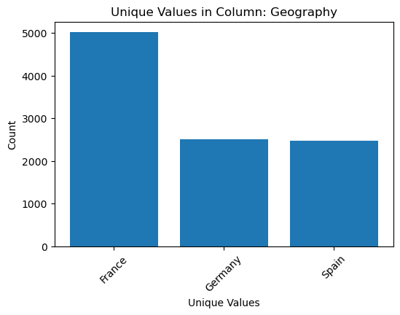
The dataset provided for this analysis comprises 13 features, including customer-specific attributes such as credit score, age, and balance, as well as behavioural indicators like the number of products held and credit card usage. The target variable, "Exited," signifies whether a customer has churned or not. The distribution of some of the features of the dataset is below:
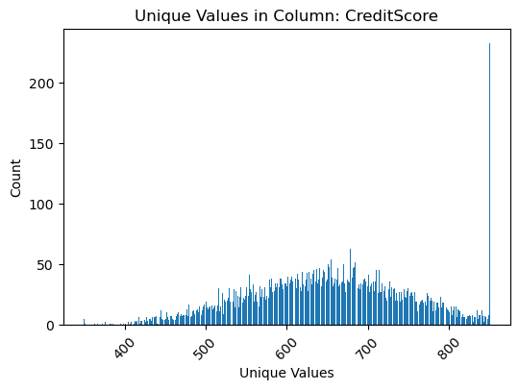

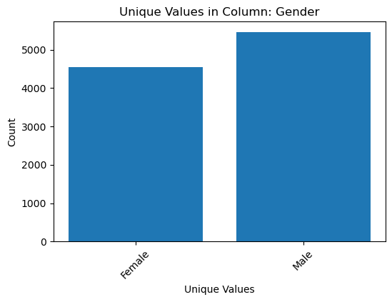
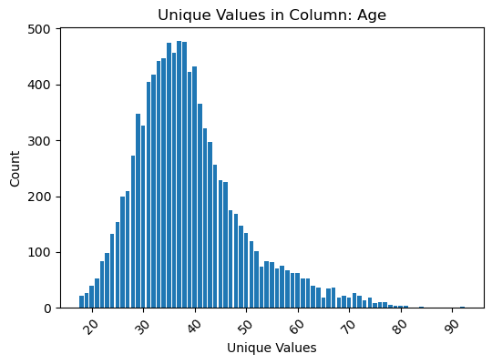

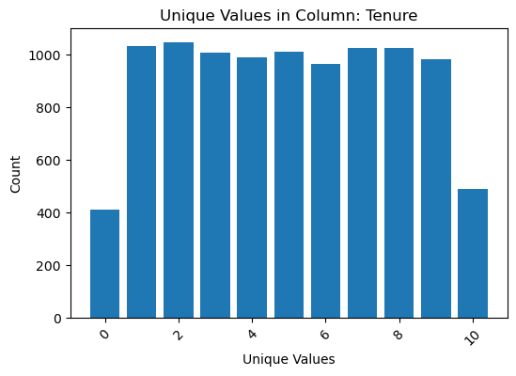
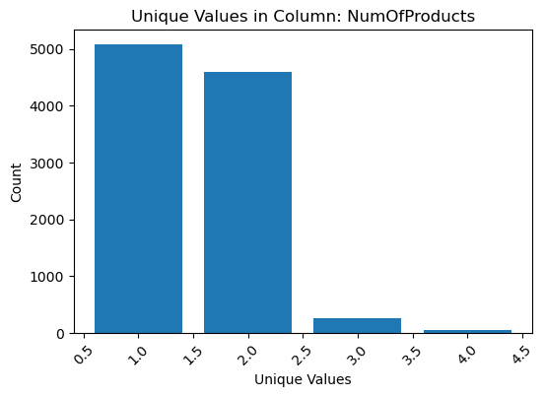

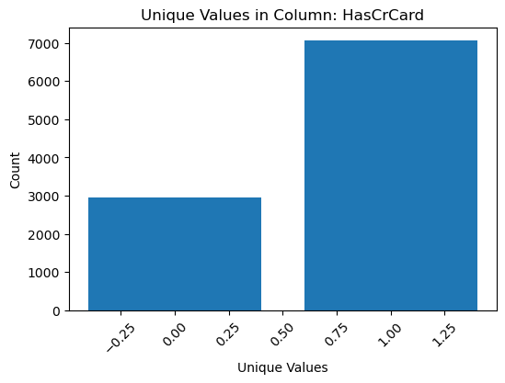
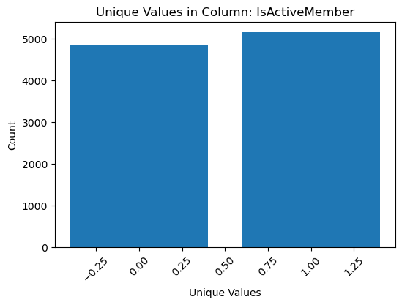

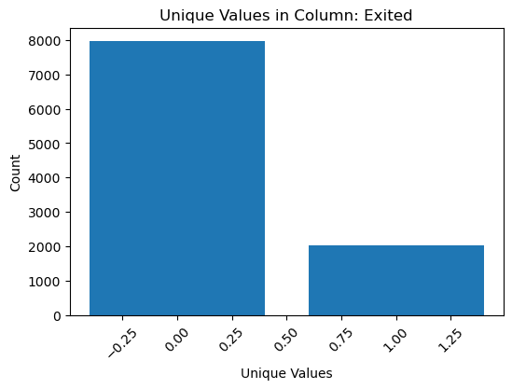

Some Machine Learning Models and Algorithms Used in Banking
In this report, I will explore six AI and machine learning algorithms, three of which are regression algorithms and the rest classification algorithms to address the problem of customer churn.

Linear Regression
Linear regression is a straightforward algorithm that establishes a linear relationship between the independent variables (features) and the dependent variable (churn probability). It assumes that changes in the features have a linear impact on the likelihood of churn. The model calculates coefficients for each feature, indicating the strength and direction of their influence.

A study by Bilal (2016) titled "Predicting customer churn in the banking industry using neural networks," demonstrates how linear regression can be used in combination with other algorithms to predict bank customer churn. By analyzing historical customer data, linear regression helps identify which factors, such as account balance, transaction frequency, and customer tenure, affect churn probabilities. Banks can then use this information to prioritize their retention efforts for at-risk customers.

Decision Tree Regression
Decision tree regression partitions data into subsets based on feature values, creating a tree-like structure. At each node, it selects the feature that best splits the data to minimize the variance in churn probabilities within each subset. Decision trees recursively split the data until reaching a predefined stopping criterion, such as a maximum depth.

A study by Breimen et al. (1984) titled " Classification and Regression Trees " showcases how decision tree regression can help banks. By constructing decision trees based on customer attributes (e.g., age, income, and transaction history), the algorithm reveals the hierarchical importance of these factors in predicting churn. Banks can use this knowledge to develop targeted retention strategies tailored to specific customer segments.

Random Forest Regression
Random forest regression is an ensemble method that combines multiple decision tree regressors. It leverages bagging (bootstrap aggregating) and feature randomization to create diverse decision trees. By averaging the predictions of these trees, random forest regression reduces overfitting and enhances predictive accuracy.

In the paper "Random Forests," (2001), Breiman highlight the use of random forest regression in banking. By aggregating predictions from various decision trees, this algorithm provides a robust estimate of churn probabilities. Banks can use collective insights to identify high-risk customers and devise retention strategies that address their unique needs.

Logistic Regression
Logistic regression is a classification algorithm that estimates the probability of binary outcomes (churn or non-churn). It employs the logistic (sigmoid) function to transform a linear combination of input features into a probability score. By setting a threshold (e.g., 0.5), customers are classified as churners or non-churners.

In the research paper, " Customer Churn Prediction in Telecom Using Machine Learning in Big Data Platform" (2020) by Ahmad et al., logistic regression is utilized to classify customers as potential churners or loyal customers. By modelling the relationship between customer attributes and churn likelihood, banks can focus their retention efforts on customers with high churn probabilities, thereby making more targeted and cost-effective decisions.
Decision Tree Classifier
Decision tree classification, similar to decision tree regression, segments data into subsets based on feature values. However, in this case, it is used for binary classification (churn or non-churn). The algorithm selects features that best discriminate between churners and non-churners, helping to identify the most significant predictors of churn.

A study by Chan et al. (2019) titled "Customer Churn Prediction in the Banking Sector Using Machine Learning" demonstrates the effectiveness of decision tree classifiers in banking. By constructing decision trees, banks can visually interpret the hierarchy of influential factors affecting churn. This information guides banks in devising retention strategies tailored to specific customer segments, improving overall customer satisfaction.

Random Forest Classifier:
Random forest classification combines multiple decision tree classifiers, similar to random forest regression. By aggregating the results of individual trees, it provides a robust classification of customers as churners or non-churners, reducing the risk of overfitting and improving accuracy.

In the paper " Predicting customer churn in the Banking Industry Using Neural Networks" (2018), Bilal emphasizes the effectiveness of random forest classifiers in churn prediction. By considering diverse decision trees, banks gain insights into the complex interactions between customer attributes and churn. This comprehensive understanding informs targeted strategies to reduce churn rates.

Conclusion
In today's fiercely competitive banking landscape, where customer retention is paramount, harnessing the power of artificial intelligence (AI) emerges as a game-changing strategy to combat customer churn. This report has examined the critical role that AI, in conjunction with a comprehensive dataset representing customers from Germany, Spain, and France, can play in mitigating churn rates.
Customer churn, driven by factors such as economic conditions, customer satisfaction, and competition, poses substantial financial risks to banks. To address these challenges, AI-powered techniques offer multifaceted solutions that empower banks to make data-driven decisions for reducing churn.

AI's contributions to the banking sector are multifaceted. It facilitates customer segmentation, allowing banks to tailor their services and communications to individual customer needs. Predictive analytics enable early detection of potential churners, giving banks the opportunity to take proactive measures to retain customers. Furthermore, AI-powered recommendation engines enhance cross-selling and upselling opportunities, while robust fraud detection systems protect both customers and banks.

Through the exploration of the six AI and machine learning algorithms, including linear regression, decision tree regression, random forest regression, logistic regression, decision tree classification, and random forest classification, this report has showcased the versatility of these algorithms in addressing the problem of customer churn. These algorithms provide actionable insights into customer behaviour, allowing banks to develop targeted retention strategies.

References
- Ahmad, A. K., Jafar, A., & Aljoumaa, K. (2019). Customer churn prediction in telecom using machine learning in the big data platform. Journal of Big Data, 6(1), 28.
- Breiman, L. (2001). Random forests. Machine Learning, 45(1), 5–32.
- Breiman, L., Friedman, J., Stone, C. J., & Olshen, R. A. (1984). Classification and regression trees. CRC Press.
- FSB (2017). Artificial intelligence and machine learning in financial services: Market developments and financial stability implications.
- Kim, M.-K., Park, M.-C., & Jeong, D.-H. (2004). The effects of customer satisfaction and switching barrier on customer loyalty in Korean mobile telecommunication services. Telecommunications Policy, 28(2), 145–159.
- Mai, Heike (2018). Card fraud in Germany: Few incidents, but high costs. Deutsche Bank Research. Talking Point.
- Schildbach, Jan (2017). Where do European banks stand? 10 years after the start of the financial crisis. Deutsche Bank Research. EU Monitor.
- Zoric, A. B. (2016). Predicting customer churn in the banking industry using neural networks. Interdisciplinary Description of Complex Systems: INDECS, 14(2), 116–124.

