Ansible

Create the:
- Control Machine (Ansible Server)
  - Ansible/Jenkins
- Remote Machines:
  - Host1_Webserver
  - Host2 _DBserver
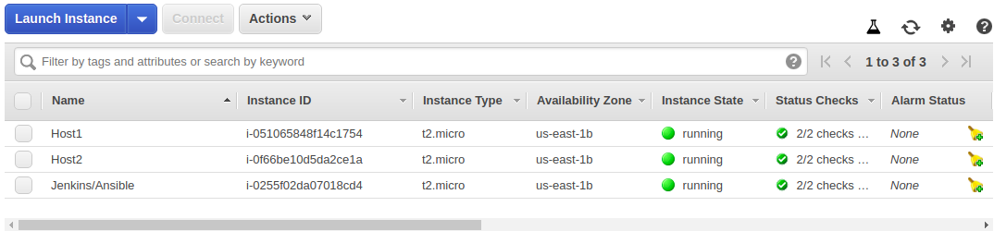

Install Ansible on the Ansible Server

$ sudo amazon-linux-extras install ansible2
$ ansible --version
$ cd /etc/ansible
$ useradd AnsibleUser
$ passwd AnsibleUser : (Password --> in this example)
$ visudo
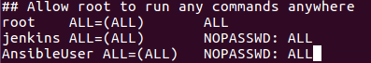

(This ensures the AnsibleUser has sudo priveledges without the requirement of having to type a password. Because when the playbook executes then if it requires a password the execution will fail)

Now create these users in each of the Remote Machines (Host1_Webserver and Host2_DBserver )
Login to Host1
$ sudo -i
- Create the User
$ useradd AnsibleUser
$ passwd AnsibleUser (Password)
- Give sudo privilege
$ visudo

Enable Password based Authentication
- $ vi /etc/ssh/sshd_config
  - Make PasswordAuthentication yes
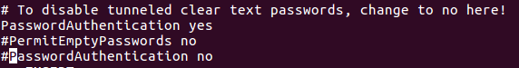
$ service sshd restart
$ su – AnsibleUser
$ sudo yum update --> if this gets executed then the above process was OK

***Follow the same steps for Host2 also***

- Login to the Ansible Server --> Login to Host 1--> ssh AnsibleUser@publicIPofHost1 --> Enter Password to Login

- Login to the Ansible Server --> Login to Host2 --> ssh AnsibleUser@publicIPofHost2--> Enter Password to Login

In the Ansible server add the hosts under group (inventory)
$ cd /etc/ansible
$ vi hosts
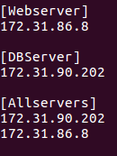

To SSH directly into the remote nodes create a private and public key pair:
- Login to Ansible server
- $ su AnsibleUser -
- $ ssh-keygen
- $ ssh-copy-id Ipaddressofinstance
  - Enter the password
- $ ssh Ipaddressofinstance

RUNNING Ad Hoc Commands
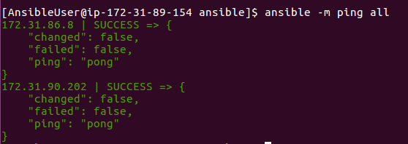

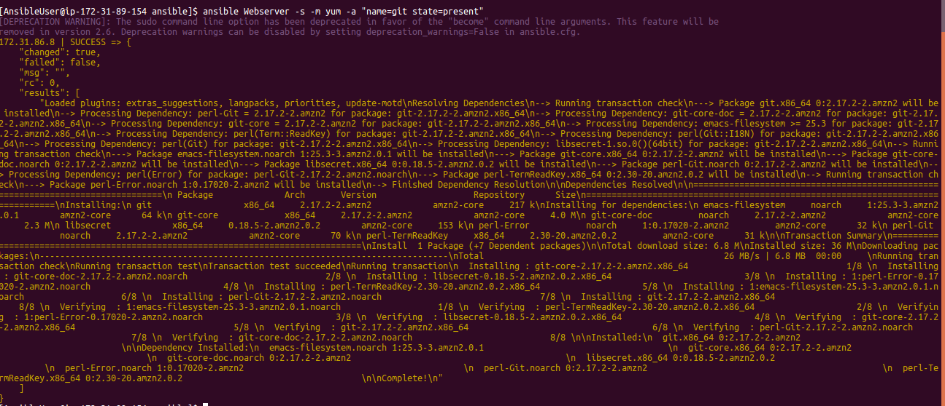

Ad Hoc Commands LAB

- Install git in all hosts
- Clone a git repo in all host machines
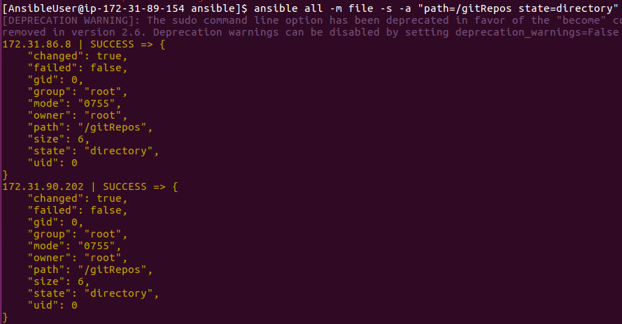
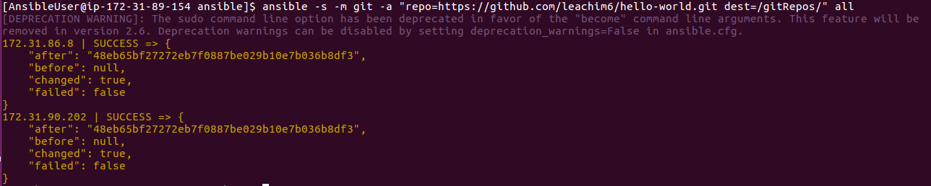
- install and start docker in all machines

- copy a file from Control machine to all machines
( From comand line)

PLAYBOOK

- $ vi playbook1. yml

- hosts: all
become: true
become_user: root
tasks:
- name: ensure httpd is at the latest version
yum: name=httpd state=present
- name: start httpd
service:
name: httpd
state: started

$ ansible-playbook playbook1.yml --syntax-check
$ ansible-playbook playbook1.yml --list-hosts
$ ansible-playbook playbook1.yml

- $ vi playbook2.yml

- hosts: Webserver

become: true

tasks:

- name: uninstall tomcat
yum: name=tomcat state=absent

- name: uninstall git
yum: name=git state=absent

$ ansible-playbook playbook1.yml

- $ vi playbook3.yml

- hosts: Allservers
become: yes
become_user: root

vars:
- packages:
- git
- java-1.8.0-openjdk
- tomcat
- httpd
- services:
- httpd
- tomcat

tasks:
- name: Install Packages
yum: name={{packages}} state=present
notify: startservices

handlers:
- name: startservices
service: name={{services}} state=restarted

$ ansible-playbook playbook3.yml

- vi debugPlaybook.yml

- hosts: all
become: yes
become_user: root
tasks:
- name: Install telnet
yum: name=telnet state=present
register: result
- debug: var=result

$ ansible-playbook playbook3.yml

