**A Mathematical Formulation for Rapid Development of Topology-Preserving Digital Twins of Smart Buildings**

Sayonsom Chanda, Kaushik Das

**Abstract**: Despite their transformative potential, commercial digital twins for buildings often fail when physical spaces change. We present a topology-preserving framework using CW-complexes that enables building twins to adapt efficiently to structural changes. Our approach expresses physical edits as algebraic operations with guaranteed homotopy invariance, requiring updates only to affected sub-graphs. The key innovation is that this approach guarantees the preservation of critical topological features of a building, while allowing localized updates. For building management systems, this means retaining digital twin validity, and its AI model compatibility even as physical spaces are remodeled. Our preliminary simulation results show 6.5x-11x speed-up over conventional digital twin simulation methods while enabling browser-based physics simulations. This innovation forms the foundation for Samsung SmartThings Pro's strategy for resilient building twins that persist through renovations and support autonomous AI applications.

# 1 Introduction

Smart building platforms face a critical challenge: digital twins become obsolete when buildings change, requiring expensive rebuilds. We propose a topological cell-complex approach that maintains structural identity through physical modifications. Our contributions include: (i) a CW-complex formalism for buildings, (ii) an edit algebra with homotopy invariance, (iii) proven complexity bounds, (iv) physics-based simulation capabilities, and (v) a commercialization pathway for Samsung SmartThings Pro.

# 2 Topological Digital Twin Formalism

**2.1 CW-Complex Building Representation**Let denote a bounded building envelope. We decompose into a finite CW-complex ( ) where is the set of -cells. Each cell carries a metric vector , semantic label , and sensor multiset .

The attaching maps specify how cells connect. For instance, : maps a 2 -cell's boundary to a cycle of edges.  
  
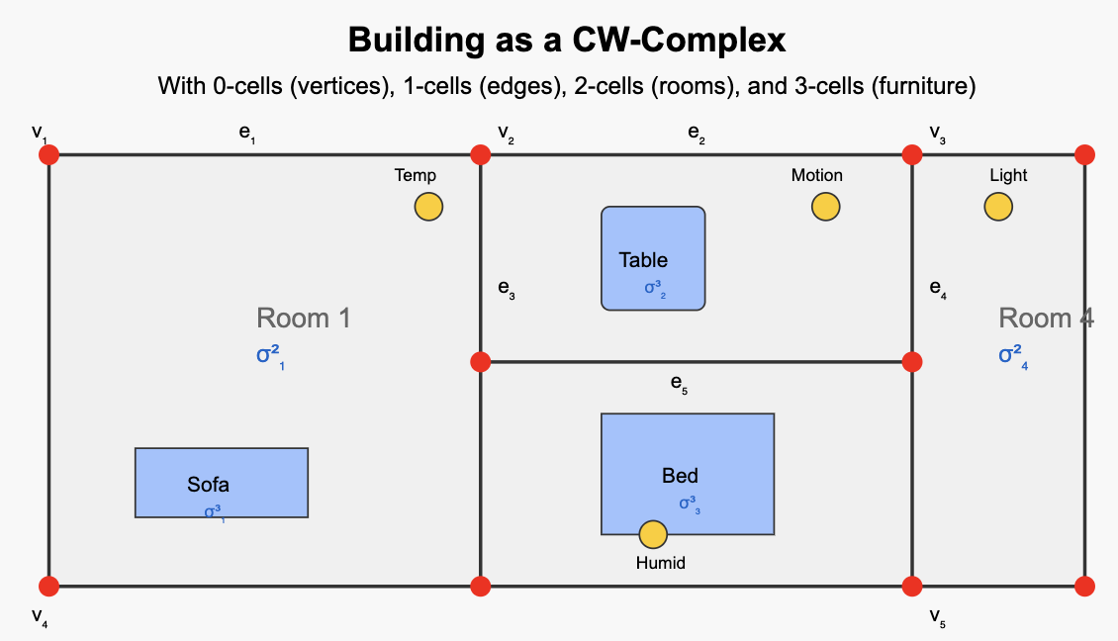

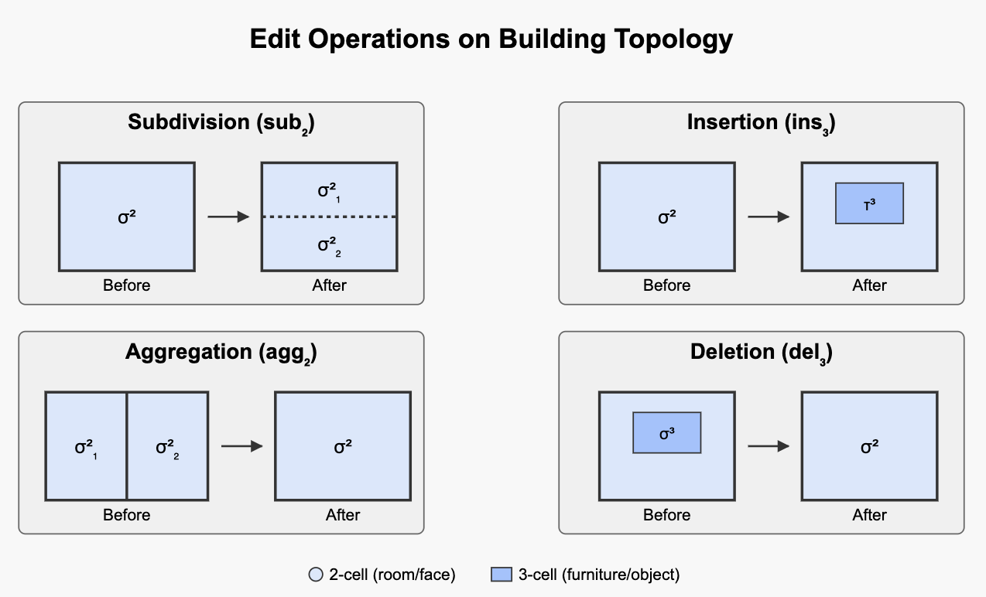

Figure 1: A building represented as a CW-complex with cells of different dimensions. Furniture items (shown in blue) are modeled as 3 -cells with boundary attachments.

***2.2 Edit Algebra and Homotopy Invariance:*** To enable topology-preserving updates, we define:  
Definition 1 (Local Edit Algebra). For , the algebra contains four generators:

1. Subdivision : Replaces with new cells
2. Aggregation Merges cells into a single cell
3. Insertion : Adds a new cell with boundary map
4. Deletion : Removes a cell not needed for higher-dimensional cells

**Theorem 1 (Homotopy Preservation).** *Any sequence in which each subdivision is followed by at most one insertion within the refined stellar neighborhood yields a complex such that (homotopy equivalent).*

The key innovation is that this approach guarantees the preservation of critical topological features while allowing localized updates.For building management systems, this means retaining AI model compatibility even as physical spaces are remodeled.

# 3 Implementation and Performance

To demonstrate practical applications, we modeled a apartment with furniture as 3 -cells and implemented computational fluid dynamics (CFD) simulations to analyze airflow patterns with an air conditioner and ceiling fan. We implemented our proposed digital twin methodology using Python and compared it with a similar implementation in OpenFOAM. Our topological approach enabled browser-based simulations without specialized software like OpenFOAM or COMSOL.  
  
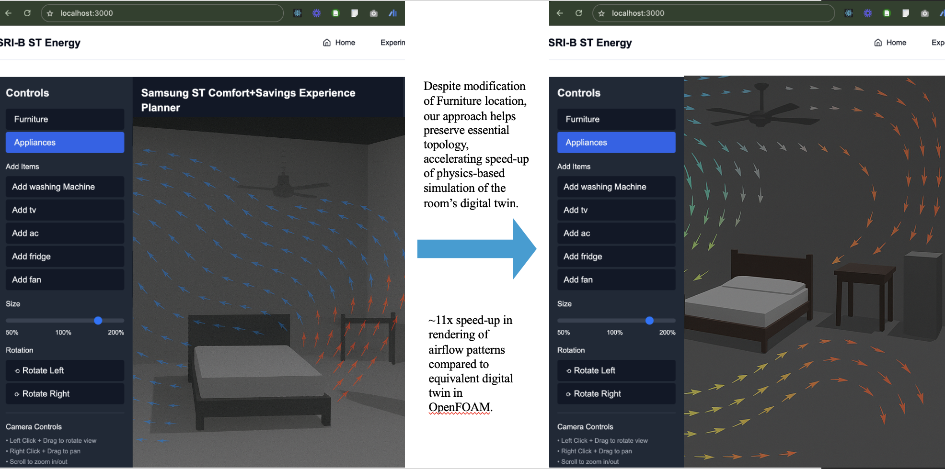

Figure 2: Browser-based CFD simulation showing airflow patterns for different furniture arrangements. Vectors represent air velocity, with color indicating temperature.

***Performance Results:*** We measured the time required to update the digital twin after physical modifications. For room modifications, our approach achieved a 10.83x speedup ( 30.3 ms vs. 2.8 s , running on the same 16GB Windows 11 running WSL Ubuntu 22.04). For furniture repositioning with airflow recalculation, we observed a 8.33x improvement ( 63 ms vs. 4.1 s ). These gains stem from our topology-preserving approach that updates only affected subgraphs rather than rebuilding entire models.

# 4 Commercial Applications and Pathway

This framework forms the technical foundation for Samsung b.IOT business unit, or SmartThings Pro's next-generation building management platform. Key commercial advantages include:

1. *Persistent Digital Twins:* Buildings maintain digital representation through renovations
2. *Autonomous Systems:* AI agents can adapt to spatial changes without retraining
3. *Real-time Physics:* Environmental simulations update instantly with physical changes
4. *Edge Deployment:* Lightweight implementation suitable for on-premises hardware

While the simulation models have shown great results, next steps towards commercializing this will be by testing with large-scale buildings, followed by integration with SmartThings Pro, releasing developer APIs, and finally a SaaS analytics platform for energy optimization and compliance reporting.

# 5 Conclusion

Our topology-preserving digital twin framework represents a fundamental advance in building informatics, enabling persistent spatial intelligence that survives physical modifications. The mathematical approach delivers both theoretical elegance and practical performance advantages that will serve as the core foundation for Samsung SmartThings Pro commercialization in the coming years. As buildings become increasingly adaptive, this framework ensures their digital counterparts can evolve with equal flexibility.

# References

[1] Denk, Martin, et al. "Generating digital twins for path-planning of autonomous robots and drones using constrained homotopic shrinking for 2D and 3D environment modeling." Applied Sciences 13.1 (2022): 105.  
[2] C. Galindo et al., "Modeling and updating of dynamic indoor environments by means of fuzzy topological maps," Robotics and Autonomous Systems, 2005.